GIST publishes first volume of 'Long-Term Cold War Series' 《Long-Term Cold War Structure and Knowledge Mechanism》

- The Center for Interdisciplinary Education and Research (CIER), led by Professor Donghyuk Kim of the School of Humanities and Social Sciences at GIST, published a series of research results that shed new light on the Cold War knowledge system (‘Long-Term Cold War Structure Research: Focusing on Knowledge, Emotions, and Life’)

- Shedding light on the continuity of knowledge, economy, and politics during the Cold War through an examination of the internalization process of the Cold War in the knowledge system

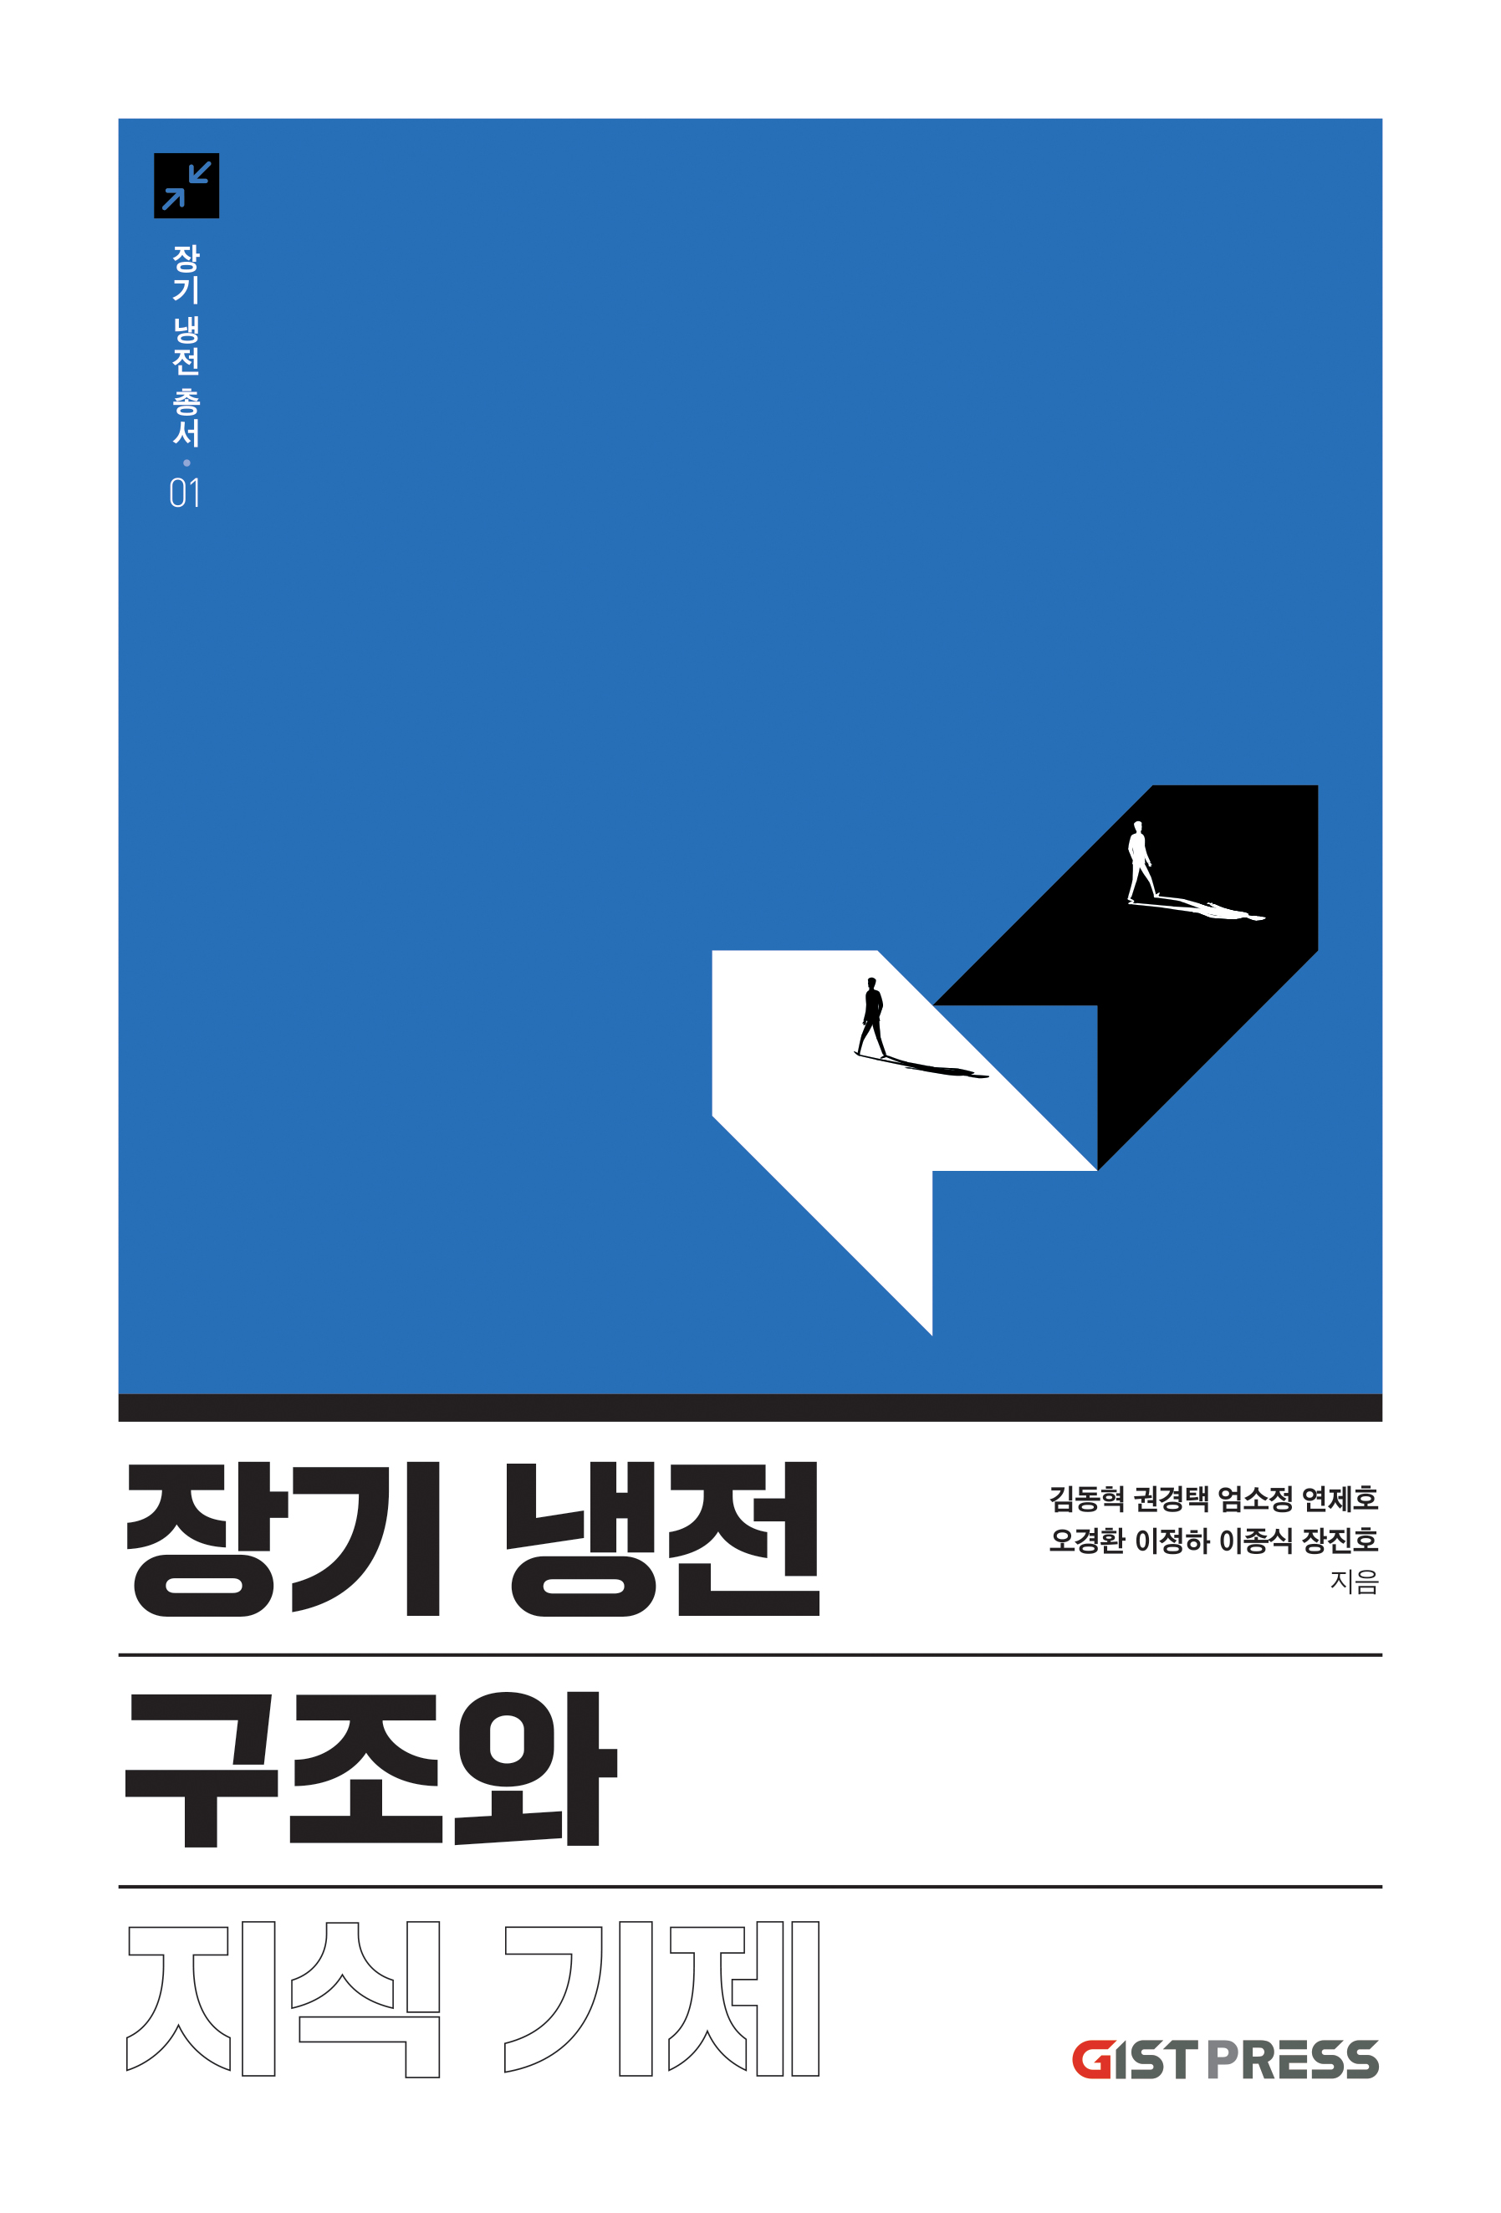

▲ Cover of the book <'Long-Term Cold War Series' Series 01: Long-Term Cold War Structure and Knowledge Mechanism>

The Gwangju Institute of Science and Technology (GIST, President Kichul Lim) announced that the Center for Interdisciplinary Education and Research (CIER, Director Donghyuk Kim, School of Humanities and Social Sciences Professor) has published the first volume of the Long-term Cold War series, <Long-Term Cold War Structure and Knowledge Mechanism>, through the university press ‘GIST PRESS’.

The Long-Term Cold War series compiles the main results of the project “Long-Term Cold War Structure Research: Focusing on Knowledge, Emotion, and Life” conducted by CIER as part of the National Research Foundation of Korea’s Humanities and Social Sciences Research Institute support project. It contains convergent research results that analyze the Cold War system not as a simple ideological conflict or a past political and historical event, but as a long-term and structural phenomenon rooted throughout the knowledge system.

The first output of the project, the first volume of the ‘Long Cold War’ series, ‘Long-Term Cold War Structure and Knowledge Mechanism’, examines the operation of ‘knowledge’ that justified and sustained the Cold War system through various historical cases, and analyzes how the Cold War was internalized as a knowledge structure in everyday life. This book consists of a total of eight chapters.

▴ In Chapter 1, Researcher Je-ho Yeon (GIST) interprets the process by which neoclassical economics combined with modernity to become the mainstream theory through the theories of Bidet and Marx, and ▴ In Chapter 2, Professor Kyung-hwan Oh (Sungshin Women’s University) reveals that Cold War development economics was a political and knowledge system formed through competition between the two camps. ▴ In Chapter 3, Professor Donghyuk Kim (GIST) analyzes the process by which the Soviet Union’s planned economy shifted to focus on mathematical economics, and ▴ In Chapter 4, Professor Jin-Ho Jang (GIST) explores the US’ strategy for establishing a liberal international order and the process of securing economic hegemony.

▴ In Chapter 5, Researcher So-jeong Eom (GIST) analyzes the aspects in which Tobata Seiichi’s development theory was accepted and transformed in East Asia during the Cold War, and ▴ In Chapter 6, Researcher Kyung-taek Kwon (GIST) interprets the Soviet Union’s Far East urban planning as a geopolitical strategy for showing off the system. ▴ In Chapter 7, Researcher Jeong-ha Lee (GIST) examines the formation and reproduction process of geopolitical thinking inherent in Cold War scholarship from the perspective of critical geopolitics, and ▴ In Chapter 8, Professor Jong-sik Lee (POSTECH) analyzes the political formation and institutionalization process of science, focusing on Chinese medicine during the Mao Zedong era in China.

Professor Donghyuk Kim, who wrote the series, is a researcher in the fields of modern Russian history and Soviet economics/economic history and is currently an associate professor in the School of Humanities and Social Sciences at GIST and the director of the CIER Center.

Professor Kim is conducting research focusing on the rise of global neoclassicalism during the Cold War, the spread of influence of Soviet mathematical economics, and the issues of Soviet foreign trade and the global capitalist system during the Cold War.

He stated, “This series aims to shed light on the fact that the Cold War was not simply a political confrontation of the past, but a legacy of knowledge structures that are deeply imprinted throughout society even today,” and “We sought to elucidate how the Cold War functioned as ‘knowledge’ through various cases such as Soviet economics, the U.S. hegemony strategy, and China’s science policy.”

This study provides a new perspective on the post-Cold War era by understanding the Cold War not as a past event but as a knowledge structure that is still valid today.

The research team plans to expand the scope of the research to the areas of ‘emotion’ and ‘life’ in the future to elucidate the long-term impact of the Cold War structure on human emotions and life phenomena.

Through this, it is expected to contribute to a more comprehensive and three-dimensional understanding of the Cold War, as well as historical reflection on the complex problems we face today and seeking solutions.

Meanwhile, the GIST Center for Interdisciplinary Education and Research (CIER) is seeking a new understanding of humans and nature based on convergent thinking that crosses the boundaries of science and technology and humanities and social sciences, and is also leading the development of a Korean-style convergence education model.

Based on the results of this research, various follow-up projects are also being promoted, such as establishing a ‘digital Cold War knowledge hub,’ developing a convergence curriculum, and planning public education content.



