"Future Entrepreneurs, Gather!" GIST intensive startup camp 'Design Thinking Education' completed

- Startup Promotion Center, ‘2025 1st Intensive Startup Camp’ held at Yeosu Venezia Hotel & Resort from May 17th to 18th

- Strengthening creative problem solving and teamwork capabilities through design thinking-based practical startup education... “We will continue to operate various programs to strengthen practical startup capabilities”

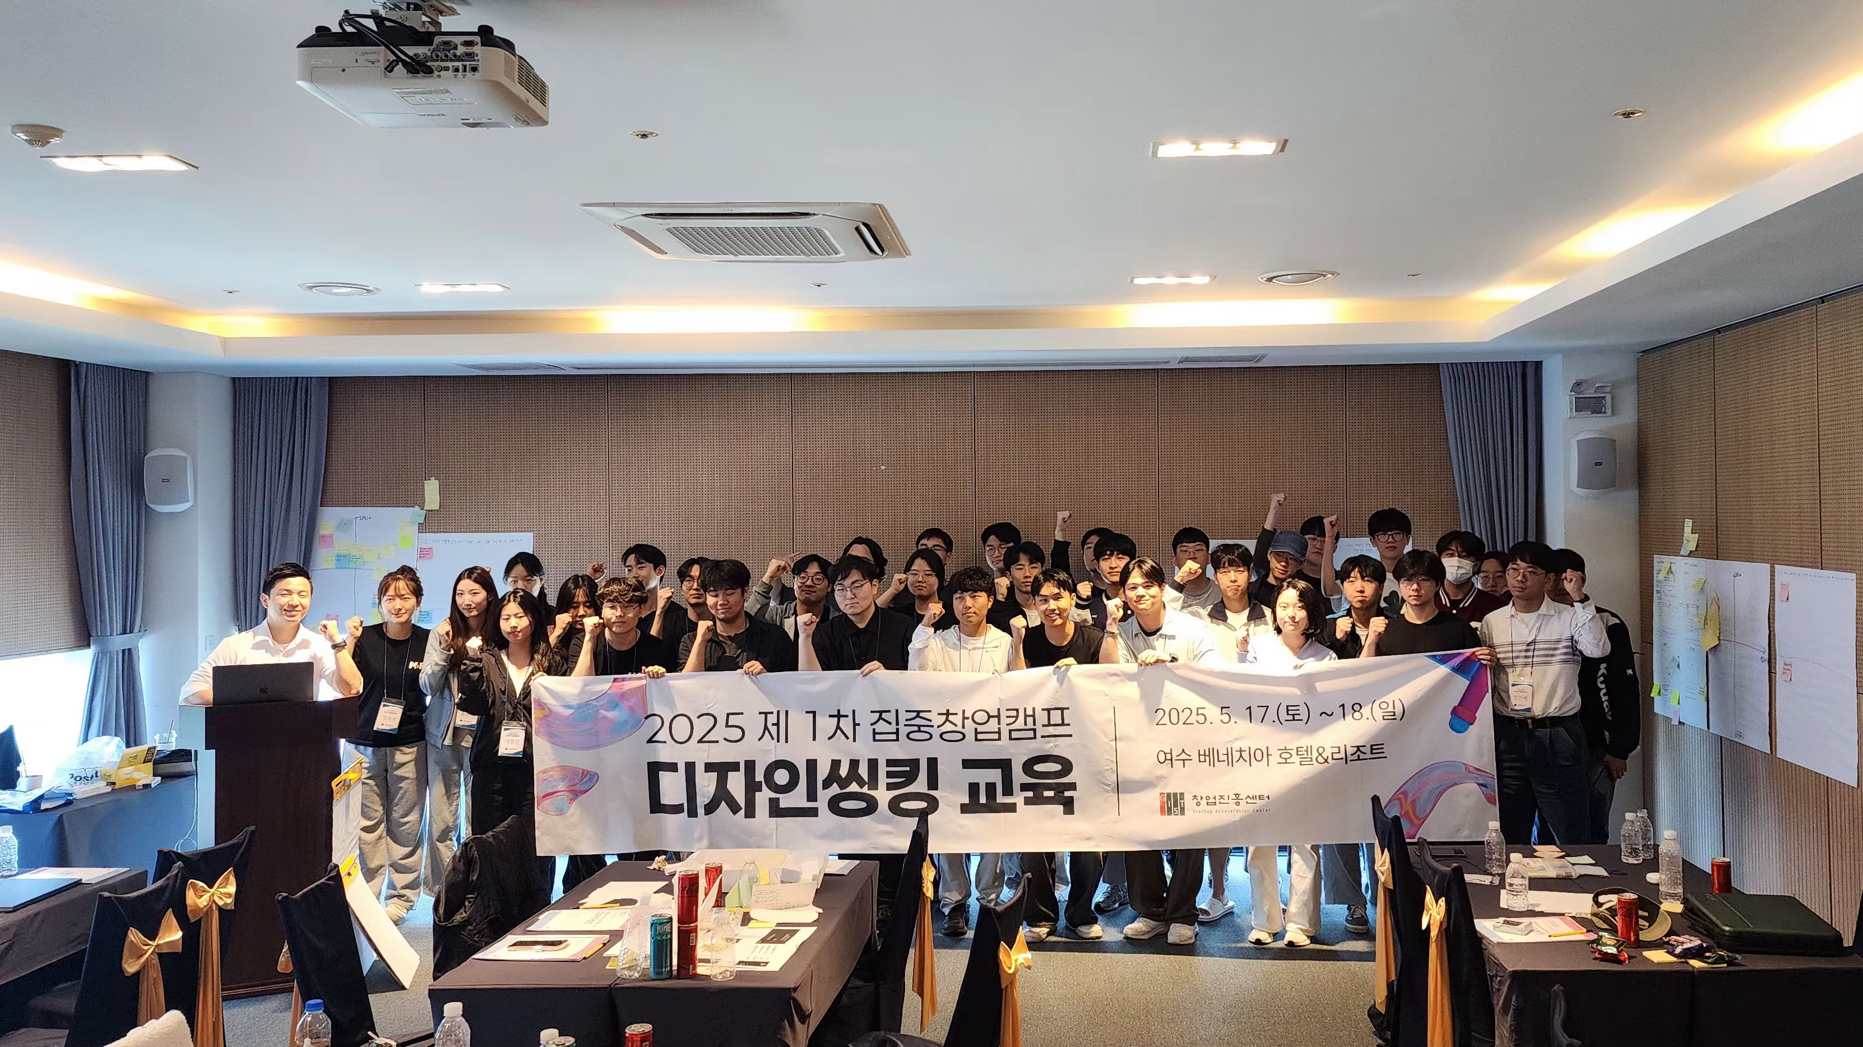

▲ GIST held the 1st Intensive Startup Camp of 2025 at the Venezia Hotel & Resort in Yeosu for two days from May 17 to 18, and participants are taking a commemorative photo.

The Gwangju Institute of Science and Technology (GIST, President Kichul Lim) announced that it held the ‘1st Intensive Startup Camp of 2025’ at the Venezia Hotel & Resort in Yeosu for two days from May 17 to 18 to strengthen the creative problem-solving ability and startup idea discovery capacity of students interested in startups.

This camp was hosted by the GIST Startup Acceleration Center and operated in cooperation with an external entrepreneurship education specialized organization under the theme of ‘Creative Problem Solving and Solution Derivation Based on Design Thinking.’

Students who participated in the camp practiced the five core stages of design thinking: ▴ Empathize, ▴ Define, ▴ Ideate, ▴ Prototype, ▴T est throughout the entire process, and had time to enhance their practical entrepreneurial capabilities through the experience of concretizing user-centered entrepreneurial ideas and directly presenting them.

In particular, students formed teams and conducted user research and interviews, and brainstormed based on the core issues derived from these to come up with creative ideas.

Afterwards, by implementing the idea into a prototype and autonomously designing and executing the entire process up to the final presentation, the practice-centered curriculum was able to strengthen not only creative problem-solving skills but also planning skills, design skills, and collaboration skills.

On the second day of the camp, each team worked on supplementing the solution developed on the first day by reflecting actual user feedback. In the final presentation held afterwards, each team demonstrated their practical skills by deeply explaining how the idea they proposed solves user-centered problems and what social and industrial value propositions it contains.

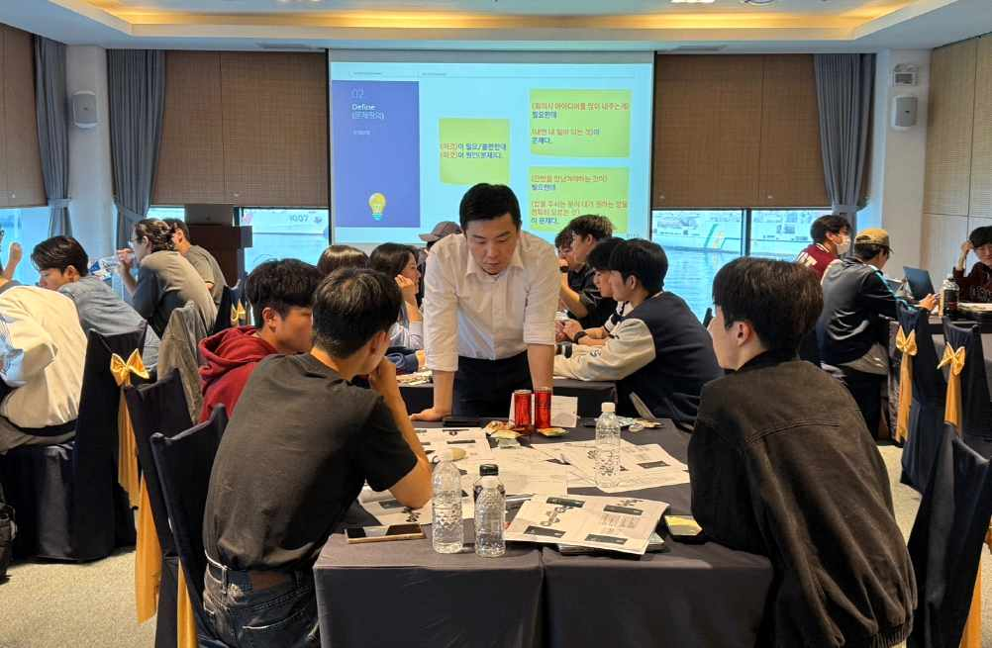

▲ On the last day of the camp, the 18th, they discussed how their ideas solve user-centered problems and what value propositions they contain through the final presentation.

A GIST official said, “This intensive entrepreneurship camp is a place for practical education designed to allow students to actually experience the process of defining problems anew and creatively solving them,” and added, “We will continue to operate various programs in the future so that students can systematically develop their entrepreneurial skills.”

Meanwhile, in addition to the intensive startup camp, the GIST Startup Acceleration Center operates a number of student-led startup support programs, including the ▴ Entrepreneurship Supporters, ▴ Student Entrepreneurship Club, ▴ Entrepreneurship Mini-School, and ▴ Practical/Mock Entrepreneurship Programs. Through these programs, the center is taking the lead in spreading the entrepreneurship culture, providing practical experience, and fostering prospective entrepreneurs with an entrepreneurial spirit.



