GIST begins development of customized assistive devices to help the disabled and elderly live independently

- GIST, Gwangju Techno Park, Chonnam National University, with the support of the Ministry of Health and Welfare, establish an industry-academia-research collaboration system to promote R&D projects for practical use of assistive devices centered on actual users... Seminar to be held on April 30

- Following ‘Wrist Grabber for People with Cervical Disorders’ and ‘Kiosk Touch Stick’, 3 additional assistive devices to be developed this year... Expected to support self-reliance and revitalize the industry through development and distribution of assistive devices based on regional demand

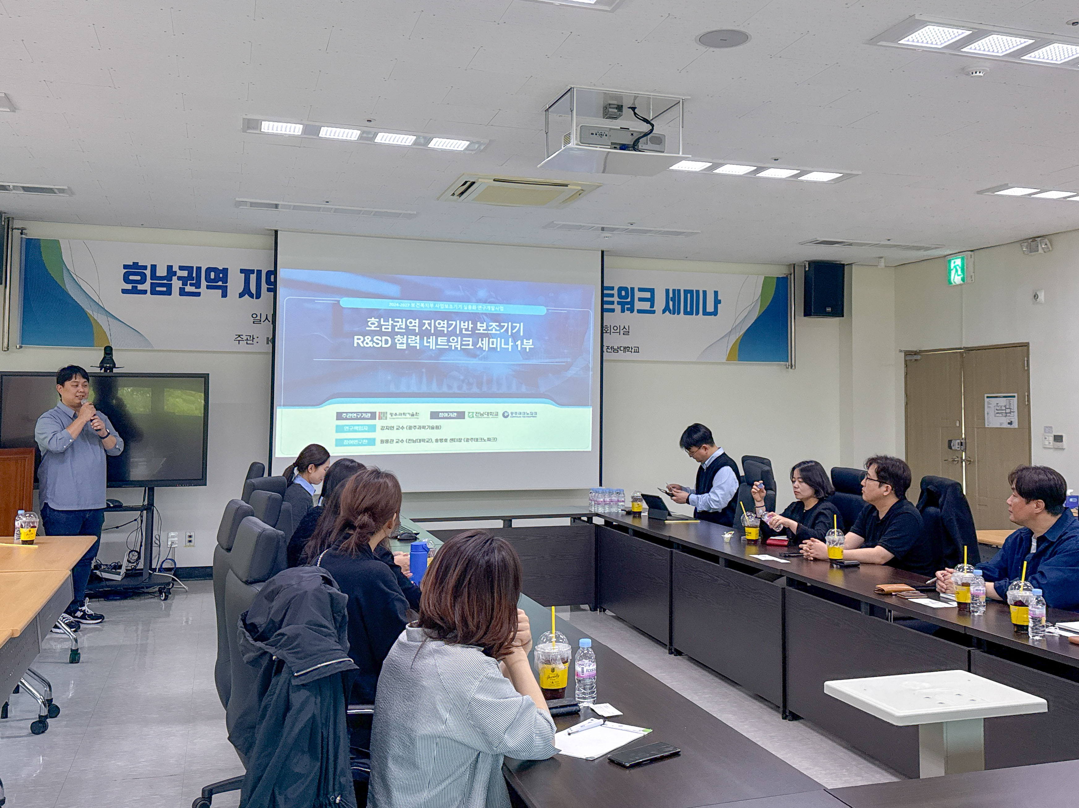

▲ GIST, Gwangju Techno Park, and Chonnam National University are holding a networking workshop on April 30 (Wed) to discuss close cooperation measures for the smooth progress of the ‘Research and Development of Assistive Devices for Independent Living for the Elderly and the Disabled’ with the Ministry of Health and Welfare.

The Gwangju Institute of Science and Technology (GIST, President Kichul Lim) has begun the development of customized assistive devices for the region to practically support the independent living of the disabled and the elderly.

On April 30 (Wed), a networking seminar was held at the Senior-Friendly Industry Support Center as part of the ‘Research and Development of Assistive Devices for Independent Living for the Disabled and the Elderly’ project, where the specific direction of the project and collaboration measures between participating organizations were discussed in depth.

The seminar was attended by 12 people from research and industry, including Professor JiYeon Kang of GIST’s Department of AI Convergence, Professor Yeong-jin Jeong of Chonnam National University, and Director Byeong-ho Song of Gwangju Techno Park. They exchanged various opinions on ▴sharing the research results of the first year, ▴ the business promotion plan for the second year, and ▴ measures to strengthen the regional cooperation network.

This project, jointly promoted by GIST, Gwangju Techno Park, and Chonnam National University, aims to develop and distribute demand-based assistive devices that meet the actual needs of the disabled and elderly in the Honam region with the support of the Ministry of Health and Welfare. Through this, it is expected to support independent living centered on actual users and further promote the activation of the assistive device industry.

In particular, in this seminar, the technical feasibility of the assistive device design ideas proposed by participating institutions such as GIST and Chonnam National University was closely examined with regional cooperative organizations including the Gwangju-Jeonnam Assistive Device Center.

In the future, they plan to focus on making the collaboration system more specific and efficient in the technology development process and speed up the establishment of a practical implementation plan.

Professor JiYeon Kang, who is in charge of this project, said, “We will be able to drive the actual growth of the assistive device industry by organically linking the excellent research capabilities of the region with the vivid demands of the field,” and added, “We will continue to develop assistive device kits that are easy to manufacture and have high distribution efficiency, establish a distribution system centered on actual users, and also work hard to expand related education programs.”

Meanwhile, through this project, ‘Wrist Grabbers for People with Spinal Cord Injuries’ to help people with disabilities with the convenience of daily life due to spinal cord injuries and ‘Kiosk Touch Sticks’ to improve the convenience of using kiosks were developed last year. This year, three additional assistive device kits that reflect the diverse needs of a wider range of users are scheduled to be developed.

GIST and its partner organizations plan to continue to actively support the convenient and independent living of people with disabilities and the elderly through the development of practical assistive devices based on regional demands.



