"Imagination Rocket Launch! A Special Universe Drawn by Children" GIST holds the 2nd Science Imagination Children's Art Contest

- The second Science Imagination Children's Art Contest will be held on May 17 (Sat) for kindergarten and elementary school students nationwide... 200 people will be recruited on a first-come, first-served basis to unfold their imagination toward the future with the theme of 'Drawing the Universe'

- A special family outing to enjoy on the GIST campus in May with family photo shoots and cotton candy and magic balloon events... 47 people will be awarded, including the GIST President's Award (Grand Prize), and the winning works will be exhibited for a month at Oryong Art Hall

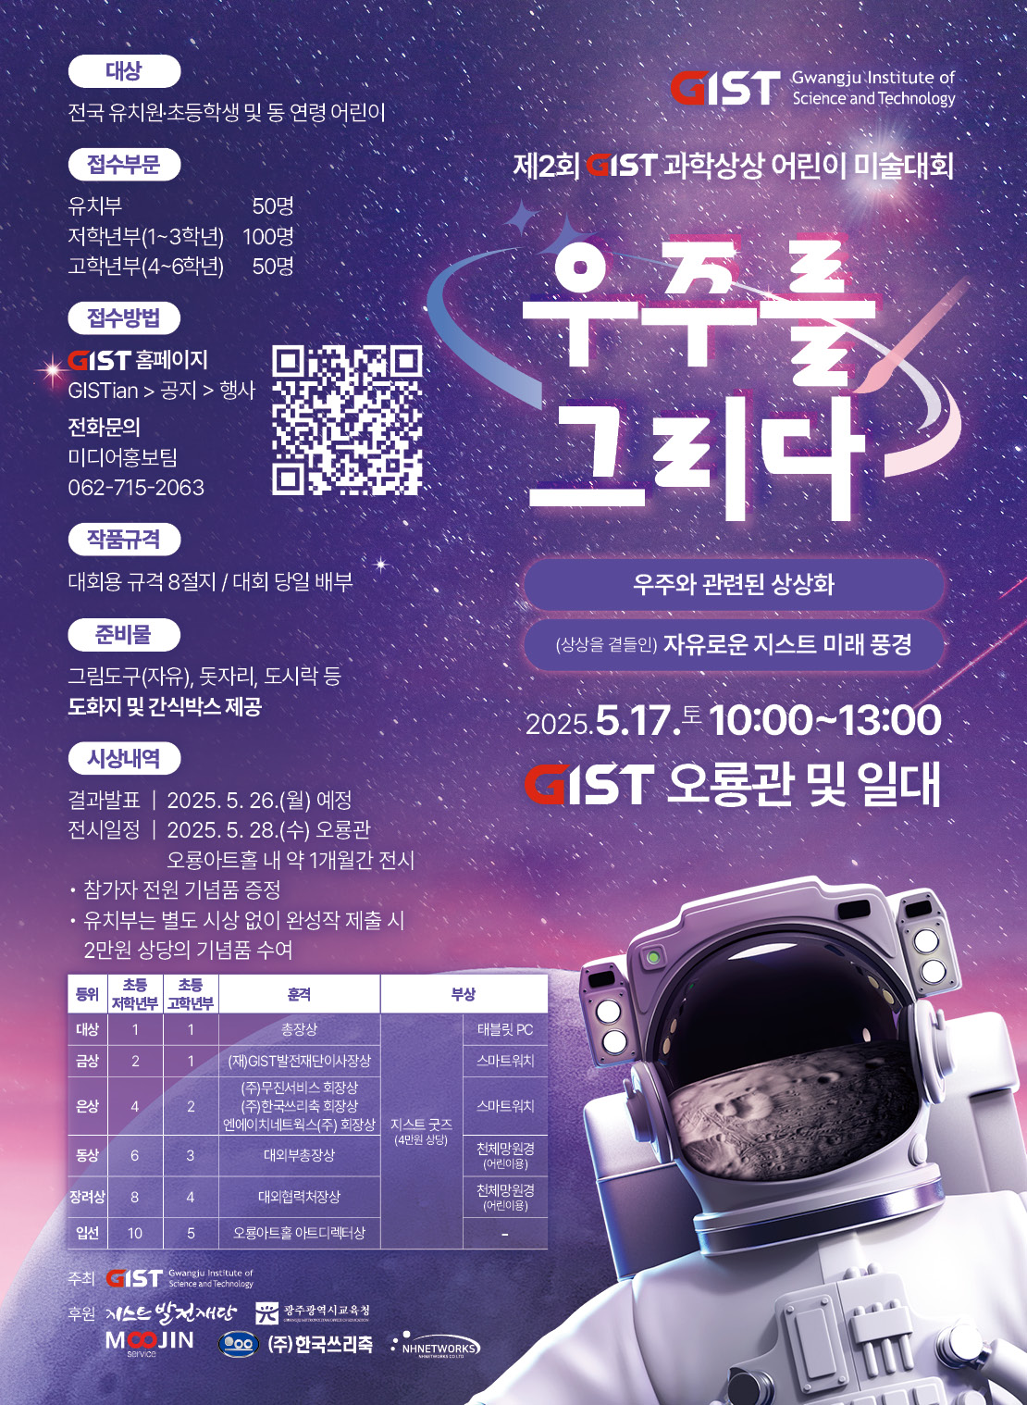

▲ 2nd GIST Science Imagination Children's Art Contest Event Poster

The Gwangju Institute of Science and Technology (GIST, President Kichul Lim) announced that it will hold the ‘2nd GIST Science Imagination Children’s Art Contest’ from 10:00 AM to 1:00 PM on Saturday, May 17 at GIST Oryong Hall and surrounding areas.

This contest, which has the slogan ‘Drawing the Universe’, is jointly sponsored by the GIST Development Foundation, Gwangju Metropolitan Office of Education, Mujin Service Co., Ltd., Korea Three Axis Co., Ltd., and NH Networks Co., Ltd.

As part of its external cooperation vision of adding the value of ‘sharing’ to science and technology, GIST successfully held the 1st GIST Science Imagination Children’s Art Contest last year, and through this second contest this year, it aims to reflect on the meaning of sharing and further expand mutual growth with the local community.

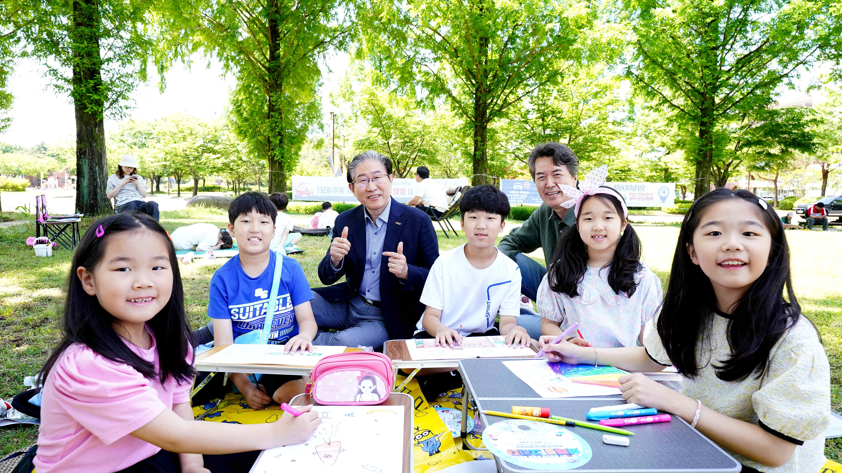

▲ President Kichul Lim and Vice President for Public Affairs Yonghwa Chung are taking a photo with participating children at the 1st GIST Science Imagination Children’s Art Contest held last year.

The target of the participation is kindergarten and elementary school students nationwide and children of the same age. You can apply for participation through the GIST homepage or poster QR code. The number of applicants is 200 people, including 50 kindergarten students, 100 elementary school lower grades (1st to 3rd grade), and 50 upper grades (4th to 6th grade), and the application will be closed on a first-come, first-served basis.

Participants will be provided with drawing paper and snack boxes, but they must prepare their own drawing tools (optional), mats, lunch boxes, etc.

On this day, GIST will hold an event where a photography expert will take family photos so that families visiting the campus to participate in the art contest can make special memories, and children will be given cotton candy and magic balloons.

On the day of the art contest, participants will submit a work of imagination on the theme of space or a freely imagined future landscape of GIST on the standard 8-section paper distributed on the day of the contest.

All participants will receive a souvenir, and all kindergarten participants who complete and submit their works will be given a prize without a separate award ceremony.

The submitted works will be reviewed by art experts and a total of 47 award-winning works will be selected, and the GIST President Award, GIST Development Foundation Chairman Award, Sponsor Chairman Award, etc. will be awarded.

In particular, the award-winning works will be displayed for about a month in the ‘Oryong Art Hall,’ an exhibition space created on the inner walls of the 1st and 2nd floors of Oryong Hall, a multipurpose building on campus, to promote exchange and cooperation with the local community.

Vice President for Public Affairs Yonghwa Chung said, “This children’s art contest will be a valuable opportunity to support children’s brilliant imagination and creativity, and for GIST to become closer to the local community,” and added, “GIST will continue to do its best to practice the values ​​of sharing and coexistence through science and technology and grow together with the local community.”

For more information about this art contest, check the GIST homepage (notice (event) bulletin board) or contact the Media Relations Team (062-715-2063).



