GIST hosts 56th Academy Breakfast Forum… Inviting Ok-seop Jin, Director of Damyang-gun Cultural Foundation, to reflect on the value and meaning of traditional arts

- Ok-seop Jin, representative of traditional arts performance planner, lectures on traditional dance and the life of an entertainer... 50 local businesspeople in attendance

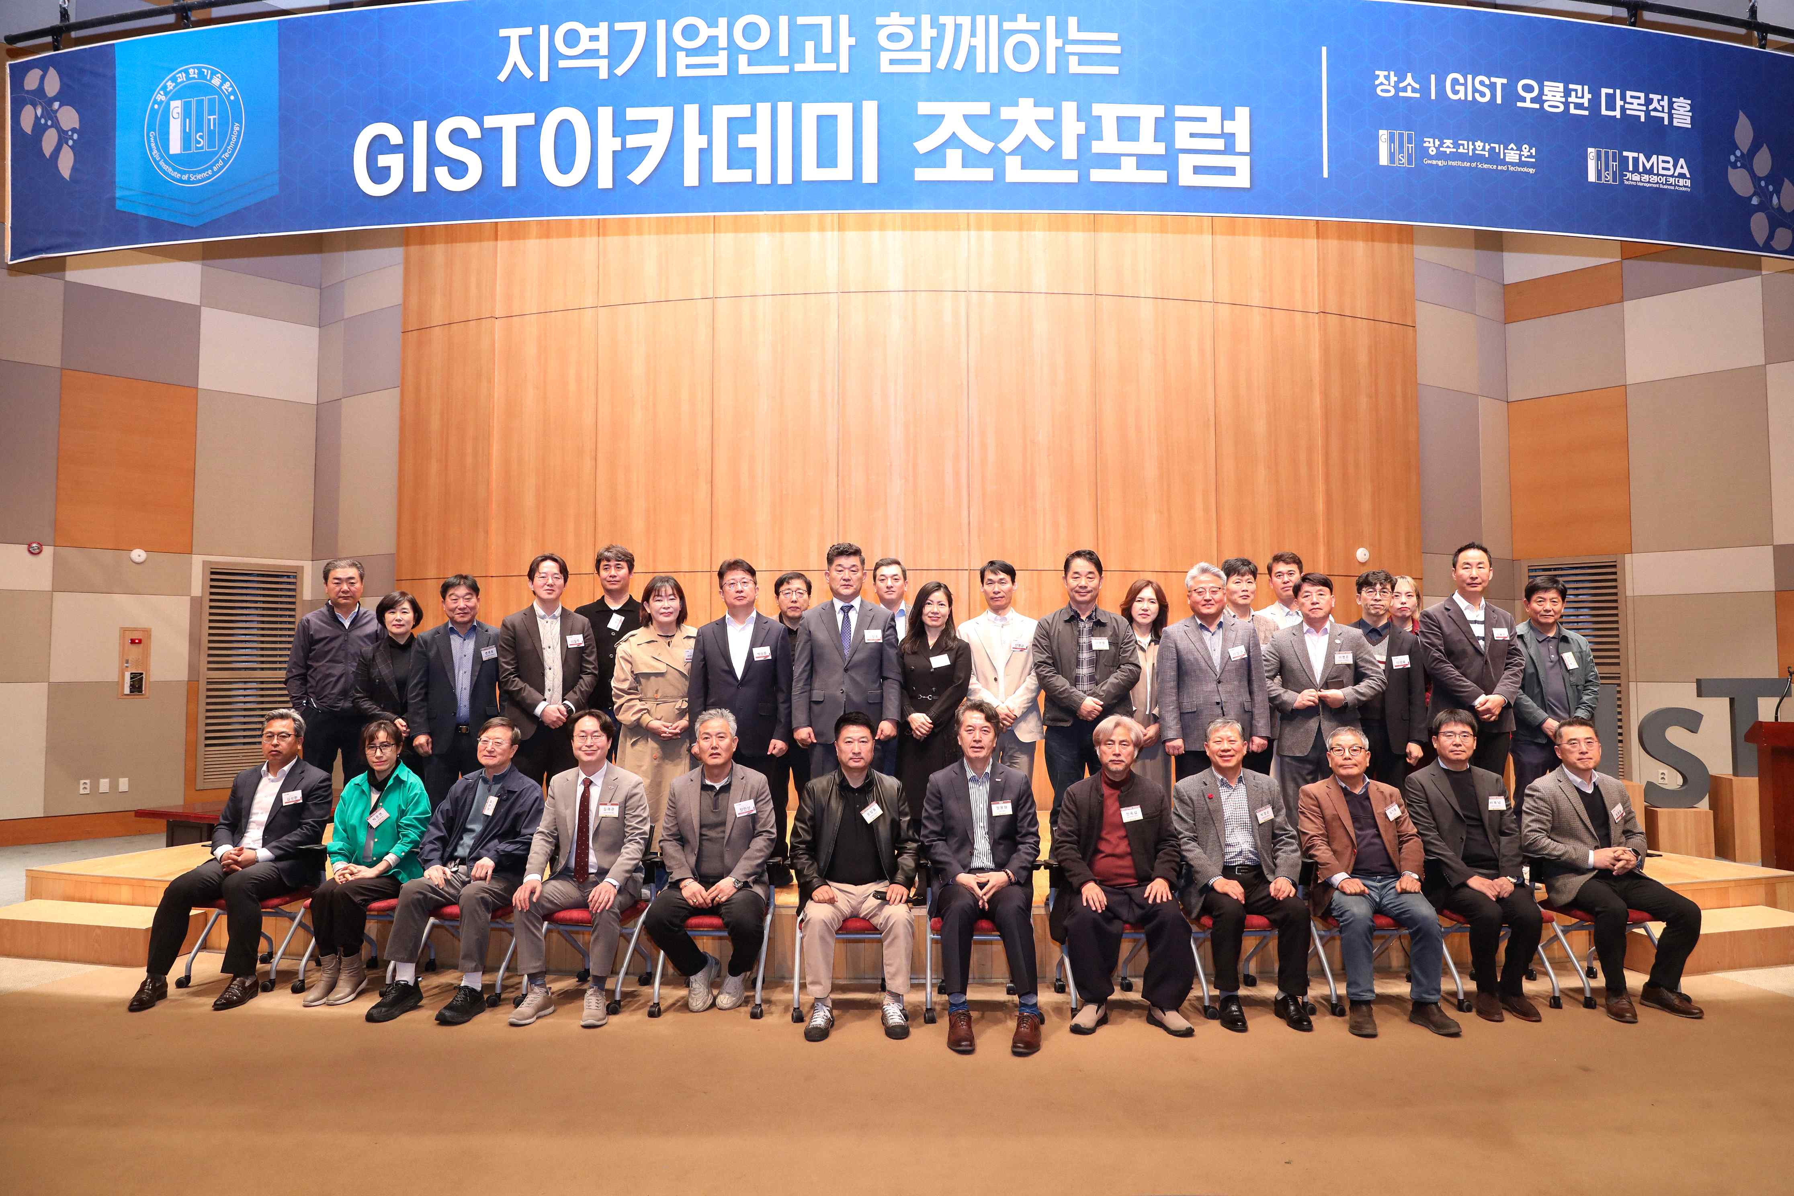

▲ GIST Academy is holding the March Breakfast Forum at Oryong Hall on Monday, March 24.

The Gwangju Institute of Science and Technology (GIST, President Kichul Lim) announced that it held the 56th GIST Academy (Director Jae Gwan Kim) Breakfast Forum on Monday, March 24 at Oryong Hall, inviting CEO Ok-seop Jin of Damyang-gun Cultural Heritage Group.

About 50 businesspeople from the Gwangju and Jeonnam regions attended the forum, and CEO Jin, who gave a lecture on the topic of ‘In Search of Noreummachi (Master)’, conveyed the value and meaning of Korean traditional arts based on his vivid experiences.

CEO Ok-seop Jin first took his first steps into culture and arts through theater as a child, and became deeply interested in traditional arts through mask dance.

After that, he worked as a PD for KBS’ <Good Morning Korea> and produced various contents that connected the public and tradition, such as traditional music programs. In 1996, he founded the performance planning company ‘Land of Festivals’ and presented many traditional art performances, including <Nammu_Dancing Cheoyongabi> and <Yeomu_Years Drawn in the Sky>.

In particular, in 2006, he won the ‘Art of the Year’ award from the Korea Arts and Culture Committee for his <Pungmul Myeongmujeon>, solidifying his position in the performing arts world. The following year, in 2007, his book <Noreummachi>, which compiled stories of traditional artists he met while traveling around the country, became a bestseller and caused a huge stir. He currently resides in his hometown of Damyang and serves as the CEO of the Damyang County Cultural Foundation.

Regarding the term ‘Noreummachi’, CEO Jin explained that it is a combination of the meanings of ‘noreum’, meaning performance, and ‘finish’, and is a slang term for the best entertainers of Namsadangpae who have outstanding skills enough to finish a play.

He traveled around the country to find and discover traditional art successors such as gisaengs, shamans, clowns, and vagrants, and introduced his journey to put them on stage. He also emphasized efforts to restore and shed new light on traditional art performances that are disappearing, and the deep cultural meaning contained within them.

At the end of the lecture, there was a time to compare traditional dances of Honam and Yeongnam regions, and to demonstrate dance steps to the accompaniment of actual janggu. Jin explained, “Yeongnam dances are dynamically developed based on the rhythm of gutgeori, while Honam dances stand out for their aesthetics of slowness,” and interestingly explained the characteristics of each region’s traditions.

He said, “Traditional dances are not just techniques, but the language of life that embodies the person’s life, era, sorrow, and joy.” He also shared his thoughts on discovering traditional arts, saying, “Just because it has disappeared from the stage, that doesn’t mean the art has disappeared. I have been searching for dances and people with the intention of putting their lives back on stage.”

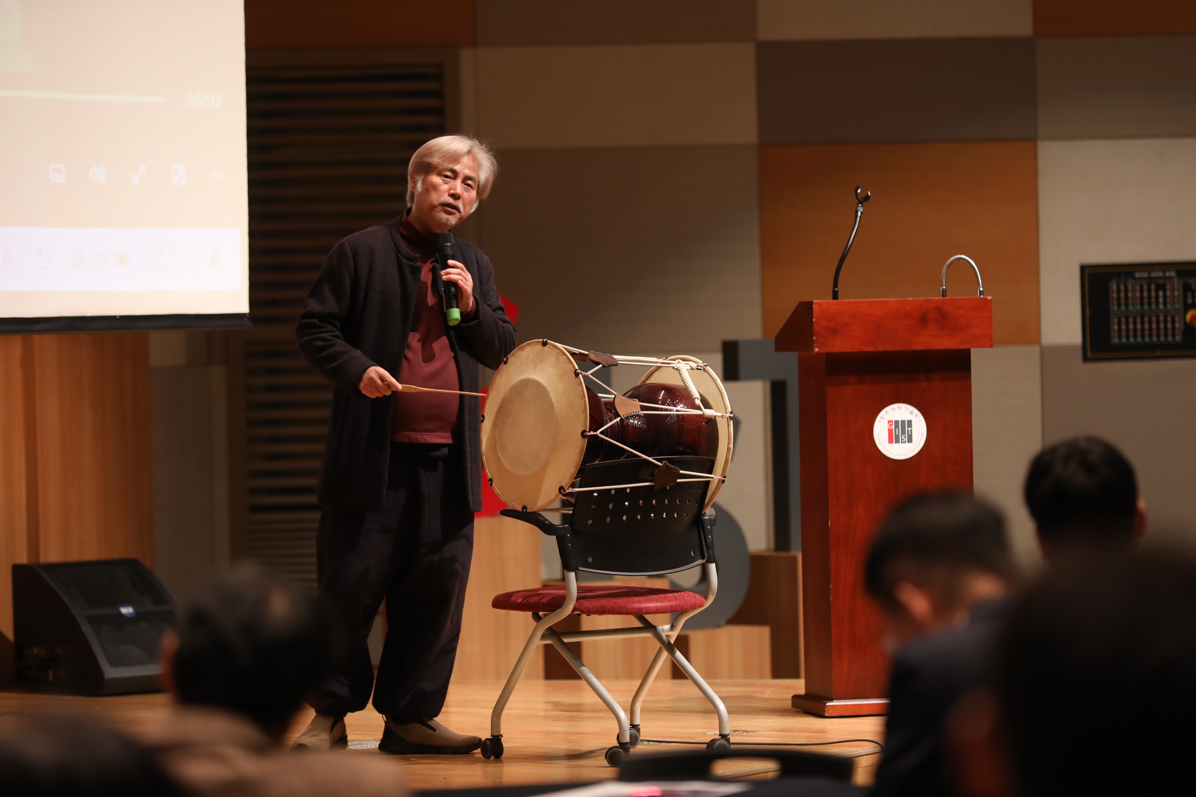

▲ Damyang-gun Cultural Foundation CEO Ok-seop Jin is giving a lecture on the topic of ‘In Search of Noreummachi (Master)’ at the GIST Academy March Breakfast Forum.

Meanwhile, GIST Academy, which oversees GIST’s non-degree education program, operates the Techno Management Business Academy (GTMBA) program as its representative program. Every year, on the last Tuesday of March, May, June, September, and October, experts from various fields are invited to host a breakfast forum for local businesspeople and alumni.



