"Meet the spirit of Goguryeo, different from Baekje and Silla, through photos" GIST Oryong Art Hall, Photographer Ha-seon Park's Invitational Exhibition

- Ha-seon Park, who has established a unique position as a documentary photographer by recording life and culture in remote and conflict-ridden areas around the world, explores Goguryeo ruins over a 10-year journey... until May 29th

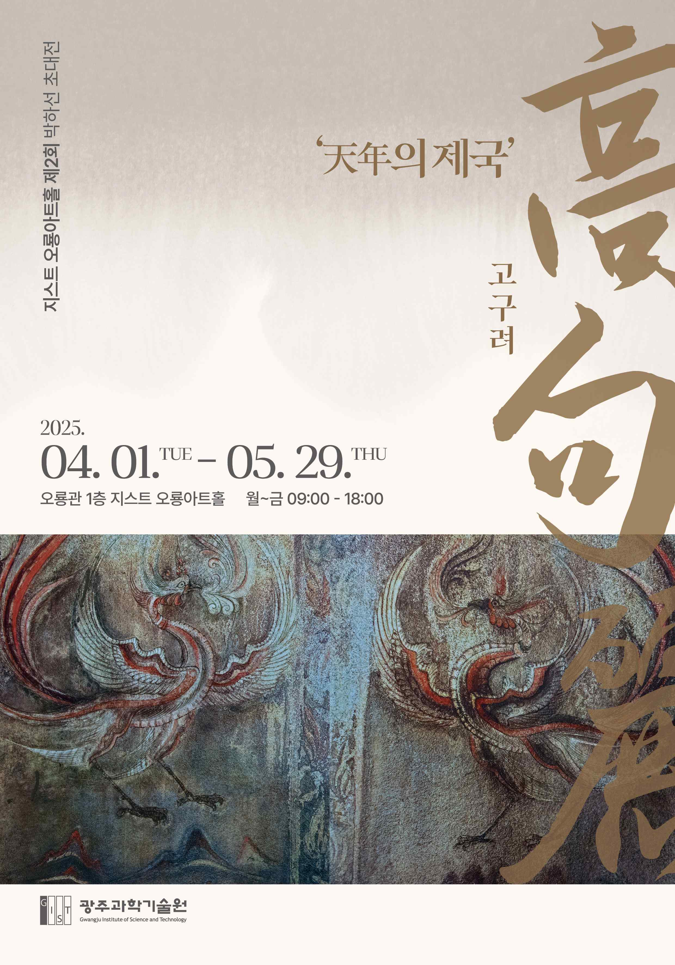

▲ Poster for the 2025 Oryong Art Hall 2nd Exhibition ‘Goguryeo’

The Gwangju Institute of Science and Technology (GIST, President Kichul Lim) announced that Oryong Art Hall will hold its 2nd invitational exhibition of the year, photographer Ha-seon Park’s solo exhibition ‘Goguryeo’ from April 1 to May 29.

This exhibition is the first photo exhibition held since the opening of Oryong Art Hall in December 2022, and will display 18 photos of Goguryeo relics taken by Ha-seon Park over a period of 10 years. The works include relics from the Liaoning region in China to Chungju in the south, where traces of Goguryeo remain.

Ha-seon Park is a former navigator who has continued his photography work while traveling the five oceans. Since 1984, he has visited remote areas and conflict zones around the world to record their lives and culture, establishing his unique position as a documentary photographer.

His representative works include photographs taken along the Oasis Silk Road and the Maritime Silk Road, and in particular, he won the 2021 World Press Photo Award for his work on the Tibetan funeral custom of ‘sky burial.’

Park has been capturing Goguryeo sites with his camera, following traces left in ancient records, in order to record the scenes of human life and revive our history that is fading away. His photographs vividly convey the strong power and spirit of Goguryeo and leave a deep resonance.

This ‘Goguryeo’ exhibition will feature the ‘Jian Tomb No. 5 Murals’ taken in 1996. This mural is a rare piece of material that has been banned from being photographed since 2000. It fully conveys the vitality of Goguryeo art through its splendid decorative patterns, the shapes of the four guardian deities, and the colors blue and red.

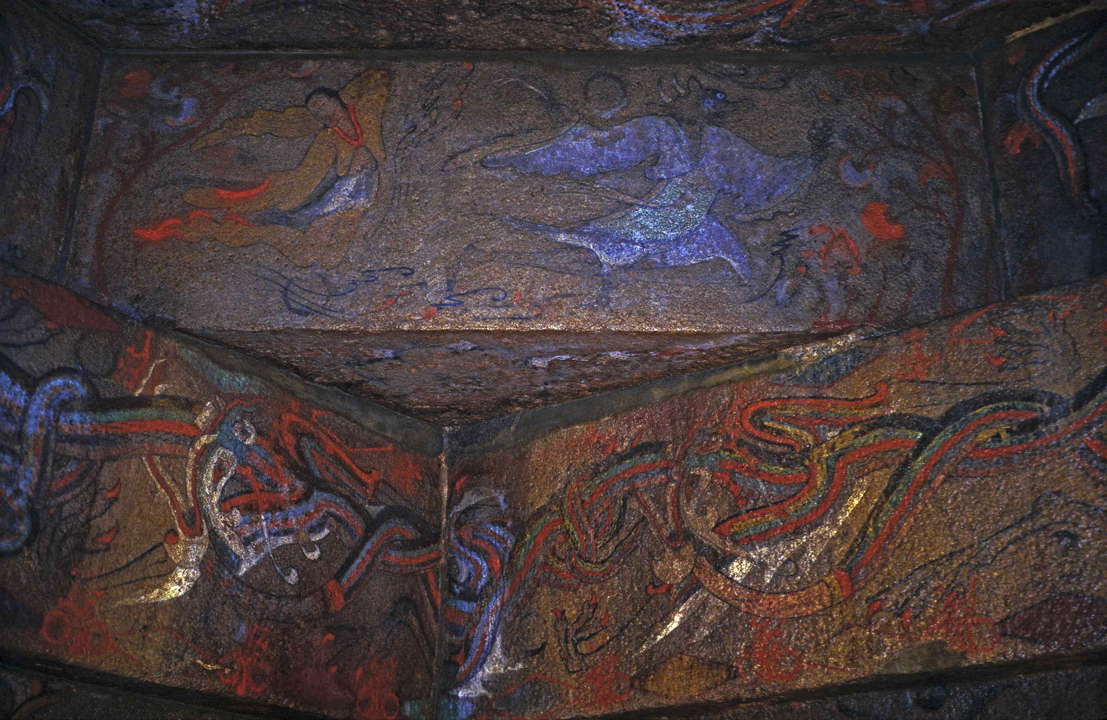

▲ 2025 Oryong Art Hall 2nd Exhibition ‘Goguryeo’ Jian Tomb 5th Tomb Mural (1996)

Artist Park focuses on the fact that Goguryeo in history did not yield to foreign powers but stood up to them with dignity, embraced foreign peoples, and achieved unity among the people. He said, “I hope this exhibition will be a small help in reviving the spark of national spirit by following the example of Goguryeo.”

Oryong Art Hall is a multipurpose exhibition space prepared by GIST for cultural and artistic exchanges in the local community, and has held a total of 15 exhibitions including this ‘Goguryeo’ exhibition, establishing itself as an open cultural and artistic space with local residents.

Ha-seon Park's Invitational Exhibition 'Goguryeo' is open for viewing from 9:00 AM to 6:00 PM on weekdays at GIST Oryong Art Hall until May 29. (For inquiries about weekend viewing: 062-715-2622)



