Professor Hyeong Jin Kim talks about the future of secondary batteries in Gwangyang City

- Next-generation battery technology lecture at 2:30 PM on Tuesday, March 18, in the conference room of Gwangyang City Hall

- GIST appoints Professor Hyeong Jin Kim, a pioneer in the domestic lithium secondary battery field, as the ‘Gwangyang City Science and Technology Special Ambassador’ to contribute to the development of local industries and support the leap forward as a K-battery-centered city

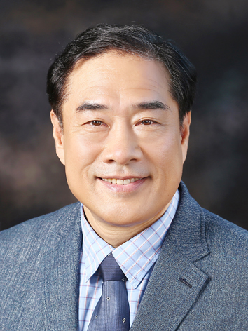

▲ Professor Emeritus Hyeong Jin Kim, Department of Chemistry, GIST

The Gwangju Institute of Science and Technology (GIST) announced that Professor Emeritus Hyeong Jin Kim (Department of Chemistry) will give a lecture on the topic of ‘Lithium-ion Battery: Electric Vehicle Battery Industry and Future Technology’ at 2:30 PM on Tuesday, March 18th in the conference room of Gwangyang City Hall.

This seminar was organized to strengthen the industry-academia-research cooperation between GIST and Gwangyang City and discuss the latest trends in the secondary battery industry and the direction of core technology development. Through this, positive ripple effects are expected, such as strengthening the competitiveness of Gwangyang City’s next-generation battery industry, discovering and fostering new industries, supporting technological innovation, and fostering professional manpower.

Recently designated as a secondary battery opportunity development special zone, Gwangyang City is focusing on fostering new growth engine industries centered on the secondary battery material industry in order to leap forward as a ‘K-battery-centered city.’

Professor Kim, who was appointed as Gwangyang City’s special ambassador for science and technology, will introduce the development process of lithium-ion batteries and the latest research results on the development of future battery materials in this lecture.

GIST is operating a ‘Science and Technology Special Rental System’ in cooperation with 10 cities and counties in the Jeonnam region (Naju, Mokpo, Suncheon, Yeosu, Gwangyang, Haenam, Jangseong, Damyang, Boseong, and Gangjin) to provide customized consulting to promising industries in each region.

Currently, 15 full-time GIST faculty members, including Professor Hyeong Jin Kim, are working as special ambassadors for science and technology, conducting consulting and cooperation activities to strengthen regional industrial competitiveness, foster new industries, innovate technology, and cultivate talent.

Professor Hyeong Jin Kim is considered a pioneer in the domestic lithium secondary battery field who has greatly contributed to the development of battery technology in Korea based on his long-term research and industrial experience.

After receiving his doctorate from Texas State University in 1993, he worked as a research assistant professor at the University of Wisconsin in the United States until 1995. After that, he led the development of battery materials, 18650 cells and pouch cells, production, and quality control at LG Chem for over 20 years. He also served as the president of LG Chem Michigan (LGCMI) from 2014 to 2016, working hard to strengthen global competitiveness.

Since then, he has been working as a professor at the GIST Graduate School of Energy Convergence from 2016 to 2024, and has devoted himself to education and research in the fields of electric vehicles and energy storage devices. Currently, as an honorary professor and visiting professor at the Department of Chemistry at GIST, he is dedicated to nurturing future generations and researching next-generation battery materials.

Professor Kim said, “Lithium secondary battery technology is a core technology of the future energy industry, and Gwangyang City is strategically fostering the industry with the goal of completing the only full-cycle supply chain for secondary battery materials in Korea. As a special ambassador for science and technology in Gwangyang City, I will help Gwangyang City strengthen cooperation between industry, academia, and research, develop innovative battery technologies, and nurture talents.”

GIST International and Public Affairs Dean Jae Gwan Kim said, “This seminar will be an important opportunity to present the development direction of the secondary battery industry, which is attracting attention as a future growth engine for the Jeonnam region, and to strengthen cooperation between companies, research institutes, and local governments. GIST will actively cooperate to strengthen regional-based technological innovation and industrial competitiveness based on the special ambassador for science and technology system.”



