GIST Techno Management Business Academy (GTMBA), 15th entrance ceremony… 46 leaders from various social fields enter

- The donation ceremony of Won-man Kim, the 14th Alumni Association president and Saehan Group chairman, was also held... 10 million won donated for cooperation and mutual development with the region

- Opened in 2010... Provides a venue for the exchange of the latest industrial technology knowledge information and expansion of a wide human network for successful management activities in the rapidly changing digital transformation business environment

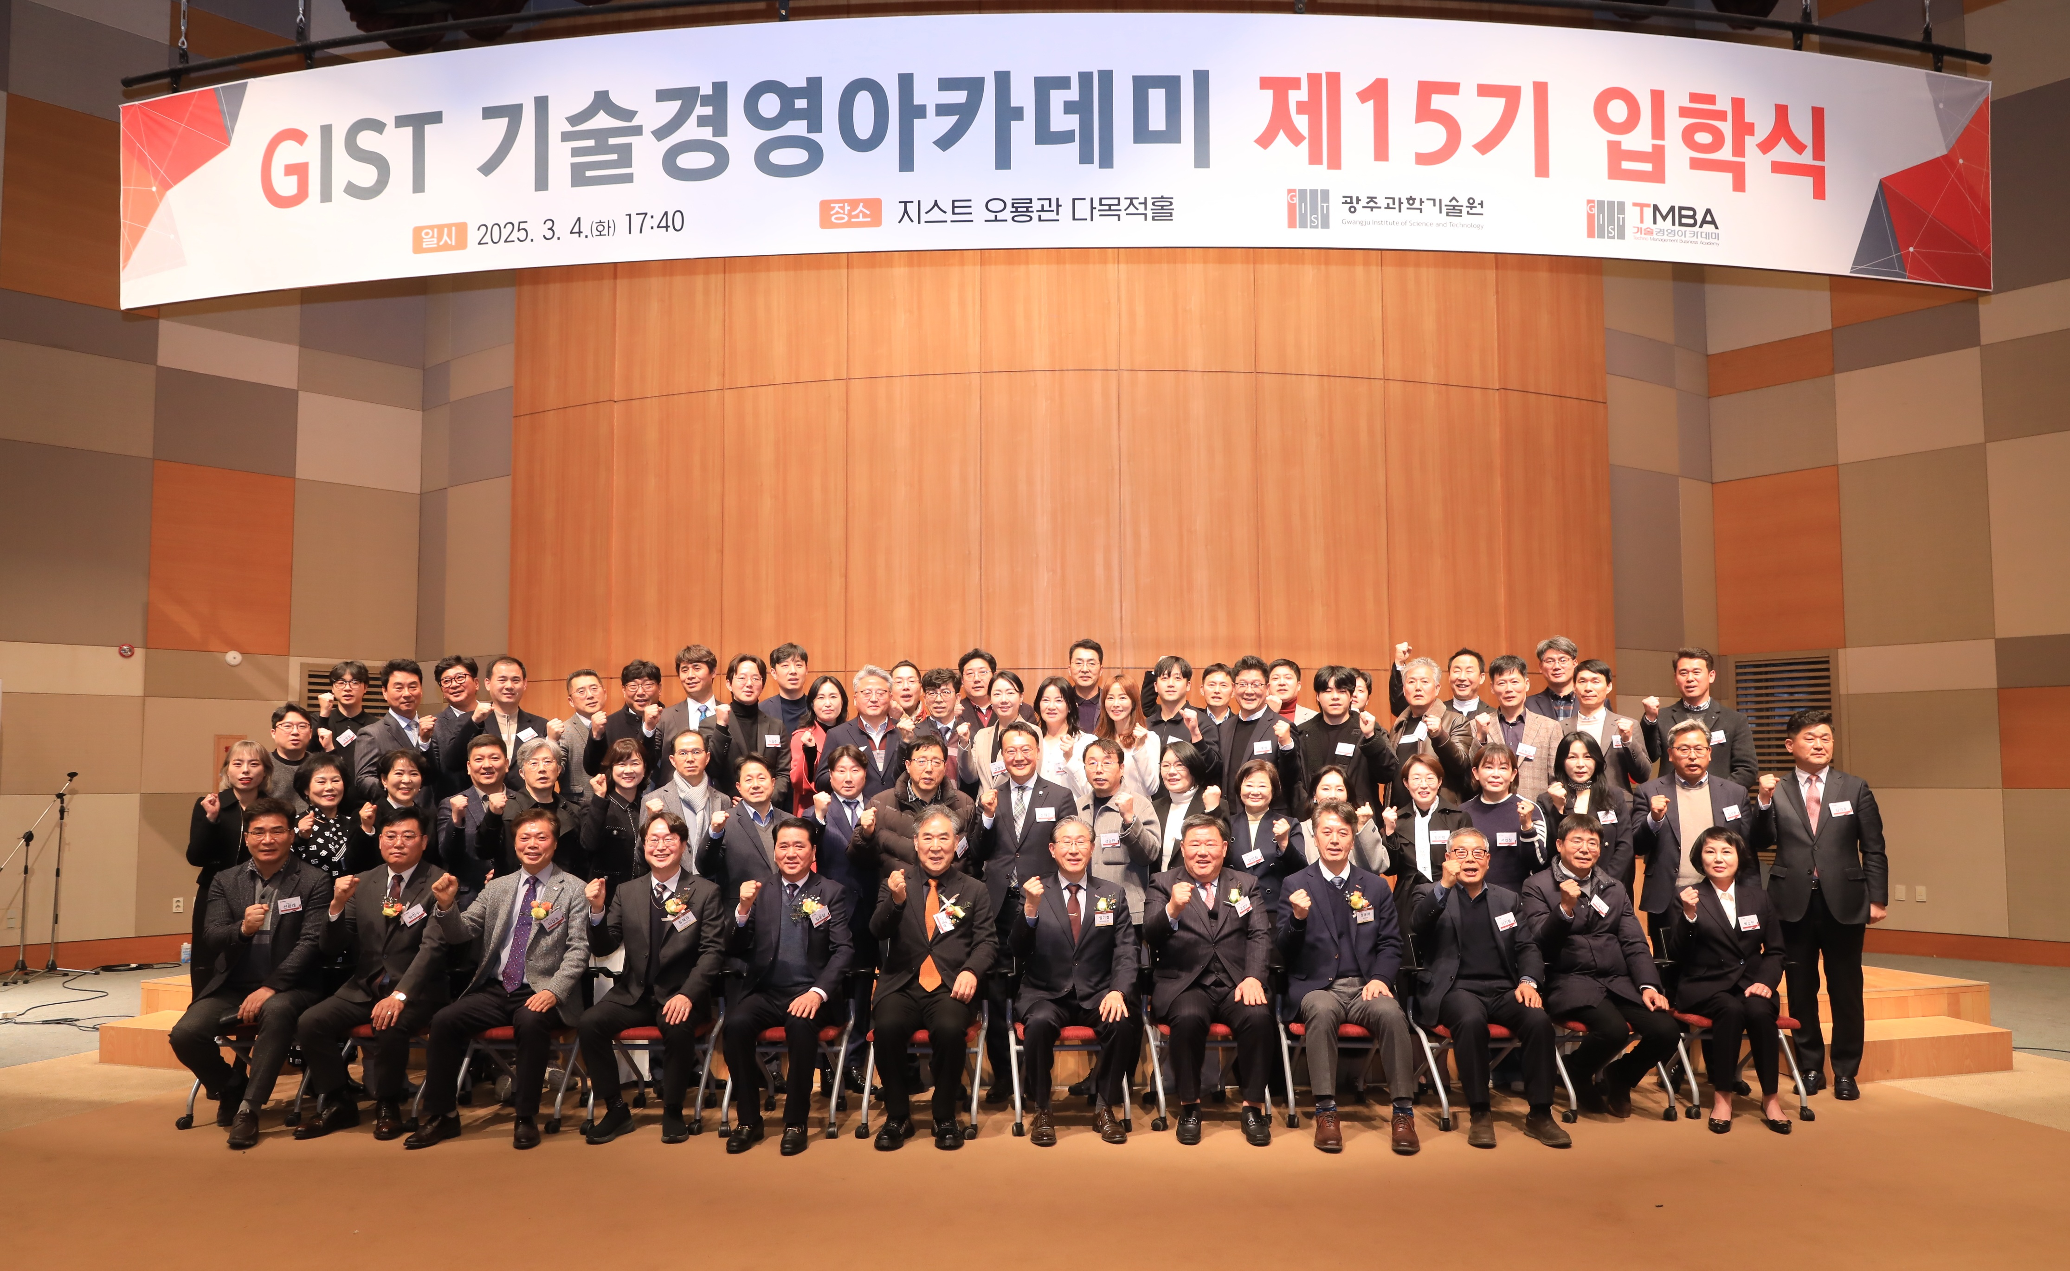

▲ GTMBA is holding its 15th entrance ceremony at Oryong Hall on Tuesday, March 4th, and taking a commemorative photo.

The Gwangju Institute of Science and Technology (GIST, President Kichul Lim) announced that it held the 15th entrance ceremony for the Techno Management Business Academy (GTMBA, Director Jae Gwan Kim) at Oryong Hall on Tuesday, March 4.

GIST President Kichul Lim, Vice President for Public Affairs Yonghwa Chung, GTMBA Director Jae Gwan Kim, as well as key figures such as Development Foundation Chairman Hae-myeong Kim and Honorary Doctor of Engineering Jeong-ju Ko, as well as 46 GTMBA incoming students attended the ceremony.

On this day, the 14th Alumni Association president and Saehan Group Chairman Won-man Kim also held a development fund donation ceremony. The 10 million won donated by Chairman Kim will be used for cooperation and mutual development with the region.

Saehan Group, a company specializing in the manufacturing of plastics for white goods and automobile parts, established the Saehan I.M AI-related business division last year, centering on Saehan Hi-Tech Co., Ltd., Saehan Global Co., Ltd., Geo Global Co., Ltd., Saehan Plus Co., Ltd., and SM Chemical Co., Ltd., and completed preparations for the promotion of new businesses.

In his welcoming speech, read by GTMBA 14th Secretary General An-soo Park, Chairman Won-man Kim said, “I decided to donate the development fund with the hope that GIST will surpass its remarkable development and success so far and stand tall as a world-renowned educational institution, and with the hope for regional and national economic development. I am confident that if GTMBA alumni practice sharing and giving as the center of the local community, we will develop together with GIST.”

In his welcoming speech that day, President Kichul Lim said, “This year, we expect to provide a venue for the exchange of the latest industrial technology knowledge information and a wide human network for successful management activities in the digital transformation business environment by organizing the best-level faculty and curriculum in the country.”

He also emphasized, “GTMBA alumni will be able to create groundbreaking growth momentum through GIST’s differentiated infrastructure of startups, technology transfer, patents, and research institute establishment as part of GIST,” and “Let’s all create One-Team GIST together.”

Meanwhile, GIST Academy, which started its Top Technology Management Course in 2010 and is now in its 15th year, is performing the role of a business hub and industry-academia cooperation through systematic CEO education programs, and about 600 alumni have been active as global leaders in various fields of society.



