"Become a philosopher of the AI era, not just a simple researcher" GIST holds 2024 academic year degree award ceremony

- On the 21st (Friday) at 2 PM, a total of 309 people (78 PhDs, etc.) were awarded degrees, and a total of 8,657 science and technology talents were produced (2,023 PhDs, etc.)... Congratulatory remarks by BioFDNC founder Daehyun Jeong, etc.

- 4.4 SCI papers published per PhD graduate... 11 academic conference papers in the AI field, 16 patents, 11 awards, Dr. Inhwan Bae (Minister of Science and Technology Award), Dr. Jinhwi Park (KISTI President Award), appointed as professor at Chung-Ang University's Graduate School of Advanced Imaging Science

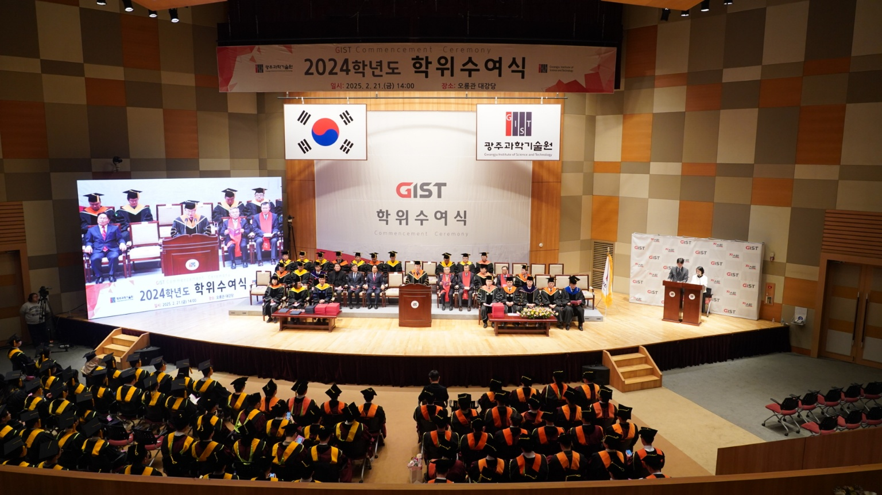

▲ GIST is holding the 2024 degree awarding ceremony at 2:00 PM on the 21st (Friday) in the Oryong Hall auditorium.

The Gwangju Institute of Science and Technology (GIST, President Kichul Lim) announced that it held the 2024 graduation ceremony at the Oryong Hall Grand Hall at 2:00 PM on Friday, the 21st.

On this day, a total of 309 people received degrees, including 78 doctorates, 109 masters, and 122 bachelors. With this, GIST has produced a total of 8,657 advanced science and technology personnel, including 2,023 doctorates, 5,195 masters, and 1,439 bachelors since its establishment in 1993.

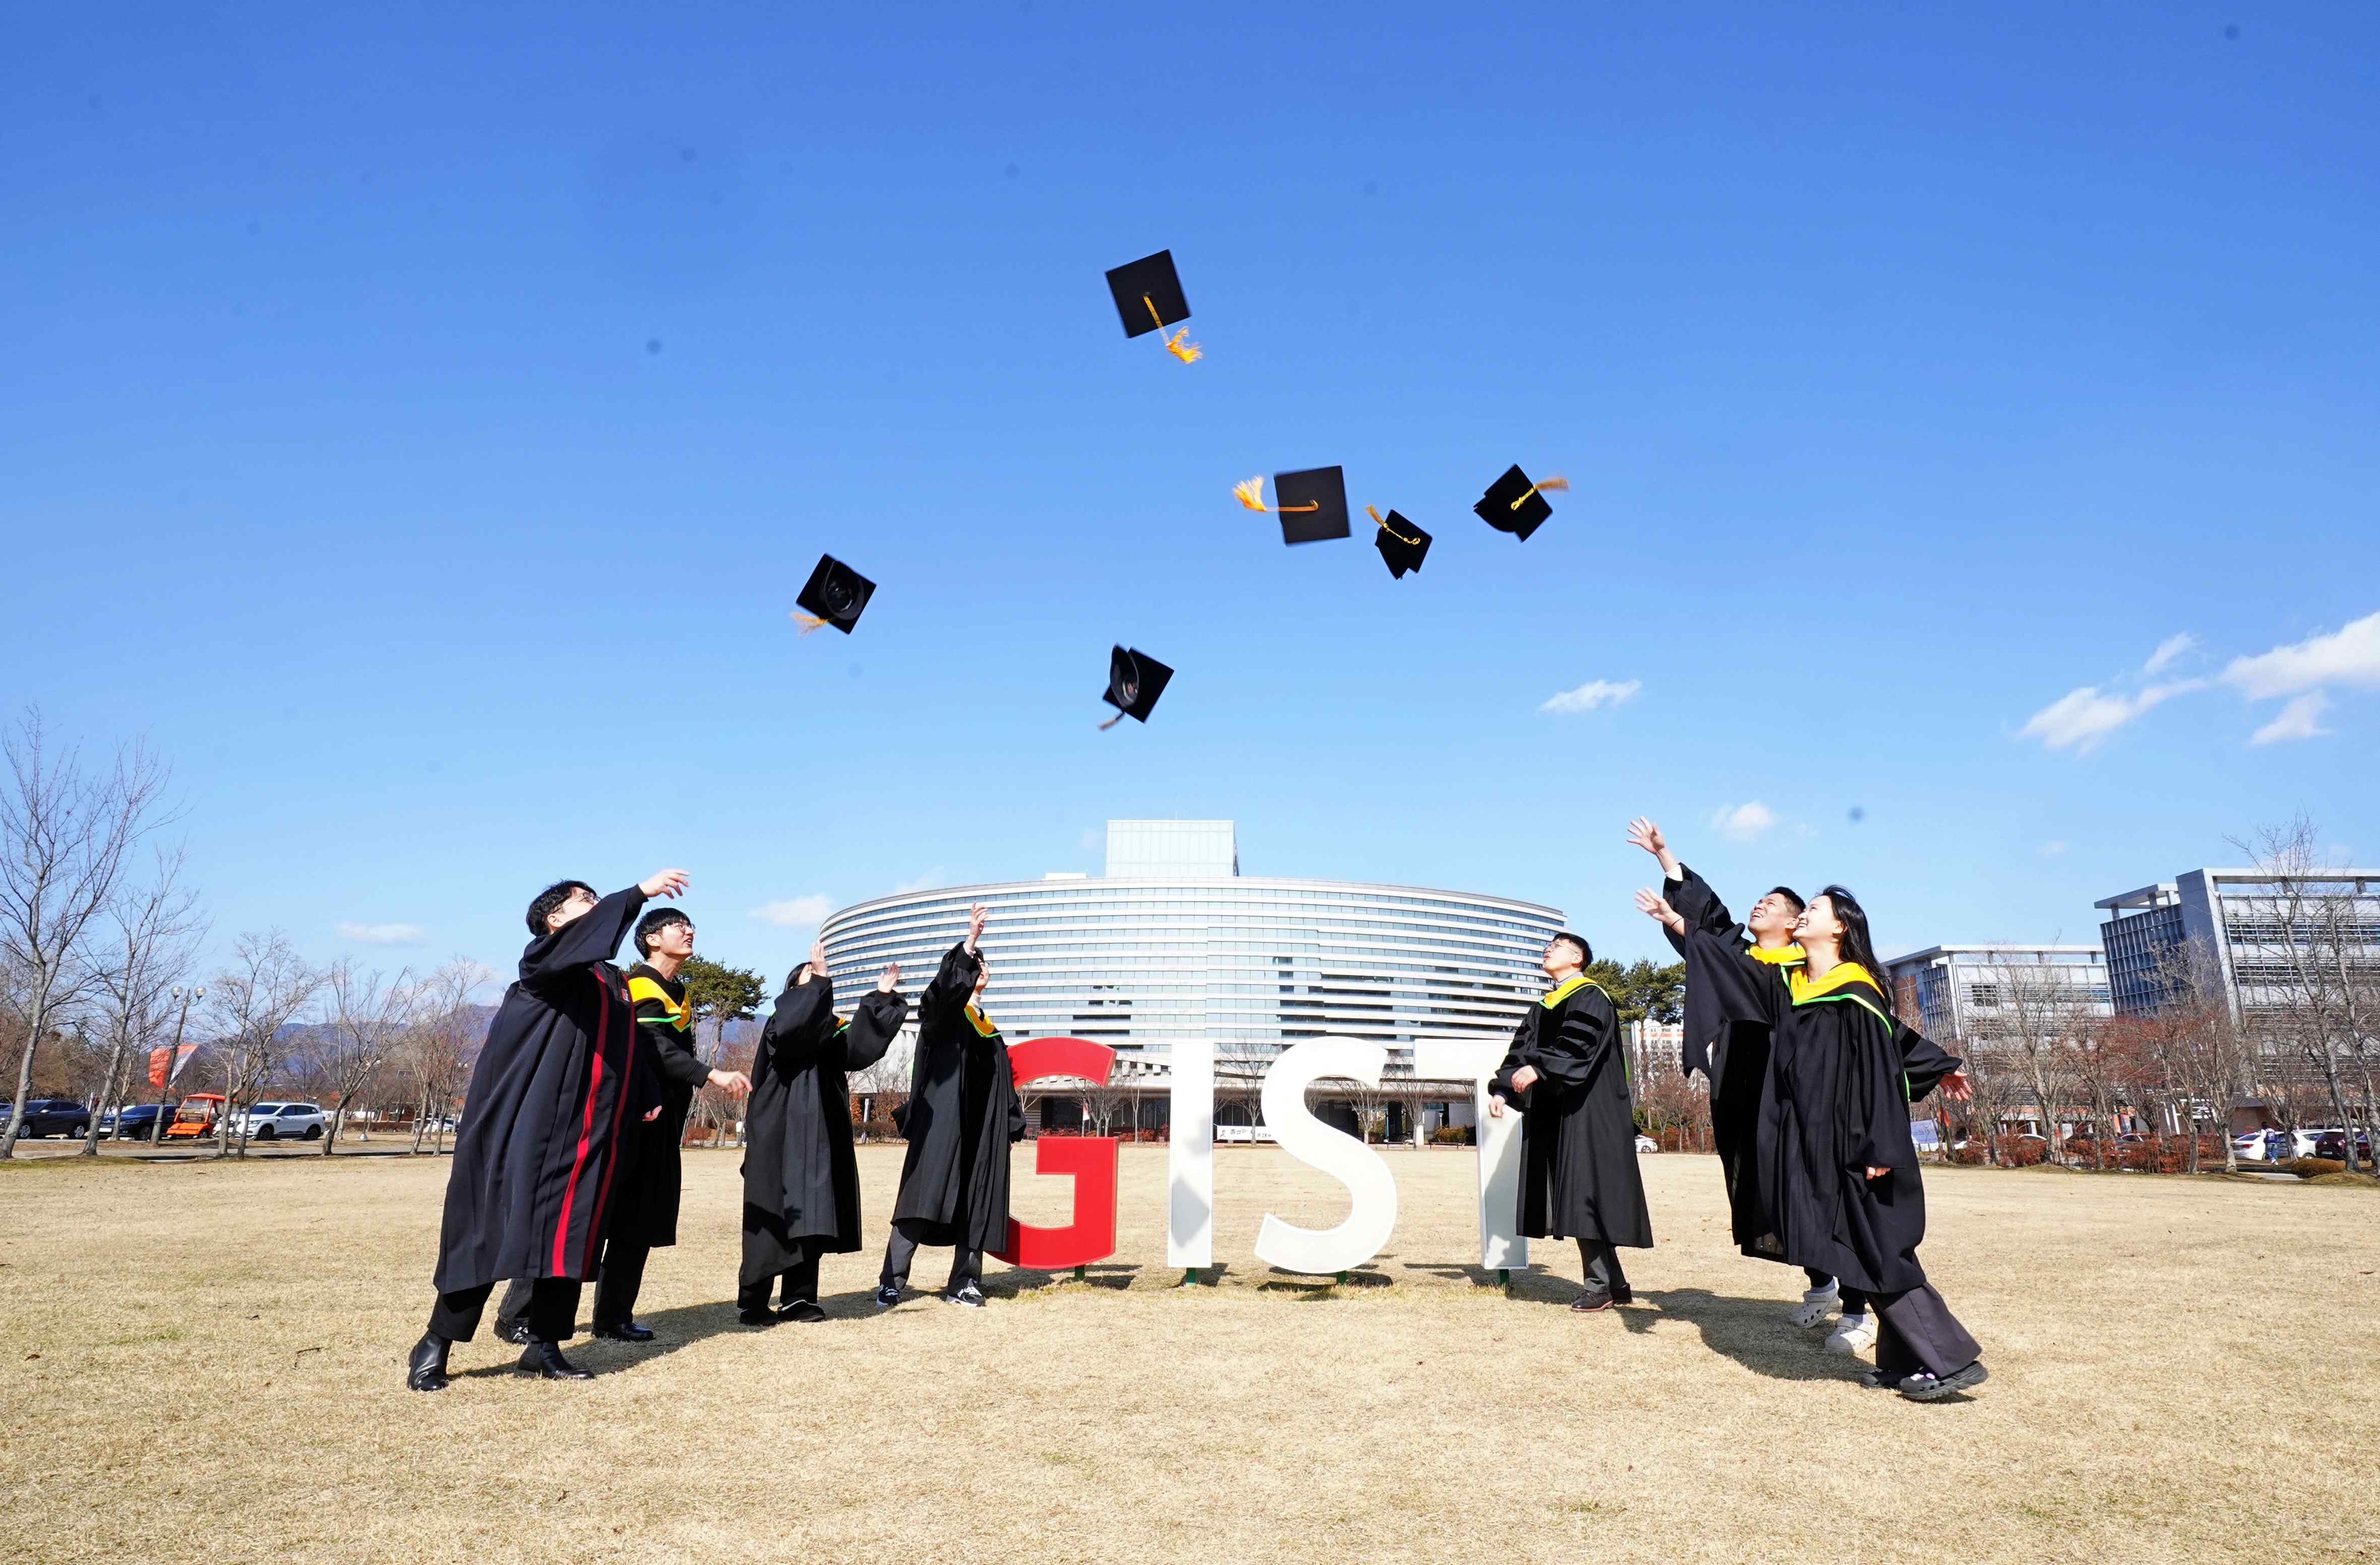

▲ GIST graduates throw their mortarboards to celebrate their graduation at the 2024 commencement ceremony.

The congratulatory remarks were made by Minister of Science and ICT Sang-im Yoo (video), Mayor of Gwangju Metropolitan City Ki-jung Kang, Assemblyman Do-geol Ahn (Gwangju Dongnam-eul), Assemblyman In-cheol Jo (Gwangju Seo-gu Gap), Chairman of GIST Woo-seung Kim, Chairman of GIST Development Foundation Hae-myeong Kim (video), and as a representative of the alumni, Co-CEO of BioFDNC Daehyun Jeong took the stage.

Alumnus Jeong said to his juniors, “I know better than anyone else the many failures, anxieties, and difficulties that have led to today’s glory. I hope you will never forget that you were fortunate enough to pursue academic truth and knowledge at GIST, and I hope you will always have a sense of mission to solve the difficult problems facing the world.”

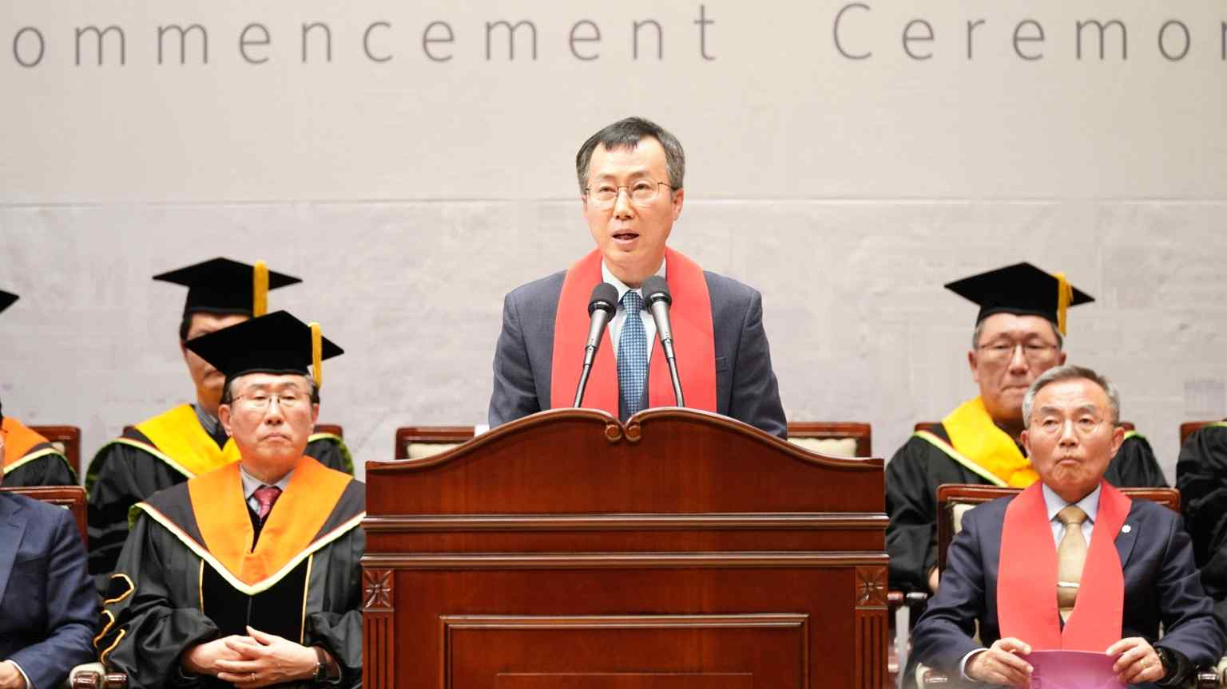

▲ BioFDNC CEO Daehyun Jeong is giving a graduation speech.

The 78 PhDs who received their degrees this time published a total of 346 papers in SCI (Science Citation Index) journals during their studies, and it was confirmed that each person published an average of 4.4 papers as the main author.

Among the outstanding achievements of the AI Graduate School (now the AI Convergence Department) that opened in 2019, PhD graduate Bae In-hwan presented a total of 11 papers (7 as the main author) at authoritative academic conferences (SCI level) in the field of artificial intelligence (AI), and received the Minister of Science and ICT Award for his outstanding research capabilities through 16 patent applications and registrations (including 6 US applications) and 11 awards from Samsung Electronics, Qualcomm, etc.

AI Graduate School PhD graduate Jinhwi Park, who received the Korea Institute of Science and Technology Information President’s Award, added to the joy of graduation when his appointment as a professor at Chung-Ang University’s Advanced Imaging Science Graduate School was confirmed as of March 1 of this year. During his time at GIST, Mr. Park published seven papers in the world's top AI academic conferences and three papers in renowned international academic journals, and applied for and registered a total of 14 patents in Korea and abroad (including four overseas applications).

GIST, a science and technology specialized university, encourages students to participate in volunteer activities utilizing their talents in mathematics and science. At this graduation ceremony, Su-yeon Sim and So-jeong Kim (School of Electrical Engineering and Computer Science), who received their bachelor’s degrees, were recognized for their contributions to the social contribution group ‘PIUM’ during their time at GIST, including their diligent educational service and online mentoring for students in remote areas.

Yang-hyun Joo (School of Environment and Energy Engineering), a bachelor’s graduate who achieved outstanding results in the field of entrepreneurship, received the Future Person Award. Joo has received many awards, including the Excellence Award at the 10th Laboratory Startup Festival hosted by the Ministry of Science and ICT, the 1st place at the KIC DC (Korea Innovation Center Washington DC) Tech Frontier Excellence Award, and the Excellence Award at the National ICT Innovation Idea Contest.

The newly established GIST Development Foundation Chairman’s Award went to Min-ji Jo (School of Environment and Energy Engineering), a bachelor’s graduate. Mr. Jo was recognized for his active participation in the GIST startup program, registering a fire extinguisher technology patent, and contributing to creative and practical technology development such as providing technical consulting to companies, fostering a startup culture, and expanding industry-academic cooperation.

President Kichul Lim urged the graduates to “grow into leaders of the Republic of Korea who have insight into the direction humanity should take, beyond the boundaries of specialized knowledge” and “become ‘philosophers of the AI era’ who can think about the social and global impacts of the topics they research, beyond the role of scientists who simply perform research projects.”

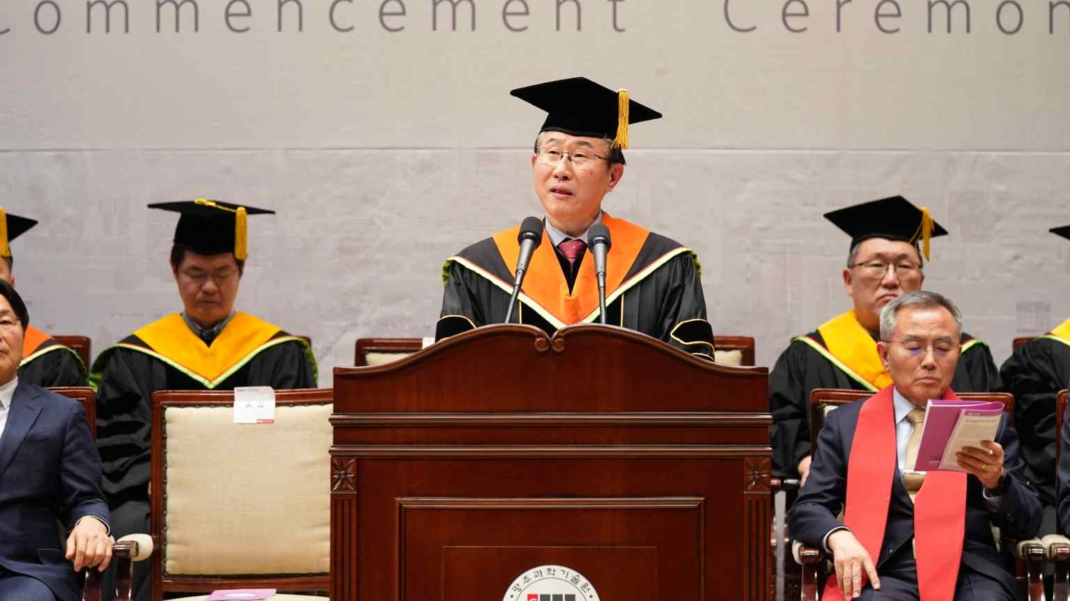

▲ GIST President Kichul Lim is speaking at the 2024 graduation ceremony.

Following the Quantum Conversion Research Group (Director Yousoo Kim) in the chemistry field that was launched in September of last year, the Relativistic Laser Science Research Group (Director Kyung Taec Kim) in the physics field is scheduled to hold an opening ceremony next week (the 28th), and in the second half of this year, a research group in the life science field will begin operation, thereby establishing a foundation for professors and researchers with world-class research capabilities to gather and immerse themselves in adventurous and experimental research by attracting three IBS campus research groups.

In addition, as part of the recent reorganization of the academic organization, the ‘AI Convergence Department’, which expanded the size of the former AI Graduate School, and the ‘AI Policy Strategy Graduate School’, which opened in September of last year as the first in Korea, are being established, including the ‘AI Gifted High School’, which is currently being promoted for establishment with the goal of opening in 2027, thereby completing the ‘AI Talent Development Ladder’ and establishing a future-oriented education system to respond to the era of AI transformation.



