"The beautiful plum blossoms bloomed here first" GIST Oryong Art Hall, Jikheon Huh Dal Jae Invitational Exhibition

- GIST Oryong Art Hall, the grandson of the master of Namjong literati painting, Heo Baek-ryeon, invites artist Huh Dal Jae, who represents the new Namjong painting, to the ‘HUH DAL JAE’ exhibition, which will be held until March 27 (Thursday)

- 15 white plum blossoms and red plum blossoms that add modern sensibility and splendor to traditional literati painting

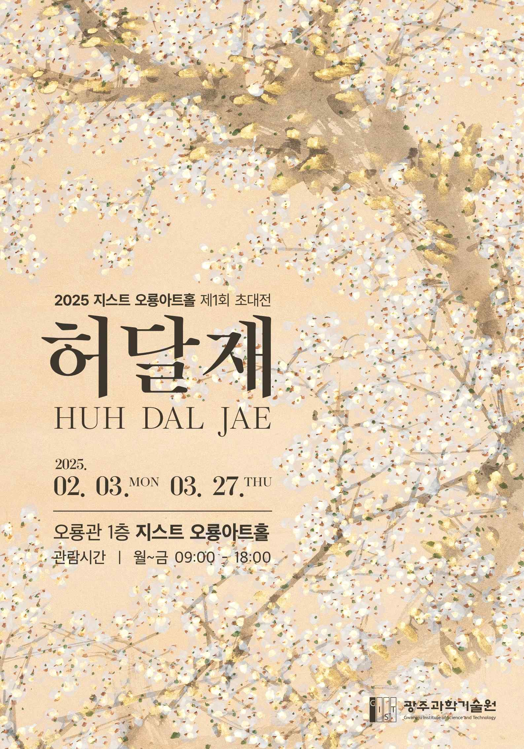

▲ Poster for the 1st 2025 Oryong Art Hall Exhibition ‘HUH DAL JAE’

The invitational exhibition of the master of Nam Jong Hwa*, Jikheon artist Huh Dal Jae, will be held at GIST until March 27 (Thursday).

* Nam Jong Hwa: From the anthology of Dong Qichang, a painter from the Ming Dynasty, it was divided into two streams, and they are called Namhwa and Bukhwa, respectively. Namjonghwa developed mainly with ink and wash, and Bukjonghwa developed mainly with color. Unlike Bukjonghwa, which is realistic and mainly with color, Namjonghwa is a pictorial painting that comes from the artist’s imagination and feelings.

The Gwangju Institute of Science and Technology (GIST, President Kichul Lim) announced that it will hold the ‘HUH DAL JAE’ exhibition as the first invitational exhibition of the year at Oryong Art Hall.

In this exhibition, where you can fully experience the essence of Namjonghwa, which is painted ‘as the brush moves,’ you can appreciate 15 white and red plum blossoms that use the traditional painting style’s plain colors but are reinterpreted with modern techniques to add new sensibility and splendor.

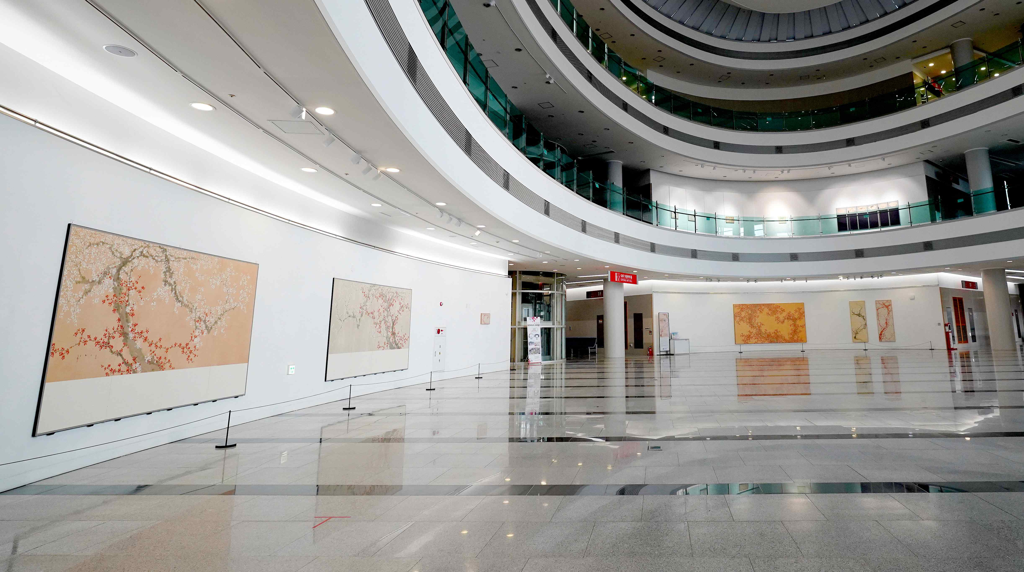

▲ Panoramic view of Oryong Art Hall where the first invitational exhibition of 2025, ‘HUH DAL JAE’, is being held

Heo Baek-ryeon, the grandson of the master of Namjong literati painting, was born in Gwangju in 1952. Heo Baek-ryeon began visiting his grandfather’s studio, Chunsulheon, at the age of five and learned painting and calligraphy from his grandfather.

In particular, the plum blossoms that frequently appear in his works are the plum trees planted around his grandfather’s studio when he was young, and they have been living and breathing in his works to this day.

Choi Soon-im, the art director of Oryong Art Hall, said, “This exhibition is very meaningful in that it introduces literati painting expressed as contemporary art through the works of an artist who inherits Namjong painting, the foundation of Namdo art. This exhibition, which centers around plum blossoms, shows the process of sublimating the artistic essence of Heo Dal-jae’s literati spirit into a modern visual language, rather than simply a desire for aesthetic expression.”

She also said, “We expect that the Plum Blossom Exhibition by artist Heo Dal-jae, who was recently announced as the winner of the 66th March 1st Cultural and Arts Award, will be held at Oryong Art Hall, and that it will be a meaningful exhibition that will open the early spring of 2025.”

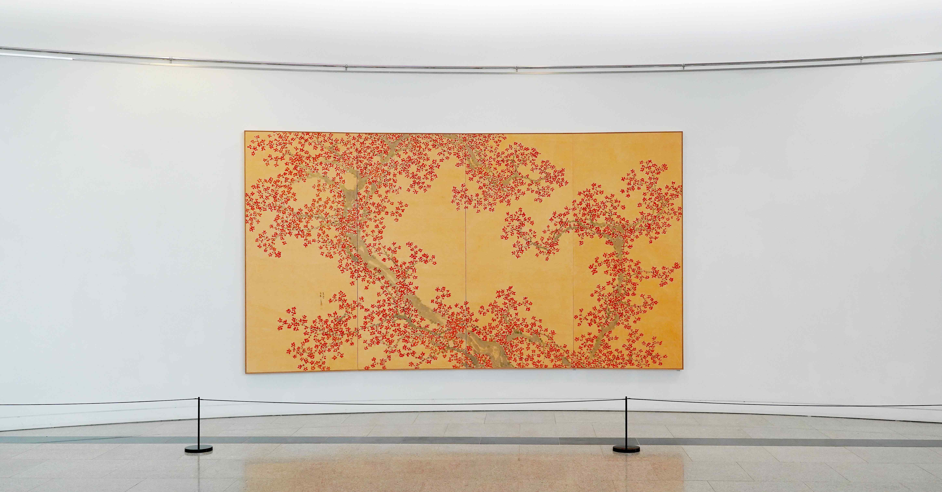

▲ Representative work of the 1st Invitational Exhibition of 2025, ‘HUH DAL JAE’, ‘Red Blossoms (2021, 272x384, ink and color on Korean paper)’

The 'HUH DAL JAE' exhibition, which will be held at the GIST Oryong Art Hall until March 27, is open to anyone interested from 9 AM to 6 PM on weekdays. (Weekend opening inquiries / T. 062-715-2622)

Meanwhile, Oryong Art Hall is an exhibition space created on the inner walls of the 1st and 2nd floors of Oryong Hall, a multipurpose building for events, conferences, lectures, and seminars, in order to provide a venue for GIST, which has grown through the interest of local residents, to strengthen exchanges and cooperation with the local community.

Starting with the first invitational exhibition in December 2022, a total of 14 exhibitions including this 'HUH DAL JAE' exhibition have been held, practicing the value of sharing as an 'open cultural and artistic space'.



