GIST introduces cutting-edge research equipment, 'ultra-low temperature transmission electron microscope (300kV Cryo-EM)'

- 300kV(kilovolt) Cryo-EM, 10th in Korea, installed at GIST Advanced Institute of Instrumental Analysis (GAIA)... It can elucidate the 3D structure of biomolecules such as proteins, viruses, and cells at the atomic level

- Tae-Young Kim, Director of GAIA, “Analysis of protein complexes and virus structures using Cryo-EM equipment will become a new foundation for technological innovation in the biomedical sciences such as life sciences, medicine, and new drug development.”

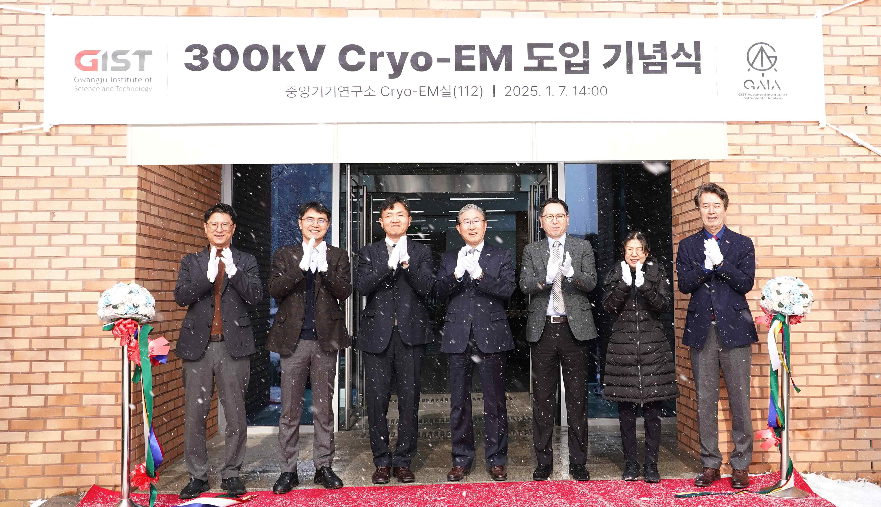

▲ Attendees pose for a commemorative photo at the 300kV Cryo-EM introduction ceremony held at the GIST Advanced Institute of Instrumental Analysis on Tuesday, January 7. (From left) Research Dean Jae Young Lee, Vice President for R&DB Sungho Jeong, Director of GAIA Tae-Young Kim, President Kichul Lim, Vice President for Academic Affairs Sang-Don Kim, Library and Information Resources Dean Hyunju Lee, and Vice President for Public Affairs Yonghwa Chung

The Gwangju Institute of Science and Technology (GIST, President Kichul Lim) announced that it held a ceremony to introduce the cutting-edge 300kV (kilovolt) high-resolution cryogenic transmission electron microscope (300kV Cryo-EM) at the Advanced Institute of Instrumental Analysis (GAIA) on Tuesday, January 7.

President Kichul Lim, Vice President for Academic Affairs Kim Sang-don, Vice President for Research Jeong Seong-ho, Vice President for Academic Affairs Sang-Don Kim, Director of GAIA Tae-Young Kim, Research Dean Jae Young Lee, and Library and Information Resources Dean Hyunju Lee attended the event.

‘Cryogenic transmission electron microscope (Cryo-EM)’ is a technology that rapidly cools biomolecules such as proteins, viruses, and cells to an extremely low temperature (-196°C) to observe them in their physiological state. It can precisely analyze the three-dimensional structure of biomolecules at the atomic level, and innovative developments in the fields of life sciences, medicine, and new drug development can be expected.

Professor Richard Henderson of the Medical Research Council (MRC) in the UK and others were awarded the Nobel Prize in Chemistry in 2017 in recognition of their contributions to the development of Cryo-EM technology. GIST is the 10th university in Korea to introduce this cutting-edge equipment.

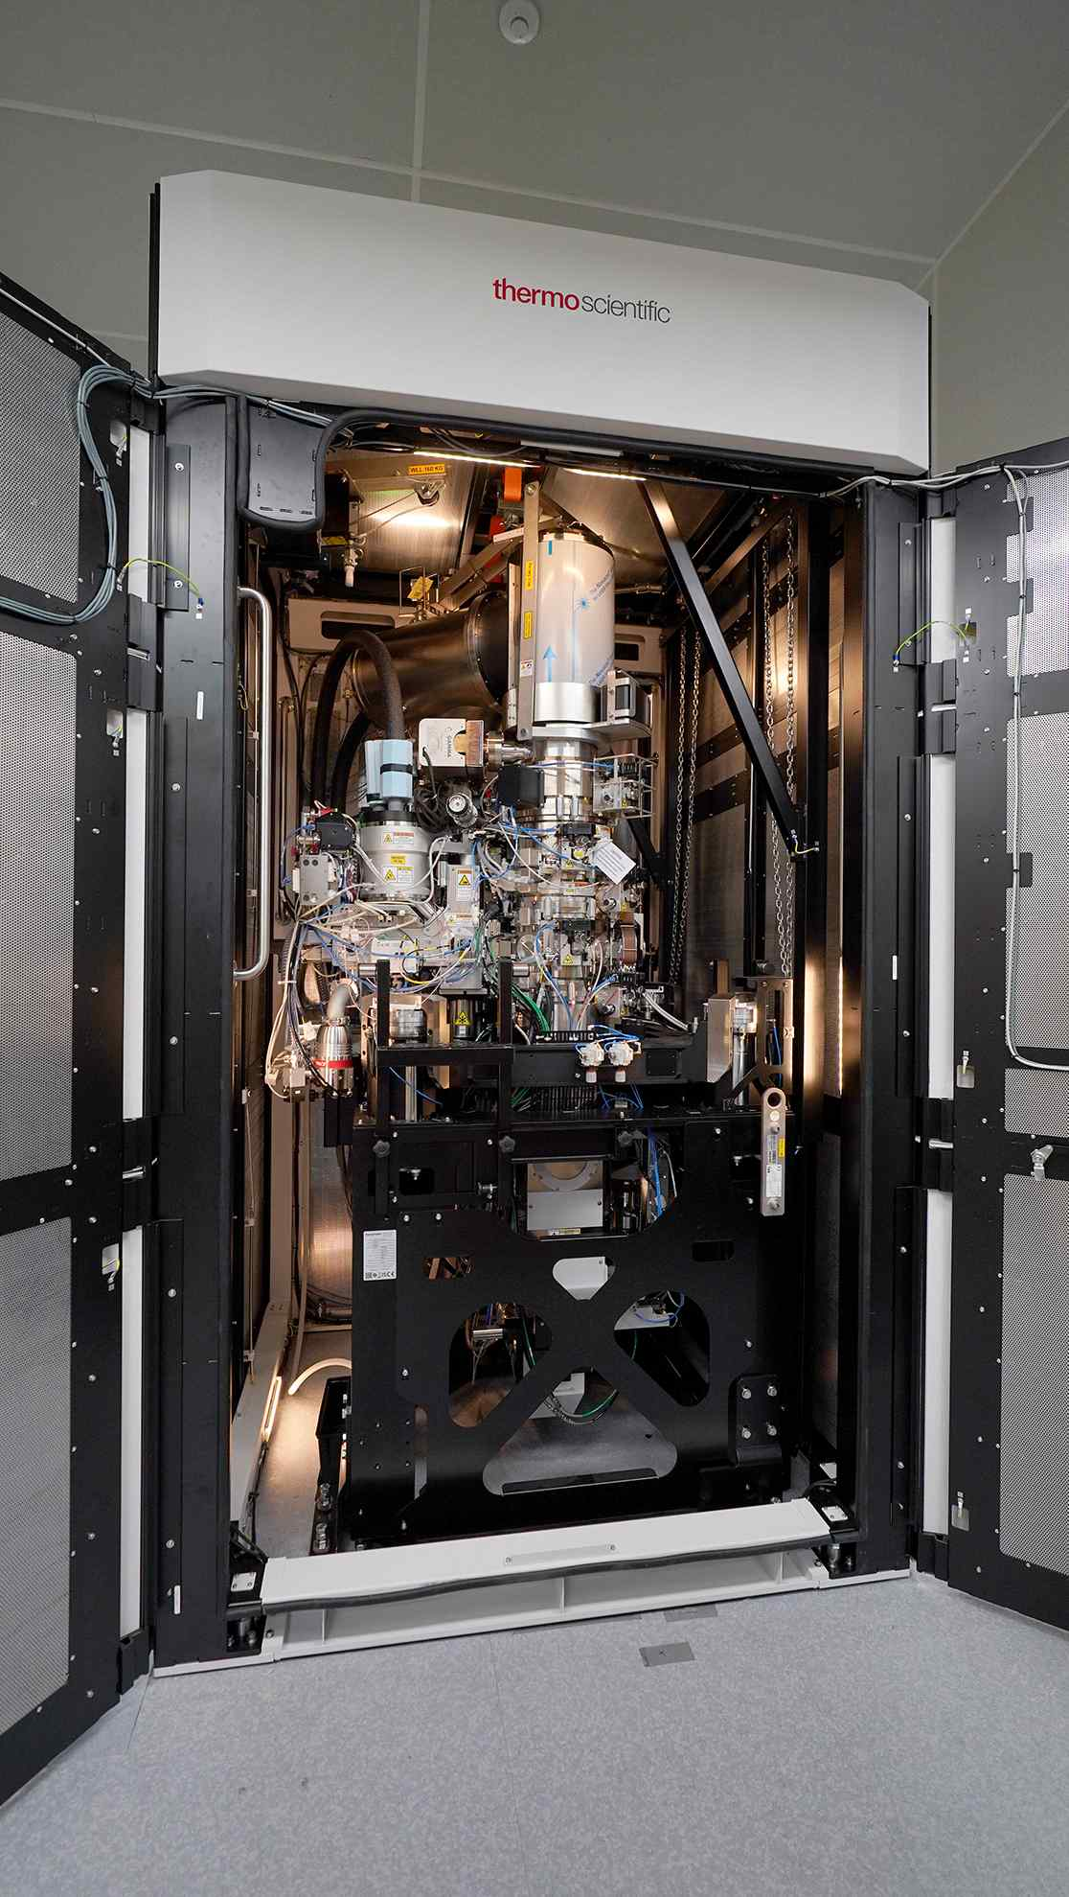

▲ The 10th state-of-the-art 300kV (kilovolt) high-resolution cryogenic transmission electron microscope (300kV Cryo-EM) installed in the Advanced Institute of Instrumental Analysis (GAIA)

At the ceremony, Director Tae-Young Kim emphasized the institute’s capabilities by introducing the latest equipment, including the Cryo-EM, the environmental scanning electron microscope (E-SEM), X-ray photoelectron spectrometer (XPS), the 200kV transmission electron microscope (200kV TEM), and the Orbitrap mass spectrometer (Orbitrap MS), which were newly introduced last year.

Director Kim said, “Cryo-EM will play an important role in various cutting-edge research fields, including life sciences, medicine, new drug development, nanomaterials, and polymer structural analysis. Through this, we expect it to contribute greatly to the development of GIST and the Honam region’s industries.”

He also emphasized the importance of stable construction and systematic management of cutting-edge joint research equipment, and promised to continue to provide the highest level of research support in the future.

GAIA opened as the GIST Central Research Equipment Center in 2019 to establish cutting-edge research equipment and centralize major research equipment within the university. It was upgraded to a research institute in November 2023 to strengthen cutting-edge research infrastructure such as developing new cutting-edge instrument analysis methods and research equipment and to conduct world-class instrument analysis research.

All of GAIA's equipment provides joint utilization services, and all usage procedures, such as real-time reservations and analysis result confirmation, can be conveniently used online through the Research Equipment Integrated Management System (gaia.gist.ac.kr). The institute also regularly holds training and seminars to ensure efficient use of research equipment.

In particular, in February of last year, GIST signed an agreement with 20 universities in the Gwangju and Jeonnam regions, including Chonnam National University, Chosun University, Korea Institute of Energy Technology, Mokpo National University, and Suncheon National University, to increase cooperation in the joint use of research equipment, thereby actively promoting regional research cooperation. This agreement includes updating and sharing research equipment information, and a 30% discount on test analysis fees.



