GIST develops 'fishing gear automatic identification monitoring system' to find and manage discarded fishing gear using IoT technology

- Information and Communication Convergence Research Center, after 8 years of research and development, technology transfer to private companies completed and commercialization is imminent... Groundbreaking electricity expected for preventing marine vessel accidents and protecting marine ecosystems

- Recorded communication rate of over 99.5% in a real fishing ground environment 29~35km away from a communication base station... “If distributed to Southeast Asia, where marine waste is abundant, it will be able to lead international fishing gear management policy”

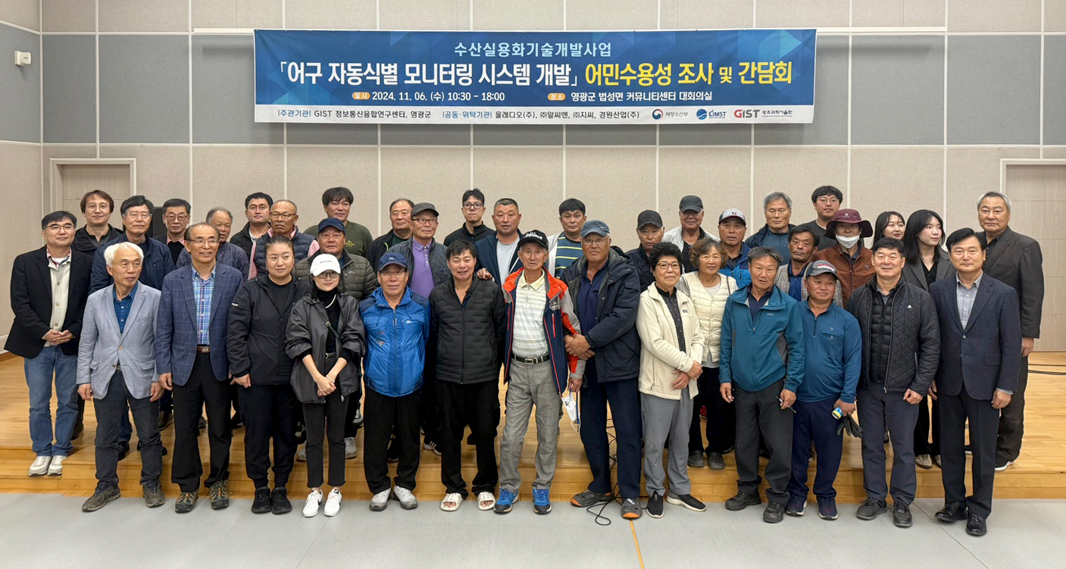

▲ On Wednesday, November 6, the GIST Information and Communication Convergence Research Center and Yeonggwang-gun held a fishermen acceptance survey and discussion meeting on the development of an automatic fishing gear identification monitoring system at the Yeonggwang-gun Beopseong-myeon Community Center, and the attendees took a commemorative photo.

Worldwide, more than 100,000 marine creatures, including sea turtles and dolphins, are injured or killed by discarded fishing gear every year. In Korea, along with the loss of marine resources due to discarded fishing gear, safety accidents caused by discarded fishing gear entangled in ship propellers also occur every year.

The government has been continuously carrying out discarded fishing gear collection projects, such as implementing a real-name fishing gear system, but they have not been effective, and approximately 5,000 tons of discarded fishing gear are left in the ocean every year.

Accordingly, the marine and fisheries industry has consistently raised the need for developing an electronic fishing gear management system, and the Gwangju Institute of Science and Technology (GIST, President Kichul Lim) has succeeded in developing an ‘automatic fishing gear identification monitoring system’ and is about to commercialize it, which is expected to be a groundbreaking turning point in preventing marine vessel accidents and protecting the marine ecosystem.

The GIST Information and Communication Convergence Research Center (Research Director Professor Kiseon Kim) was selected as the main organization for the development project of the ‘Fishing Gear Automatic Identification Monitoring System’ by the Ministry of Oceans and Fisheries and the Korea Institute of Ocean Science and Technology in 2017, and formed a consortium with 16 organizations including Jeollanam-do and SK Telecom. After an 8-year research and development process (2017-2024), the technology was transferred to Ocean Graphics, a private company headquartered in Muan-gun, Jeollanam-do, in October.

The system began full-scale commercialization by receiving commercialization certification from a basic telecommunications operator in November of this year, and the Information and Communication Convergence Research Center is taking steps to apply it to the fishing industry by introducing policies and holding briefing sessions.

The ‘fishing gear automatic identification monitoring system’, which attaches electronic buoys that transmit location information to each fishing gear based on maritime IoT (Internet of Things) technology, can monitor the owner, type, location, etc. of fishing gear in real time through wireless communication with fishing boats, management vessels (fishery management teams), and land.

When this system is introduced, information on fishing gear in operation can be checked in real time by fishermen, management vessels, and land-based integrated control centers, which is expected to reduce maritime accidents and greatly contribute to the protection of marine ecosystems and fishery resources through the management of lost and discarded fishing gear.

The Information and Communication Convergence Research Center conducted a real-sea integrated linkage and reliability verification of electronic fishing gear prototypes in the waters of Heuksando Island and other areas, and succeeded in all communications, recording a communication rate of over 99.5% in a real-world fishing ground environment 29-35 km away from the nearest communication base station.

In addition, officials stated that they have continuously held explanatory sessions for a total of 600 fishermen, including meetings held in Taean-gun, Chungcheongnam-do on Friday, December 20 and Yeonggwang-gun, Jeollanam-do on Wednesday, November 6, so that fishermen, who are the actual users, can utilize this system, and have confirmed positive responses in the field.

Professor Kiseon Kim said, "Until now, the discarded fishing gear that was thrown into the sea was not properly collected, causing massive damages due to ship accidents and ghost fishing. If this system is commercialized, it will contribute to the sustainable development of the national fishing industry."

He also said, "If this system is distributed to Indonesia and Vietnam, which have high marine waste discharge rates, through official development assistance (ODA), Korea will be able to lead the international fishing gear management policy."



