GIST, IBS Quantum Conversion Research Group Kick-off Symposium held

- IBS Quantum Transformation Research Group Kick-off Symposium led by Director Yousoo Kim held from December 5th (Thu) to 7th (Sat)... Leading researchers and students from RIKEN, Tokyo University, and Chinese Academy of Sciences visit GIST

- “Expecting research collaboration between GIST-RIKEN-Tokyo University... Efforts to secure scientific and technological competitiveness that contributes to building an international research network and revitalizing the regional economy and industrial innovation”

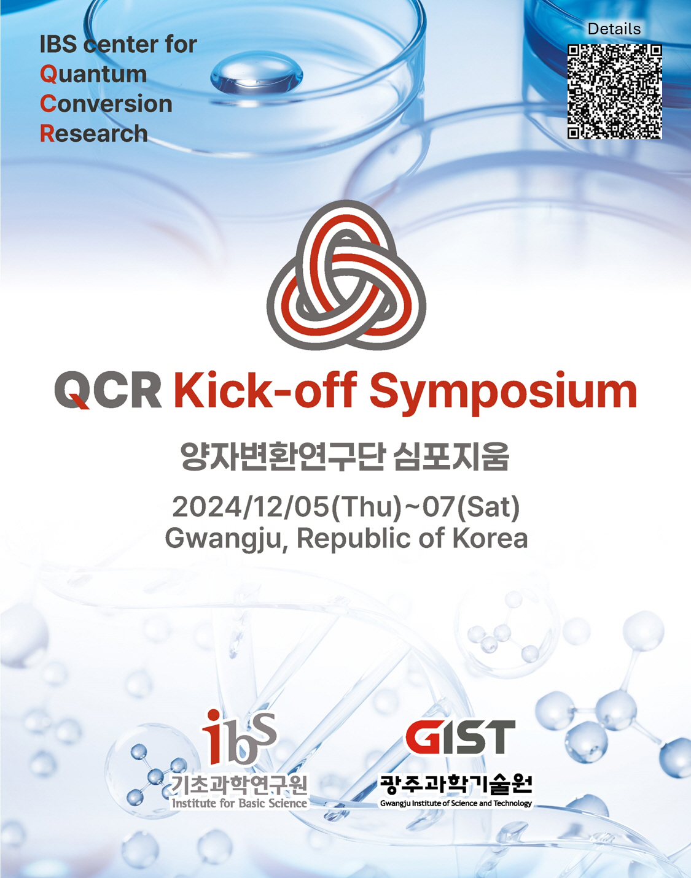

▲ Quantum Conversion Research Group Symposium event poster

The Gwangju Institute of Science and Technology (GIST, President Kichul Lim) announced that it will hold a kick-off symposium for the Institute for Basic Science (IBS) Quantum Transformation Conversion Group (Director Yousoo Kim, Professor of Chemistry, GIST) from Thursday, December 5 to Saturday, December 7.

The event will be attended by leading figures in the Japanese science and technology community, including ▴ Director of the National Institute of Natural Science Maki Kawai, ▴ Rikei Tahei, a senior researcher at the Institute of Physical and Chemical Research (RIKEN), ▴ Takeshi Yanagida, Dean of the Department of Applied Chemistry, University of Tokyo, and ▴ Jun YOSHINOBU, former Vice Director of the Physical Research Institute.

On the first day, Thursday the 5th, from 6:30 PM to 9:00 PM, there will be poster presentations by researchers from RIKEN, the University of Tokyo, and the Chinese Academy of Sciences, 20 Tokyo University students, and GIST students in the lobby of GIST Oryong Hall, followed by the Best Poster Award ceremony.

On the second day, Friday the 6th, from 9:30 AM to 5:30 PM, in Room 101 of GIST Oryong Hall, there will be a keynote speech by Director Maki KAWAI of the National Institute for Comprehensive Science, followed by an introduction by Director Yousoo Kim about this event and the Quantum Conversion Research Group, followed by presentations by researchers from Korea, China, and Japan.

From GIST, Professor Bongjin Mun of the Department of Physics and Photon Science, Professor Myung-Han Yoon of the School of Materials Science and Engineering, and Professors Yoonsoo Pang and Hohjai Lee of the Department of Chemistry will participate.

On the last day, Saturday the 7th, a program for research exchange and networking between IBS Quantum Conversion Research Center researchers and Tokyo University students will be held.

Director Yousoo Kim, who is recognized as a world-class researcher in the field of interface chemistry that studies chemical reactions at the atomic and molecular levels that occur on the surface of materials, became a hot topic when he moved from RIKEN, where he was the first Korean to become a chief scientist, to GIST in September.

The IBS Center for Quantum Conversion Research aims to develop innovative methodologies to quantitatively measure and control interactions between quantum states, thereby understanding the fundamental principles that form the basis of energy conversion and material conversion, and thereby creating innovative functions and properties that are expressed by the quantum conversion phenomenon of materials.

Director Yousoo Kim said, "We would like to express our gratitude to the GIST staff who worked hard to prepare for this symposium event and to all those who attended from overseas. We look forward to active research collaboration between GIST, RIKEN, and the University of Tokyo, with the BS Quantum Transformation Research Group as the center. We will do our best to secure scientific and technological competitiveness that contributes to regional economic activation and industrial innovation while building an international research network."

Meanwhile, detailed schedule and information about the IBS Quantum Transformation Research Group Symposium event can be found through the QR code in the announcement.



