GIST Oryong Art Hall holds 'Prayer, PRAY' invitational exhibition by Seo Mira

- The 7th Invitational Exhibition in 2024... About 20 works that create unique and rich forms and emotions through delicate combinations of materials such as old Korean paper, colorful threads, and hemp will be on display until January 24th next year.

- You can see the changes in Seo Mira's work and the results of her artistic ability over the past 10 years, including her representative work 'Han-gyeol (Tremendous Layers)', which expresses the Daedongyeojido map through stitching on cloth.

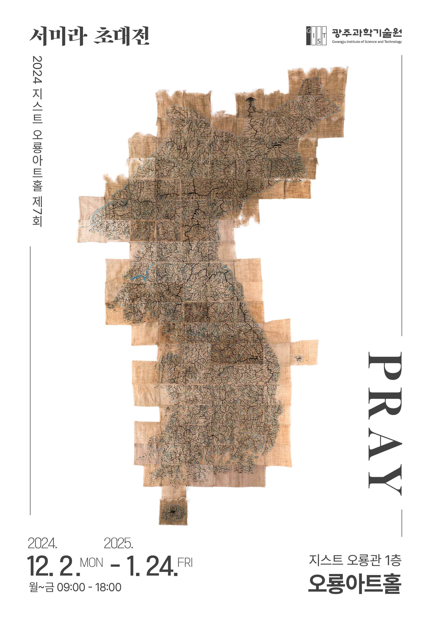

▲ 2024 Oryong Art Hall 7th Exhibition ‘Prayer, PRAY’ Poster

The act of dotting a work is rather an act of freeing myself from the desire to consciously express something, by focusing on the pure act itself. ... (omitted) ... Compared to the work I have done so far, the recent 'dotting work' is the most monotonous and calm. I think that calmness gives me comfort. I can escape from the effort to control or understand myself and immerse myself in the experience of pure creation.

- From Seo Mira's note

The Gwangju Institute of Science and Technology (GIST, President Kichul Lim) announced that it will hold the exhibition of artist Seo Mira's 'Prayer, PRAY' from December 2 to January 24 next year at Oryong Art Hall.

This exhibition is the seventh invitational exhibition held at Oryong Art Hall this year, and it will display about 20 works that delicately combine materials such as old Korean paper, colorful threads, and hemp to create unique and rich forms and emotions.

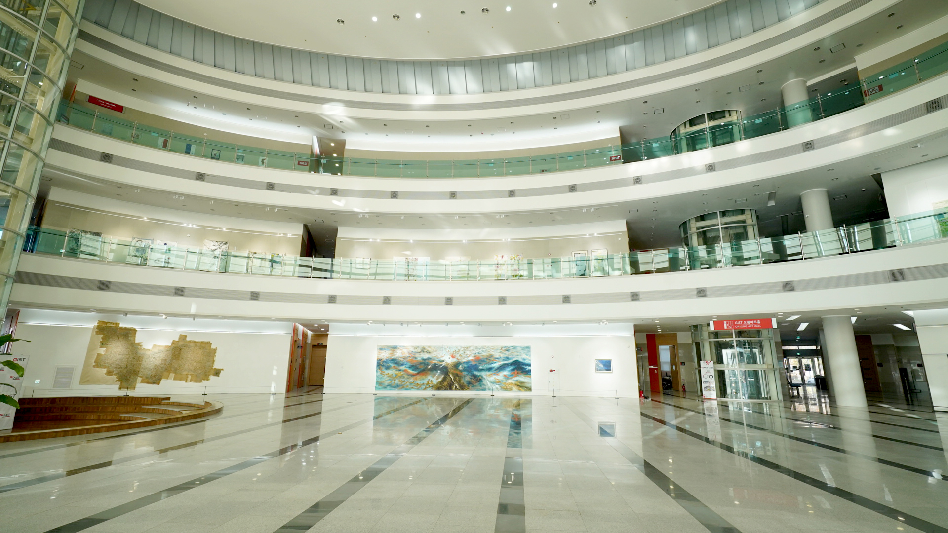

▲ Panoramic view of the 2024 Oryong Art Hall 7th Exhibition at Oryong Art Hall

Born in Gwangju and graduated from the Department of Fine Arts at Chonnam National University and its graduate school, Seo Mira has held about 100 group exhibitions and 20 solo exhibitions, and her major works include <Old Memories>, <Traces>, and <Prayer>. She mainly works by arranging various materials in a collage format to add meaning and depth to her works.

In particular, in her works using hemp, which women have woven and woven by hand since ancient times, we can see traces of her contemplation on how her paintings and drawings can harmonize with the weaving of unknown women from the past beyond time.

Her representative work, ‘Han-gyeol (Tremendous Layers)’, which expresses the Daedongyeojido map through sewing on cloth, was completed through the artist’s inspiration and manual labor, revealing traces revealed between visible presence and invisible absence.

Artist Seo Mira said about her masterpiece, ‘Han-gyeol,’ "It was difficult to make because it was sewing, not drawing, but I felt like I was breathing like a giant living creature as each stitch was connected like a thread to form a mountain range and a river. Just as many people worked hard to make their imaginations a reality during the time when the Daedongyeojido was made, my work is also filled with countless desires and efforts to make such imaginations a reality."

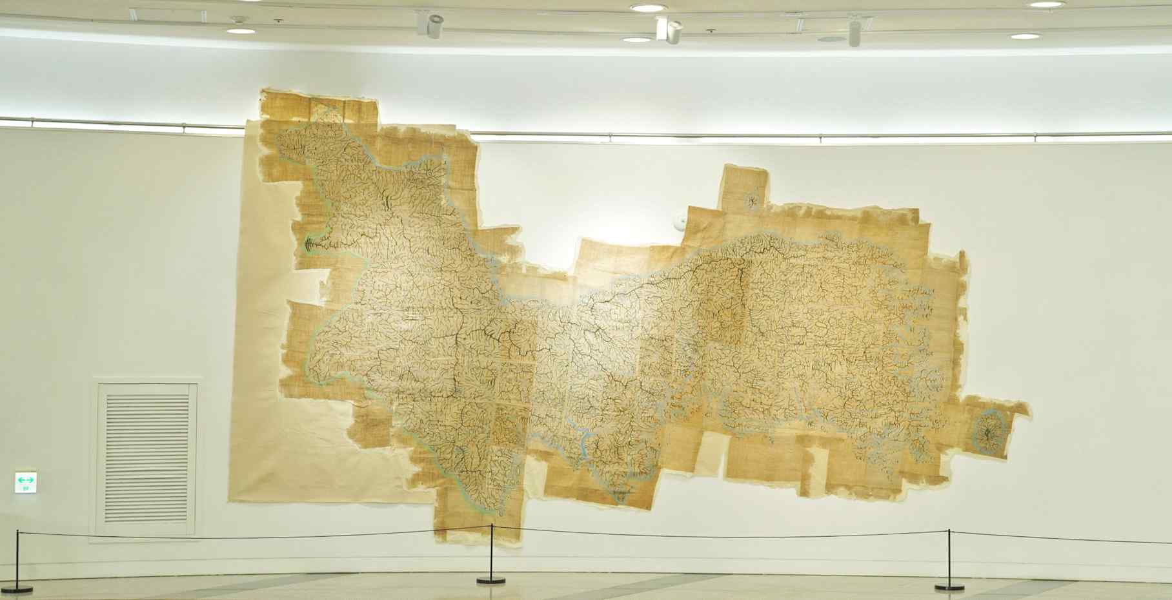

▲ Representative work ‘Tremendous Layers’, which depicts the Daedongyeojido map through stitching on cloth

Artist Seo Mira said, "This exhibition is the result of the changes in work and the artist's ability over the past 10 years, starting from the Beijing Creative Studio operated by the Gwangju City Art Museum in 2014 and continuing to the United States. I am honored to be exhibiting the work of a Korean artist who completed it in the United States, where East and West intersect, at Oryong Art Hall, and I am grateful to be invited to such a meaningful space."

The 'Prayer, PRAY' exhibition, which will be held at GIST Oryong Art Hall until January 24th (Friday) next year, is open to anyone interested from 9 AM to 6 PM on weekdays. (For inquiries regarding weekend openings, please contact T. 062-715-2622)

Oryong Art Hall is an exhibition space created on the inner walls of the 1st and 2nd floors of Oryong Hall, a multipurpose building for events, meetings, lectures, and seminars, in order to provide a venue for GIST, which has grown through the interest of local residents, to strengthen exchanges and cooperation with the local community. Starting with the first invitation exhibition in December 2022, a total of 13 exhibitions have been held up to this 'Prayer, PRAY' exhibition, practicing the value of sharing as an 'open cultural and artistic space'.

Meanwhile, Robert C. Morgan, an international critic and curator based in New York, said, "Seo Mira's work mainly reflects the balance between the concept and the materials needed to create the work. She delicately combines materials such as old Korean paper, colorful threads, and handmade hemp to give her work a sense of time, and her painting process is a process of transforming mental concepts into visual and material properties, so that the painting gradually becomes clearly defined according to its own reality."



