GIST-Credit Guarantee Fund sign mutual cooperation MOU to establish a cooperative system for the diffusion of innovative technologies and the creation of a technology startup ecosystem

- President Kichul Lim, Chairman Won-mok Choi, and other officials in attendance at the GIST Administrative Building on Monday, December 2... Promise to actively promote linked projects to spread innovative technologies and create a technology startup ecosystem

- President Kichul Lim, “I hope this will be the first step toward opening an era of localization by contributing to job creation”

- Chairman Won-mok Choi, “Honam region companies are expected to utilize GIST’s innovative technologies to create new markets and businesses”

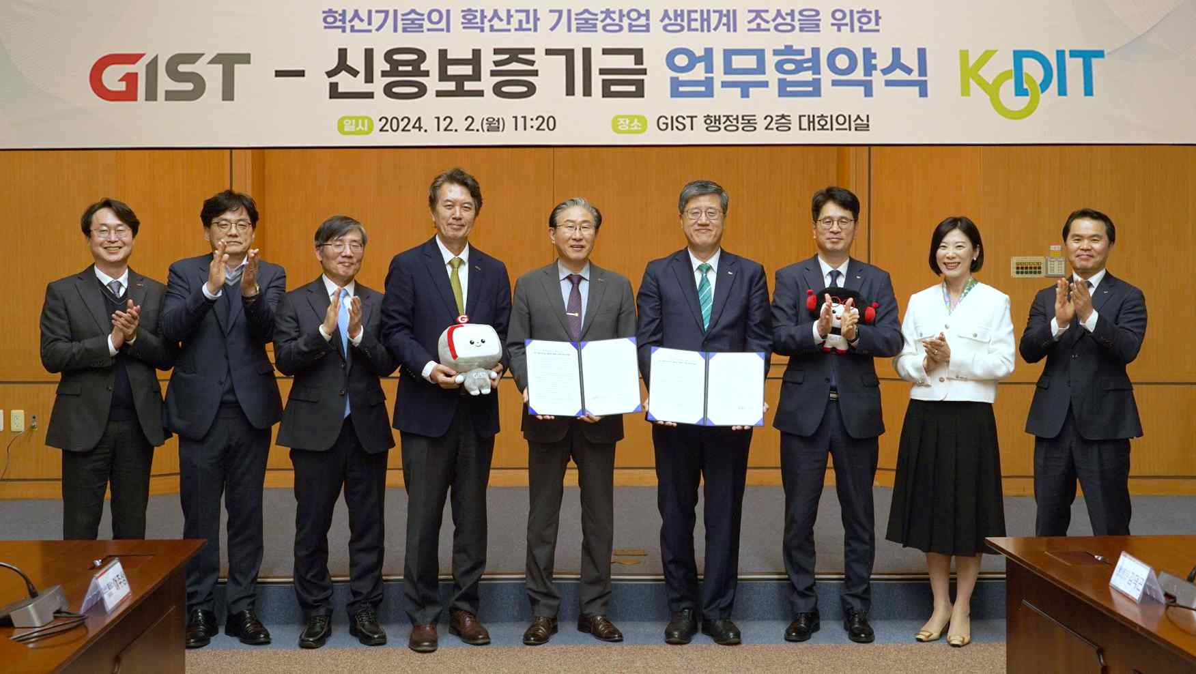

▲ GIST and Korea Credit Guarantee Fund signed a business agreement (MOU) to promote the spread of innovative technologies and create a technology startup ecosystem, and attendees are taking a commemorative photo. (From left) GIST International and Public Affairs Dean Jae Gwan Kim, GIST Holdings CEO Ju-sang Yeo, Science and Technology Innovation Division Director Min-Gon Kim, Vice President for Public Affairs Yonghwa Chung, President Kichul Lim, Korea Credit Guarantee Fund Chairman Won-mok Choi, Honam Sales Headquarters Director Seung-kwan Kim, 4.0 Startup Department Manager Hyo-jin Lim, and Gwangju Startup Branch Manager Deok-gon Kim

The Gwangju Institute of Science and Technology (GIST, President Kichul Lim) announced that it signed a business agreement (MOU) with the Korea Credit Guarantee Fund (KODIT, Chairman Won-mok Choi) for the diffusion of innovative technologies and the creation of a technology startup ecosystem.

The signing ceremony was held on Monday, December 2nd in the conference room of the GIST Administration Building with about 10 key officials in attendance, including GIST President Kichul Lim, Vice President for Public Affairs Yonghwa Chung, International and Public Affairs Dean Jae Gwan Kim, Director of the Science and Technology Innovation Business Division Min-Gon Kim, CEO of GIST Holdings Ju-sang Yeo, and Korea Credit Guarantee Fund Chairman Won-mok Choi, Honam Sales Headquarters Director Seung-kwan Kim, 4.0 Startup Department Director Hyo-jin Lim, and Gwangju Startup Branch Manager Deok-gon Kim.

Through this agreement, GIST will combine its innovative technology startup discovery and nurturing capabilities with the Korea Credit Guarantee Fund's financial support expertise to support the growth of technology-based startups and small and medium-sized enterprises and strengthen the financial support system to contribute to the revitalization of the local economy.

GIST will recommend innovative companies to Shinbo and provide technical guidance to the companies recommended by Shinbo to help them overcome technical difficulties and secure competitiveness. Shinbo announced that it will continue to provide financial and non-financial support to help GIST-related companies grow in the market.

The main contents of the agreement include: ▴ Recommendation of GIST faculty/student startups and technology transfer companies as guaranteed investment targets ▴ Support for technology guidance for companies recommended by Shinbo ▴ Actively promoting linked projects with Shinbo to spread innovative technologies and create a technology startup ecosystem ▴ Financial support such as technology transfer, additional research and development (R&BD) after technology transfer, and commercialization guarantees for companies that wish to receive or have received innovative technologies developed by GIST ▴ Support for investment attraction programs for faculty/student startups recommended by GIST ▴ Support for ‘INNOVATION1’, a customized solution to meet the complex needs of GIST recommended companies ▴ Actively promoting linked projects with GIST to spread innovative technologies and create a technology startup ecosystem.

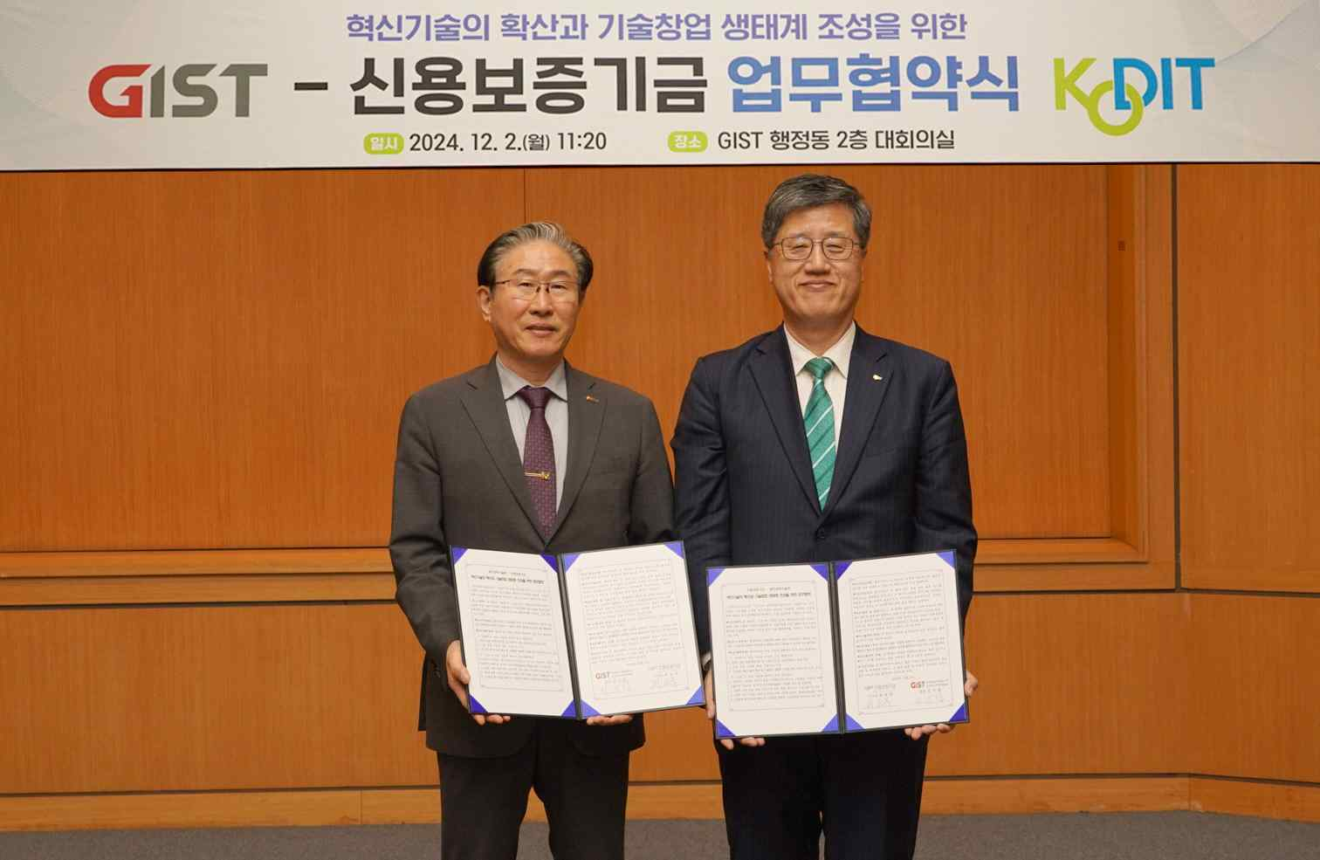

▲ GIST and the Korea Credit Guarantee Fund signed a business agreement (MOU) to promote the spread of innovative technologies and create a technology startup ecosystem. (From left) GIST President Kichul Lim and Korea Credit Guarantee Fund Chairman Won-mok Choi are taking a commemorative photo.

GIST President Kichul Lim said, "GIST, which has set forth a vision to lead the innovation economy together with the Credit Guarantee Fund, a partner that supports corporate challenges and growth, and the region, have similar goals. We hope to overcome the phenomenon of local extinction and contribute to job creation together with Shinbo, thereby becoming the first step toward opening the era of localization."

Korea Credit Guarantee Fund Chairman Won-mok Choi said, "Through this agreement, we hope that companies in the Honam region will use GIST's innovative technology to create new markets and businesses. Shinbo will continue its efforts to spread excellent public technology to the private sector and implement the local era."



