GIST surveys preferences for new main gate design for all citizens

- Online voting until December 10th for the three winning entries in the main gate design contest... A landmark that embodies GIST's vision and sustainable local community and the growth and development of the Republic of Korea will be built

- The process of building the main gate of the second-established national science and technology institute will be elevated to a 'local and national festival'... Anyone can participate in the main gate design preference survey and a small gift will be drawn.

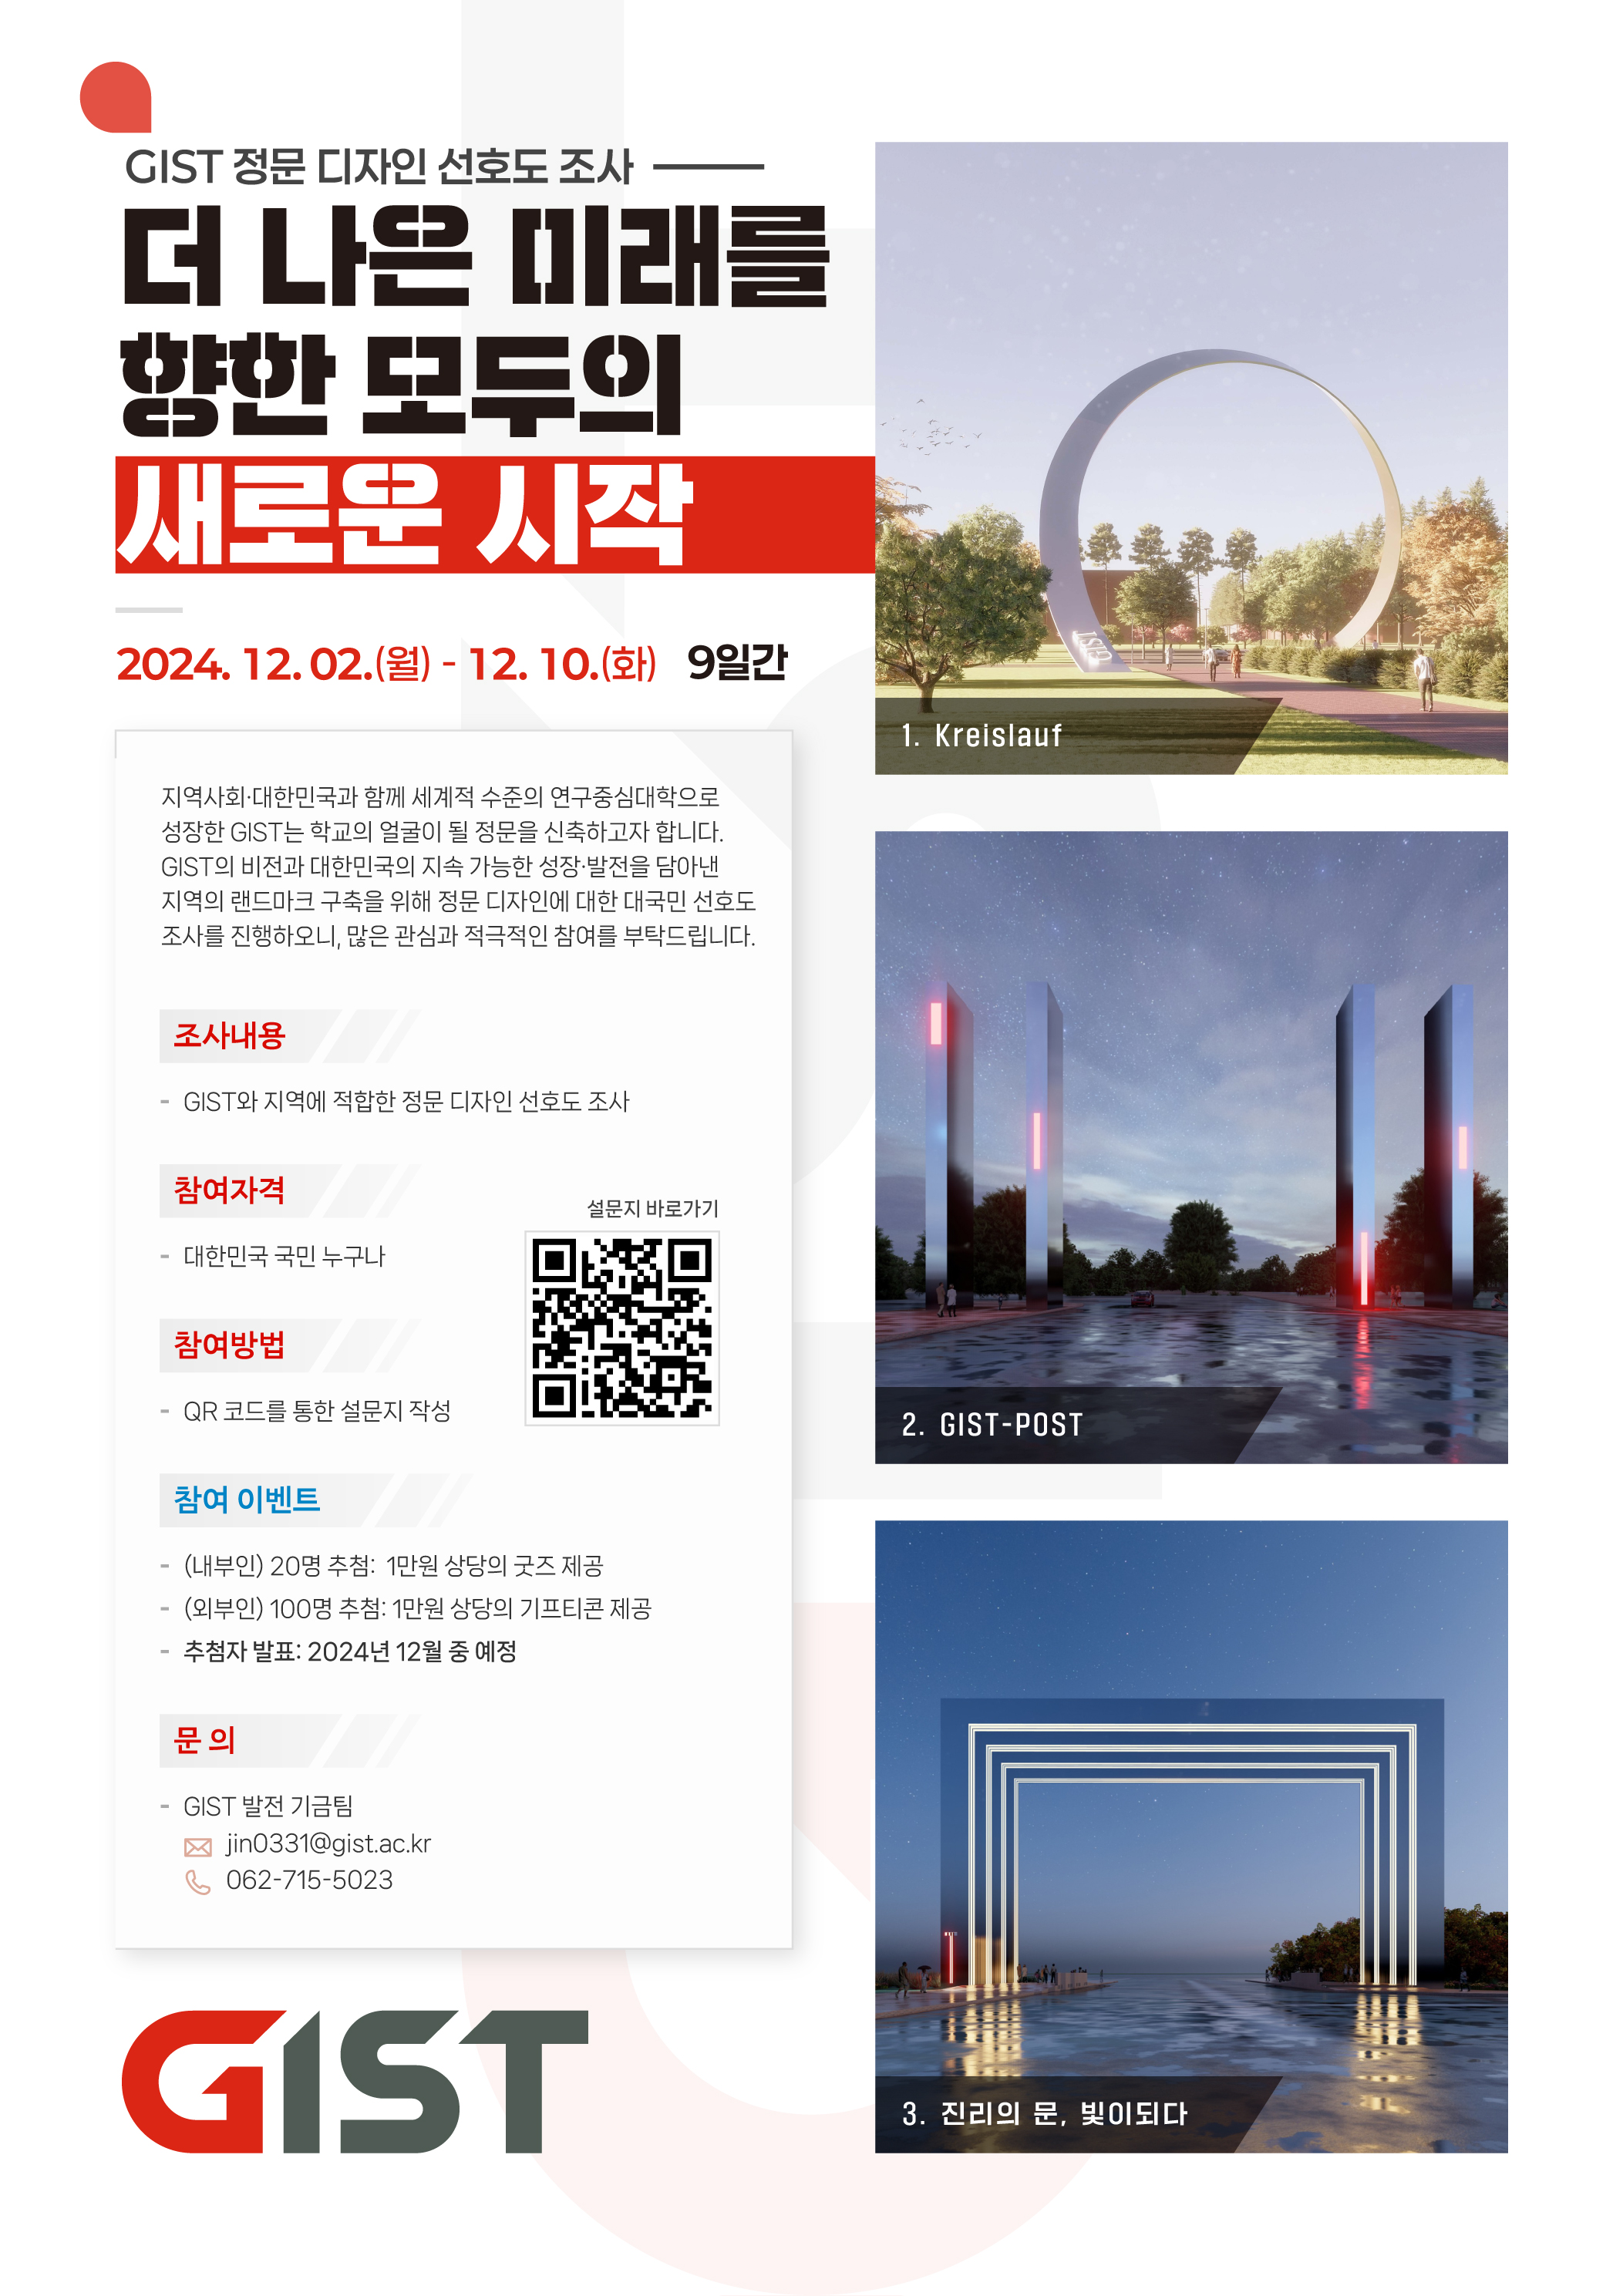

▲ GIST main gate design preference survey poster

GIST aims to build a landmark that embodies GIST’s vision of becoming a world-class research-oriented university with the sustainable growth and development of the local community and the Republic of Korea through the construction of the main gate.

GIST held a main gate design contest from September 9 to October 28. Of the 39 works submitted, GIST selected three works (one each for the grand prize, best prize, and excellence prize) through a review committee comprised of experts, considering the following: ▴ having the identity and symbolism of GIST, ▴ being in harmony with the surrounding environment, and ▴ being able to be manufactured and installed using steel materials. The winners were announced on November 14.

GIST plans to conduct a preference survey targeting the entire nation regarding the three winning works and reflect the results in the construction of the main gate along with the results of an internal preference survey of GIST members.

The three winning works are ▴ Kreislauf ▴ GIST-POST ▴ The Gate of Truth, Become Light. The design intention and expected effects of each work are as follows.

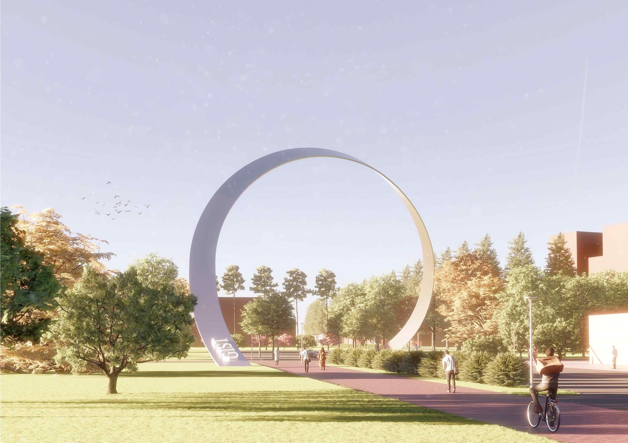

▲ Title: Kreislauf

The first work, ‘Kreislauf’, which contains the meaning of the endless circulation of the circular main gate form, symbolizes the continuous development and growth of research and academic inquiry. While harmonizing with the surrounding natural landscape and implementing a harmonious form that is not heterogeneous, you can feel a new change in the form depending on the viewing angle, and the large size of the gate adds seriousness and grandeur, emphasizing that this is an important place for academic inquiry.

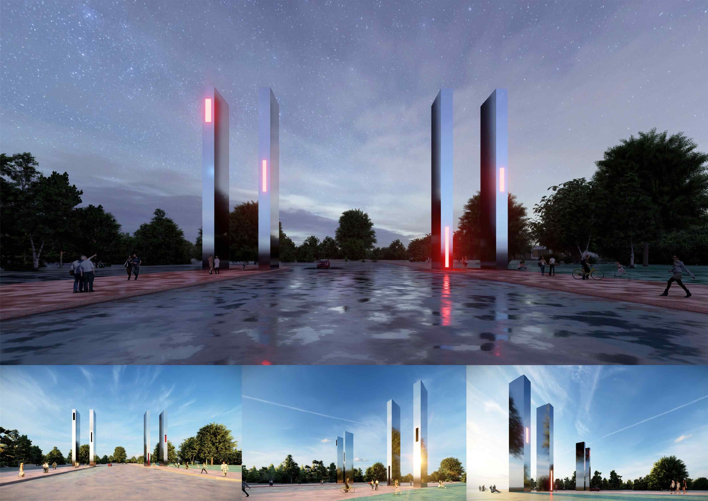

▲ Title: GIST-POST

The second work, ‘GIST-POST’, features a design of four pillars that symbolize GIST as a research institute representing the region. The reflective metal material of the pillars, which represent intelligence, scholarship, passion, and youth, reflects the future vision and signifies that GIST will become a treasure trove of future talents. The holes made of different heights contain a line of communication to dynamically represent the symbolism of the university, and knowledge, passion, and youth are transmitted between the four pillars. Each pillar, like an object, becomes a symbolic light of the city, lighting the light of truth.

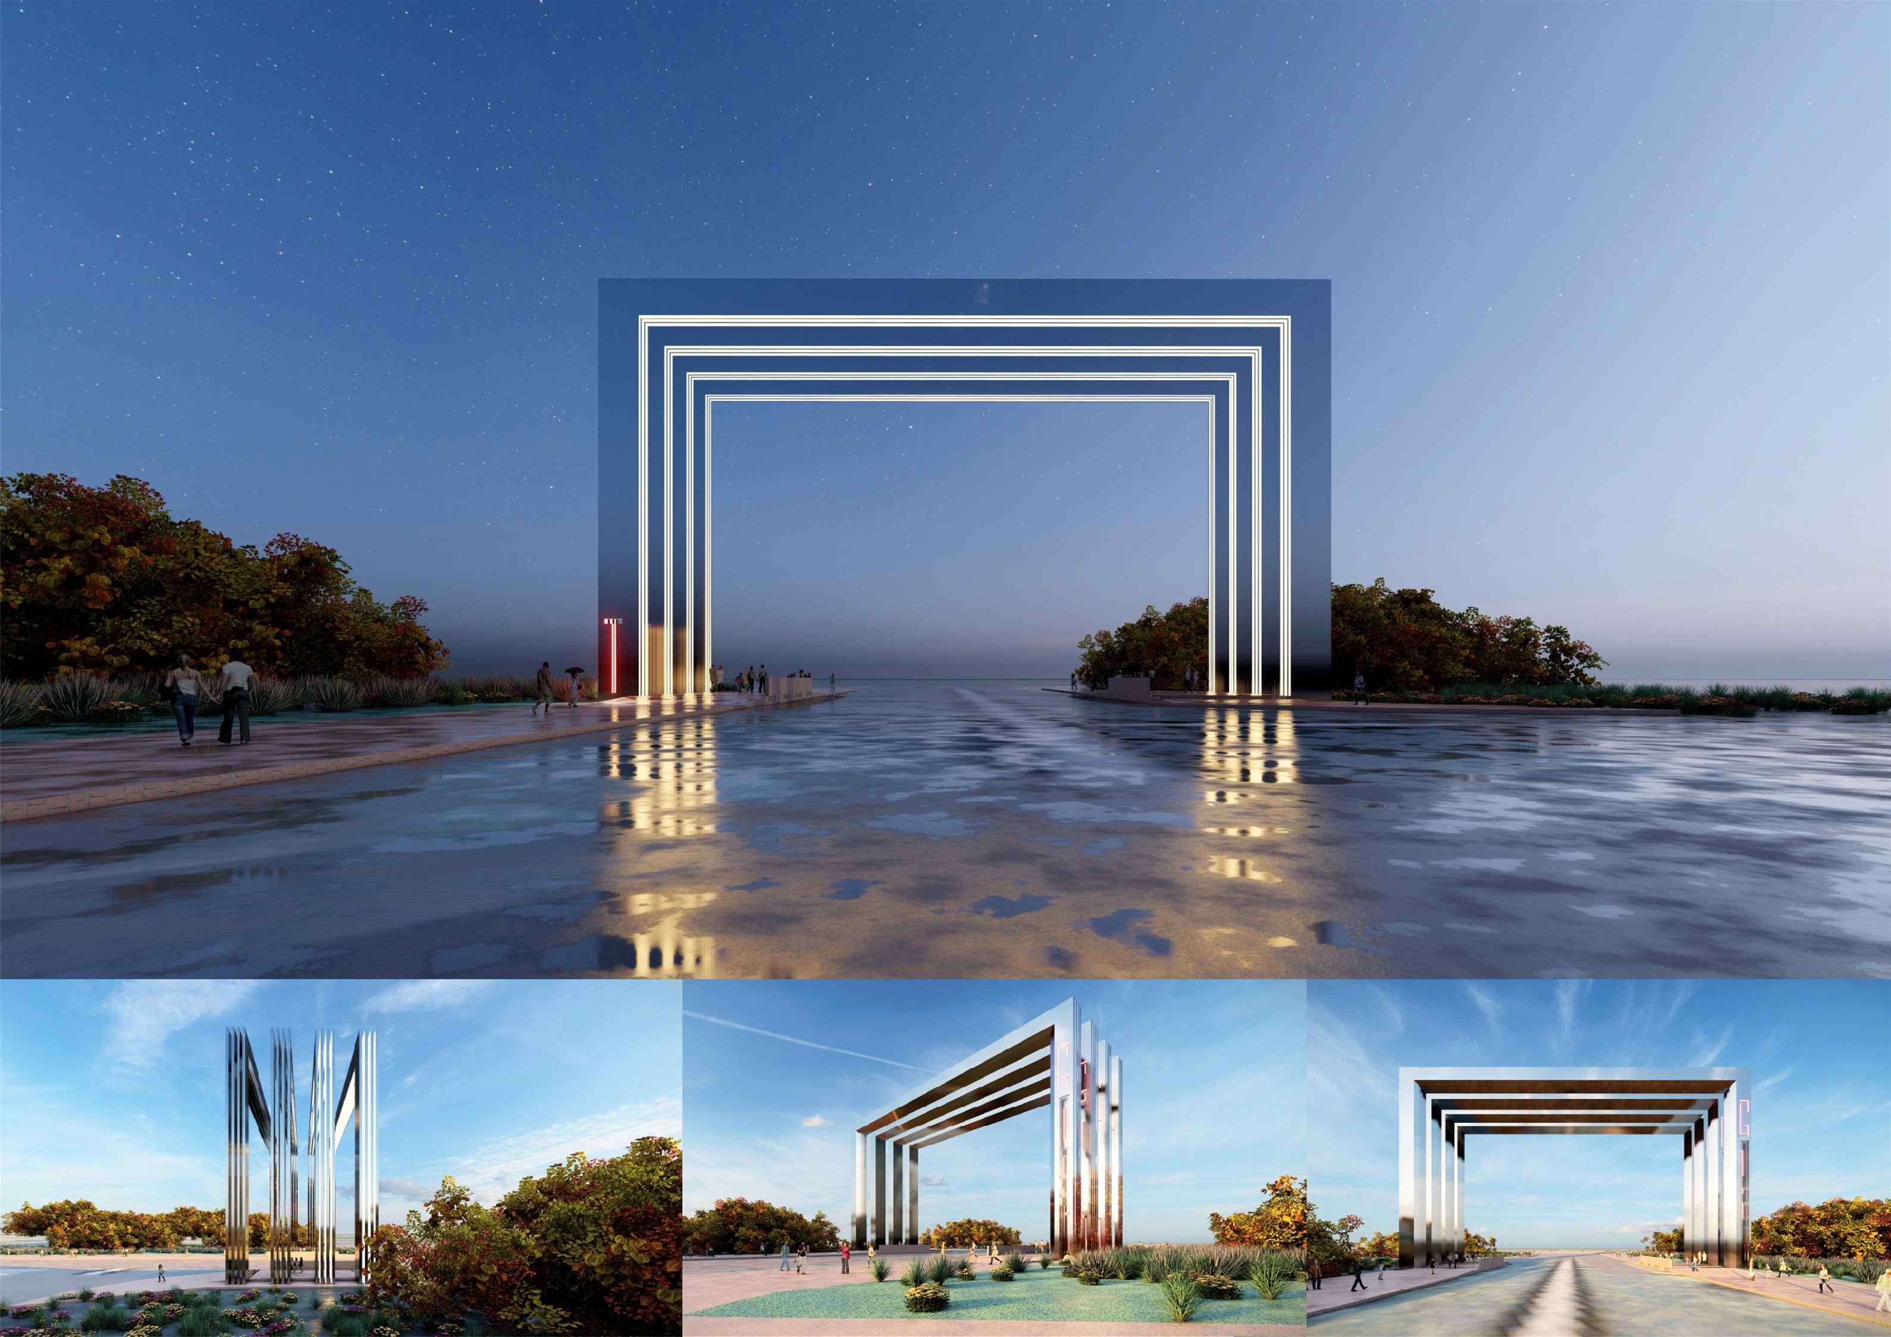

▲ Title: The Gate of Truth, Become Light

The third work, ‘The Gate of Truth, Become Light,’ features four rectangular doors lined up in a row. Each door has a pattern punched into it so that light rises between them. The first door means ‘Gate of Truth,’ the second door means ‘Gate of Wisdom,’ the third door means ‘Gate of Light,’ and the fourth door means ‘Gate of the Future.’ The light created by the spatial experience and symbolic panels becomes the light of truth. The four doors overlap to form a gateway to the future, capturing a schoolyard full of knowledge, youth, passion, and truth as a feast of scholarship.

President Kichul Lim said, "As a global research-oriented university, GIST hopes that this main gate design selection process will be another starting point for the future of GIST, the local community, and the Republic of Korea. We will continue to listen to the diverse opinions of our citizens and members to create a GIST that everyone can be proud of. We ask for your interest and participation in this main gate design preference survey."

This preference survey will be conducted for 9 days from Monday, December 2nd to Tuesday, December 10th via an online Google survey, and an event will also be held where 100 participants will be selected to receive a gift card (10,000 won).



