GIST-Gwangju Metropolitan City-KEPCO, carbon neutrality and energy efficiency policy briefing session held

- To secure the sustainability of small and medium-sized enterprises, on Wednesday, November 27th, at the mini-theater on the first floor of the GIST Library... In response to the increasing need for future car industry transition and RE100 support, central government ministries and regional innovation organizations participated

- In addition to introducing policies and facility subsidy support projects by each organization and expert presentations, preliminary consulting linked to government policy projects such as coaching on energy efficiency improvement plans for regional companies was also conducted

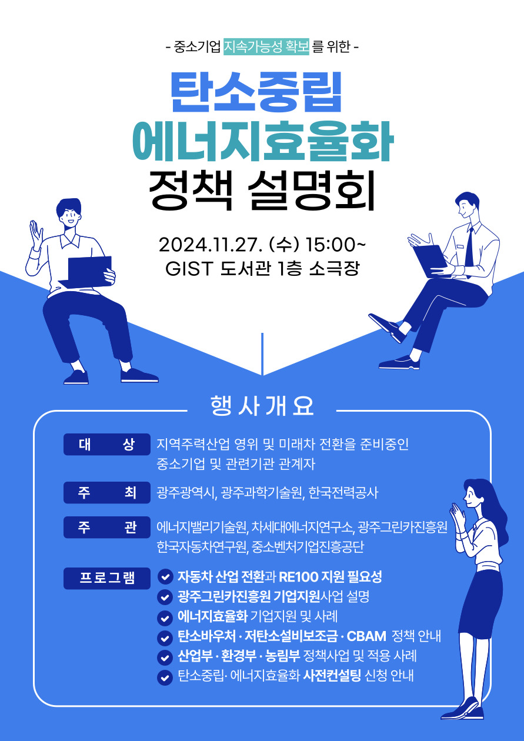

▲ Carbon Neutrality and Energy Efficiency Policy Briefing Event poster

The Gwangju Institute of Science and Technology (GIST, President Kichul Lim) announced that the Energy Valley Technology Institute (President Kwanghee Lee) will hold a carbon neutrality and energy efficiency policy briefing session at 3:00 PM on Wednesday, November 27, to strengthen carbon neutrality and ESG (environment, society, and governance) response of small and medium-sized enterprises located in Gwangju Metropolitan City.

This briefing session, co-hosted by GIST, Gwangju Metropolitan City, and Korea Electric Power Corporation, and co-hosted by the GIST Research Institute For Solar and Sustainable Energies (Director Sanghan Lee), Energy Valley Technology Institute (Director Kwanghee Lee), and Gwangju Regional Headquarters of the Korea SMEs and Startups Agency (Director Woo-joo Jo), is being held in response to the growing need for support to secure the sustainability of local SMEs, such as the increase in carbon neutrality and ESG requirements from the supply chain perspective and the strengthening of due diligence on the supply chains of major exporting countries. Central government agencies (Ministry of SMEs and Startups, Ministry of Trade, Industry and Energy, Ministry of Environment), Gwangju Green Car Promotion Agency, and regional innovation organizations such as the Korea Automobile Research Institute will participate.

The briefing session, which will be held in the mini-theater on the first floor of the GIST Library, will include ▴ an introduction to each organization's policies and facility subsidy support projects, as well as ▴ energy efficiency pre-consulting, including coaching on energy intensity measurement and energy efficiency improvement measures within the workplace.

In addition, presentations by experts are scheduled on topics such as ▴ ‘Automobile industry transition and the need for RE100 support’ (Hyeon-cheol Lee, Director of the Materials Convergence Center at the Korea Automobile Research Institute and adjunct professor at the GIST Research Institute For Solar and Sustainable Energies), ▴ ‘Explanation of carbon voucher, low-carbon facility subsidy, and CBAM policy’ (Yeong-nam Kim, Team Leader, Gwangju Regional Headquarters, Small and Medium Venture Business Agency), ▴ ‘Explanation of Gwangju Green Car Promotion Agency corporate support project’ (Seung-hyun Choi, Team Leader, Gwangju Green Car Promotion Agency Corporate Support Team).

Director Kwanghee Lee said, "We hope that this policy briefing session will serve as an opportunity to further strengthen cooperation with local communities and to seek specific implementation strategies for carbon neutrality and energy efficiency. The Energy Valley Technology Institute will actively contribute to solving national issues by creating results that contribute to both the local economy and the environment at the center of industry-academia-research cooperation."

This briefing session is open to anyone interested in carbon neutrality and energy efficiency, not just those in the automobile industry, and online pre-registration is available.
(https://forms.gle/uGBFEzxHaTxQLFB28)



