GIST AI Policy & Strategy Graduate School joins forces with aws to cultivate cloud talents

- 2-day, 1-night camp held at Amazon Web Services (AWS) Korea headquarters to foster cloud technology talents in the era of digital transformation... 27 GIST undergraduate and graduate students participated

- ▴ Gen AI service development practice ▴ Cloud service development practice, etc. Education... “Expecting to strengthen cloud-based practical capabilities and perform innovative projects utilizing AI and cloud technology”

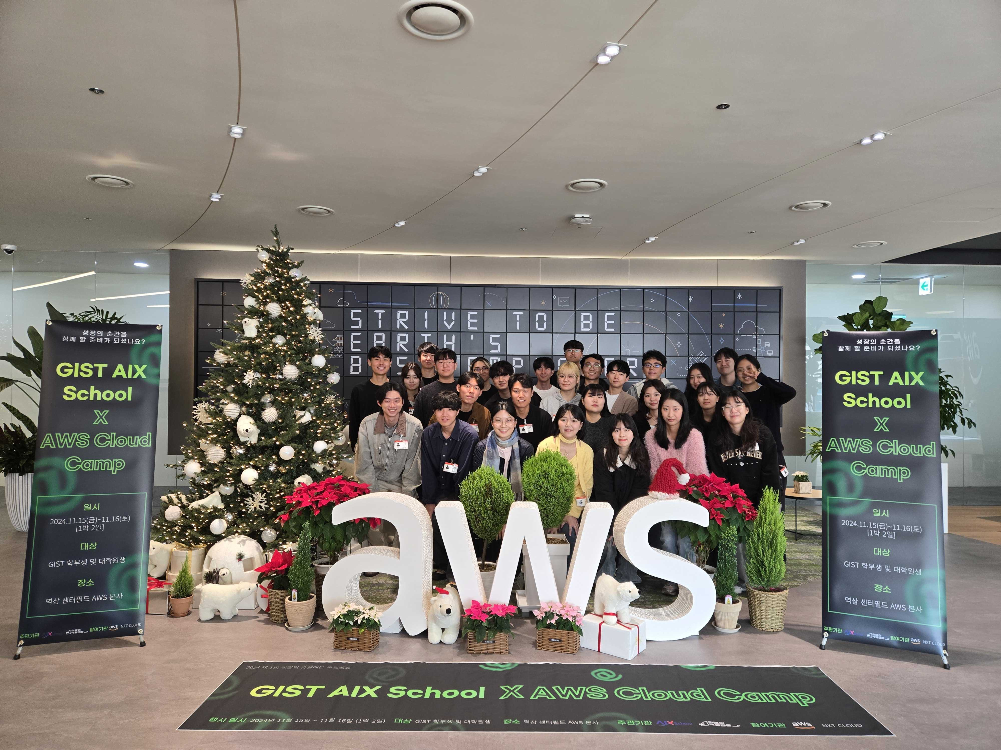

▲ GIST AI Policy & Strategy Graduate School is holding the ‘GIST AIX School X AWS Cloud Camp’ in collaboration with Amazon Web Services (AWS) Korea and NXT CLOUD, and participants are taking a commemorative photo.

The Gwangju Institute of Science and Technology (GIST, President Kichul Lim) announced that it held a 2-day, 1-night camp in cooperation with Amazon Web Services (AWS) Korea and NXT CLOUD to foster cloud-based artificial intelligence (AI) talent.

GIST AI Policy & Strategy Graduate School (Dean Joon Ha Kim) held the ‘GIST AIX School X AWS Cloud Camp’ so that students can directly experience and learn so-called cloud technology that processes and analyzes large amounts of data.

27 GIST undergraduate and graduate students participated in this camp, which was held from Friday, November 15 to Saturday, November 16 at the Amazon Web Services (AWS) Korea headquarters in Yeoksam Centerfield, Seoul.

* cloud: Data is stored on a central computer connected to the internet, so that data can be accessed anytime, anywhere by simply connecting to the Internet.

The camp began with a welcoming speech by Dean Joon Ha Kim, and training was provided on ▴ Gen AI service development practice ▴C loud service development practice (3-tier, Serverless, etc.) ▴ Guidance on development trends ▴ Architecture practice considering cost efficiency, etc.

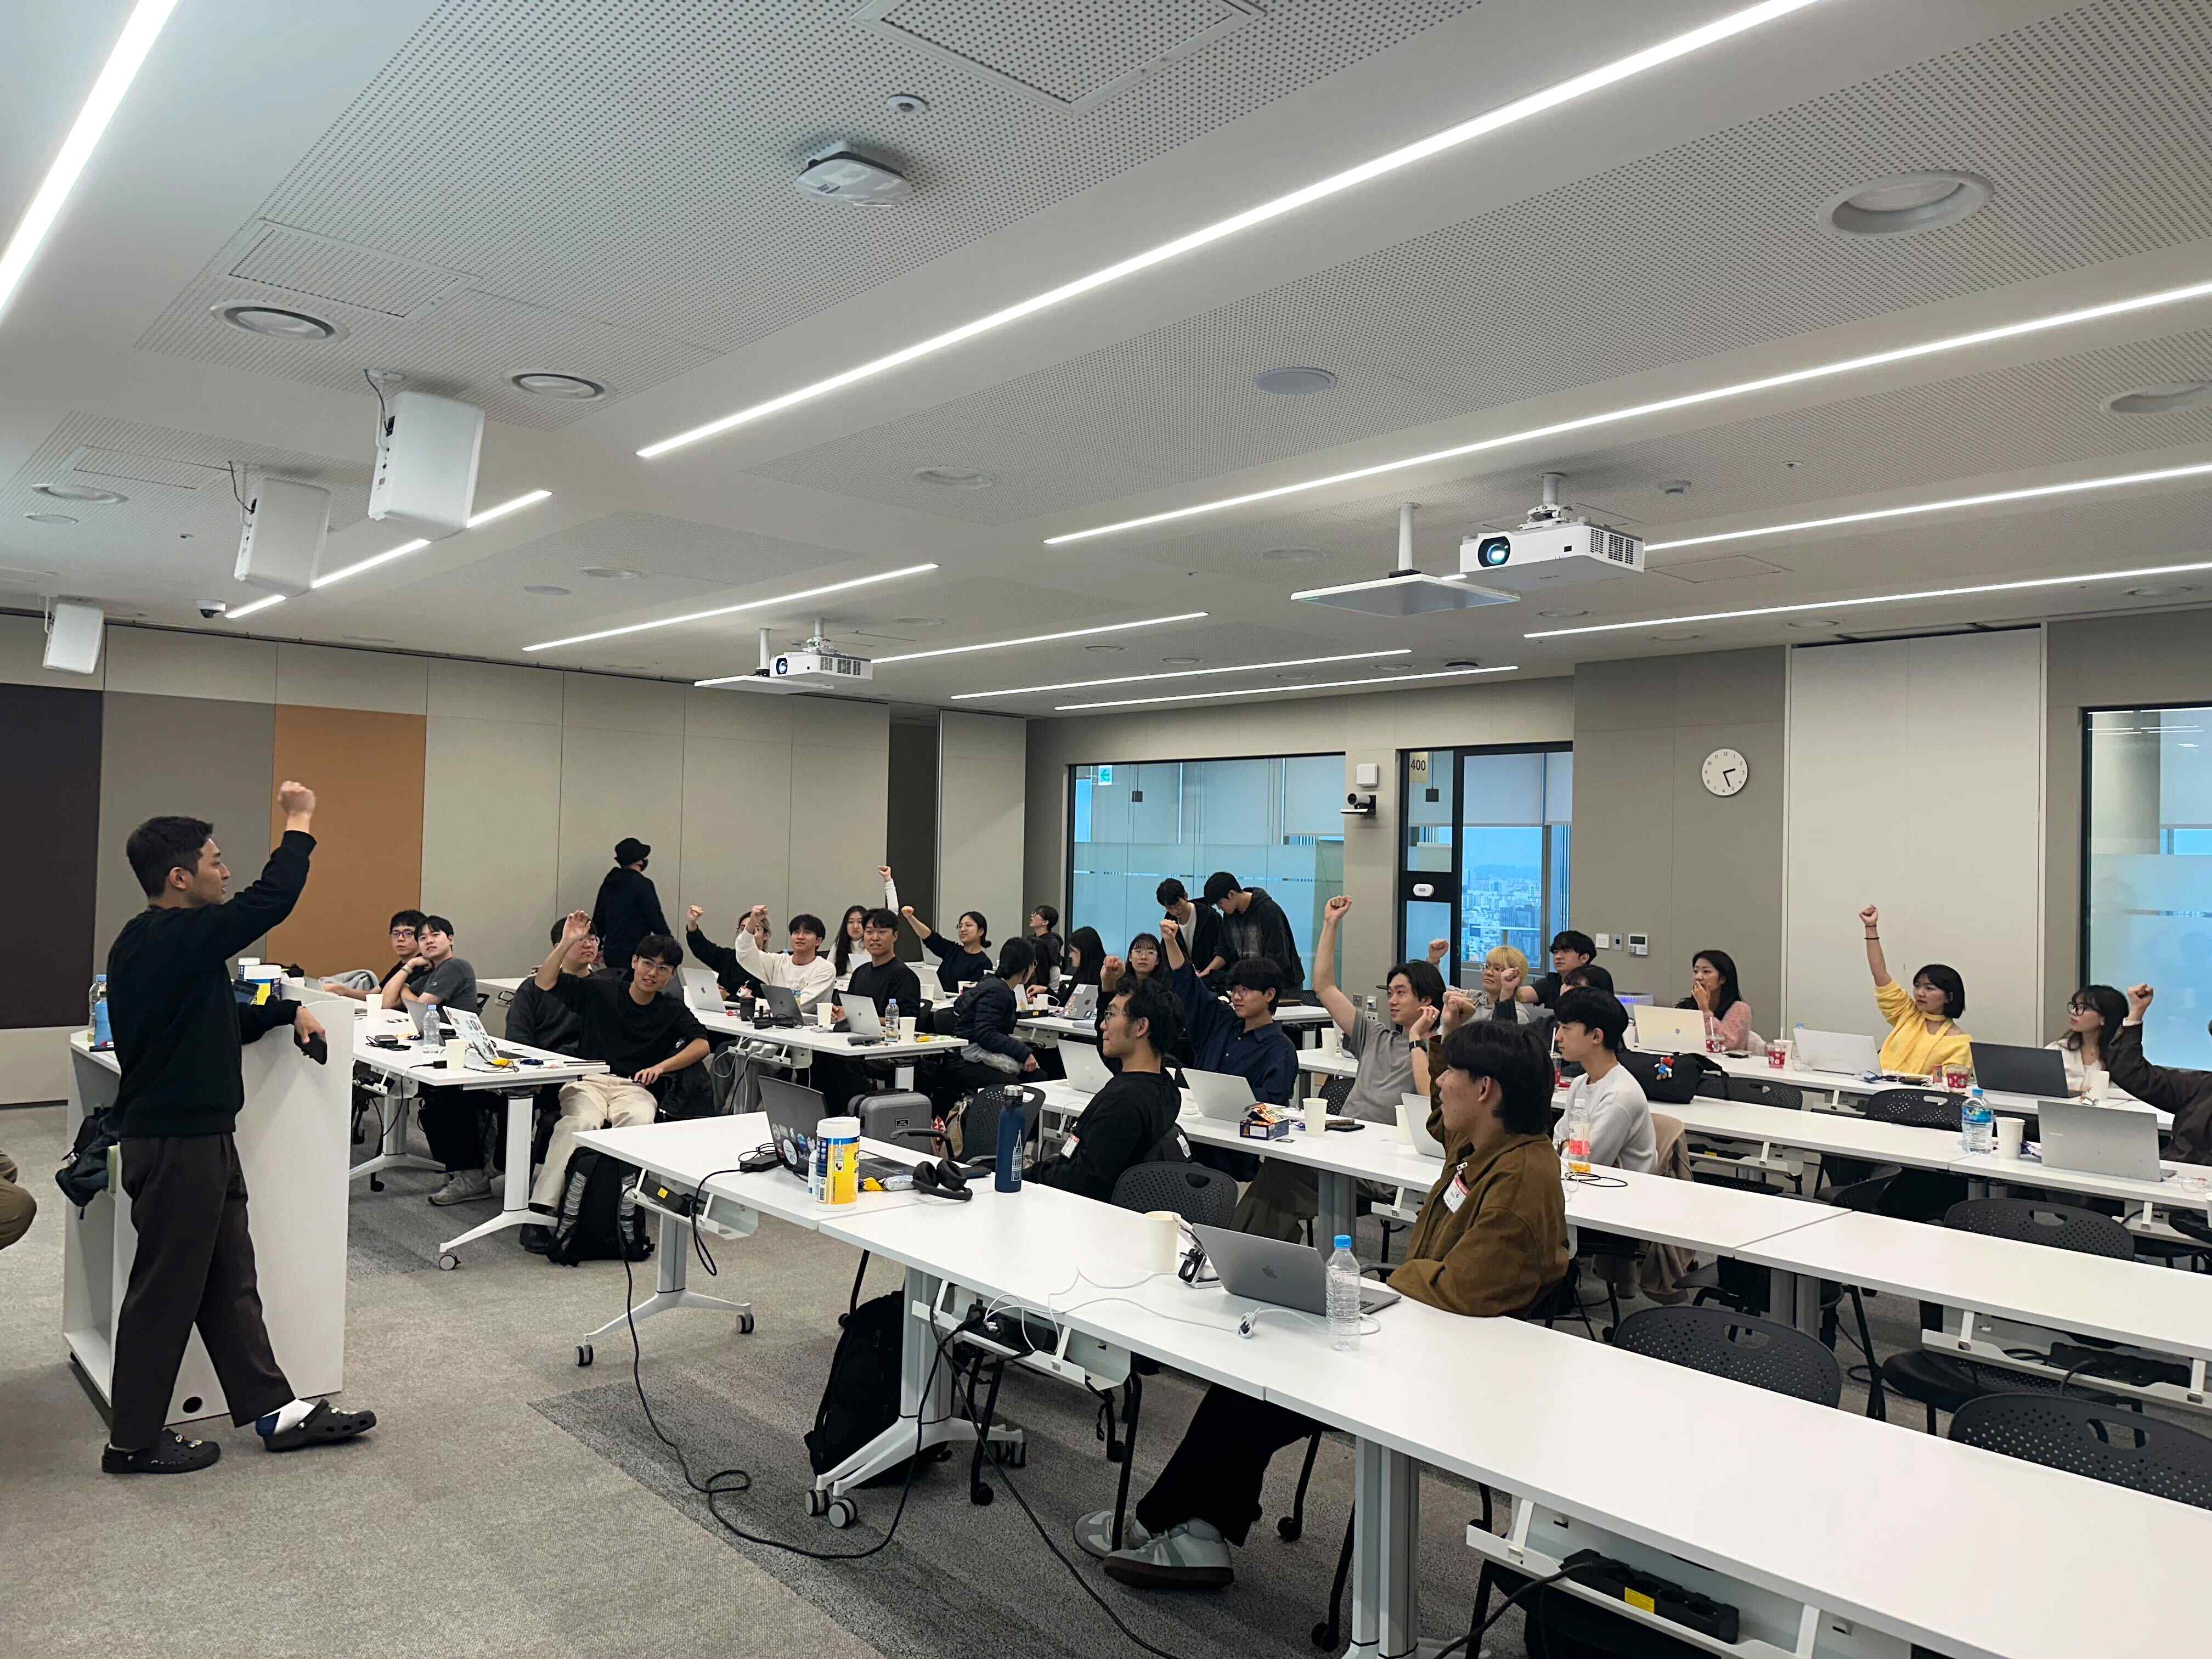

▲ GIST AI Policy & Strategy Graduate School is holding a 2-day, 1-night camp to foster cloud-based artificial intelligence talent.

Participating students acquired core technologies to prepare for the AI society, from basic cloud concepts to practical training. In addition, they shared their experiences in operating cloud-based hackathons and contests through interactions with industry mentors and had time to cultivate practical technology utilization skills.

One of the students who attended the camp said, "It was a very beneficial time to be able to experience the theory and practice of cloud technology firsthand. In particular, I was able to strengthen my practical skills through Gen AI service development practice and cloud service development practice."

Dean Joon Ha Kim said, "Cloud technology is a key element of digital transformation, increasing the efficiency of infrastructure operations in enterprises and the public sector. We hope that this camp will help students strengthen their cloud-based practical capabilities and carry out innovative projects utilizing AI and cloud technologies."

Meanwhile, the GIST AI Policy & Strategy Graduate School, which opened in September to train AI policy strategy experts with master's and doctoral degrees for the first time in Korea, is being taught by professors at the level of CTOs from domestic and global companies to establish and operate policies and strategies by converging AI technology in various fields such as economy, society, and culture. It focuses on producing experts who solve problems in various fields of society by utilizing AI, rather than AI technology developers.



