GIST, 31st Anniversary Ceremony held: "Let's become One Team, GIST, and write a new history together"

- 31st Anniversary Ceremony Held on the 15th (Friday)... President Kichul Lim, “GIST started out with bold and brave wings, and when we respect each other and come together, we can soar again.”

- Vice President for Public Affairs Yonghwa Chung, Declaration of the ‘Growing by Sharing (Na·Da·Kuh)’ Campaign... “Building a culture of giving that starts with us to create the school's future together.”

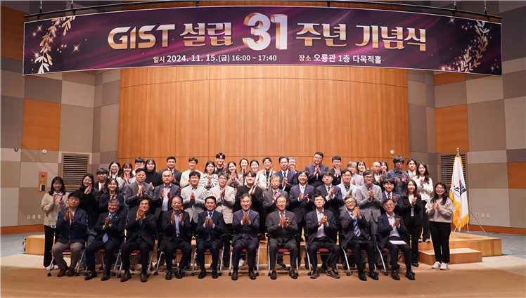

▲ GIST held its 31st anniversary ceremony on Friday, November 15th at 4 PM in the multipurpose hall on the first floor of Oryong Hall, and attendees are taking a commemorative photo.

The Gwangju Institute of Science and Technology (GIST, President Kichul Lim) held its 31st anniversary celebration ceremony on November 15th (Friday) at 4 PM in the multipurpose hall on the first floor of GIST Oryong Hall.

The ceremony was attended by about 100 people including the 7th Alumni Association President of GIST Techno Management Business Academy (GTMBA) Yun-seop Kim, GIST Development Foundation Chairman Hae-myeong Kim, and GIST students and faculty members. The ceremony was held in the following order: ▴ Planning Dean Hisam Kim’s history report ▴ President Kichul Lim’s commemorative speech ▴ National Assembly member Do-geol Ahn’s congratulatory speech Ahn ▴ President’s commendation for internal members ▴ Vice President for Public Affairs Yonghwa Chung’s declaration of the ‘Sharing Makes It Bigger’ campaign.

President Kichul Lim in his commemorative speech said, "Today, as we celebrate the 31st anniversary of our founding, we must strengthen our solidarity and resolve to open up the future together. I am confident that when we respect each other and become one, we will be able to achieve true harmony-up and make a leap forward."

He also said, "GIST has once again begun to flap its wings boldly and courageously" and will continue long-standing projects that have been at a standstill one by one, including ▴ establishing 30 innovation plans, ▴establishing GIST Holdings, ▴ attracting the IBS Campus Research Group, ▴ selecting the IRC as a global leading research center, and designing the main gate and community lounge, which will become landmarks at GIST.

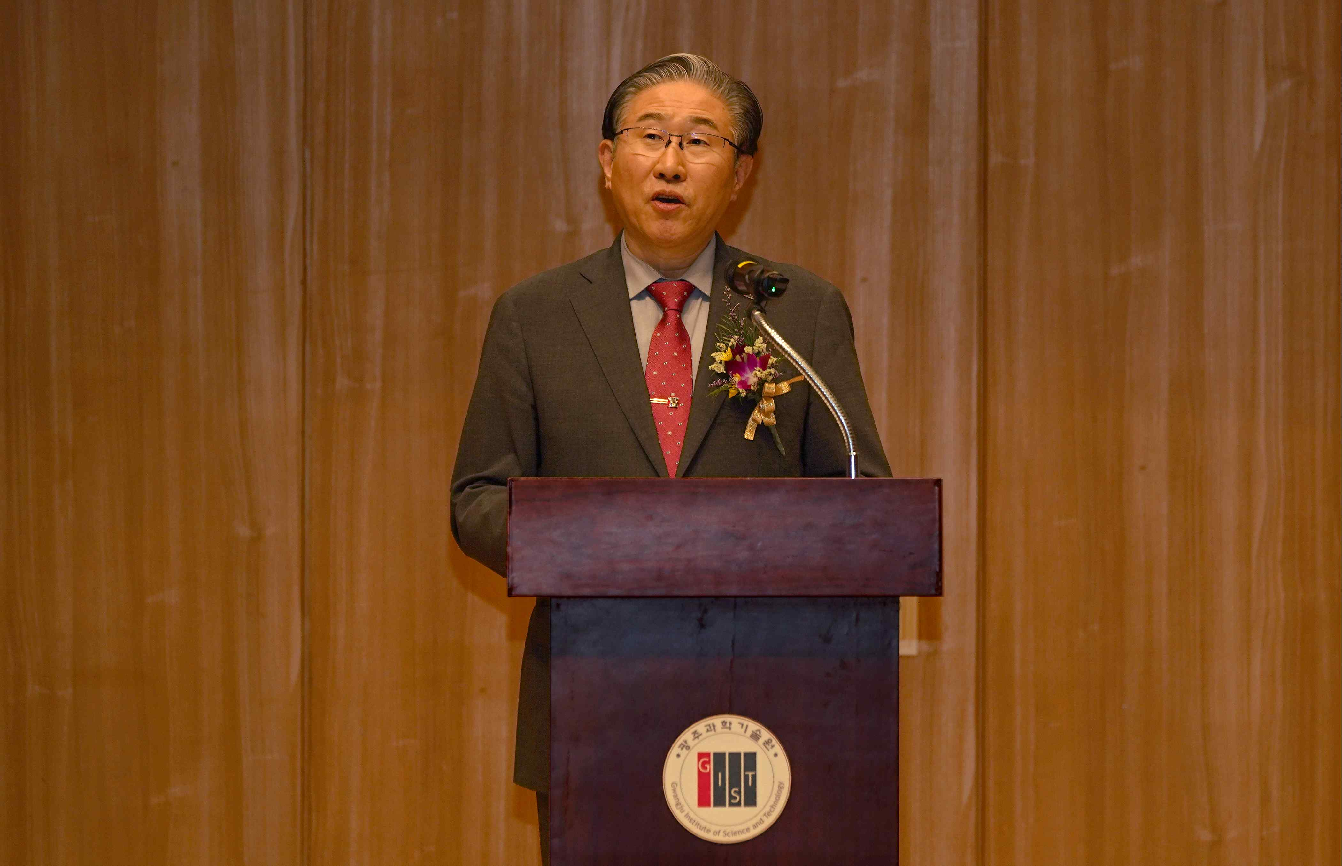

▲ President Kichul Lim is giving a commemorative speech at the 31st anniversary ceremony of GIST.

He concluded by saying, "With the founding anniversary as a starting point, let us all reflect on the meaning of ‘One Team, GIST’ and gather our precious ideas under the name of GIST to write a new history together."

National Assembly member Do-geol Ahn said in a video message, "On its 31st anniversary, ee congratulate GIST, which has been creating various research results and nurturing excellent scientific and technological researchers since it took root in Gwangju Metropolitan City in 1993 with the wishes of the people and local residents. I hope that it will grow into a world-class research institute in the future and play a significant role as a central institution for regional innovation."

In addition, on this day, the GIST International and Public Affairs Team declared the ‘Growing by Sharing (Na·Da·Kuh) Campaign’ to increase the financial stability of the university through voluntary participation of internal members and to create an atmosphere that promotes external fundraising.

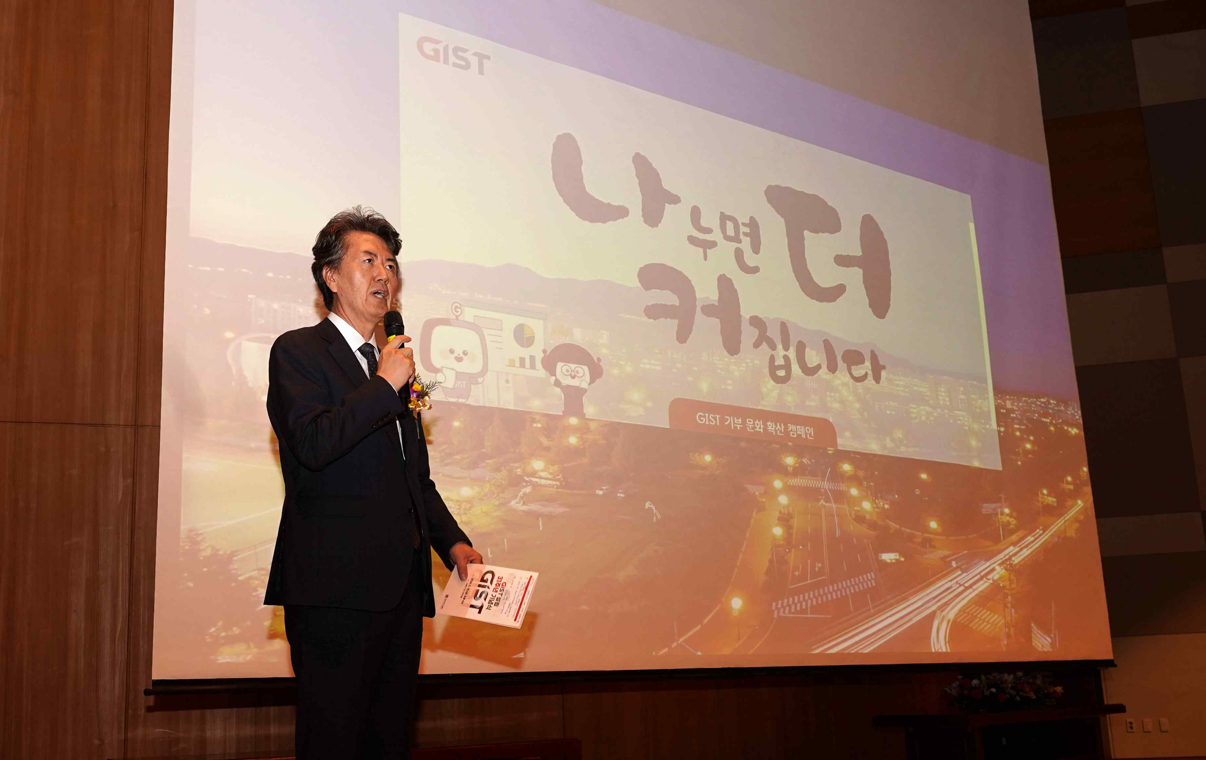

▲ At the 31st anniversary ceremony of GIST Vice President for Public Affairs Yonghwa Chung declared the ‘Growing by Sharing’ campaign.

This campaign aims to spread a culture of donation with the participation of more than 3,000 internal and external members, and to consistently participate by donating at least 5,000 won per account every month or every year. Rather than focusing on the size of the fundraising amount, it focuses on the number of participants.

Vice President for Public Affairs Yonghwa Chung said, "We decided to launch the ‘Na·Da·Kuh Campaign’ to strengthen the sense of community among GIST members and to create the school's future together. If our small donations come together, many things in the school can change."

Meanwhile, GIST was established in 1993 in accordance with the Gwangju Institute of Science and Technology Act with the purpose of contributing to the development of national science and technology by fostering advanced science and technology talents who will lead the innovation of cutting-edge science and technology, promoting collaborative research with industry, educational and research exchanges with foreign countries, transfer and commercialization of technology, and supporting entrepreneurship.

GIST, which has grown with a focus on ‘integrated education and research’ and ‘internationalization’, has produced a total of 8,348 excellent talents (1,945 doctorates, 5,086 masters, and 1,317 bachelors) to date*, while also actively engaging in international cooperation, such as establishing a global R&D network and carrying out the GIST-MIT AI International Joint Research Project (project period: 2021-2025). In addition, it is leading the way in spreading research achievements, as evidenced by being selected as number one in the entrepreneurship performance category in the ‘2023 Korea Excellent Startup University’ evaluation.



