"The Meaning of Life Learned from Death" Professor Seong-ho Yoo, a forensic scientist, invited to lecture during GIST Science Culture Week

- From 18:30 on Thursday, the 14th, at the multipurpose hall on the 1st floor of GIST Oryong Hall... Anyone can listen to the 'Social Contribution Academy' lecture for GIST members and local residents

- Professor Seong-ho Yoo, who has broadcast appearances such as SBS's 'I Want to Know That' and recently on YouTube, will talk about the meaning of human existence and the essence of life and death from the perspective of a forensic scientist

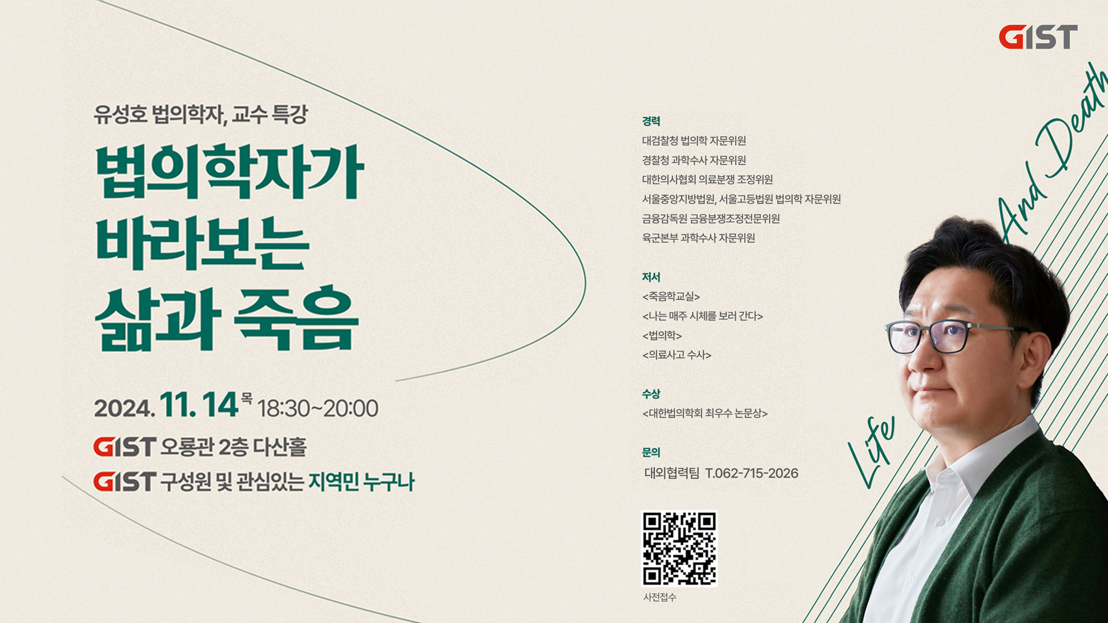

▲ Poster for the special lecture by Professor Seong-ho Yoo, a forensic scientist, at the GIST Social Contribution Academy

We, who must face death someday, why do we have to live and how should we live? When we ask fundamental questions about the essence of life like this, we seek someone's wisdom.

As part of the 'Social Contribution Academy', the Gwangju Institute of Science and Technology (GIST, President Kichul Lim) announced that it will invite Professor Seong-ho Yoo of the Department of Forensic Medicine at Seoul National University College of Medicine to hold a special lecture on the 14th (Thursday) to mark the 'GIST Science Culture Week (2024. 11. 4. - 15.)'.

Professor Seong-ho Yoo, who chose forensic medicine out of regret for the unjust deaths and the desire to uncover the truth, is the best forensic scientist in Korea, and based on his practical experience as a forensic scientist at the National Institute of Scientific Investigation along with his forensic research, he has provided students and the public with deep insight and inspiration on life and death.

He is also leading the way in easily conveying forensic medicine on topics such as health, disease, and death through current affairs and cultural programs such as SBS’s “I Want to Know That” and KBS’s “Smoking Gun” and the YouTube channel “Seong-ho Yoo’s Deadmantalk.”

In this lecture, Professor Seong-ho Yoo will talk about the meaning of human existence as seen through the eyes of a forensic scientist under the theme of ‘Life and Death as Seen by a Forensic Scientist’ and will talk about the essence of life and death discovered in the cases he encountered as a forensic scientist.

Professor Seong-ho Yoo’s public lecture, which will be held at the GIST Oryong Hall 1st floor multipurpose hall from 6:30 PM on Thursday, the 14th, is open to everyone. Those who pre-register will be able to enter on a priority basis starting at 6:00 PM, 30 minutes before the lecture begins. Those who have not pre-registered will be able to enter only if there are any remaining seats on site.

In addition, a Q&A session is scheduled after the lecture, where the lecturer and the audience can communicate sufficiently.

Meanwhile, the 'GIST Social Contribution Academy' program, which started in 2021, is practicing knowledge sharing by providing various indirect experiences to GIST members and local residents through lectures by experts from various fields.

The Social Contribution Academy invited Professor Guk-jong Lee of Ajou University (Director of the Armed Forces Daejeon Hospital) in 2023 and poet Ho-seung Jeong in 2022, which received a positive response from GIST members and local residents.



