GIST Holds 12th Creative Space G AI&IoT Makathon

- From November 8 (Fri) to 9 (Sat), prototype production based on startup ideas at the GIST campus complex startup space ‘Creative Space G’... 41 university students from Kyungpook National University, Chonnam National University, etc., 10 teams participated

- Chonnam National University’s Ponte team, which produced the AI-based reading assistance device for the visually impaired, ‘Bodot’, won the grand prize “Impressive display of creativity and collaboration skills... I hope this will be a valuable opportunity to lay the foundation for startups”

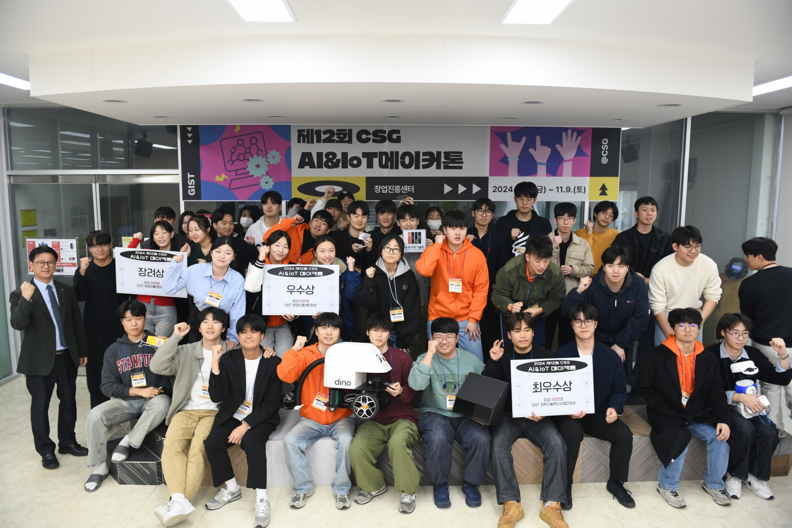

▲ GIST Startup Promotion Center is holding the 12th Creative Space G AI&IoT Makathon, and participants are taking a commemorative photo.

The Gwangju Institute of Science and Technology (GIST, President Kichul Lim) announced that it held the ‘12th Creative Space G AI&IoT Makathon*’ in which university students and the general public from all over the country participated.

‘Creative Space G AI&IoT Makathon’ is a competition to create prototypes of startup ideas related to artificial intelligence (AI) and the Internet of Things (IoT). The GIST Startup Promotion Center (Director Min-Gon Kim) started the first event in 2013 to promote a healthy startup culture in the region and on campus. This year marks the 12th event.

* AI&IoT Makathon (MAK·ATHON: Make + Marathon): A hackathon-style competition to create prototypes using digital manufacturing equipment related to artificial intelligence and the Internet of Things.

A total of 41 people from 10 teams participated in this competition held for two days from Friday, November 8 to Saturday, November 9. Each team's startup idea was directly produced as a prototype and verified.

Participants used digital manufacturing equipment such as 3D printers and laser processing machines to produce prototypes at Creative Space G, a complex startup space on the GIST campus.

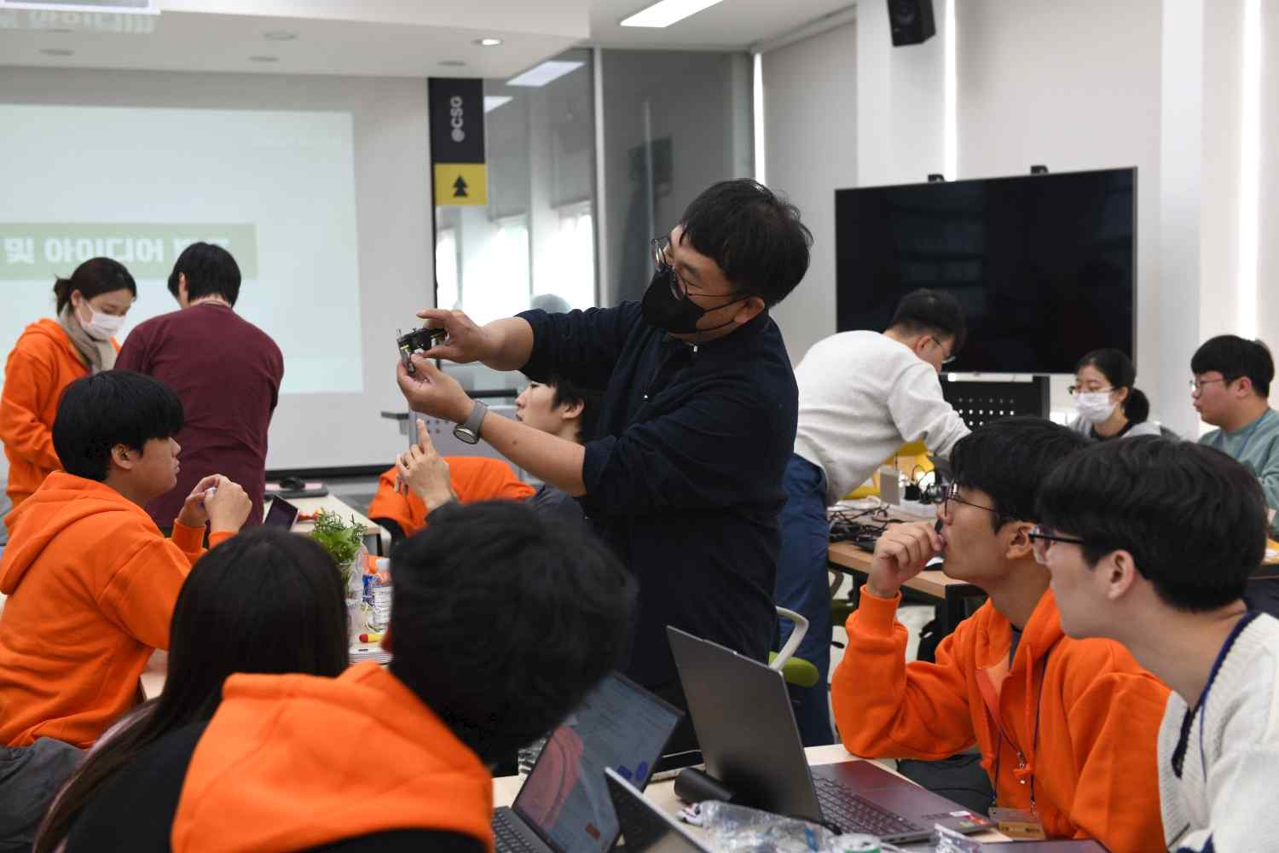

▲ Participants in the 12th Creative Space G AI&IoT Makathon are turning creative ideas into prototypes at Creative Space G on the GIST campus. Creative Space G is a complex startup space that operates digital manufacturing equipment, provides support for production professionals, and provides startup education.

For each team’s idea, working mock-up (a prototype with implemented movements) mentoring was provided by the Makerthon operator, ‘Mandeldot Co., Ltd. (CEO: Eun-ji Shim)’ in a wide range of areas including idea enhancement, product design, 3D modeling, use of digital manufacturing equipment, circuits, and software.

The Grand Prize went to the ‘Ponte’ team (Chonnam National University, Chae-woong Ma, Shin-hye Kim, Hyeon-woo Park, Ji-hyeok Jang, and Chan Jeong) for creating the ‘Bodot’, a reading assistance device for the visually impaired using AI. The Excellence Award went to the ‘Dyno’ team (Chonnam National University, Myeong-hyeon Han, Seong-ju Kwon, Jae-min Park, Hee-cheon Jang, and Yeon-woo Jo) for creating the ‘WAPPER’, a self-driving rainwater drain cleaning robot. The Encouragement Awards went to the ‘Bokdeungi’ team (GIST, Cheol-hee Kim, Yeo-won Kim, Jae-seon Lee, and Jae-hee Lee) for creating the ‘ZipPT 집피티’, a home maintenance recording device & app using IoT sensors and AI, and the ‘Hicoding’ team (Kyungpook National University, Chae-hee Won, Seong-bae Lee, and Kang-min Chu) for creating an intelligent circuit block kit that helps transition learning from block coding to text coding.

GIST Research Director Jaeyoung Lee said, "It was very impressive to see creativity and collaboration skills being demonstrated to actually implement AI&IoT related ideas in a short period of 1 night and 2 days. I hope that this competition will be a valuable opportunity to discover many novel ideas and establish a foundation for startups that can lead to commercialization in the future."



