The play "Photo 51," which starred Nicole Kidman, to be staged at GIST

- The original play, "Photo 51," translated by Professor Siyeon Lee (English Literature) of the Division of Liberal Arts and Sciences and published through GIST PRESS, will be performed on stage... On Wednesday, November 6, 7 PM, at CT Art Hall in the GIST Administrative Building

- The exciting true story of the research competition on the discovery of the DNA double helix structure has been reinterpreted by the 'Project Yeon:gyeol' theater company and turned into a play... Anyone can watch for free and admission is on a first-come, first-served basis.

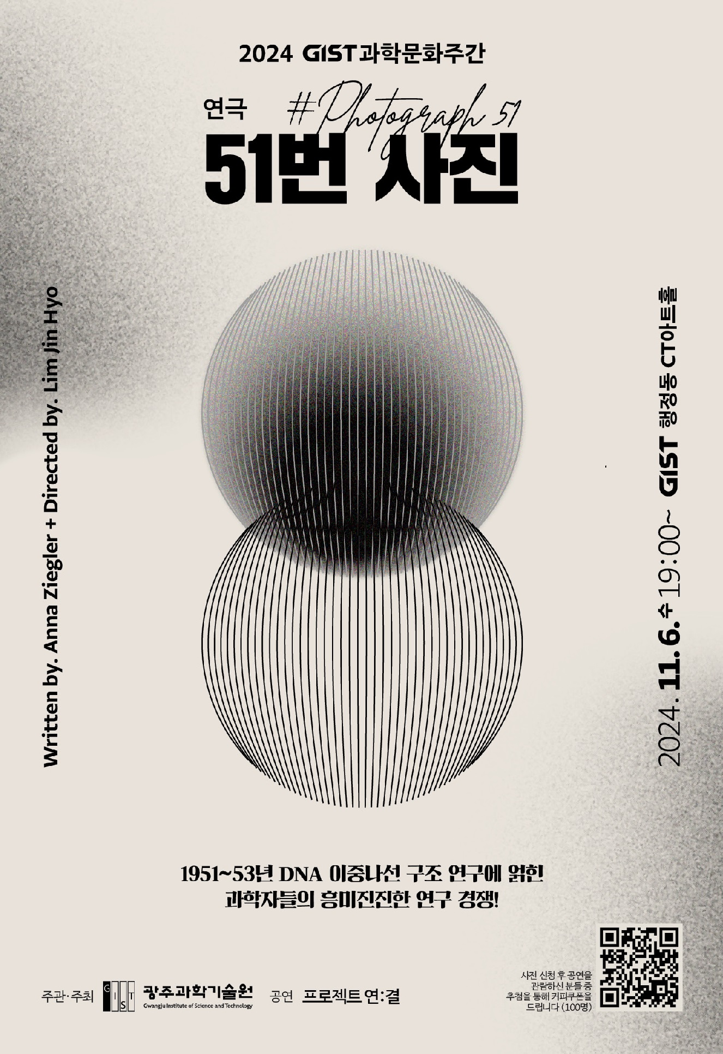

▲ Theatrical poster for the play collection ‘Photo 51’ published by GIST PRESS. It contains an image symbolizing the DNA helix structure.

The Gwangju Institute of Science and Technology (GIST, President Kichul Lim) announced that it will invite the “Project Yeon:gyeol” theater troupe to perform the play “Photo 51,” based on the play “Photo 51” (written by Anna Ziegler, translated by Professor Siyeon Lee (English Literature), Division of Liberal Arts and Sciences, GIST) published by the school’s publishing company “GIST PRESS” in 2019, at 7 PM on Wednesday, November 6 at CT Art Hall in the GIST Administrative Building.

This performance, hosted by the International and Public Affairs Team (Dean Jae Gwan Kim) to coincide with GIST Science Culture Week (Nov. 4-15), was made possible through the arrangement of translator Professor Siyeon Lee, who was contacted while the ‘Project Yeon:Kyeol’ theater troupe was preparing for a performance in Seoul.

"Photo 51" is a work that combines scientific elements with interesting literary elements, based on the true story of the research competition to discover the double helix structure of DNA in England between 1951 and 1953. It was a play that was performed on the West End stage in England in 2015, and Hollywood star Nicole Kidman played the main character Rosalind Elsie Franklin, which became a hot topic.

The ‘Project Yeon:gyeol’ theater troupe is a project team formed with the hope of connecting with the audience through language on stage, starting with the play ‘Incognito’ in 2022.

This Gwangju performance will be directed by Jin-hyo Im, planned by Soo-bin Kwon, and stars Rin-ah Kim (as scientist Rosalind Franklin), Jin-hyung Kim (as scientist Maurice Wilkins), Ho-jang Moon (as Ray Gosling), Woo-seong Lee (as scientist Don Casper), Min-seok Park (as scientist James Watson), and Tae-yoon Kim (as scientist Francis Crick). They plan to vividly and interestingly portray the conflict between Rosalind Franklin and Maurice Wilkins, as well as the competition among the six scholars.

Professor Siyeon Lee, who translated “Photo 51,” said, "This work is about the exciting research competition among scientists, centering around the female scientist behind the great discovery of the ‘DNA helix structure’. I am very curious and excited about how this work will be expressed as a play."

Director Jin-hyo Im said, "Each scene based on the original was a process of thinking about the meaning of each character's choice and the resulting consequences. I hope that it becomes a story that permeates everyone in the theater space in their own way, beyond the story of the characters."

He also said, "In the future, we plan to discover and stage good foreign works that have not been introduced in Korea, such as “Photo 51,” and we are also planning our own original performances."

This performance will start at 7 PM at the CT Art Hall on the first floor of the the GIST Administrative Building, and is free for all GIST members and local residents.

Starbucks coupons (worth 10,000 won) will be given out through a raffle to visitors who pre-register through the QR code at the bottom of the event poster. There will also be an event where 100 copies of the book 《51st Photo》 published by GIST PRESS will be given away on a first-come, first-served basis on-site.

Meanwhile, the Seoul performance of 《51st Photo》 will be held for 4 days from December 12 to 15 at ‘Theater PLOT (Yonsei-ro 4-gil, Seodaemun-gu)’.



