GIST, pilot operation of customized sign language interpretation and translation service for the hearing impaired at cultural facilities

- The Korea Culture Technology Institute and the National Asia Culture Center (ACC) Cultural Information Center will conduct a pilot operation of the ‘AI-based sign language interpretation and translation service for the hearing impaired’ until November 10 (Sun)

- An avatar will appear on the kiosk screen to provide sign language guidance and explanation of cultural facility space information and video content... “I hope that the hearing impaired can enjoy culture without being excluded.”

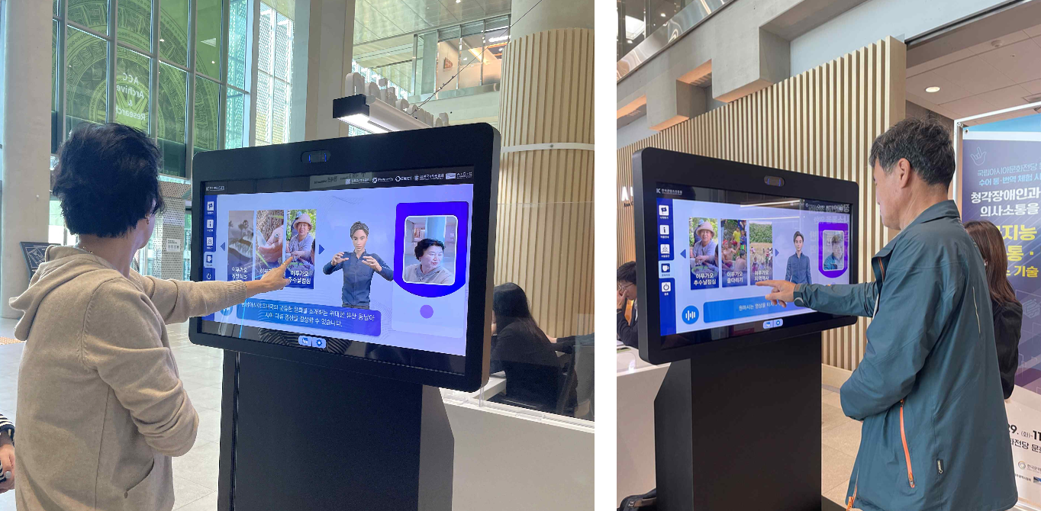

▲ ACC Cultural Information Center Sign Language Interpretation and Translation Pilot Service: The sign language interpretation and translation-only kiosk provides avatar sign language commentary service and simple Q&A-type interactive information service about Cultural Information Center facilities and Asian cultural content (documentary videos).

Next to the information desk of the Cultural Information Center of the National Asia Culture Center (ACC, Director Kang-hyun Lee), a kiosk for experiencing sign language interpretation and translation for the hearing impaired was installed. This kiosk, designed to enable simple communication with the hearing impaired, provides information on the Cultural Information Center’s facilities and spaces, as well as Asian cultural video materials, in which an avatar provides sign language guidance and explanations.

The Gwangju Institute of Science and Technology (GIST, President Kichul Lim) announced that it will present a barrier-free* service that provides information on cultural facilities through sign language communication with the hearing impaired at the ACC Cultural Information Center (museum) by applying the sign language interpretation and translation service technology developed by the Korea Culture Technology Institute (Director Kyung-Joong Kim, hereinafter referred to as CT Research Institute) until November 10 (Sun).

* barrier free: Movements and policies aimed at lowering physical and institutional barriers so that socially vulnerable people, such as the disabled and the elderly, do not experience inconvenience in terms of accessibility.

Voice-to-text conversion services for the hearing impaired have already become widespread, but as existing sign language translation services are mainly provided for daily life, there is a lack of customized services to help the hearing impaired enjoy their cultural life.

To lower the barriers to cultural life for the hearing impaired and realize high-quality cultural life, the CT Research Institute has been developing AI-based Korean and Korean sign language interpretation and translation service technology to help the hearing impaired communicate in major cultural infrastructure facilities such as museums, art galleries, and exhibition halls.

The institute announced that it is introducing a demonstration service with the goal of building Korean sign language data for guidance and explanation of public cultural facility services, as well as developing ▴ deep learning-based Korean sign language translation technology, ▴ image recognition technology for sign language recognition and translation, ▴ AI-based voice recognition and synthesis technology, and ▴ AI-based sign language avatar.

In particular, the institute was selected as the main research institute for the policy designation project for supporting cultural technology research led by the Ministry of Culture, Sports and Tourism in August 2023, and has been developing technology to convert exhibition commentary and guidance broadcasts at cultural facilities into text and Korean sign language animation for the past year or so for the purpose of ‘Development of AI-based sign language interpretation and translation service technology for communication between the hearing impaired and the hearing (Research Director: Kyung-Joong Kim)’. (Project implementation period: August 1, 2023 - December 31, 2025)

For the development of technology currently being piloted at ACC, they have been collaborating with joint research institute GNICT (CEO Seung-geon Lee) and commissioned research institute Gwangju Association of the Korea Association for the Deaf (Chairman Sang-wan Kim). Through the advice and expertise of the sign language interpretation team, they have been able to implement advanced services based on a practical understanding of sign language.

To verify the excellence of the research results, the CT Research Institute plans to conduct a usability evaluation by forming a group of 45 hearing-impaired people during the pilot service period, and plans to provide expanded sign language interpretation and translation services in conjunction with museums, etc. next year.

CT Research Institute Director Kyung-Joong Kim said, "The pilot service conducted by the ACC Cultural Information Center focuses on lowering barriers to cultural life for the disabled and implementing practical services. We hope that through our institute’s advanced sign language interpretation and translation service, the hearing impaired will also be able to enjoy culture without being excluded."

Meanwhile, the Korea Institute of Culture Technology is a cultural technology research institute established at GIST in accordance with Article 17-5 of the Cultural Industry Promotion Act (Designation of Cultural Technology Research Institutions Affiliated with the Ministry of Culture, Sports and Tourism, etc.). It is currently carrying out numerous projects, including cultural technology research and development policy-designated tasks, and is focusing on core cultural technology research and development to drive the development of the national cultural industry.



