GIST-Gwangju Metropolitan City, BIXPO 2024 Gwangju Energy Innovation Conference Held

- Energy industry experts gather to share the latest technologies and cases, including the demonstration of distributed energy and energy storage (ESS) business... November 8 at the Kim Dae-jung Convention Center

- Pre-registration is now open... Anyone interested in the energy industry can attend. “We expect this to be a place to explore the future of the energy industry together and seek leading innovation.”

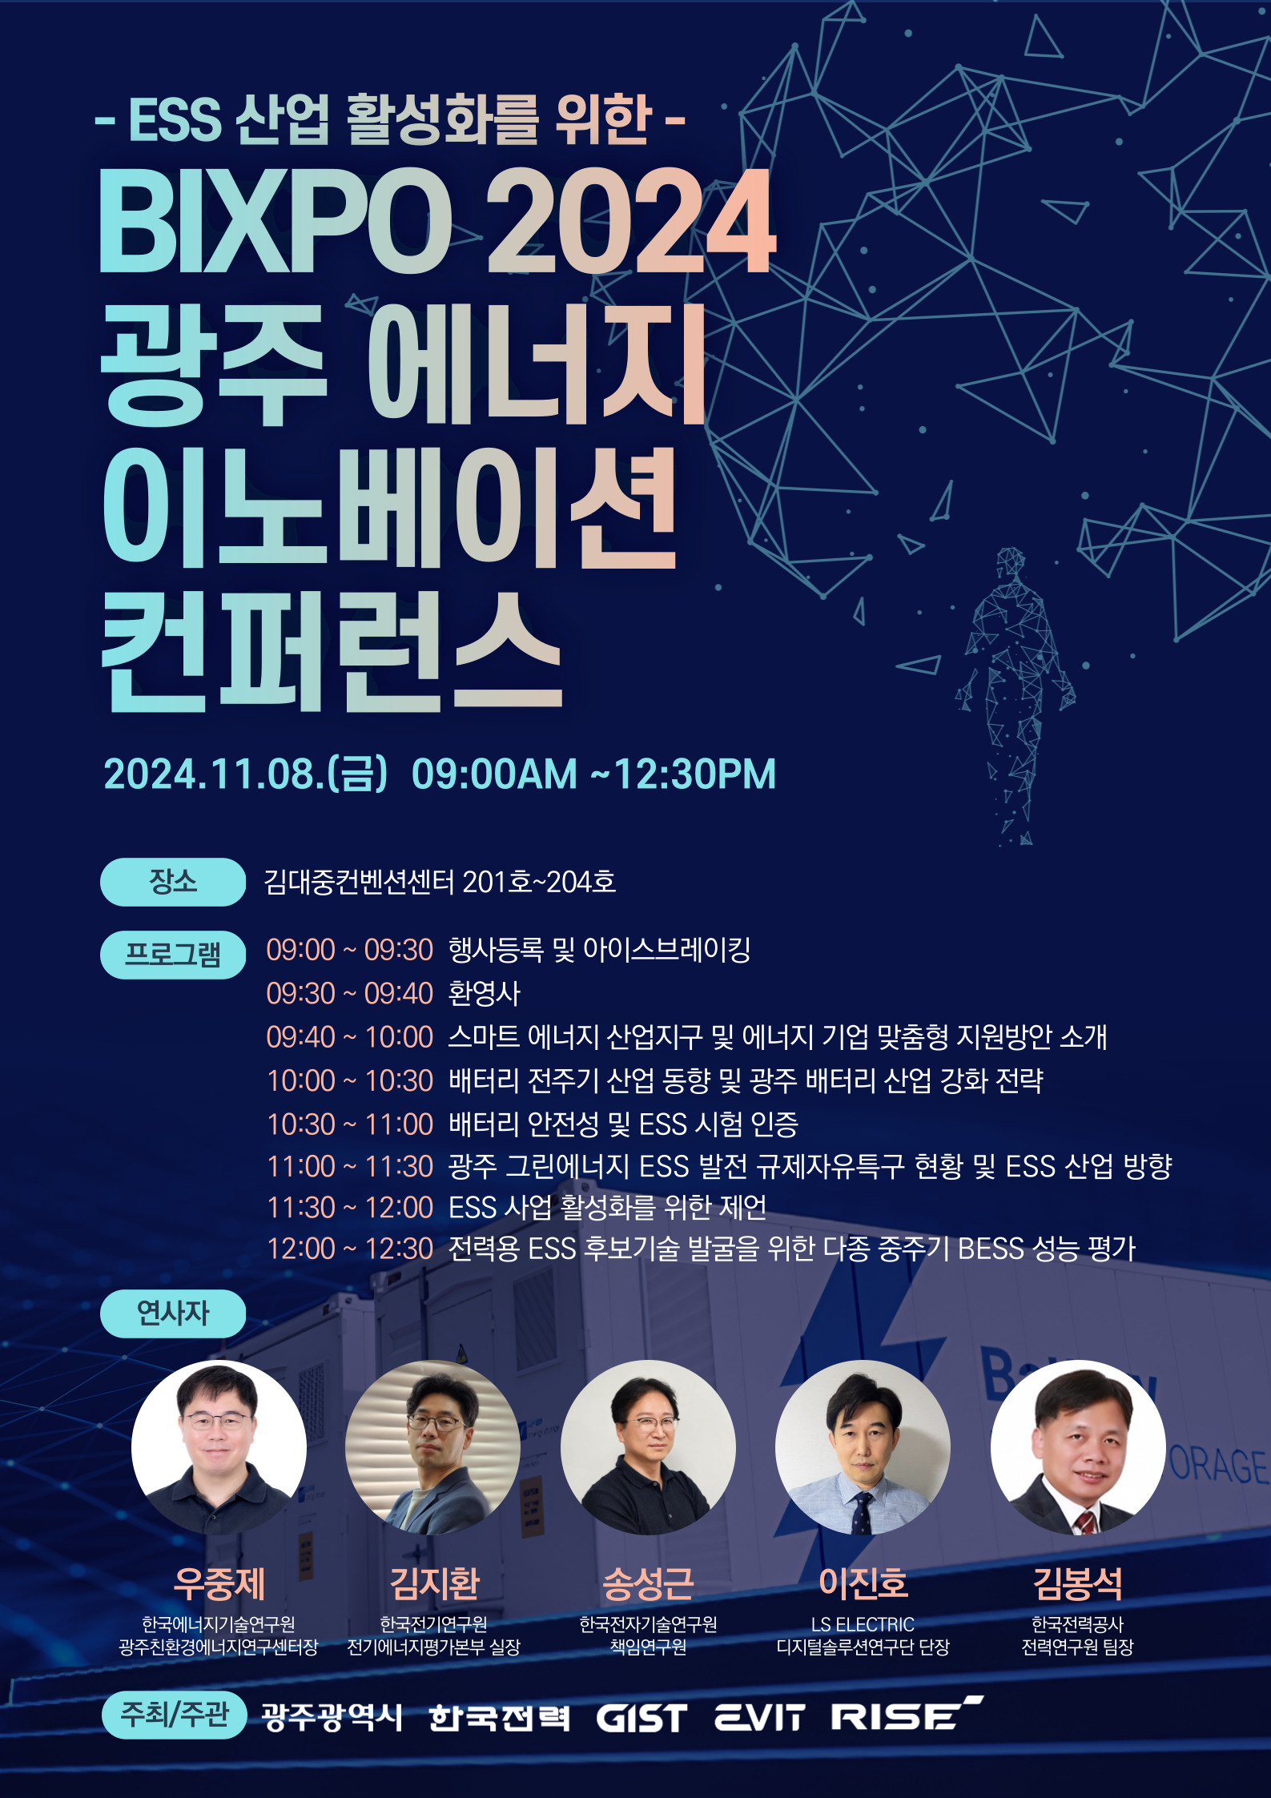

▲ ‘BIXPO 2024 Gwangju Energy Innovation Conference’ poster

The Gwangju Institute of Science and Technology (GIST, President Kichul Lim) announced that the Energy Valley Technology Institute (Director Kwanghee Lee) and the NResearch Institute For Solar And Sustainable Energies (Director Sanghan Lee) will hold the ‘2024 Gwangju Energy Innovation Conference’ on Friday, November 8, to promote the energy storage system (ESS) industry in cooperation with Gwangju Metropolitan City.

This event will be held during the Bitgaram International Power Technology Expo (BIXPO 2024) at the Gwangju Kim Dae-jung Convention Center, and will share the latest technologies and cases of distributed energy and ESS power trading, which have emerged as hot issues in the energy industry, through presentations by experts from various fields.

In addition, the Gwangju Free Economic Zone Authority's smart energy industrial complex and customized support measures for energy companies to enhance the competitiveness of local companies, such as attracting investment from energy companies, expanding business, and expanding sales channels, will also be introduced.

At the ‘BIXPO 2024 Gwangju Energy Innovation Conference,’ experts from energy-related research institutes and companies will present topics by field, such as ▴ Jung-je Woo, Director of Gwangju Eco-friendly Energy Research Center at Korea Institute of Energy Research, ‘Battery Full-cycle Industry Trends and Gwangju Battery Industry Reinforcement Strategy’, ▴ Ji-hwan Kim, Director of Electric Energy Evaluation Center at Korea Electrotechnology Research Institute, ‘Battery Safety and ESS Testing and Certification’, ▴ Seong-geun Song, Senior Researcher at Korea Electronics Technology Research Institute, ‘Current Status of Gwangju Green Energy ESS Development Regulatory-Free Special Zone and ESS Industry Direction’, ▴ Jin-ho Lee, Director of DS Research Group at LS Electric, ‘Suggestions for Activating ESS Business’, ▴ Bong-seok Kim, Team Leader at KEPCO Research Institute, ‘Performance Evaluation of Various Mid-cycle BESS for Discovery of Candidate Technologies for Electric ESS’.

This conference is open to anyone interested in related fields, including those in the energy industry, including batteries and ESS. Detailed information and advance registration are available on the website (https://forms.gle/fbeuDxTZokFWFdWf9).

Energy Valley Technology Institute Director Kwanghee Lee said, "We expect this conference to be a place to explore the future of the energy industry together and to seek leading innovation. GIST Energy Valley Technology Institute will continue to do its best to play a central role in strengthening the regional energy network."



