"Gwangju is in the middle of a science and culture festival" 2024 GIST Science and Culture Week opens... 5th year this year

- From Monday the 4th, for 2 weeks, ▴ Math and Physics lecture series ▴ Play 'Photo 51' ▴ Online science lecture for middle school students (Science Talk Talk) ▴ Startup Night ▴ Investment attraction IR competition ▴ GIST Hidden Singer 5 ▴ Social contribution Academy lecture (Professor Seong-ho Yoo, a forensic scientist), etc., science and culture events in a row

- Aiming for a science and culture festival that everyone can enjoy... "Efforts to communicate with the local community and spread science culture"

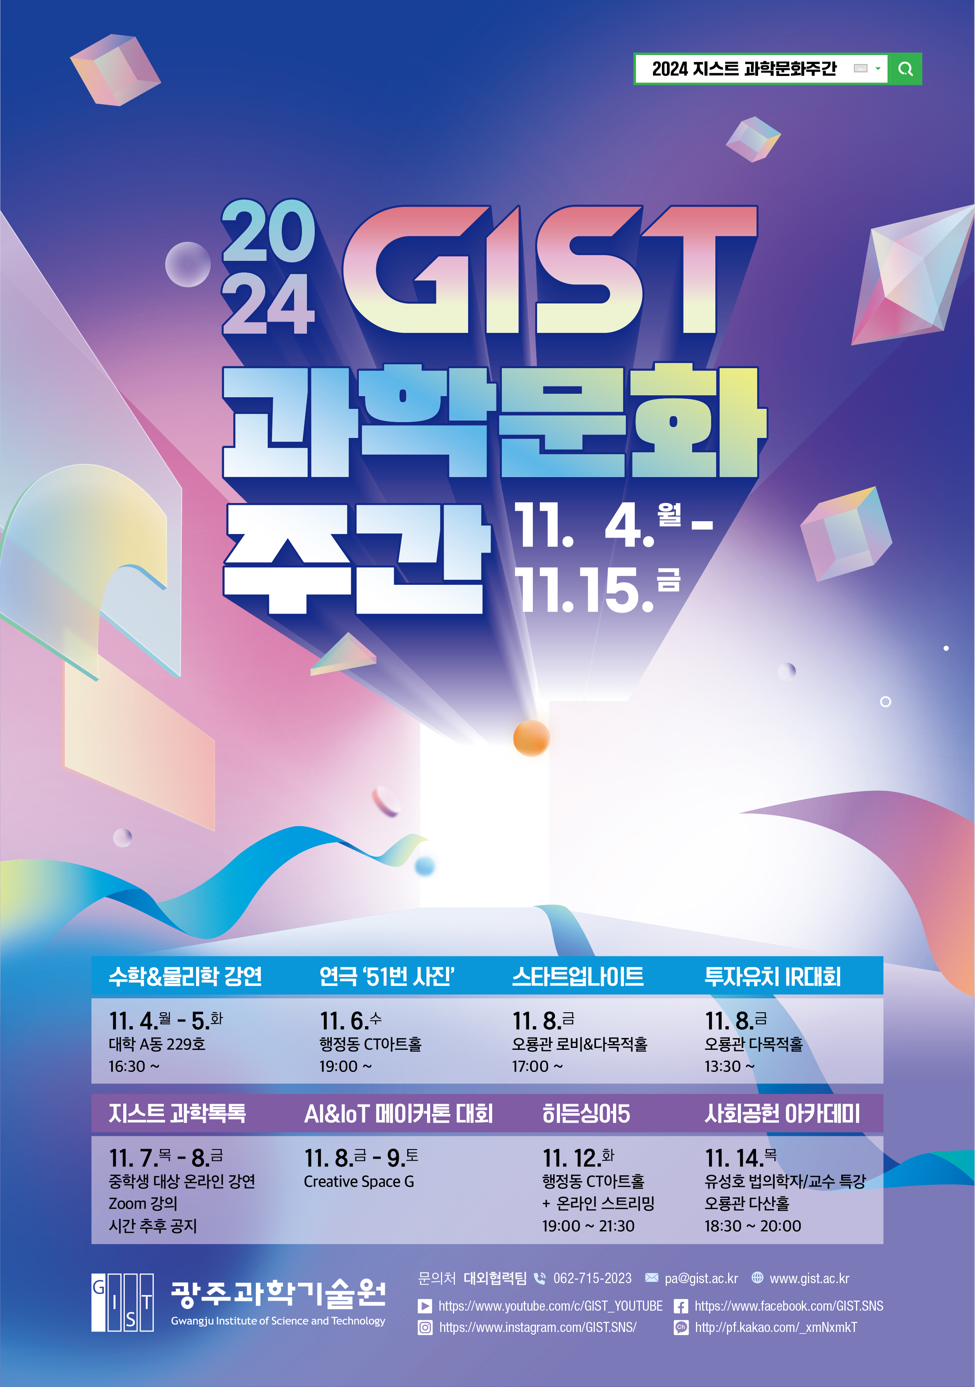

▲ 2024 GIST Science Culture Week Event Poster

The Gwangju Institute of Science and Technology (GIST, President Kichul Lim) announced that it will hold the ‘2024 GIST Science Culture Week’ for two weeks from Monday, November 4 to Friday, November 15, and will host various events.

The ‘GIST Science Culture Week’, which is in its fifth year this year, is expected to be enjoyed by not only GIST members but also citizens, as it will feature in-depth lectures, theater performances, and various programs such as startup events.

In the first week of the event, the ▴ Mathematics and Physics Lecture Series, in which emerging researchers in the fields of mathematics and physics are invited to give lectures, will be held for two days from Monday, November 4 to Tuesday, November 5.

On Wednesday, November 6th at 7 PM, the play ▴ The 51st Photograph, a dramatization of the play 《The 51st Photograph (Author: Anna Ziegler, Translator: Professor Siyeon Lee, Department of General Education, GIST)》 published by GIST PRESS, a school publishing company, in 2019, will be performed on the stage of CT Art Hall on the first floor of the Haengjeong Building. 《The 51st Photograph》 is a work that adds exciting literary elements based on the true story of the research competition to discover the double helix structure of DNA from 1951 to 1953. It became a hot topic when Hollywood star Nicole Kidman played the lead role of Rosalind Elsie Franklin in the play that was performed on the West End stage in England in 2015.

▴ Science Talk Talk, a two-day science lecture program held on Thursday, November 7th and Friday, November 8th, will see students from middle schools in the Jeollanam-do region (Muan Haeje Middle School, Yeosu Yeodo Middle School, Hwasun Bukmyeon Middle School) who have pre-registered participate in online lectures by Professor Dae-Cheong Ha of the Division of Liberal Arts and Sciences at GIST, Professor Jaeyoung Lee of the School of Environment and Energy Engineering, and Professor Young Min Song of the School of Electrical Engineering and Computer Science.

On Friday the 8th, various events related to startups will be held simultaneously. The ▴ Startup Night, themed ‘Go, Get EveryThing,’ will introduce the latest startup trends and items, providing information for aspiring entrepreneurs to successfully start a business. On the same day, the ▴ GIST Investment Attraction IR Competition, where the achievements of excellent startups on campus will be shared and business proposals will be made, and the ▴ AI&IoT Makerthon Competition, an idea prototype competition utilizing artificial intelligence (AI) and the Internet of Things (IoT), will be held on Friday, November 8th and Saturday, November 9th.

On Tuesday, November 12, the ▴ GIST Hidden Singer 5, which will select the best singer of GIST, will be held at the CT Art Hall in the Main Admin Building with a live broadcast on YouTube.

On the last day, Thursday, November 14, Seoul National University Professor Seong-ho Yoo, a forensic scientist, will visit GIST Oryong Hall to give a ▴ Social Contribution Academy lecture on the topic of ‘Life and Death as Seen by a Forensic Scientist.’

Detailed information about the 2024 GIST Science Culture Week event and how to participate can be found on the GIST website (www.gist.ac.kr).

President Kichul Lim said, "Since 2020, GIST has been making steady efforts to communicate with the local community and spread scientific culture through the annual Science Culture Week event. As a result, GIST, which celebrates its 31st anniversary this year, will grow into a science and technology research institute that leads the future of the innovative economy together with the local community."



