GIST Techno Management Business Academy (GTMBA) Alumni Association donates to the school's Development Fund

- On October 29, 10 million won was donated to the development fund to commemorate the GTMBA Alumni Association President’s Cup Sports Competition... “GTMBA alumni will join us on our journey to grow into a world-class science and technology university.”

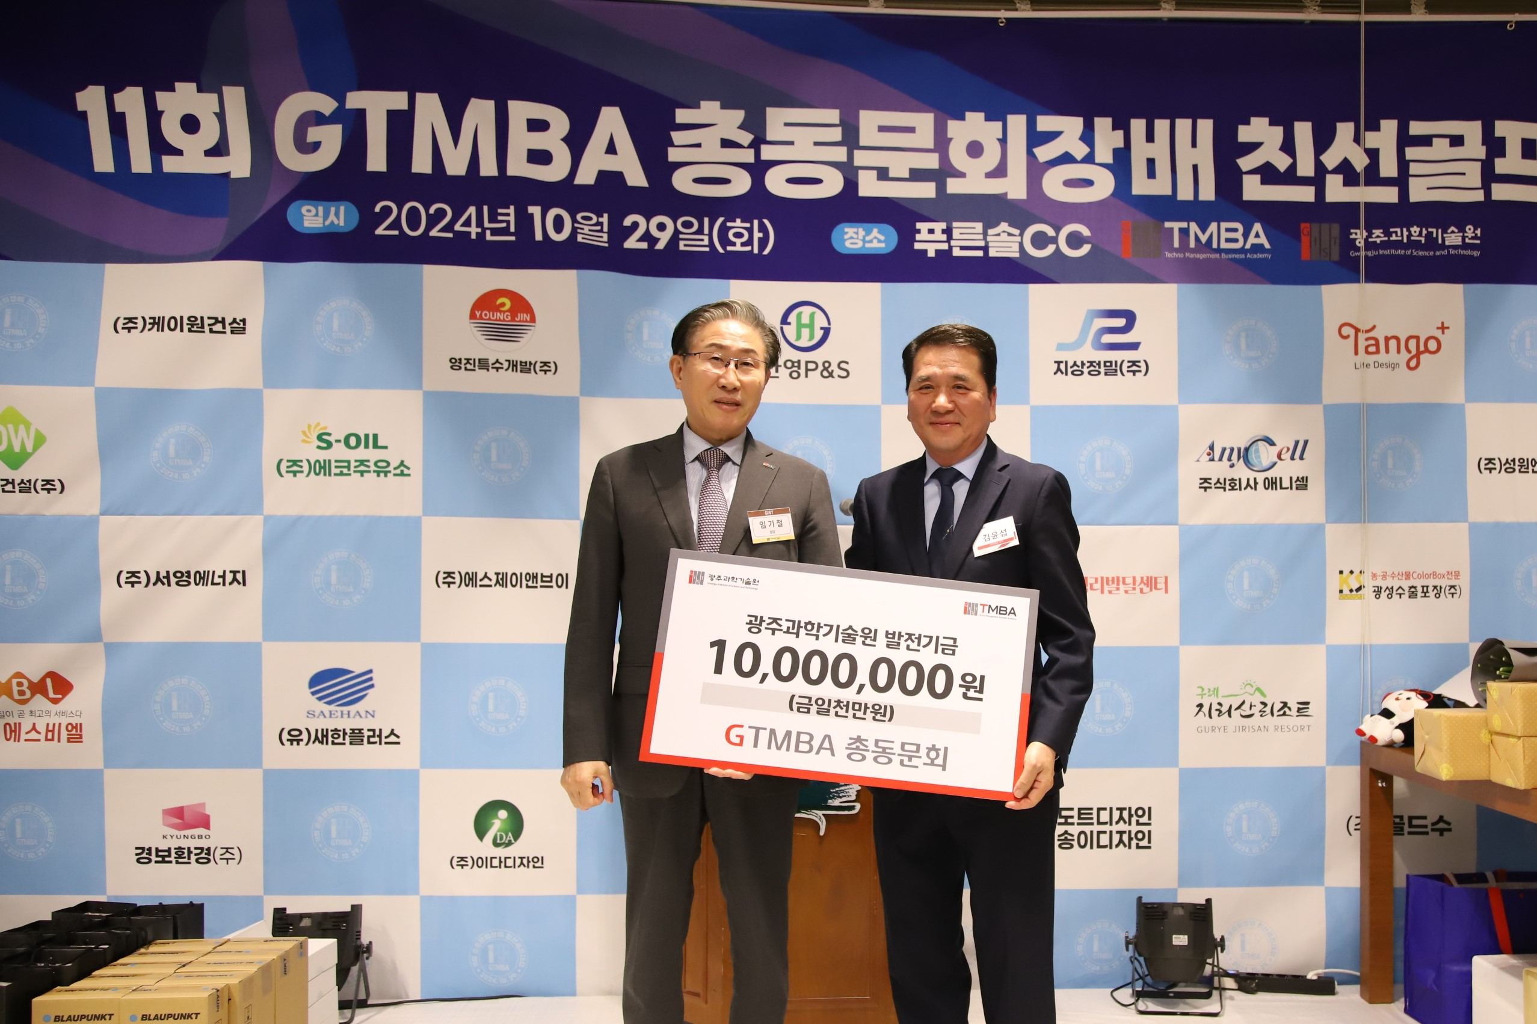

▲ On Tuesday, October 29, the GTMBA Alumni Association donated 10 million won to the GIST Development Fund and took a commemorative photo. (From left) GIST President Kichul Lim and 7th GTBMA Alumni Association President Yun-seop Kim

The Gwangju Institute of Science and Technology (GIST, President Kichul Lim) announced that it received a 10 million won development fund donation from the GTMBA Alumni Association (7th Alumni Association President Yun-seop Kim, Chairman of Hanyoung P&S Co., Ltd.).

Chairman Yun-seop Kim of Hanyoung P&S Co., Ltd., who is the 7th GTMBA Alumni Association President, and all GTMBA members raised the fund with the hope of developing the school.

The donation ceremony was held on Tuesday, October 29th, after the GTMBA Alumni Association President’s Cup Sports Competition, with the attendance of GIST President Kichul Lim, ViceVice President for Public Affairs Yonghwa Chung, the 7th GTMBA Alumni Association President Yun-seop Kim, and approximately 230 GTMBA executives and alumni.

Alumni Association President Yun-seop Kim said, "As a member of the GIST alumni community, GTMBA alumni will continue to show interest and support for the future development of the school. We hope that GIST will continue to grow into a world-class science and technology university through innovative research and education, and GTMBA alumni will join us on that journey.

President Kichul Lim said, "We would like to express our gratitude for the warm hearts and deep affection shown by the GTMBA Alumni Association, and this has once again served as an opportunity to confirm the bright future of the school. GIST promises to work even harder for the development of the region and the nation, thanks to the strong support of GTMBA alumni."

GIST Academy (Director Jae Gwan Kim, professor in the Department of Biomedical Science and Engineering), which operates the Techno Management Business Academy (opened in 2010) as a non-degree program at GIST, helps managers in each field learn management strategies for responding to changes in the global corporate environment in depth through lectures by the best experts in Korea and form a wide personal network, thereby contributing to the revitalization of the regional economy and industry-academia cooperation.

Currently, GIST Academy is recruiting the 15th GTMBA class, aiming to open in March 2025. (Inquiries: GIST Academy 062-715-2623)



