“Reading books while interacting with a robot puppy in a library where a robot walks around with you and selects books for you” GIST develops AI-based robot to support children’s reading activities

- The Korea Culture Technology Institute, the main research institute for the Ministry of Culture, Sports and Tourism's cultural technology research and development policy designation project, has developed a 'book location guide robot' and 'Read to a Robot (Pome)' to help children's reading activities

- A guide robot walks around to help children choose books, and a puppy robot can read books out loud... A pilot service will be operated at the National Library for Children and Young Adults until Sunday, November 3

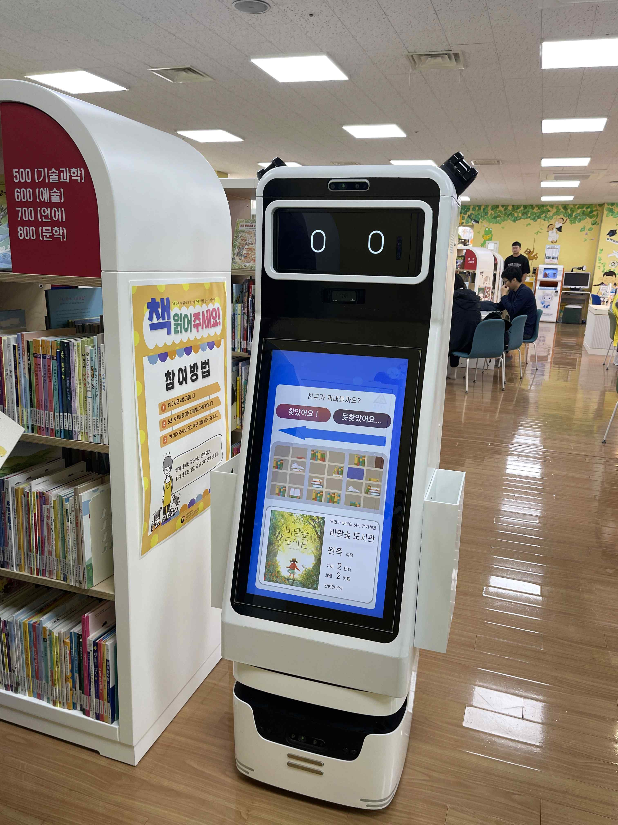

▲ National Children's Library Book Location Guidance Robot Prototype Pilot Service: Reading Activity Support Service Mobile Robot Response Technology is a service that recommends books to children in the library using mobile robots.

Recently, public libraries have seen a significant increase in demand for new technology reading activity support services that provide children with an ‘enjoyable’ reading experience rather than ‘forced’ reading.

The Gwangju Institute of Science and Technology (GIST, President Kichul Lim) announced that it has developed a ‘Book Location Guide Robot’ and ‘Read to a Robot (Pome*)’ to help children’s reading activities and will conduct a pilot operation at the National Children’s Library on weekends (Sat, Sun) until November 3 (Sun).

* Pome: Abbreviation for the Pomeranian breed

The GIST Korea Culture Technology Institute (Director Kyung-Joong Kim), the main research institute, is conducting a research project (Period: April 2022 ~ December 2024) titled ‘Development of AI-based Children’s Reading Activity Support Robot and Service Content (Research Director: Professor HongKook Kim, School of Electrical Engineering and Computer Science)’ to expand reading activity support services to public children and youth libraries nationwide.

As a research result, the institute developed two types of ‘UI/UX (user environment/experience) and sustainable services’ that support reading activities by reflecting the psychological characteristics of children, and ‘interactive robot software (SW)’ and ‘reading activity support robots’ to provide services that stimulate children’s interest in reading.

The GIST Korea Culture Technology Institute will introduce the prototypes of robots that help children between the ages of 7 and 10 read at the Children’s Reading Room on the first floor of the National Library for Children and Young Adults, ▴ ‘Book Location Guide Robot’ and ▴ ‘Read to a Robot (Pome)’, and will proceed with verifying the technology through usability evaluation.

The ‘Book Location Guide Robot’ placed in the library will move around the reading room to recommend books suitable for young users and find the location of books. In addition, the puppy-shaped ‘Read to a Robot (Pome)’ will help children feel the joy of reading more by identifying the various emotional states of children reading out loud and making appropriate facial expressions or wagging their tails to communicate with them.

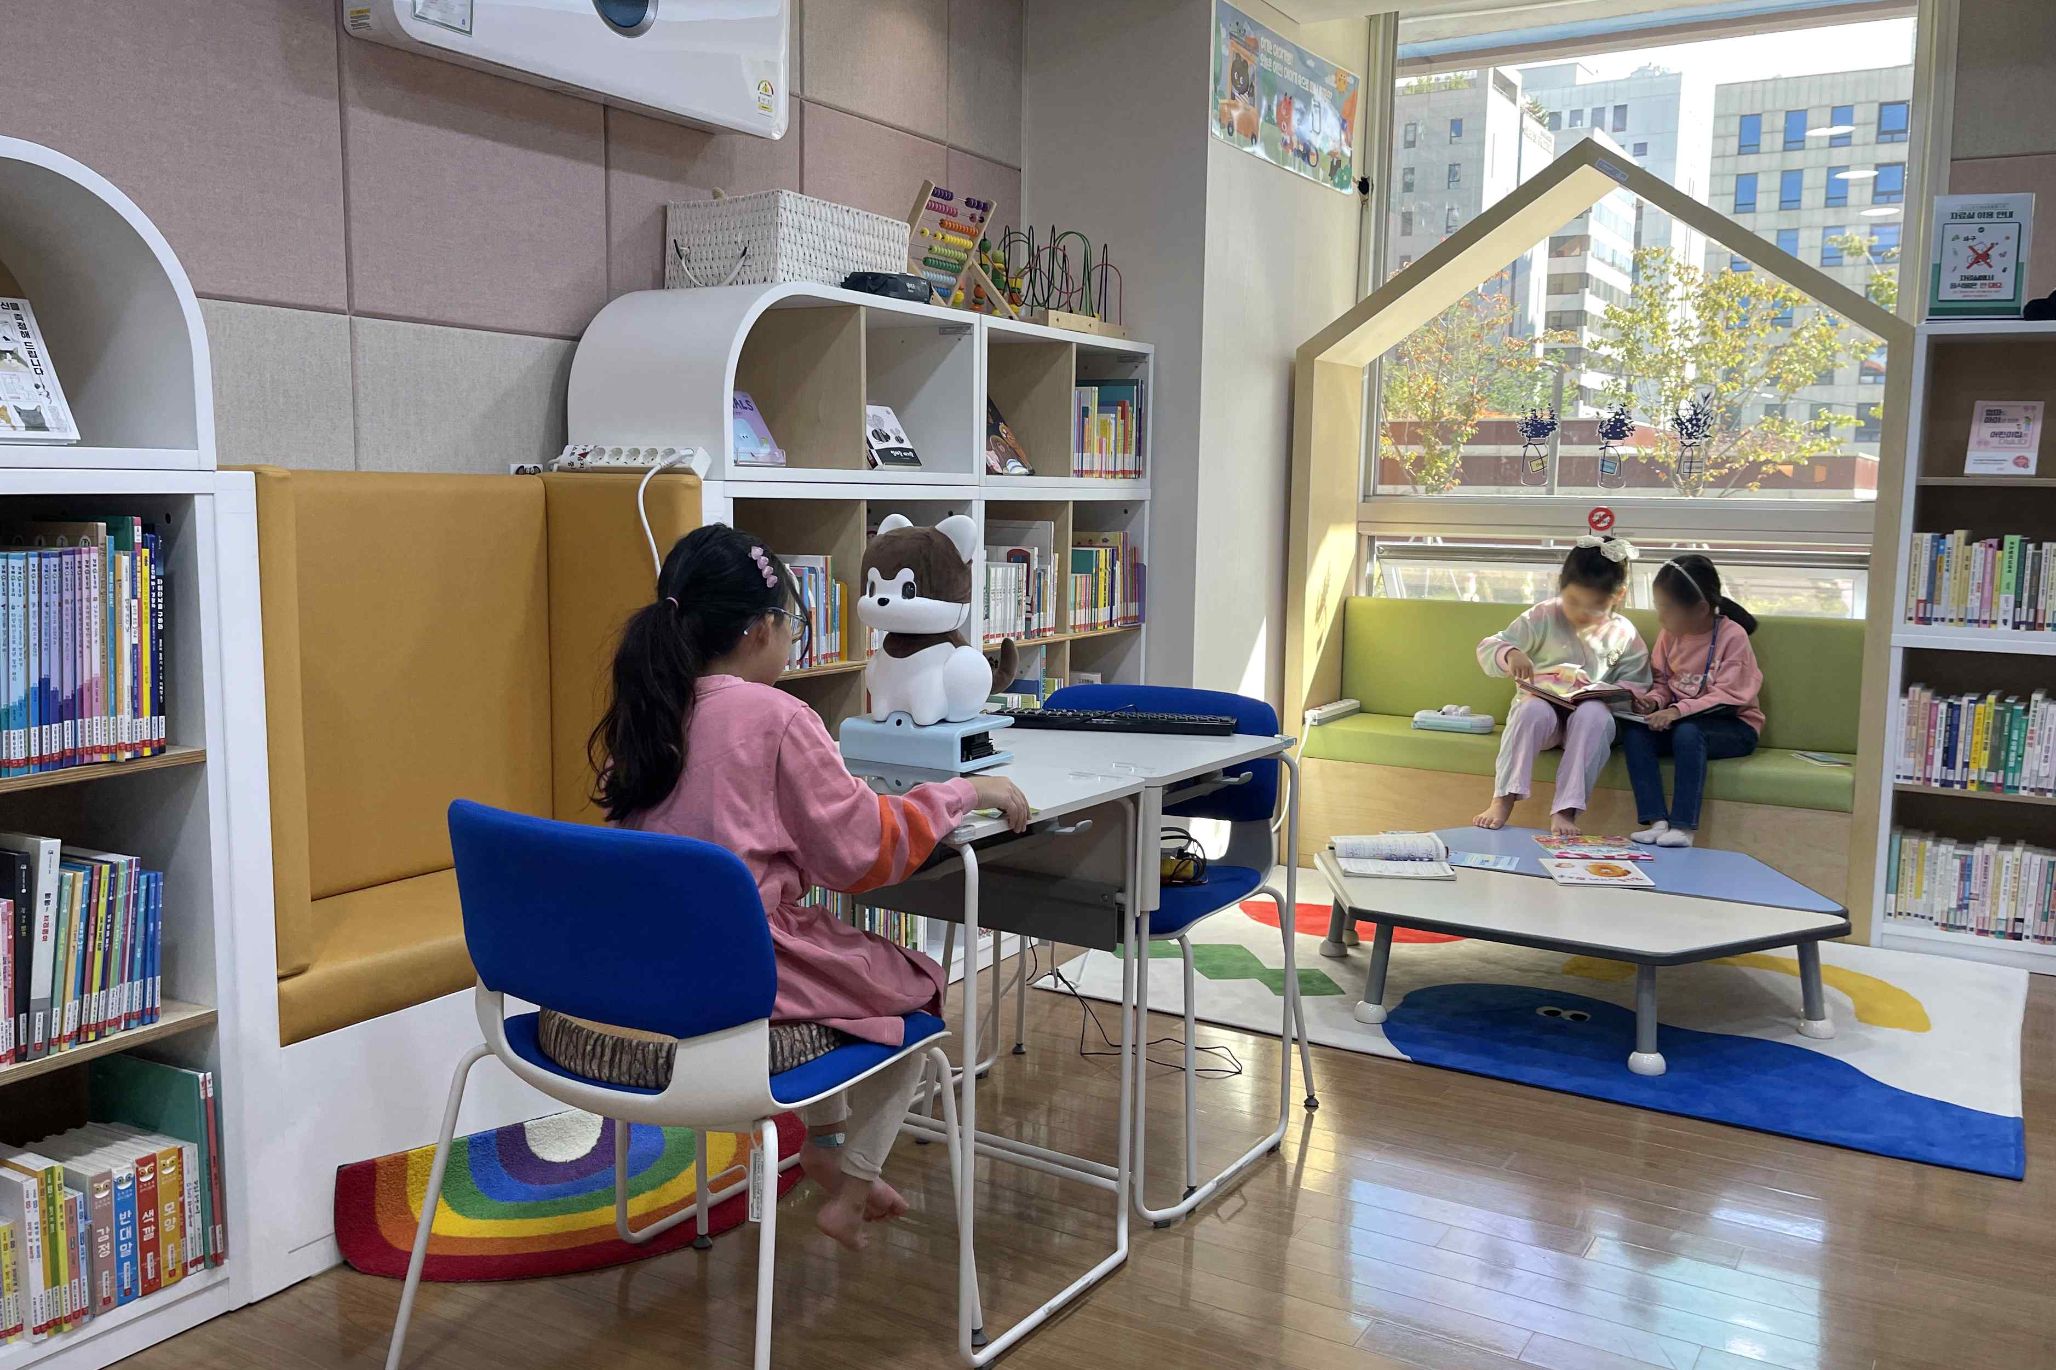

▲ Children can read books to the puppy-shaped ‘Read to a Robot’.

The institute and its collaborators Ulsan National Institute of Science and Technology (UNIST), Sogang University Industry-Academic Cooperation Foundation, and Interflow Co., Ltd.) plan to showcase expanded technologies through ▴ prototype and verification of a reading activity support robot, ▴ technology to understand user behavior and intention using a tactile sensor, ▴ ‘Advanced server-based emotion analysis/expression system’ and ‘integration of robot control according to touch-based behavioral patterns,’ ▴ advancement of a book location guidance robot, and ▴ verification of a ‘Read to a Robot (Pome)’ prototype.

Research Institute Director Kyung-Joong Kim said, "We hope that the robot service for supporting children's reading activities will be successfully piloted and expanded to many public libraries in the future. We hope that children will be able to improve their reading skills in an interactive and immersive way by experiencing the experience of selecting and finding books with a robot, interacting with a puppy robot, and reading books out loud, as if they were playing with a friend, rather than simply going to the library to read books."

The Korea Culture Technology Institute was selected as the main research institute for the ‘Cultural Technology Research Main Institution Support Policy Designation Project’ hosted by the Ministry of Culture, Sports and Tourism in April 2022, and has been collaborating with joint research institutes Ulsan National Institute of Science and Technology (UNIST), Sogang University Industry-Academic Cooperation Foundation, and Interflow Co., Ltd. for the past two years, and has been developing AI-based children’s reading activity support robots and service content in collaboration with the National Library for Children and Young Adults.

The institute is carrying out numerous projects, including cultural heritage utilization realistic content, AI-based art convergence creation, and media facade mapping technology, including the Ministry of Culture, Sports and Tourism’s cultural technology research and development policy designation project, and is focusing on core cultural technology research and development to drive the development of the national cultural industry.



