GIST Student Cafeteria ‘RakRak’ CEO Seong-mi Park donates 20 million won to GIST Development Fund for student welfare: Since the inauguration of the 9th President, Kichul Lim, the foundation for the university to become a world-class research-oriented university has been laid by securing a development fund of 3.2 billion won in accumulated development fund payments

- ‘RakRak’, famous as ‘GIST Campus Restaurant’, operating a student cafeteria for 10 years since 2014... “Hopefully GIST students will be healthier in body and mind through improved student welfare”

- CEO Seong-mi Park, a ‘mother’-like figure to GIST students living in dormitories away from their families... “GIST will also always strive to improve the welfare and living conditions of students”

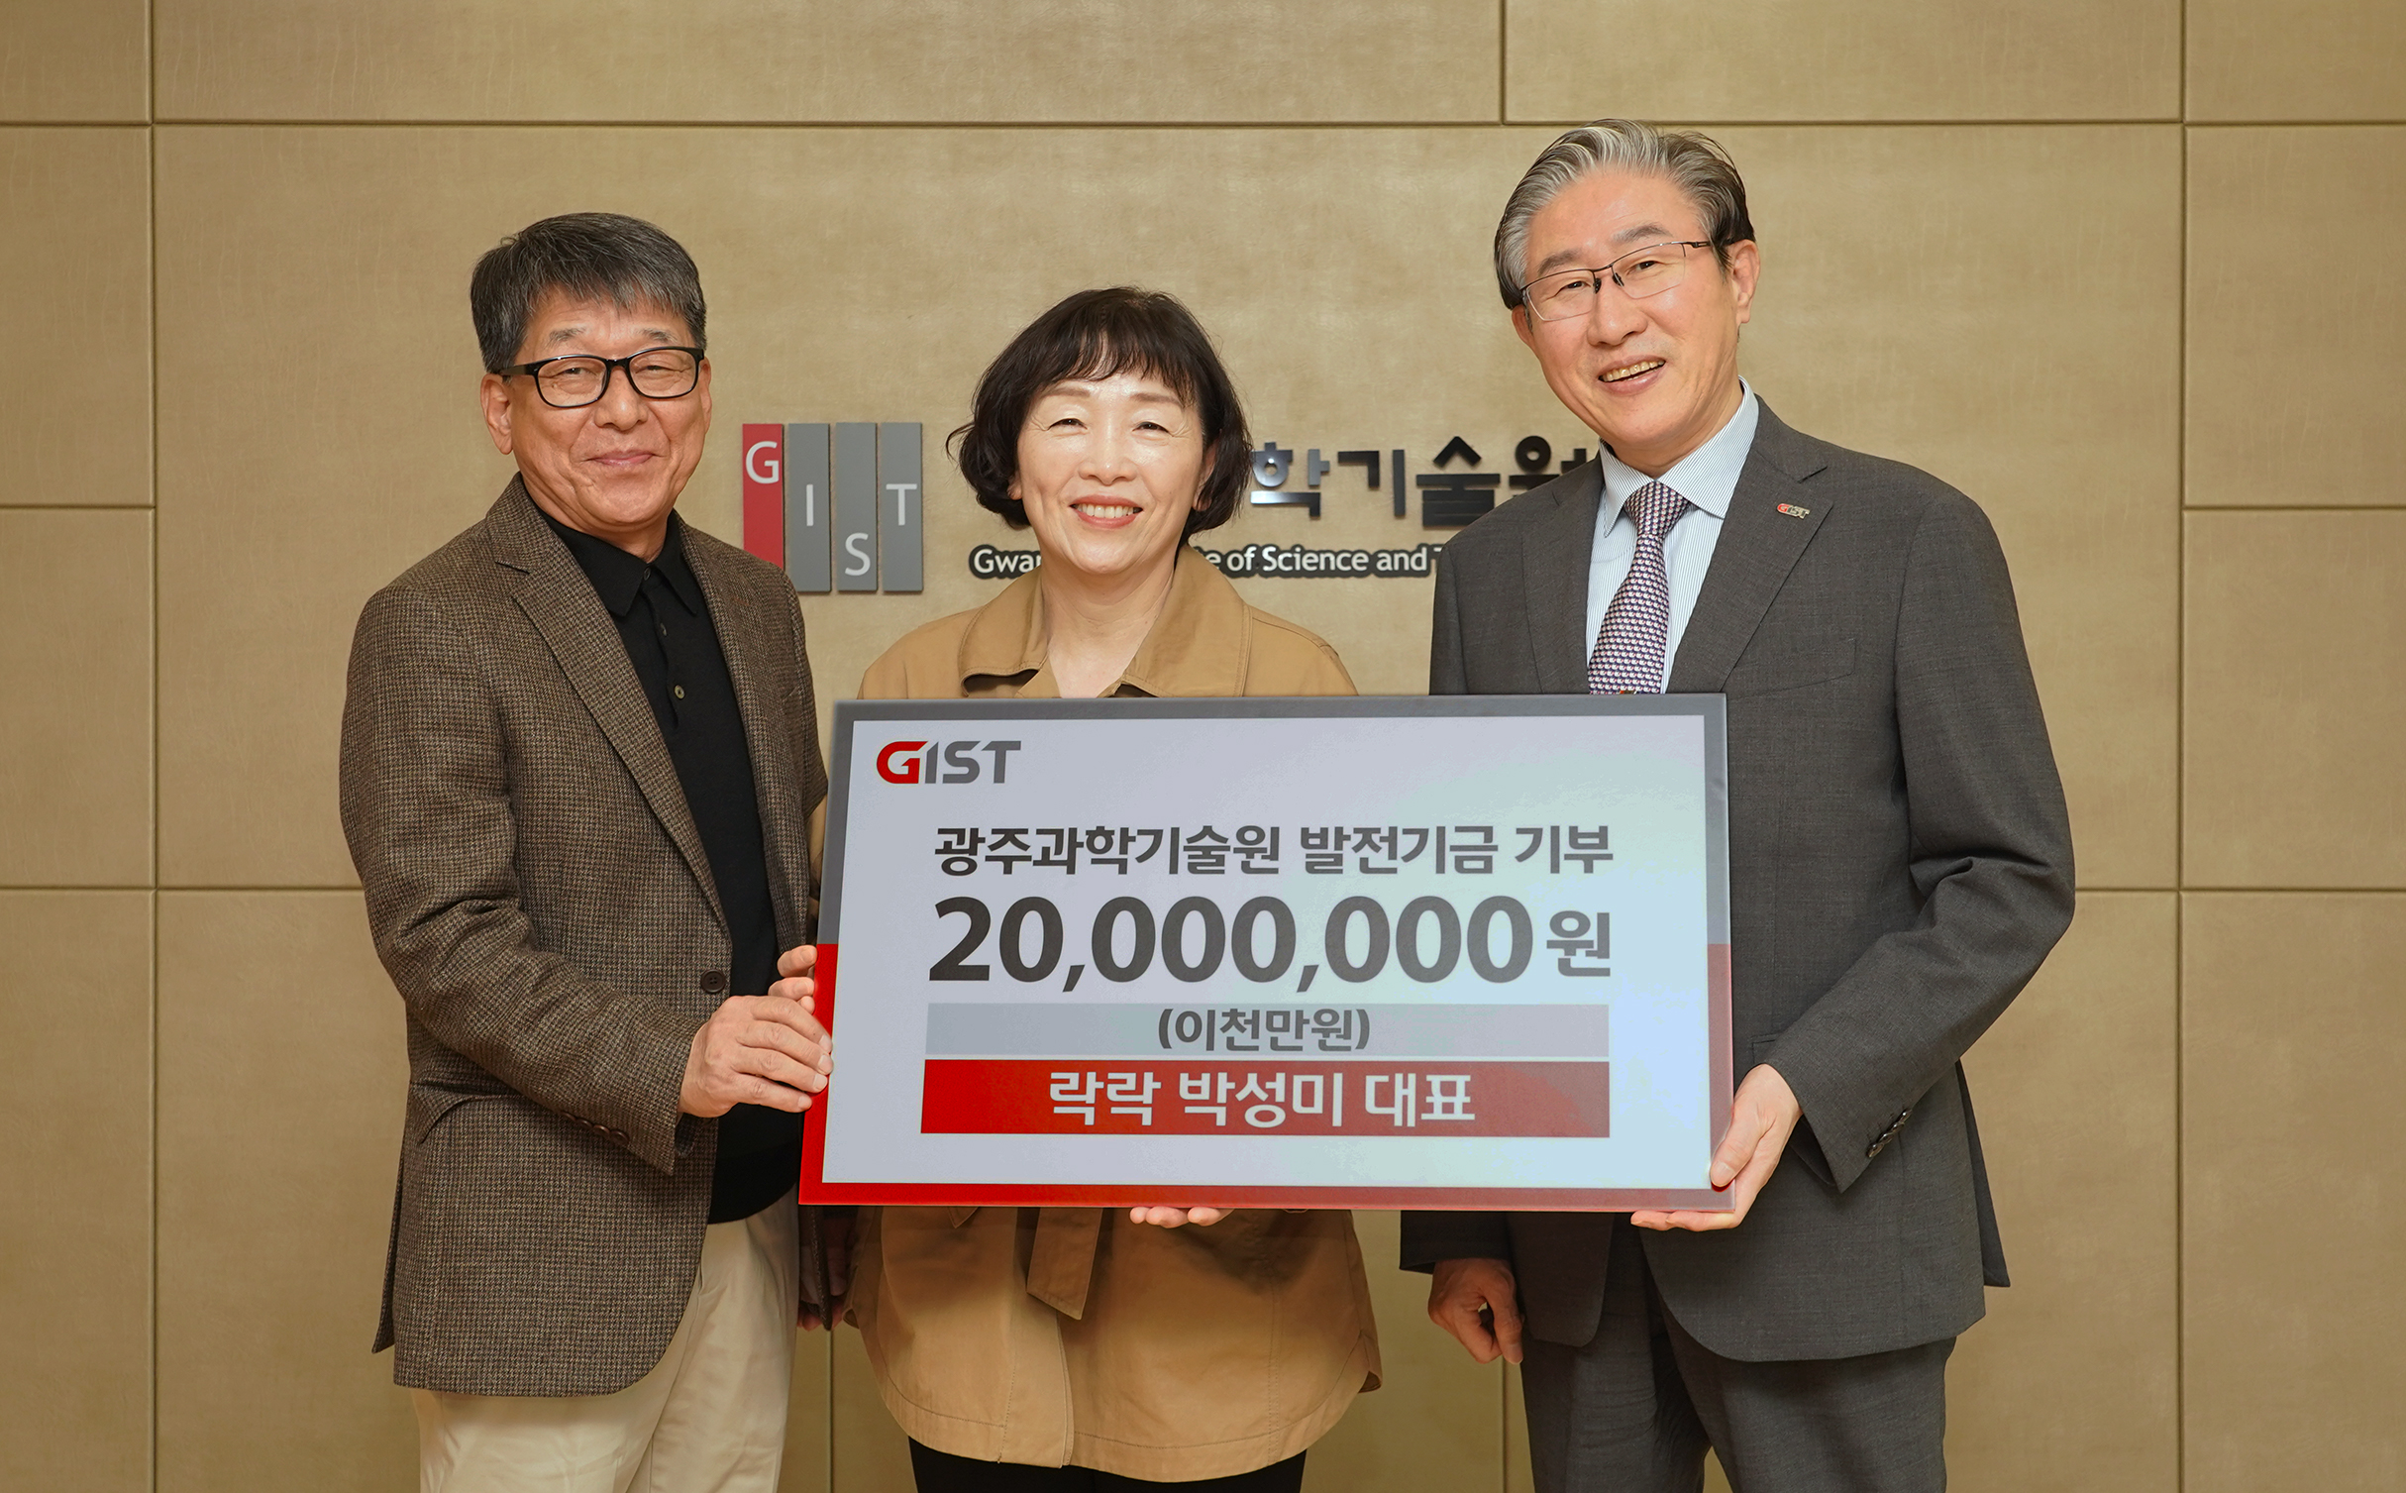▲ On Monday, October 21, GIST student cafeteria ‘RakRak’ CEO Seong-mi Park (center) donated 20 million won to GIST as a development fund and took a commemorative photo with GIST President Kichul Lim (right).

The Gwangju Institute of Science and Technology (GIST, President Kichul Lim) announced that CEO Seong-mi Park of ‘RakRak’, a cafeteria operator located on campus, donated 20 million won to the Development Fund.

The donation ceremony was held on the 5th floor of the administrative building at 2:30 PM on Monday, October 21, with President Kichul Lim, Vice President for Academic Affairs Sang-Don Kim, Vice President for Public Affairs Yonghwa Chung, and International and Public Affairs Dean Jae Gwan Kim in attendance.

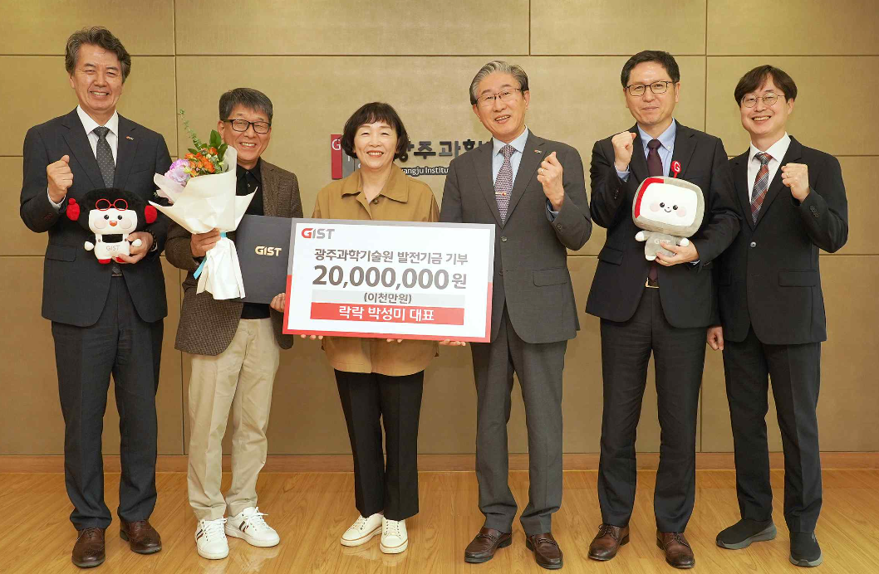▲ On Monday, October 21, CEO Seong-mi Park of GIST’s student cafeteria ‘RakRak’ donated 20 million won to GIST and took a commemorative photo. (From left) Vice President for Public Affairs Yonghwa Chung, CEO Park Sung-mi of RakRak, his wife Jae-bong Kim, GIST President Kichul Lim, GIST Vice President for Academic Affairs Sang-Don Kim, and GIST International and Public Affairs Dean Jae Gwan Kim

Since 2014, CEO Seong-mi Park has been running the student cafeteria ‘RakRak’ on the 2nd floor of the GIST 2nd Student Center for 10 years, providing a variety of nutritious meals that suit the tastes of students and GIST members at a low price.

Thanks to these efforts, ‘RakRak’ has become known as a ‘campus restaurant’ among GIST students, and its popular menu items include cheese donkatsu (6,000 won), pork rice bowl (5,500 won), and kimchi fried rice (4,500 won).

CEO Park said, "We are preparing meals for GIST students who are smart and well-mannered with the thought that they are 'my children.' We decided to donate because we want GIST students to be healthier in body and mind through improving student welfare. We hope that the food made by ’RakRak' will nourish their studies and research activities and help them grow into the human resources that our society needs."

President Kichul Lim said, "CEO Seong-mi Park is like a mother to our students who live in dormitories away from their families, so the students will feel even more moved. We express our deepest gratitude for his's warm heart and sharing with GIST and its students, and our university will always strive to improve the welfare and living conditions of our students."

Meanwhile, GIST announced that the total amount of Development Fund payments made over the past 16 months since the inauguration of the 9th President Kichul Lim in July last year is 3.2 billion won, and the amount of payment promised for donation is 6.1 billion won.

In particular, the total amount paid and the amount to be paid include 300 million won for the Special Professor Fund and 300 million won for the Advanced AI-based Convergence Research Fund, laying the foundation for GIST to leap forward as a world-class research-oriented university through talent recruitment and training and AI convergence research.

President Lim himself also pledged to donate 100 million won to the development fund immediately after taking office and is currently paying approximately 20% of his monthly salary.



