GIST, 2024 Fall Semester Doran Doran Language Exchange Program successfully concluded first seminar

- 26 domestic and foreign students participated, first seminar hosted by Professor Sangjun Lee of the Department of Biomedical Science and Engineering

- Students take the lead in running the program... “Expected to contribute greatly to understanding various languages and cultures”

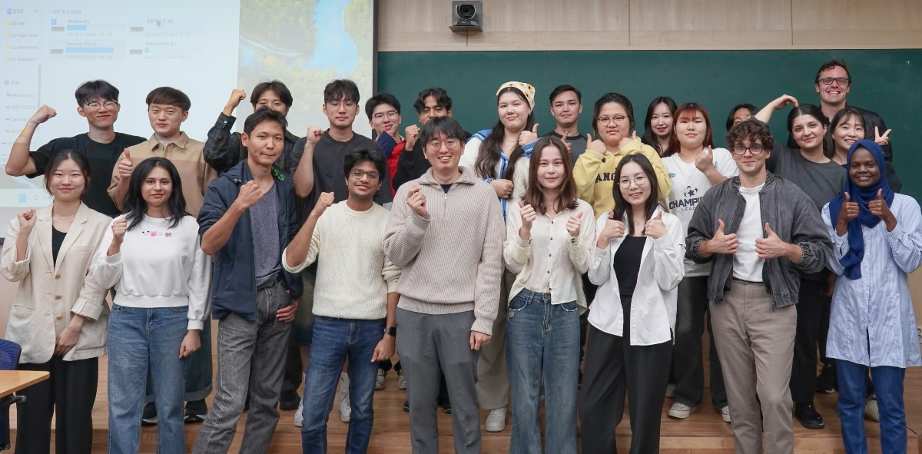▲ 2024 Fall Semester Language Exchange Program ‘Doran Doran’ hosted its first seminar with Professor Sangjun Lee (center) [photo credit: Mohanad Ahmed Farag]

The Gwangju Institute of Science and Technology (GIST, President Kichul Lim) announced that Professor Sangjun Lee of the Department of Biomedical Science and Engineering hosted the first lunch seminar for this year’s fall semester language exchange program ‘Doran Doran’ on Thursday, October 10.

‘Doran Doran’ is characterized by students taking the initiative in sharing languages and cultures. A total of 26 Korean and international students are participating in this program, with 13 Korean students and 13 foreign students formed into groups to communicate in both Korean and English. In addition to language exchanges, the students also had time to introduce and understand each other's cultural backgrounds.

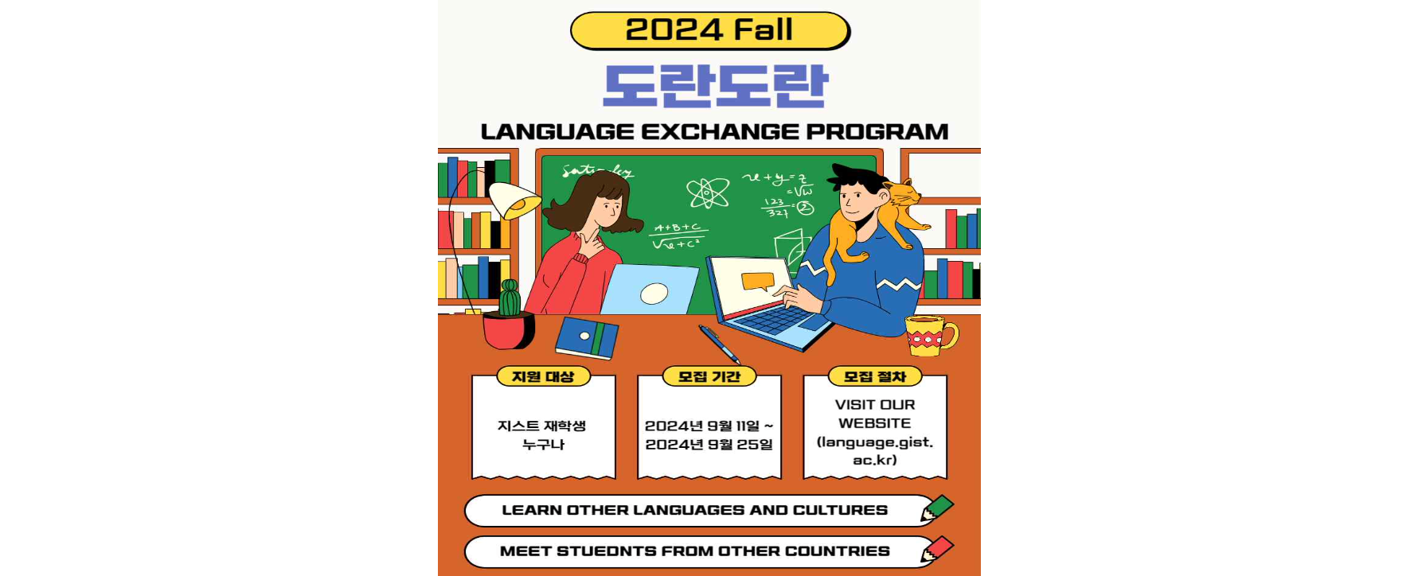
▲ ‘Doran Doran’ program promotional poster

The ‘Doran Doran’ program consists of three seminars during the fall semester, with the second seminar scheduled for Wednesday, November 13 (hosted by GIST College Dean Kwanghee Ko), and the third seminar scheduled for Wednesday, December 4 (hosted by Department of Chemistry Professor Hiroshi Imada), so continuous exchange and learning among program participants is expected.

GIST College Dean Kwanghee Ko said, "It is expected that the Doran Doran program will greatly contribute to understanding various languages and cultures. We will also encourage students to actively participate in future seminars."

Detailed information about this program can be found on the GIST Language Education website, and participating students can strengthen their global communication skills through various seminar activities in addition to language exchange.

