GIST Research Institute for Solar and Sustainable Energies participates in the Gwangju National Science Museum 2024 Art Science Festival and 200 citizens experience making eco-friendly electric vehicles

- About 200 citizens participated in the ‘Making Electric Cars with the Family’ experience booth for two days from Saturday, October 12... “We will spread positive awareness of science and technology through the development of eco-friendly energy content”

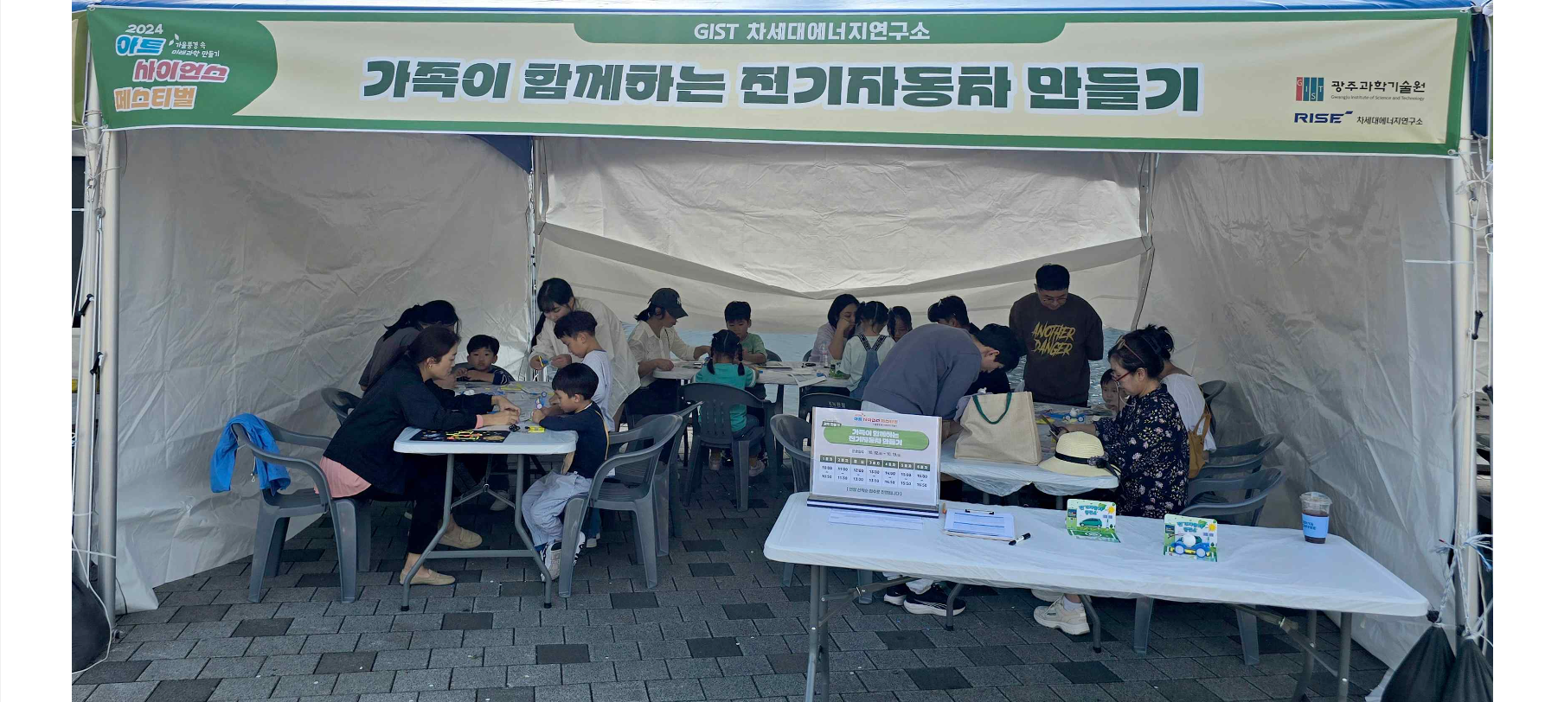▲ A view of the ‘Making Electric Cars with Your Family’ experience booth operated by the GIST Research Institute for Solar and Sustainable Energies at the ‘2024 Art Science Festival’ held at the Gwangju National Science Museum on October 12 and 13. Students, parents, and other citizens who visited the GIST experience booth on that day are experiencing the electric car manufacturing process firsthand.

The Gwangju Institute of Science and Technology (GIST, President Kichul Lim) announced that it successfully operated an ‘Eco-friendly electric vehicle making experience booth’ at the ‘2024 Art Science Festival: Creating Future Science in the Autumn Scenery’ held at the Gwangju National Science Museum last weekend.

The '2024 Art Science Festival' hosted by the Gwangju National Science Museum on Saturday, October 12th and Sunday, October 13th is an event that informs citizens of the importance of science through creative activities where science, technology, and art meet. This year, it was held under the theme of 'Creating Future Science in Autumn Scenery'.

About 200 students, parents, and other citizens who visited the ‘Making Electric Cars with Your Family’ experiential booth of the GIST Research Institute for Solar and Sustainable Energies (Director Sanghan Lee) had time to learn about the importance of energy storage science and technology and the possibility of applying it to real life.

A citizen who experienced the process of manufacturing an eco-friendly electric vehicle said, “I was able to feel the importance of realizing a carbon-neutral society by experiencing the operating principles and role of electric vehicles firsthand.”

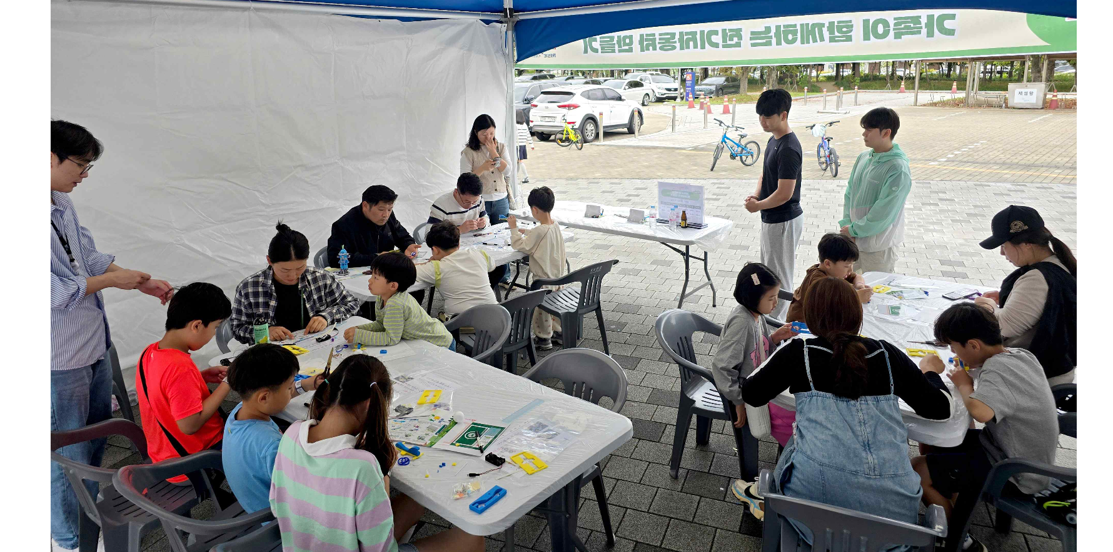▲ A view of the ‘Making Electric Cars with Your Family’ experience booth operated by the GIST Research Institute for Solar and Sustainable Energies

Director Sanghan Lee said, "GIST is leading the way in developing and disseminating eco-friendly energy technologies related to real life, and is widely informing citizens of the importance of science and technology. We will continue to strive to spread positive awareness of science and technology by developing eco-friendly energy content."

The GIST Research Institute for Solar and Sustainable Energies was established to develop core technologies that will drive the expansion of solar energy supply and industrial growth, and it is currently expanding its research scope to include not only solar energy and energy storage technologies but also core energy technologies for next-generation mobility and AI-based energy grid technologies.

In particular, the institute is leading innovation in the fields of organic solar cells and fuel cells, and is conducting international joint research by establishing the Heeger Center for Advanced Materials and the Ertl Center for Catalysis in collaboration with Nobel Prize winners in chemistry, Professor Alan Jay Heeger and Professor Gerhard Ertl, respectively. In addition, it is establishing a research foundation that transcends borders by collaborating with Imperial College London in the UK and the University of California, Santa Barbara in the US.

Meanwhile, GIST is operating the ‘GIST Science School’ through continuous cooperation with the Gwangju National Science Museum, and through this, is striving to expand the base of science and technology education and excellent research results. Such activities play an important role in increasing the local community’s understanding of science and technology and fostering future science and technology talents.



