GIST, NASA/JPL Scientist Invitation Seminar held introducing NASA satellite research and mission for soil moisture observation

- As part of the GIST-NASA research collaboration, through consultation with NASA Goddard Space Flight Center (GSFC), GIST periodically hosts seminars by inviting NASA/JPL researchers... This is the first
- Professor Hyunglok Kim of the School of Environment and Energy Engineering, who hosted the seminar, said, “We will build a soil moisture satellite data verification research facility in cooperation with NASA to secure water resource data to solve the climate crisis and food security.”

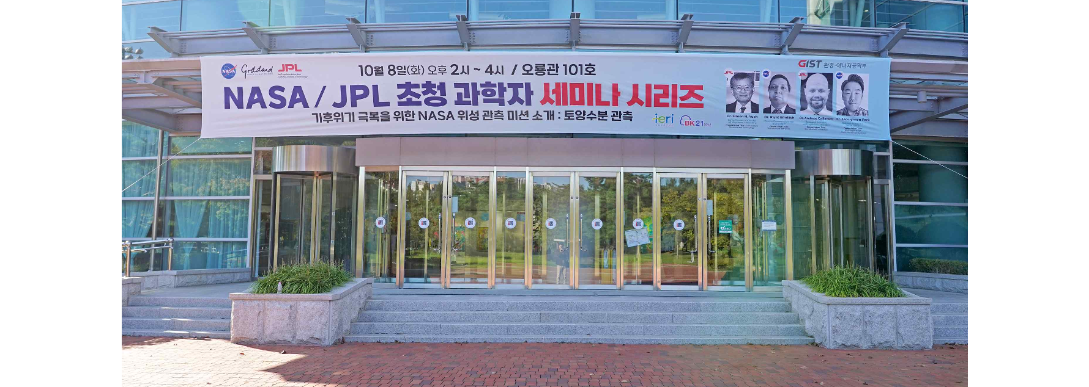▲ Panoramic view of the GIST Oryong Hall event hall where the NASA/JPL invited scientist seminar series was held

The Gwangju Institute of Science and Technology (GIST, President Kichul Lim) announced that the School of Environment and Energy Engineering (Dean Yunho Lee) hosted a seminar introducing research and missions related to NASA’s soil moisture observation satellite, inviting four scientists from NASA (National Aeronautics and Space Administration)/JPL (Jet Propulsion Laboratory) on Tuesday, October 8 at 2:00 PM in Oryong Hall.

The presenters and presentation topics are as follows: ▴ JPL Dr. Simon H. Yueh, ‘Soil Moisture Observation Mission and Technology’ ▴ JPL Dr. Andreas Colliander, ‘Soil Moisture Verification’ ▴ NASA Dr. Rajat Bindlish, ‘Soil Moisture Restoration’ ▴ NASA Dr. Jeonghwan Park, ‘NASA Work from a Korean Perspective’.

They visited GIST to discuss the establishment of a satellite data research facility and regional soil moisture monitoring system in the southern region of Korea.

Professor Hyunglok Kim of the School of Environment and Energy Engineering, who hosted the seminar, has been in contact with NASA for GIST-NASA research cooperation to correct and verify data sent by the SMAP (Soil Moisture Active Passive) satellite launched by NASA in 2015 to measure soil moisture across the entire Earth.

In particular, in consultation with the Hydrological Sciences Laboratory at NASA Goddard Space Flight Center (GSFC), GIST invited NASA/JPL researchers to hold seminars at GIST periodically, and this seminar is the first one. Professor Kim said, “We are planning to hold the second seminar in April next year.”

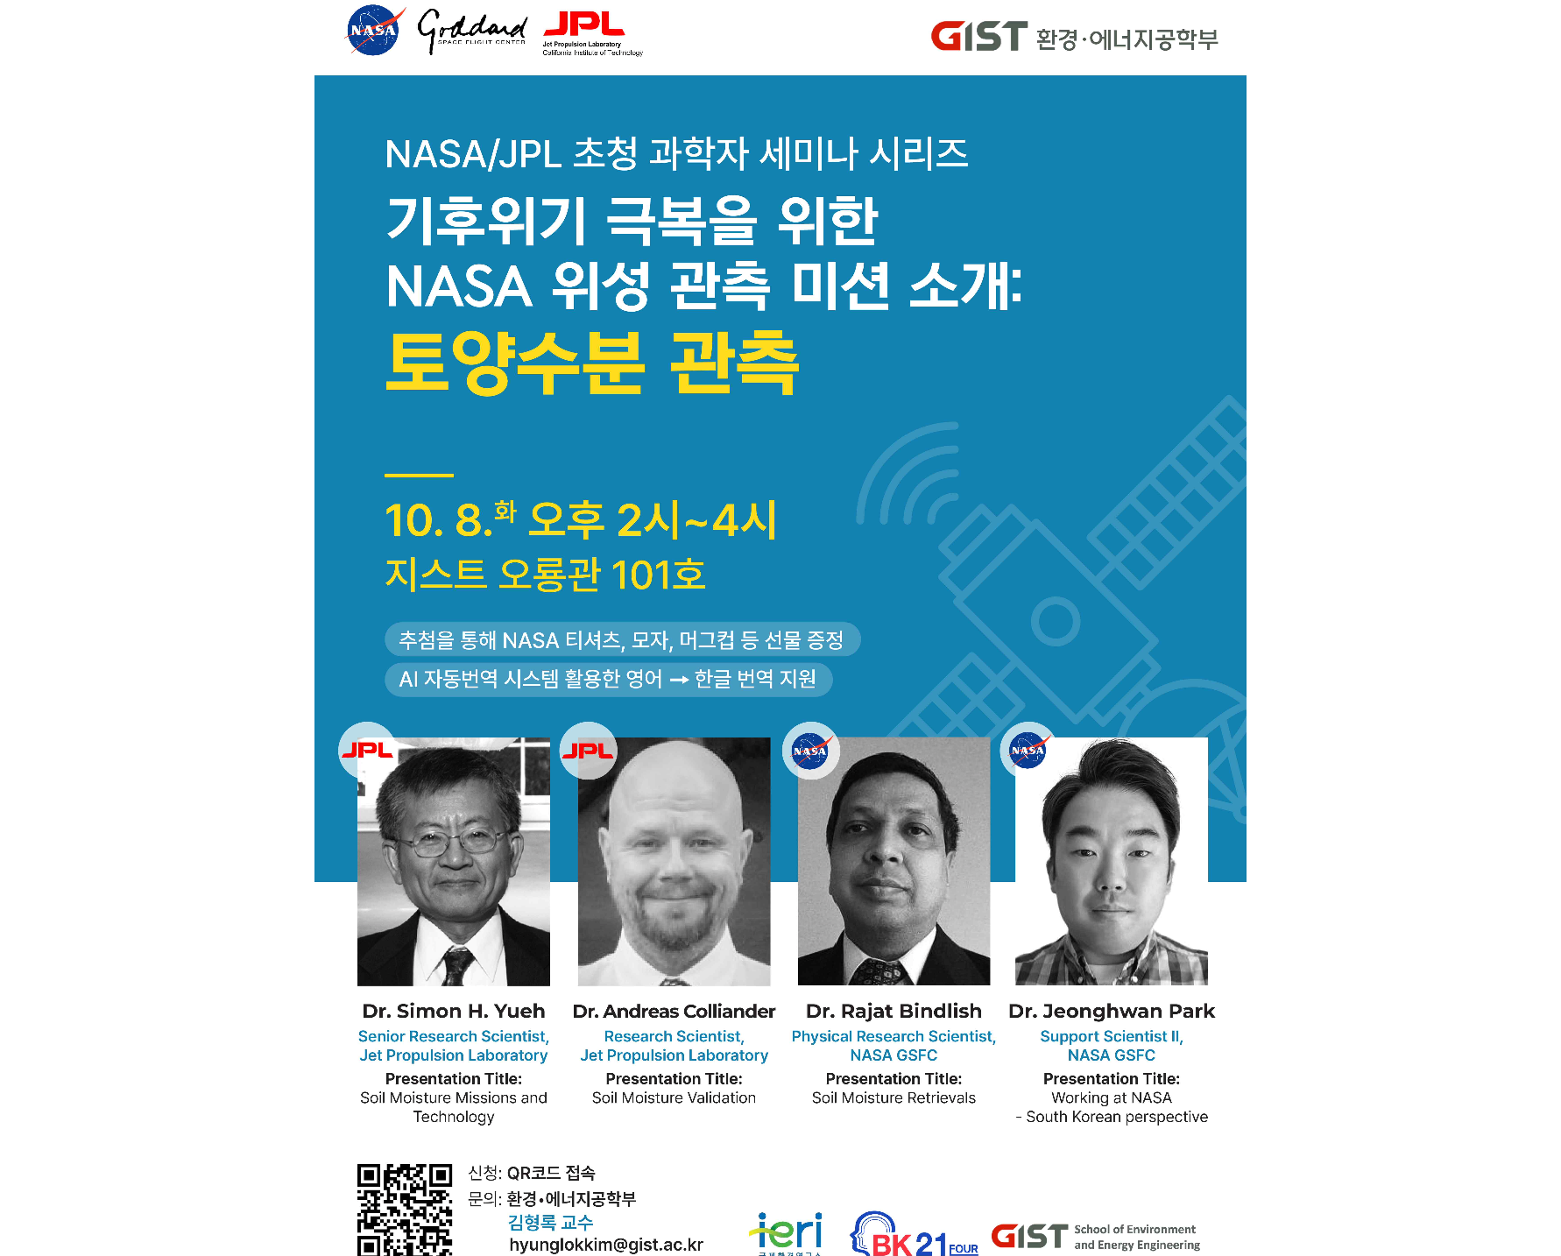▲ NASA / JPL Invited Scientist Seminar Poster

Soil moisture is an important data for predicting water availability, weather patterns, and natural disasters in climate change and hydrological studies, and it has a direct impact on agricultural productivity and food security. Monitoring it is also essential for effective water resource management and predicting natural disasters such as floods and droughts.

Professor Kim said, "Satellite-observed soil moisture data provide large-scale, consistent, and timely information that is difficult to obtain from ground-based measurements alone. NASA planned the SMAP satellite mission to develop effective strategies for water resource management and natural disaster preparedness."

He also said, "Currently, some soil moisture monitoring facilities exist in Korea, but they are operated at a point scale and provide limited data that cannot adequately reflect the wider agricultural landscape. The establishment of a satellite data verification research facility and region through GIST-NASA research collaboration will overcome these limitations and enable the collection of comprehensive data reflecting spatial variability." This will provide reliable water satellite data needed to address climate crises and food security.

In this seminar, the English-speaking presenters’ presentations will be translated in real time by an AI automatic translation system and provided with Korean subtitles. To pre-register for the seminar, access the QR code on the event poster, and NASA souvenirs such as T-shirts, hats, and mugs will be given away through a raffle for participants.



