"Pioneering a new field where existing medicines do not belong" GIST opens AI-based large molecule research center and begins building a global base for innovative new drug development

- The opening ceremony of the 'AI-based Large Molecule Research Center' led by Professor Jin Hee Ahn of the Department of Chemistry on the 26th (Thursday)... Pioneering the 'large molecule' field that does not include small molecule drugs (such as aspirin) or large molecule drugs (such as vaccines)
- Based on research funding of approximately KRW 50 billion over the next 10 years, the goal is to develop an innovative new drug, an antibody-drug conjugate (ADC), through large molecule research using AI technology... Participation of global researchers from various fields

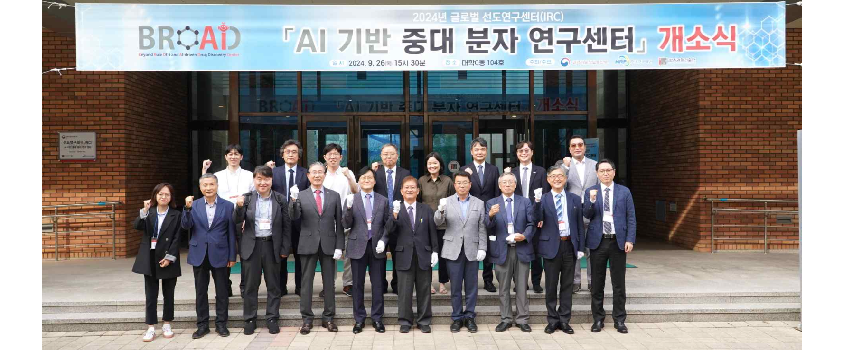▲ On Thursday, September 26, GIST held an opening ceremony for the AI-based Large Molecule Research Center in Building C of the university, and attendees took a commemorative photo.

The Gwangju Institute of Science and Technology (GIST, President Kichul Lim) held an opening ceremony for the ‘AI-based Large Molecule Research Center (Director: Jin Hee Ahn, Professor of Chemistry)’ for the development of large molecule new drugs based on artificial intelligence (AI) and announced that it will begin in earnest the establishment of a global center for the development of innovative new drugs.

The event was held on Thursday, September 26th at 3 PM in Lecture Room 104 of Building C of GIST with the attendance of approximately 100 experts from industry, academia, research, and government, including GIST President Kichul Lim, Ministry of Science and ICT Basic Research Policy Director Hyun-joon Kwon, National Research Foundation of Korea Basic Research Director Hyeok-mo Lee, Natural Sciences Director Tae-gyu Ahn, Engineering Director No-cheol Park, Gwangju Technopark Director Young-jip Kim, and Artificial Intelligence Industry Convergence Business Group Director Sang-jin Oh.

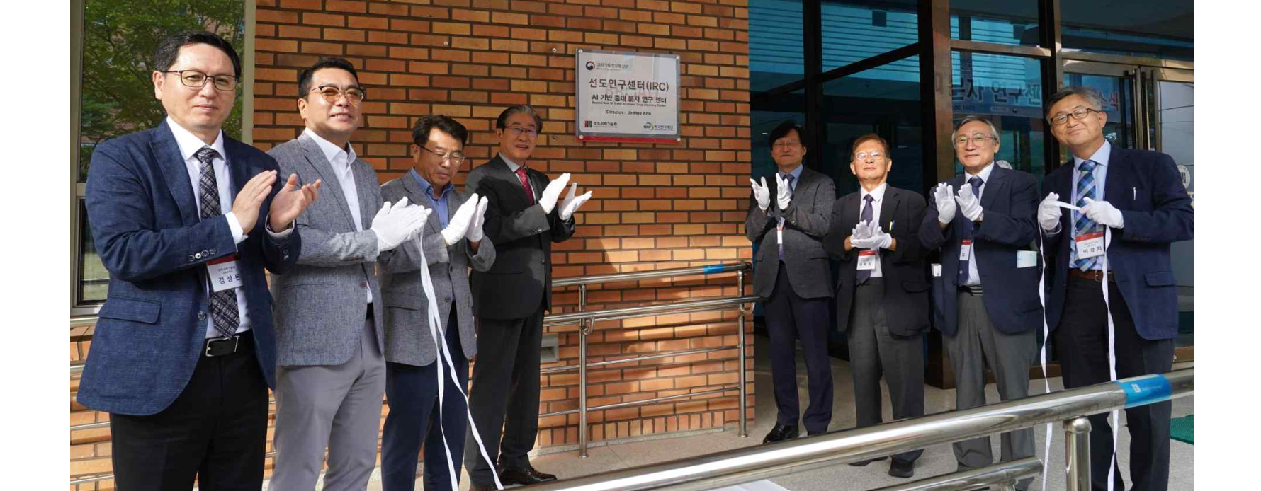▲ GIST is unveiling a plaque at the opening ceremony of the AI-based Large Molecule Research Center on Thursday, September 26.

The ‘AI-based Large Molecule Research Center’, selected for the ‘2024 Global Leading Research Center (IRC) Support Project’ hosted by the Ministry of Science and ICT, aims to develop an innovative new drug, an antibody-drug conjugation (ADC), through large molecule research* using AI technology.

The host organization, GIST, is expected to receive a budget of approximately 50 billion won over the next 10 years, and researchers from various fields, including global research institutes, will participate to develop innovative new drugs.

GIST plans to build a large molecule platform with an open innovation strategy, conduct research on original technologies based on this platform, and promote the development of new drugs.

* large and medium-sized molecule research: The pharmaceuticals developed so far are classified into small molecule compounds with a molecular weight of 500 or less (small molecule or rule of 5 region) or large molecule pharmaceuticals (or biopharmaceuticals) such as antibodies and protein drugs. The medium and large molecule region (beyond rule of 5 region or rule breaker region) located in the middle of these two is attracting attention as a new field that requires development.

President Kichul Lim said in his congratulatory speech, "Director Jin Hee Ahn, who will lead the center, has not only achieved remarkable results in the field of new drug development, but he also has a broader perspective and higher vision than anyone else while managing a start-up company based on R&D results. We will spare no support for the successful promotion of this project with all the capabilities accumulated over the past 30 years and GIST's unique spirit of innovation to build the world's best AI-based new drug development research infrastructure and secure global leading technologies."

▲ GIST President Kichul Lim is giving a congratulatory speech at the opening ceremony of the AI-based Large Molecule Research Center.

Director Jin Hee Ahn said, "Beyond Gwangju and Jeonnam, this will be an opportunity for Korea to lead AI-based innovative new drug technology in the advanced bio field. Through this project, it is expected that we will be able to foster excellent talent and create a sustainable research environment, thereby strengthening global competitiveness in related fields."

▲ Director Jin Hee Ahn (Professor of Chemistry) introduces the AI-based major molecule research center at the opening ceremony.

Meanwhile, the Ministry of Science and ICT announced the results of the selection of the ‘Global Leading Research Center’, which supports the best research groups in the country among basic research projects, on July 25.

Among these, the ‘Innovative Research Center (IRC)’, which started last year to foster research groups in 12 national strategic technology fields, has presented an unprecedented measure of supporting research expenses of up to 5 billion won per year for up to 10 years, and the ‘AI-based Large Molecule Research Center’, where Professor Jin Hee Ahn of the GIST Department of Chemistry serves as the principal investigator, was selected in the advanced bio field.



