GIST, Wando-gun to cooperate on industrial technology for seaweed bio specialization and nurture local talent

- President Kichul Lim and County Governor Woo-cheol Shin attended the MOU signing ceremony held at Wando County Office on Wednesday the 25th... Agree to cooperate in 4 areas: fostering local industries, discovering related projects, educational cooperation, and nurturing talent
- Promoting smart factories for the development of marine bio-industry and fostering related industries... “Expecting high added value creation through the fusion of Wando County’s marine resources and GIST’s advanced bio and AI research capabilities and infrastructure”

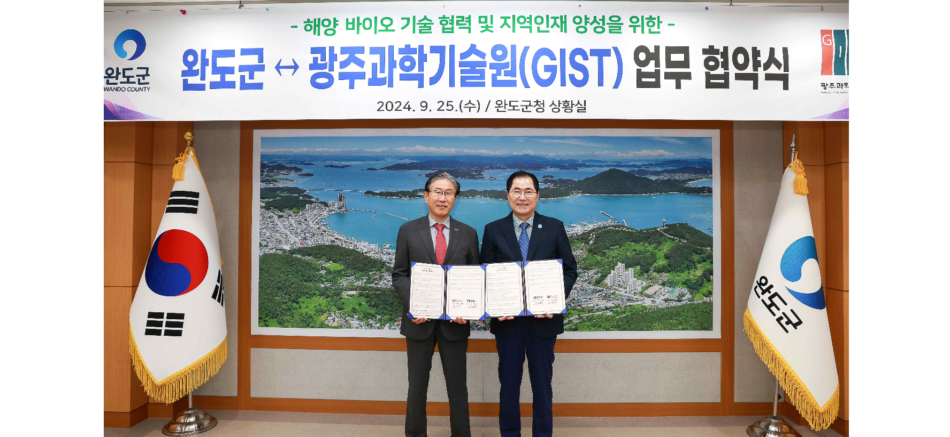▲ GIST and Wando-gun signed a business agreement (MOU) for technical cooperation in the seaweed bio-specialized industry and fostering local talent, and (from the left) GIST President Kichul Lim and Wando County Governor Woo-cheol Shin are taking a commemorative photo.

The Gwangju Institute of Science and Technology (GIST, President Kichul Lim) announced that it signed a memorandum of understanding (MOU) with Wando-gun, Jeollanam-do (Governor Woo-cheol Shin) to establish a mutual cooperation system through technological cooperation in the marine algae bio-specialized industry and fostering of local talent.

The signing ceremony was held on Wednesday, September 25th at Wando County Office with about 10 people in attendance, including GIST President Kichul Lim, Vice President for Public Affairs Yonghwa Chung, International and Public Affairs Dean Jae Gwan Kim, Professor Mi-Sun Jin of the School of Life Sciences, and Wando County Mayor Woo-cheol Shin and Deputy Mayor Hyeon-cheol Kim.

The main contents of the agreement include: ▴ Fostering regional industries: Education and technology cooperation for attracting specialized industries in the seaweed bio sector, etc. ▴ Discovering linked projects: Joint cooperation for discovering government 4th industrial revolution linked agriculture, fisheries, and livestock industries projects and selecting public offering projects ▴ Education cooperation: Joint cooperation for educational development and local talent development in Wando-gun ▴ Talent development: Cooperation in opening GIST Techno Management Business Academy (GTMBA) curriculum and selecting scholarship students, etc.

President Kichul Lim said, "Let's join forces to create even higher added value and enhance competitiveness by combining GIST's advanced bio and artificial intelligence research capabilities and infrastructure with the marine resources of Wando-gun, the number one seaweed producing area in Korea. In particular, if GIST's excellent life science research team establishes a hotline and cooperates closely, it will greatly contribute to Wando-gun's industrial development as well as its financial independence."

Wando County Governor Woo-cheol Shin said, "Wando-gun, which is the first in Korea to promote the ‘marine healing industry’ and ‘marine bio industry’ as future new growth engine businesses, is expected to promote the ‘smart factory’ for sustainable development of the marine bio industry and foster related industries through cooperation with GIST, which has excellent research capabilities and technological prowess, as well as joint growth of both organizations."

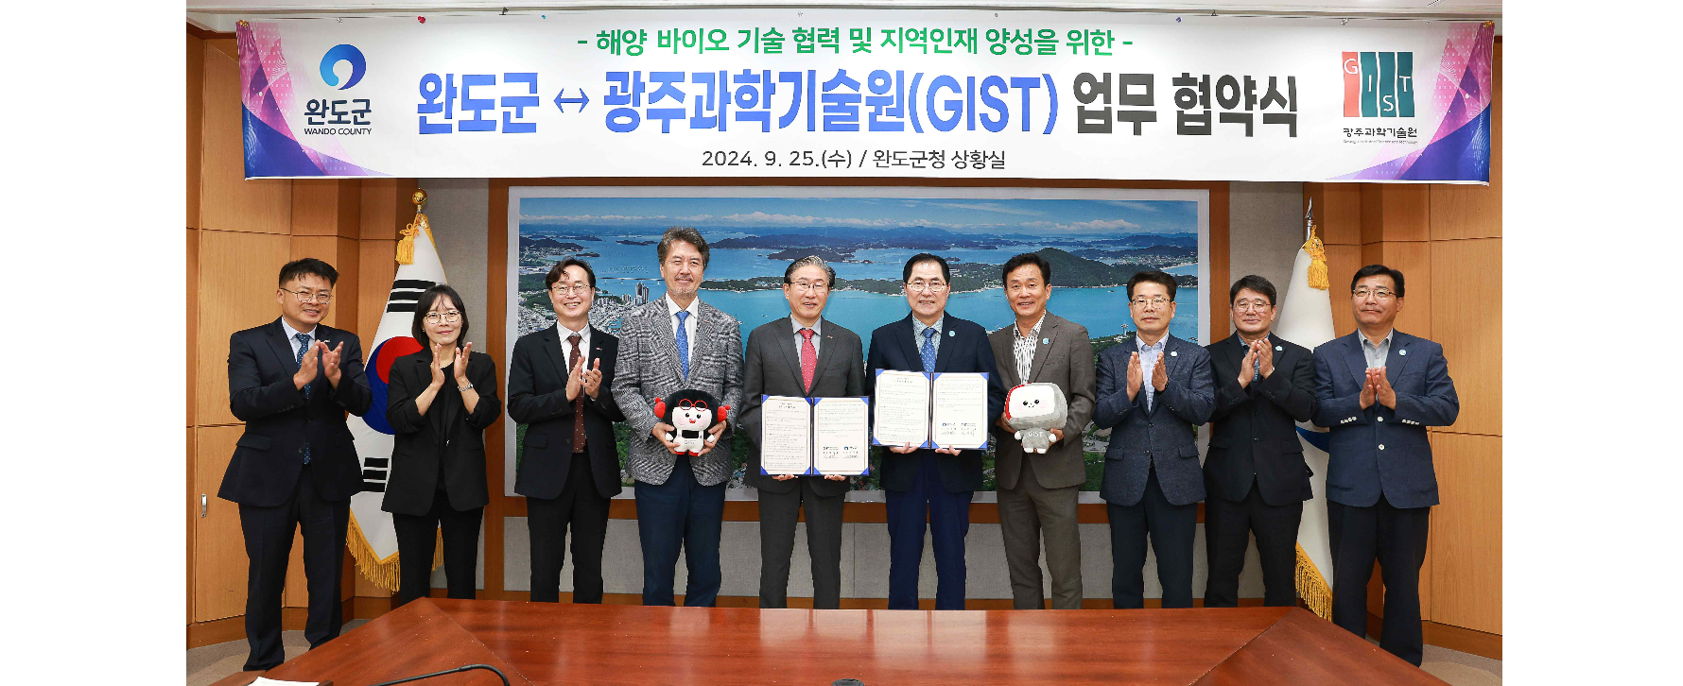▲ GIST and Wando County signed a business agreement (MOU) for technical cooperation in the seaweed bio-specialized industry and training of local talent, and attendees are taking a commemorative photo.

Meanwhile, starting with Suncheon-si, Jeollanam-do, GIST signed MOUs with 10 cities and counties including Jangseong-gun, Goheung-gun, Yeongam-gun, Gwangyang-si, Jangheung-gun, Haenam-gun, Damyang-gun, Hwasun-gun, and Wando-gun this year, establishing a large-scale education and research cooperation network covering the Jeollanam-do region. To date, 14 full-time faculty members whose fields of research and targeted intensive development are aligned with those of the nine cities and counties have been designated as ‘Science and Technology Innovation Ambassadors’ and are continuing practical cooperation.



