GIST awards scholarships to 5 local talents from the Jeongwon Scholarship Welfare Foundation

- Chairman Yongman Kim donates 10 million won to GIST for the second year in a row for the Jeongwon Scholarship Fund... “I will be a strong supporter to help talented individuals achieve their dreams.”

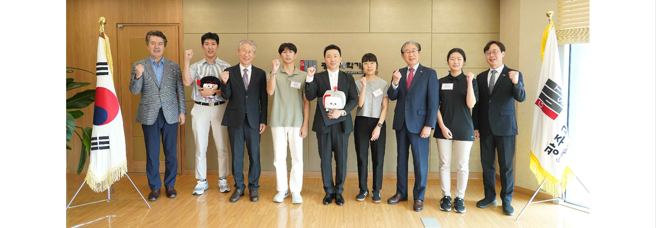▲ The ‘Jungwon Scholarship Welfare Foundation Scholarship Award Ceremony’ is being held and a commemorative photo is being taken with 9 people including President Kichul Lim, Vice President for Public Affairs Yonghwa Chung, and International and Public Affairs Dean Jae Gwan Kim in the President’s Office on the 5th floor of the GIST Administration Building. (Center of photo) Chairman Yongman Kim of the Jeongwon Scholarship Welfare Foundation and GIST President Kichul Lim (third from the right)

The Gwangju Institute of Science and Technology (GIST, President Kichul Lim) announced on Monday the 23rd that it had selected the ‘1st Jeongwon Student’ with the scholarship fund donated by Chairman Yongman Kim of the Cheongsong Academy of Soongdeok High School in Gwangju through the Jeongwon Scholarship Welfare Foundation, and held a scholarship certificate award ceremony.

The Jeongwon Scholarship is a local talent development scholarship that selects five GIST students each year who graduated from elementary, middle, and high schools in Gwangju and have excellent academic performance, and provides 2 million won per person.

The award ceremony was held in the President’s Office on the 5th floor of the Administration Building with the attendance of President Kichul Lim, Vice President for Public Affairs Yonghwa Chung, International and Public Affairs Dean Jae Gwan Kim, officials from the Jeongwon Scholarship Welfare Foundation, and selected scholarship recipients.

The Jeongwon Scholarship Welfare Foundation was established in March 2000 by Mr. Gil-su Kim, the founder of Cheongsong Academy and Sungdeok High School, to honor the noble will of his parents and has since been consistently carrying out scholarship and social welfare projects.

In particular, as part of social welfare projects, they are practicing the spirit of sharing by donating money and goods to the disabled, orphans, single-parent families, multicultural families, underprivileged youth, elderly people without support, and their protection facilities.

After the inauguration of the second Chairman, Yongman Kim, the scholarship and business welfare projects were further expanded and the Jeongwon Scholarship has been donated to GIST for the second year.

Yongman Kim, the chairman of the Jeongwon Scholarship Welfare Foundation, said, "I decided to donate because I wanted to encourage excellent science and technology talents in the region and help them grow into even greater talents. I will become a strong supporter of not only GIST students but also excellent talents in the region to help them achieve their dreams."

President Kichul Lim said, "We will do our best to create an environment where GIST students can focus on their studies so that they can understand the chairman's intentions, lead the scientific and technological research and development in the region, and contribute greatly to the development of science and technology in our country."



