"Autonomous robot follows along at the right speed and guides the exhibition" GIST develops personalized exhibition viewing concierge service for the visually impaired

- Korea Culture Technology Institute, demonstration service conducted at Gwangju Seogwang School for 3 days from Monday, September 23... Attaching a haptic device to an autonomous driving robot to guide the viewing route and adjust the driving speed according to walking speed
- “Development of technology to improve accessibility for the visually impaired to viewing cultural and artistic exhibitions”... Personalized exhibition viewing concierge service for the visually impaired to be operated at the National Gwangju Science and Technology Museum in 2025

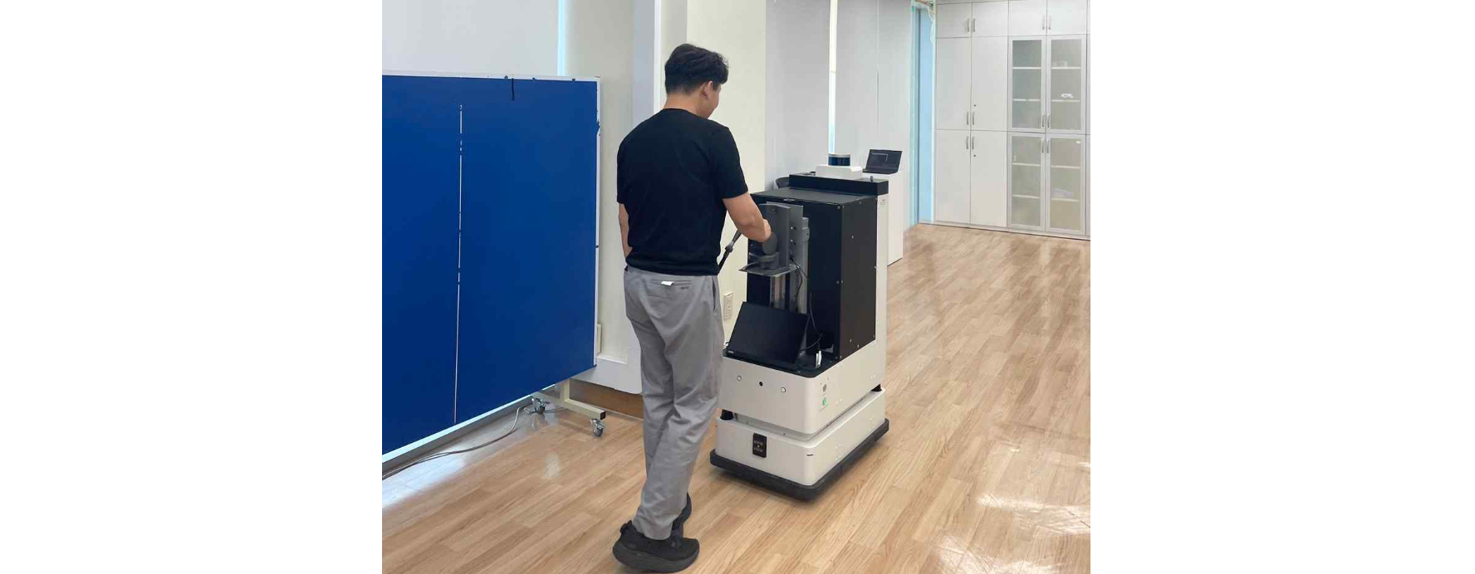▲ A teacher at Gwangju Seogwang School is moving along the exhibition route using an exhibition guide robot.

As social consensus is being formed to expand the cultural enjoyment rights of the disabled, the Gwangju Institute of Science and Technology (GIST, President Kichul Lim) is also making efforts to create new cultural enjoyment and cultural technology services for the visually impaired, centered around the Korea Culture Technology Institute (Director Kim Kyung-joong), which opened in 2013.

Last April, the institute signed a business agreement with Gwangju Seogwang School (Principal Seon-mi Kim), a special school for the visually impaired, and is currently developing technologies to improve accessibility for the visually impaired when viewing exhibitions: ▴ personalized exhibition guidance services based on the characteristics of visitors, and ▴ exhibition experience service technologies through tactile interaction.

The institute announced that it will be implementing a ‘personalized exhibition viewing concierge demonstration service’ for visually impaired students for three days from Monday, September 23rd to Wednesday, September 25th in the auditorium on the 4th floor of the main building of Gwangju Seogwang School.

In this demonstration service, autonomous driving robots developed by Twiny Inc., a specialized autonomous driving robot development company, are equipped with haptic devices to guide the viewing path so that visually impaired people can move comfortably within the exhibition space, and mobility accessibility support technology that can adjust the driving speed according to the individual's walking speed is presented.

In addition, the exhibition content based on representative relics of the Silla period was created using an authoring tool that links the exhibition hall's spatial information and exhibit data, and uses user profile recognition technology to guide the exhibition in a personalized manner while providing information on the artwork in voice form.

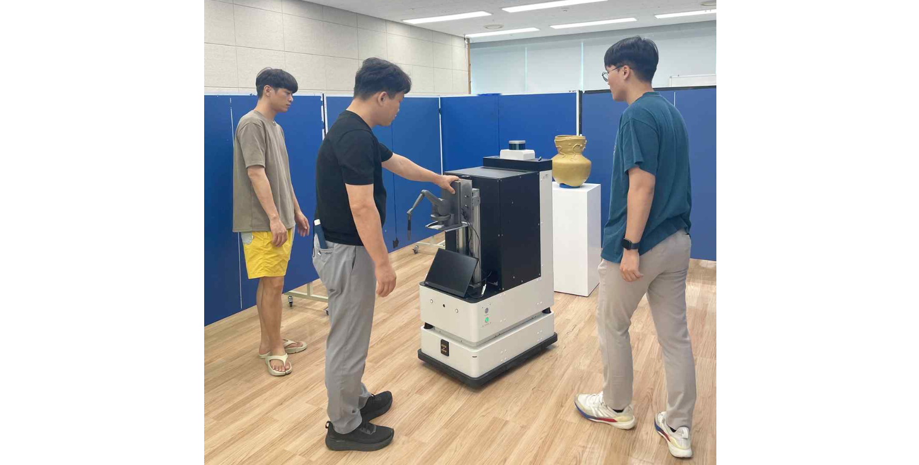▲ A teacher at Gwangju Seogwang School is using a personalized exhibition viewing demonstration service.

Professor Jung Won Yoon of the School of Integrated Technology, who is the research director, said, "The purpose of the demonstration service being conducted at Gwangju Seogwang School this time is to implement a service to improve the accessibility of cultural and artistic exhibitions for the visually impaired. Based on the advanced technology that verified the usability of the research results, a personalized exhibition viewing concierge service will be provided for visually impaired visitors at the National Gwangju Science Museum in 2025."

This service is part of a research and development project of the Ministry of Culture, Sports and Tourism conducted by the Korea Culture Technology Institute (Project name: Development of personalized exhibition viewing concierge service technology for the visually impaired, Project period: 2023.08.01.~2025.12.31.). Research and development has been conducted in collaboration with Twiny Co., Ltd., a joint research institute, for the past year.

Meanwhile, the Korea Culture Technology Institute was established at GIST as a cultural technology research institute in accordance with Article 17-5 of the Cultural Industry Promotion Act (Designation of Cultural Technology Research Institutions Affiliated with the Ministry of Culture, Sports and Tourism, etc.). It is currently carrying out numerous projects, including cultural technology research and development policy-designated tasks, and is focusing on core cultural technology research and development to drive the development of the national cultural industry.



