GIST Department of Semiconductor Engineering Consortium selected for Ministry of Science and ICT's 'Semiconductor Advanced Packaging Specialist Training Project'

- Establishing an educational system covering all areas of advanced semiconductor packaging led by 6 faculty members from the Department of Semiconductor Engineering at GIST, training master’s and doctoral level experts to lead innovation... Total project cost of 10.5 billion won for 7 years
- Training practical business talents in conjunction with the ‘AI Semiconductor Advanced Post-processing Specialized Fab’ currently under construction at GIST... “We will do our best so that Gwangju Metropolitan City can establish itself as the center of the advanced semiconductor packaging industry.”

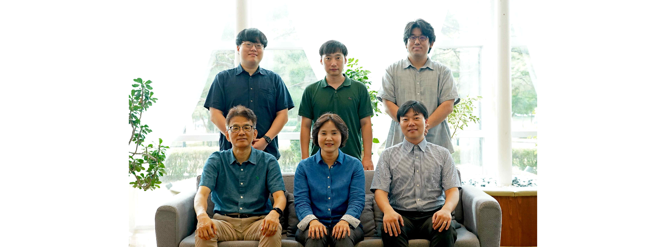▲ (Counterclockwise from the left in the front row) GIST Department of Semiconductor Engineering Dean Dong-Seon Lee, Project Manager Professor Hyeon-Jin Shin, Project Practitioner Professor Hoon Hahn Yoon, Professor Hyeon-Ho Jeong, Professor Il-Min Yi, and Professor Dong-Ho Kang

The Gwangju Institute of Science and Technology (GIST, President Kichul Lim) announced on the 12th that it had been selected for the ‘2024 Science and Technology Innovation Talent Training Project (Semiconductor Advanced Packaging Specialist Training Project)’ promoted by the Ministry of Science and ICT.

The Ministry of Science and ICT announced the results of the selection of the ‘Semiconductor Advanced Packaging Specialist Training Project’ to train professionals in the ‘advanced packaging’ field, which has recently emerged as a new topic in the semiconductor technology competition, on July 31. A consortium led by Chosun University and including GIST, Chonnam National University, Inha University, and 18 advanced packaging mid-sized and small companies was selected and will receive a total project cost of KRW 10.5 billion for 7 years starting in July 2024.

GIST will establish an education system that covers all areas of advanced semiconductor packaging, including ▴ materials, components, and equipment, ▴ process and system, ▴ design and simulation, and ▴ reliability testing and analysis, with six faculty members from the Department of Semiconductor Engineering as the core (participating professors: Department Head Dong-Seon Lee, Professors Hyeon-Jin Shin, Hoon Hahn Yoon, Dong-Ho Kang, Il-Min Yi, and Hyeon-Ho Jeong). They will also develop practical courses by track, such as basic major, specialized major, and convergence major.

Furthermore, we plan to foster customized professional manpower and conduct industry-academia cooperation research projects that reflect the needs of industrial sites through the contract garden system.

In particular, GIST is currently building a 5,520m² (fab-only 3,312m²) AI semiconductor advanced post-process specialized fab with an investment of KRW 39.05 billion (KRW 26.65 billion from the national budget and KRW 12.4 billion from the local budget) for the development of next-generation artificial intelligence (AI) semiconductors, including ‘chiplet heterogeneous integration’ and ‘fan-out packaging’, and plans to link it with the ‘Semiconductor Advanced Packaging Specialist Training Program.’

This is a strategy to establish a master's and doctoral degree training system specialized in semiconductor advanced packaging to secure global competitiveness in advanced industries by providing the best education and research environment that can foster practical talents that companies need.

Professor Hyeon-Jin Shin, who was in charge of the research, said, "With this project selection, we expect that GIST graduate students will have a greater opportunity to acquire advanced semiconductor packaging technology and gain practical experience. We will do our best to serve as a bridgehead so that Gwangju Metropolitan City can become the center of the advanced semiconductor packaging industry through cooperation with participating companies."

Meanwhile, the ‘Semiconductor Advanced Packaging Specialist Training Program’ is a professional training program run by the Ministry of Science and ICT to foster advanced human resources with master’s and doctoral degrees in advanced packaging fields such as ▴materials, parts, and equipment (SMB), ▴ process and system, ▴ design and simulation, and ▴ reliability testing and analysis, in order to strengthen the competitiveness of packaging design, foundry, assembly, and inspection (OSA) in line with the advancement of semiconductor post-processing.

From this year to 2031, a total budget of 24 billion won will be invested to select a consortium of competitive universities, companies, and research institutes to establish one ‘Advanced Packaging Specialist Training Center’ this year and one next year.

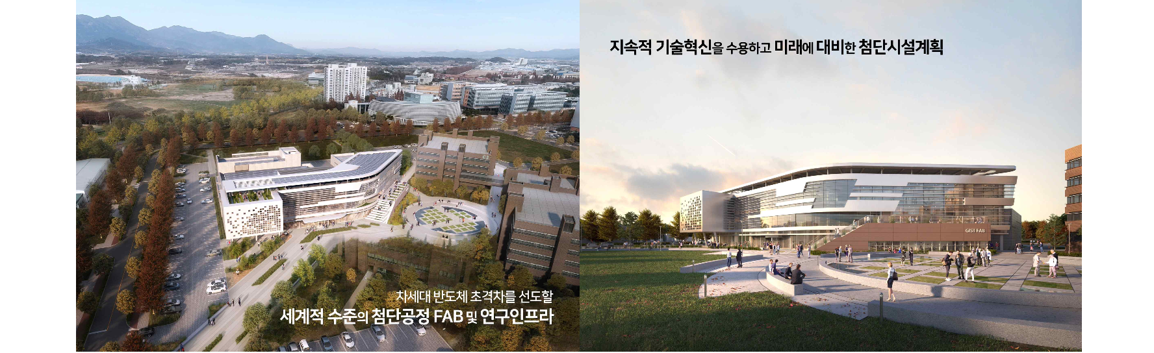▲ A perspective drawing of the 39.05 billion won, 5,520m² artificial intelligence semiconductor advanced post-processing specialized fab currently under construction in the GIST Department of Semiconductor Engineering. (Scheduled for completion in 2026)

This year, a consortium led by Chosun University and involving GIST, Chonnam National University, Inha University, and 18 advanced packaging SMEs was selected, and the goal is to establish a ‘Center for Training Advanced Packaging Specialist’ at Chosun University to produce more than 30 master’s and doctoral graduates by 2027 and more than 60 between 2028 and 2030.



