“A feast of cheerful colors, creatures in Utopia” GIST Oryong Art Hall, Haeseong Kim’s invitational exhibition ‘Flower Friends’

- GIST Oryong Art Hall, 5th Invitational Exhibition in 2024... About 50 works by artist Haeseong Kim, conveying the vitality of nature, to be exhibited for about two months until Friday, November 1
- “It will be a time to feel the harmony of life in nature and the inner childlikeness”... GIST Oryong Art Hall, as an ‘open cultural and artistic space’, open on Saturdays for communication with the local community and for the convenience of viewing

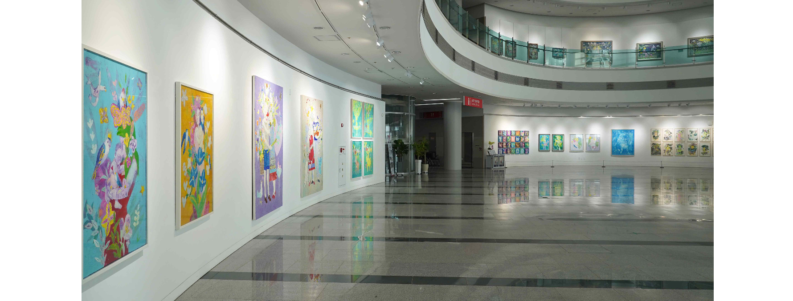▲ Panoramic view of Oryong Art Hall where the 5th exhibition ‘Flower Friends’ of Oryong Art Hall 2024 is being held

Artist Haeseong Kim's exhibition 'Flower Friends', which has continuously attempted to explore the relationship between humans and nature, will be held at the Gwangju Institute of Science and Technology (GIST, President Kichul Lim) from Monday, September 9 to Friday, November 1.

This exhibition is the fifth invitational exhibition held at Oryong Art Hall this year, and it displays around 50 works that embody artist Haeseong Kim's dream of a utopia filled with love, happiness, peace, and joy, using a unique, fantastical, and rhythmic painting style.

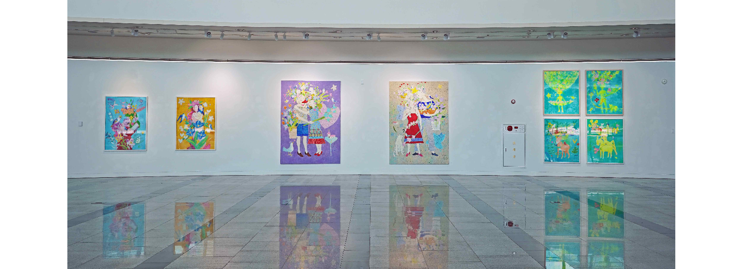▲ The lobby on the first floor of Oryong Art Hall, where the 5th exhibition ‘Flower Friends’ of Oryong Art Hall 2024 is being held

In the utopia realized by artist Haeseong Kim, people who are in harmony with animals, flowers, and plants appear. In particular, girls adorned with flowers representing the theme of the invitational exhibition greet visitors to the exhibition with bright smiles. In artist Haeseong Kim’s works, flowers, birds, butterflies, the moon, stars, and other nature, innocent children, and boys and girls with dreams are all friends and beings who are in harmony with each other.

Through these works, viewers experience visual beauty and enjoyment, while also thinking once again about the utopia that artist Haeseong Kim dreams of, where nature and people are in harmony.

Artist Haeseong Kim said, "I worked on the dream of a paradise-like Earth where all beautiful things coexist and sing together. I hope that those who visit the exhibition will also have a happy and peaceful time through the paintings that contain a world where life is in harmony."

Kim, who graduated from Chosun University's College of Fine Arts and its Graduate School of Fine Arts, served as an operating committee member and judge for the Republic of Korea National Art Exhibition and is currently a full-time professor at Chosun University's Lifelong Education Center and a member of the Korean Fine Arts Association and Line and Color and has held 33 solo exhibitions and participated in over 650 group exhibitions.

As a local veteran artist, Kim has been presenting works that contain the theme of coexistence between humans and nature and has also recently attempted a new method of digital painting, which involves overlaying digital images on drawings, and has been praised for introducing a new artistic field called digital painting.

Soon-im Choi, the director of Oryong Art Hall, said, "The world in Haeseong Kim's works is bright and cheerful. I hope this will be a time to feel the harmony of life in nature and the childlike innocence within through the fantasy and rhythm unique to Haeseong Kim's works."

In order to further strengthen its function as an ‘open cultural and artistic space,’ Oryong Art Hall is opening on Saturdays starting in July. The ‘Flower Friends’ exhibition, which will be held at GIST Oryong Art Hall until November 1, is open to anyone interested from 9:00 a.m. to 6:00 p.m. on weekdays and 10:00 a.m. to 5:00 p.m. on Saturdays. (Exhibition inquiries/T.062-715-2628)

‘I am implementing a utopia that encourages emotions of love, happiness, peace, and joy that anyone can relate to through my paintings, and the materials and objects that appear provide visual beauty and enjoyment. Just looking at them makes you feel happy, joyful, and peaceful. This is because the main characters are natural materials such as flowers, which are synonymous with beauty, as well as innocent children and boys and girls with many dreams… (omitted) The natural beauty of relationships that love, harmonize, and achieve harmony with each other, and those symbolic materials, are truly a message of salvation for this world.’ - From the artist’s note

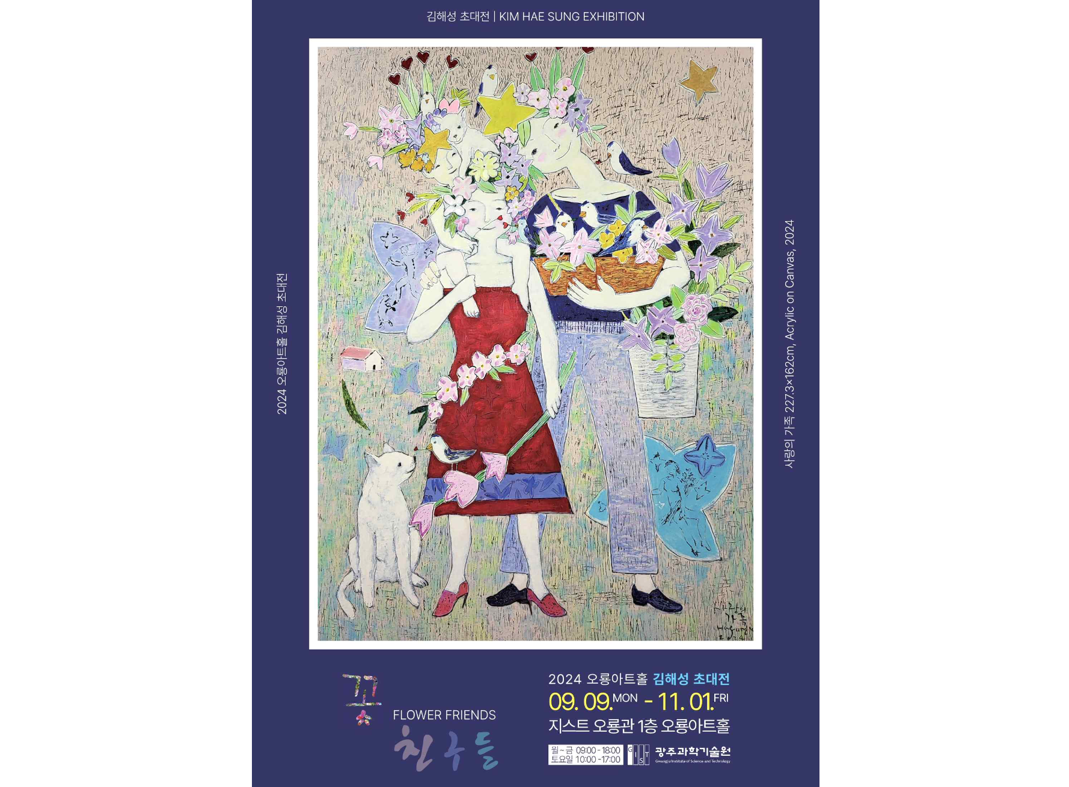▲ 2024 Oryong Art Hall 5th Exhibition ‘Flower Friends’ Poster



