Table tennis robot·EMS development...
GIST successfully held creative convergence competition for fostering convergence talents

- 35 people from 11 teams out of 21 teams that applied from all over the country participated... University students who gave up their vacations to develop table tennis robots and algorithms competed fiercely for two months
- Held annually to foster talent in convergence technology fields such as artificial intelligence and next-generation energy-based technologies, this is the 8th year

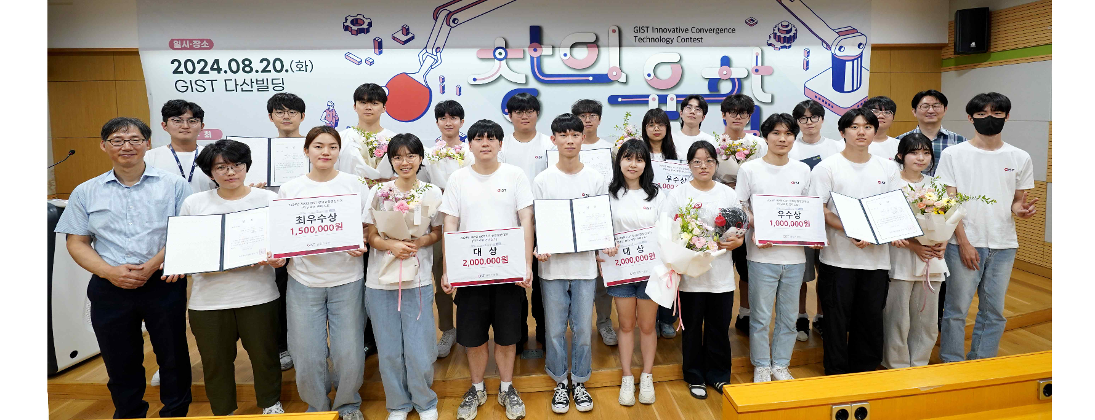▲ Participants and officials are taking a commemorative photo at the ‘2024 Creative Convergence Competition’ awards ceremony hosted by the GIST School of Integrated Technology.

College students across the country gave up their vacations to develop table tennis robots and a campus energy management system (EMS).

The Gwangju Institute of Science and Technology (GIST, President Kichul Lim) announced that the School of Integrated Technology (Dean Jung Won Yoon) held the awards ceremony for the ‘8th Creative Convergence Competition’ on Tuesday, August 20, successfully concluding the approximately two-month competition schedule.

This competition, which began in 2017, is now in its 8th year with the aim of fostering talents with creative and convergent thinking skills required in the era of the 4th Industrial Revolution, including artificial intelligence, intelligent robots, virtual environments, healthcare, and next-generation energy-based technologies.

In particular, GIST School of Integrated Technology professors and graduate student researchers serve as mentors for each team, providing practical assistance such as on-site guidance and advice, establishing it as a venue for students to freely express their creativity and implement innovative ideas. In addition, 3-4 participating college students form a team and conduct joint research, providing an opportunity to foster cooperation and group creativity.

Professors from the School of Integrated Technology, who are experts in each field including robot hardware, robot interface, and artificial intelligence, directly gave lectures, and the school also provided full support at the school level, including experimental/practical training technical support by graduate school teaching assistants assigned to each team, support for material costs, and support for space and dormitories, so that participants could focus on the competition.

This year’s competition, which took place from June 24 to August 20 for approximately two months, involved 35 undergraduate students from 9 universities in Korea (GIST, KAIST, Kyunghee University, Pusan National University, Sookmyung Women’s University, Soongsil University, Yonsei University, Chonnam National University, and Hanbat National University) forming 11 teams, and was divided into two tracks: the ‘Table Tennis Robot Contest’ and the ‘Campus Energy Management System (EMS)* Development Contest.’ The participating students gave up their summer vacations to focus on developing innovative table tennis robots and algorithms for the competition.

* energy management system (EMS): This refers to a company-wide energy management system that sets energy efficiency improvement goals and systematically and continuously promotes a management system according to certain procedures and techniques to achieve them.

In order to increase the completeness of the works and the concentration of the competition, the GIST Creative Convergence Competition is introducing new and diverse methods that are unique to the competition by conducting the final round in a tournament format after verifying basic functions in the preliminary round.

The ‘Table Tennis Robot’ category was conducted in a way that the rankings were competed by performing challenge problems, with a table tennis robot hitting a table tennis ball coming out of a table tennis machine and a match between a table tennis robot and a participating student.

The ‘Campus EMS Development’ category was a contest to develop a load prediction algorithm, solar power generation prediction algorithm, and electricity bill minimization algorithm based on data provided by the School of Integrated Technology. The rankings were determined by calculating the load prediction error rate, solar power generation error rate, and electricity bill.

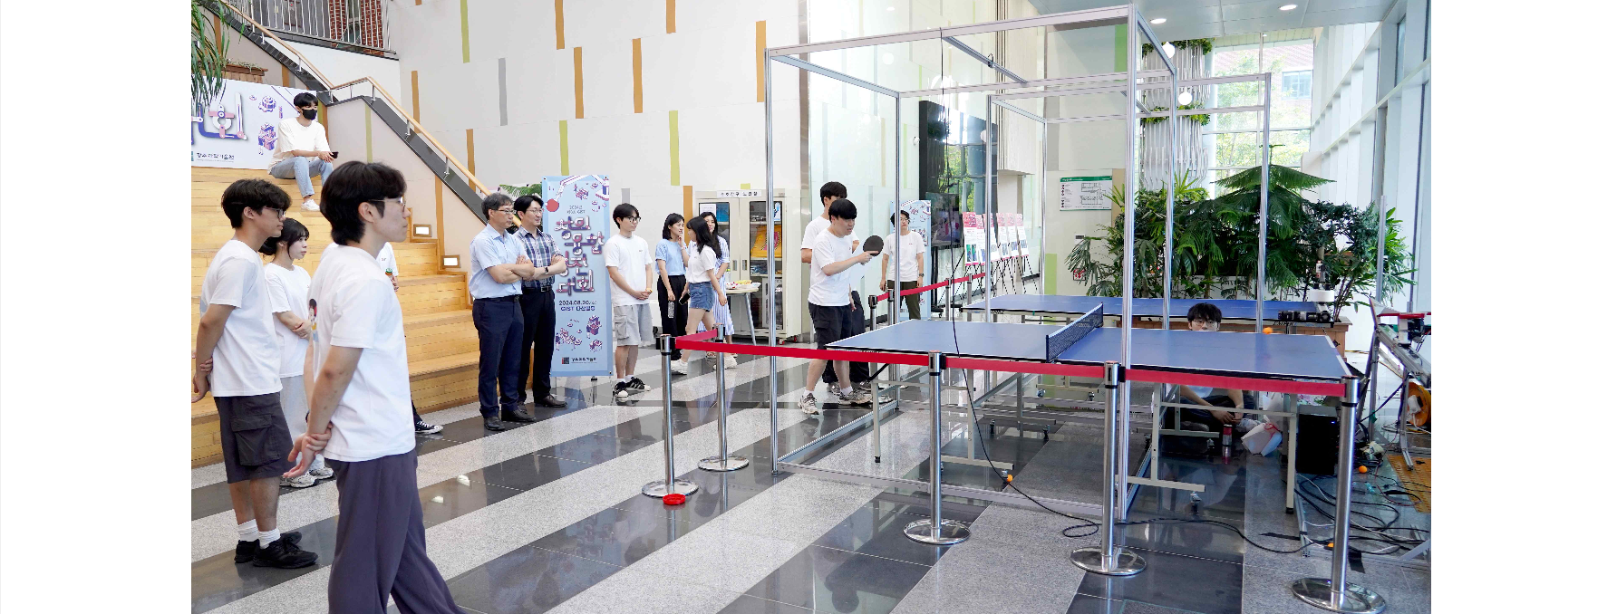▲ Participants in the ‘Table Tennis Robot Contest’ section of the ‘2024 Creative Convergence Competition’ hosted by the GIST School of Integrated Technology are rallying with table tennis robots.

The finals of this competition, which selected the final winning teams for the two tracks, were held on Wednesday, August 14, and the awards ceremony was held at 2:00 PM on Tuesday, August 20 in room 109 of the Dasan Building.

▴ The grand prize and excellence award in the ‘Table Tennis Robot Contest’ category went to the ‘Lucky Edge’ team (Yonsei University student Jeong-hyeon Yoo, Kyunghee University student Bo-gyeom Hwang, Tae-woong Lee) and the ‘RIME’ team (Sookmyung Women’s University student Ji-na Lee, Ye-rang Mok, Yeo-jin Kim) respectively. ▴ The grand prize and excellence award of the ‘Campus EMS Development Contest’ went to the ‘AICONIC’ team (Chonnam National University student Yu-gyeong Na, Seong-su Moon) and the ‘SPLP’ team (Soongsil University student Min-gyu Kang, Bo-seong Lee). The ‘Lucky Edge’ team and the ‘AICONIC’ team, which won the grand prizes, were awarded trophies and prize money of 2 million won.

The Excellence Award went to the ‘Tiki-TakAI’ team (GIST students Young-jin Lee, Rae-heon Kim, Seong-hwan Bae, and Hanbat National University student Ha-young Yoo) in the ‘Table Tennis Robot Contest’ category and the ‘E-CLIPS’ (GIST students Ji-soo Kang, Joo-won Kim, Jeong-hoon Lee, and Yu-chan Ahn) in the ‘Campus EMS Development Contest’ category. The Encouragement Award went to the ‘Robot Ping-Pong’ team (GIST students Eun-won Seo, Kang-hyun Seo, Bo-seong Lee, and Ha-young Choi) in the ‘Table Tennis Robot Contest’ category and enjoyed the joy of winning.

School of Integrated Technology Dean Jung Won Yoon said, "The competition is held in an exciting way using a convergence research topic that combines artificial intelligence and hardware (robots), and the participation of students in the competition is increasing every year. We are proud that this competition provides an experimental educational platform that can foster convergence talents with creativity and problem-solving skills required in the era of the 4th Industrial Revolution."



