“Elementary School Students Who Are Into AI: Future Scientists” GIST holds <AI Science Camp> during summer vacation

- Inviting children of soldiers and employees affiliated with the Army Sangmu Corps and POSCO who signed an MOU for a customized science camp... GIST's specialized science and engineering career experience, including lectures by faculty and lab experience, leading the AI field
- As part of GIST's social contribution program, "We will provide various science and engineering experience programs for youths"

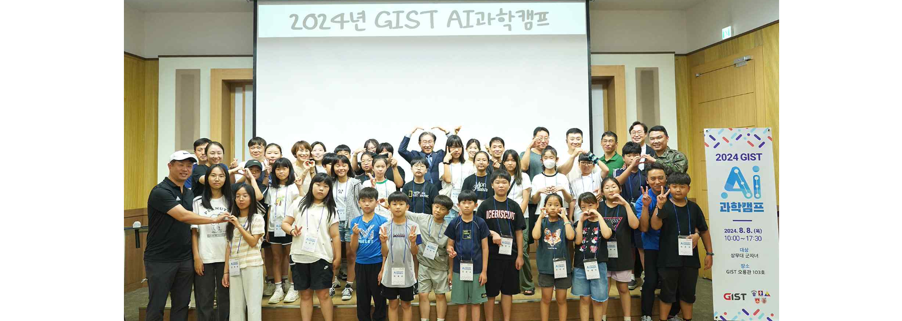▲ The GIST Social Contribution Group invited elementary school children from institutions that signed an MOU to hold a ‘Science Camp (AI Science Camp)’ and took a commemorative photo. (26 elementary school children of soldiers belonging to the Army Sangmu Unit held on the 8th)

The GIST (Gwangju Institute of Science and Technology, President Kichul Lim) announced that it held the ‘Science Camp with GIST (AI Science Camp)’ during summer vacation to support the experience of future science hopefuls in science and engineering career paths.

‘Science Camp’ is one of GIST’s social contribution programs. This year, elementary school children from institutions that signed an MOU were invited to the campus, and various programs were held, including science lectures by GIST faculty, campus tours, laboratory experiences, and viewing of exhibitions at the Gwangju National Science Museum.

This science camp, in which about 60 children of soldiers and employees from the Army Sangmu Unit (Thursday, the 8th) and POSCO (Tuesday, the 20th), which signed an MOU with GIST, participated, received a great response from students and accompanying teachers, especially because it was organized with the theme of AI, a core research field of GIST.

Students who participated in the camp listened to Professor Ue-Hwan Kim of the AI Graduate School's lecture on 'Robots that Help Humans, Artificial Intelligence' and visited the Institute for Artificial Intelligence and related laboratories to hear explanations from researchers, experience research results, and observe researchers' experiments, which gave them time to satisfy their scientific curiosity.

In addition, they were able to experience developing my scientific imagination by visiting the special exhibitions, permanent exhibitions, artificial intelligence center, children's science center, and observatory at the Gwangju National Science Museum.

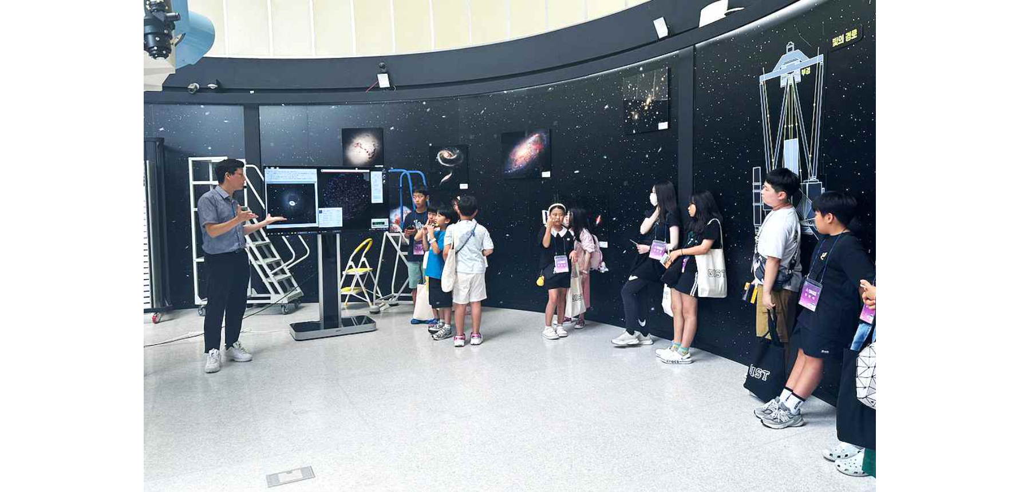▲ GIST Social Contribution Group invites elementary school children from institutions that signed an MOU to hold a ‘Science Camp (AI Science Camp)’ and visits the Gwangju Science Museum for experiential learning.

International and Public Affairs Dean Jae Gwan Kim said, "We hope that the students who participated in this camp will have more curiosity and interest in science and will be helped to grow into ‘future scientists’. The GIST Social Contribution Group will continue to provide various science and engineering experience programs to growing youth so that GIST can cooperate with the local community and especially continue closer cooperation with MOU-signed institutions."



