“A Breathtaking Competition of AI Piano Competitions” GIST Institute for Artificial Intelligence holds new technology exhibition and presentation

- Two grand pianos compete with the world's first AI composer 'EvoM' created by Professor Chang Wook Ahn of AI Graduate School... AI's unique accurate, fast, and tense performance is showcased
- AI piano and human violinist/cellist's collaboration... AI and human collaboration competition, "We want to have time to think about the future direction in which humans and AI can coexist"

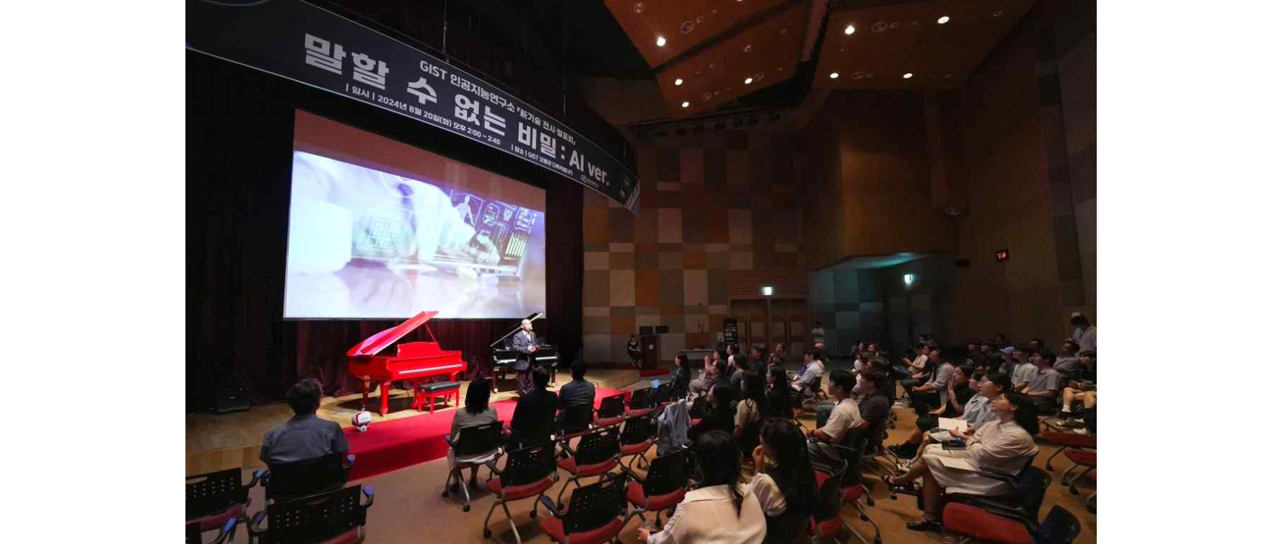▲ On Tuesday, August 20, the GIST Institute for Artificial Intelligence is holding a ‘New Technology Exhibition and Presentation’ at Oryong Hall, showcasing AI-related research results along with a piano battle performance.

A performance was held in which the famous scene from the Taiwanese film “Secret” (2007) where the two main characters engage in a piano battle was recreated using artificial intelligence (AI) on two pianos.

The Gwangju Institute of Science and Technology (GIST, President Kichul Lim) announced that it held a ‘New Technology Exhibition and Presentation’ at Oryong Hall on Tuesday, August 20th at 2:00 PM, featuring a piano battle performance and AI-related research results, hosted by the GIST Institute for Artificial Intelligence (Director Ahn Chang-wook, Professor of AI Graduate School).

At the presentation that day, two grand pianos equipped with AI composer ‘EvoM’ presented newly composed pieces with their characteristically precise, fast, and tense performances.

Director Chang Wook Ahn is an AI expert who is well known to the public for developing the world’s first AI composer, ‘EvoM’, in 2016.

‘EvoM’ basically learns music composition theory and identifies the characteristics of songs of various genres such as classical, jazz, and K-pop. Based on this, it utilizes deep learning and evolutionary computational structures to compose new songs beyond the level of partially recombining existing music.

It also uses the latest AI technology to recognize human facial expressions, and when users speak or input phrases, it understands them and instantly creates a song appropriate for the situation.

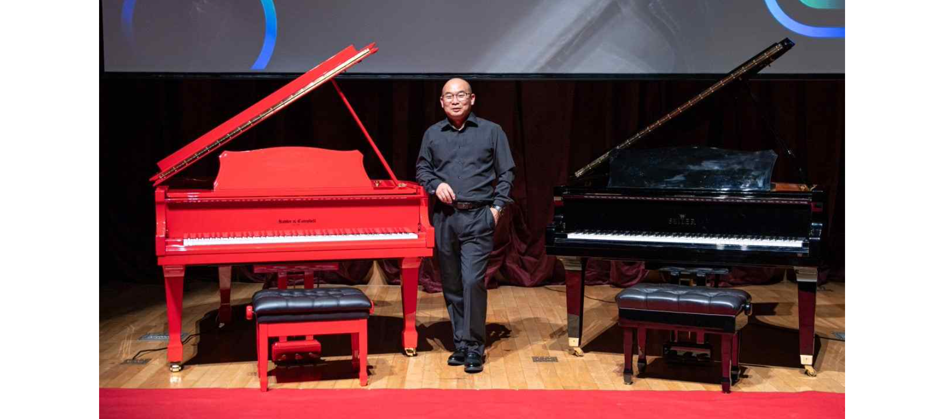▲ Two grand pianos equipped with AI composer ‘EvoM’ and Chang Wook Ahn, director of the Institute for Artificial Intelligence and professor at the AI Graduate School

The concert, which opened with a performance by Peony, known as Korea's first female VR artist, continued with a composition/performance competition between two AI pianos, followed by a collaboration between the AI piano and violinist Su-jin Yoo and cellist Seon-ju Kim, sending the message that AI technology should develop in a direction where it can coexist with humans.

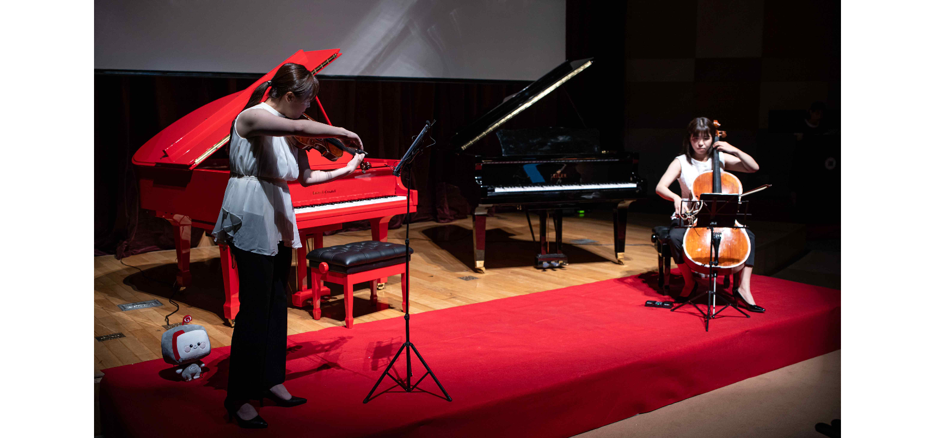▲ Violinist Su-jin Yoo and cellist Seon-ju Kim are performing with AI pianos.

The exhibition held in the lobby of Oryong Hall featured exhibition booths* related to new AI technologies and application services (music AI, logistics AI, robot AI, game AI, edge AI, education AI, vision AI, medical AI, etc.) that presented the direction of AI technology in preparation for future society, providing visitors with a variety of things to see.

* Exhibition Booths: ▴ [Music AI] Musia One: AI Composition Platform ▴ [Logistics AI] Quantum AI-based VRP Solution ▴ [Robot AI] Adaptive Environment Recognition-based Driving AI ▴ [Game AI] StarCraft II Game AI ▴ [Edge AI] Real-time Edge Computing Technology ▴ [Education AI] GPTalk: Online Lecture Learning Support System ▴ [Vision AI] Text-based Image Segmentation AI ▴ [Medical AI] AI-based Medical Service Assistance Platform

President Kichul Lim gave a congratulatory speech, saying, "AI is driving innovation in various fields and has a positive impact on our lives and society, but on the other hand, there may also be cases of misuse, such as creating false information or manipulating public opinion through technologies such as deepfakes. If many people, including those here, come together to prepare for tomorrow, AI will be able to open a new chapter in human history despite numerous trials and errors and conflicts."

President Lim also said, "The GIST Institute for Artificial Intelligence stands at the cutting edge of AI civilization and is leading the evolution of humanity. The new technology exhibited today is not simply a technological innovation, but it will become a starting point for solving our challenges and creating a better tomorrow."

Institute for Artificial Intelligence Director Chang Wook Ahn said, "AI has true value only when it exists for humans, and the GIST Institute for Artificial Intelligence has been conducting AI research and development for humans along this philosophy. Through this exhibition and presentation, we wanted to introduce the Institute for Artificial Intelligence's representative technologies and showcase new technologies, and have time to think about the future direction in which humans and AI can coexist."

Meanwhile, the GIST Artificial Intelligence Research Institute is a research institute that prepares for the future society and leads the spread of artificial intelligence technology. It is planning and promoting specific projects with the goals of artificial intelligence research achievements, infrastructure construction, national project promotion, and industry-academia cooperation. It is currently focusing on the research and development of knowledge-data synthesis artificial intelligence technology and application that can think and reason like humans even with a small amount of data.



