GIST unveils ‘Semitransparent Solar Film’ that can be used for smart windows, a key in the carbon neutral era

- Participated in the ‘K-Display 2024’ exhibition held at COEX in Seoul from August 14 to 16, exhibited a semitransparent solar film that can be applied as a power source for smart windows
- GIST Research Institute for Solar and Sustainable Energies, focusing on solar cell technology, exhibited a mobility display that applied a semitransparent solar film as a power source for smart windows for vehicles, showing great interest

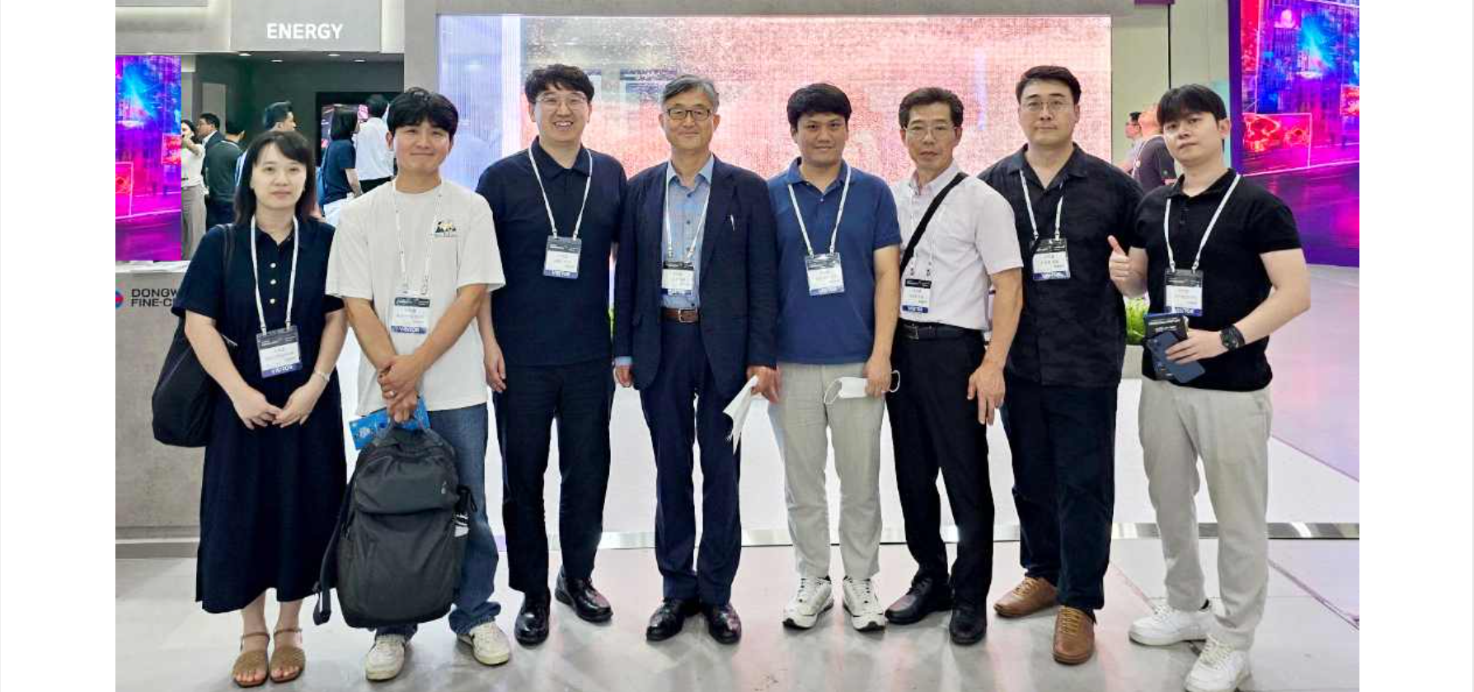▲ GIST researchers and staff members of Recell are taking a commemorative photo at the event venue. (From left) Researcher Song-i Jeong (GIST), Principal Researcher Dong-ha Lim (Recell), Principal Researcher Hongkyu Kang (GIST), Professor Kwanghee Lee (GIST), Postdoctoral Researcher Jun-ho Jang (GIST), Director Jong-seong Ha (Recell), Manager Jeong-woo Park (Recell), and Principal Researcher Hyeon-seok Jeong (Recell)

The Gwangju Institute of Science and Technology (GIST, President Kichul Lim) announced that the Research Institute for Solar and Sustainable Energies exhibited a semitransparent solar film that can be applied as a power source for smart windows at the ‘2024 Korea Display Industry Exhibition (K-Display 2024)’ where the latest display technology and products could be seen in one place.

Semitransparent solar films are made of organic solar cells, so they are cheaper to produce than conventional silicon solar cells, and they are also lightweight, flexible, and transparent. In particular, they can be used as a power source by attaching them in film form to various fields such as buildings, car windows, and glass greenhouses.

GIST Research Institute for Solar and Sustainable Energies presented a semitransparent solar film as a result of industry-academia cooperation that combined the large-area solar cell production technology of Recell Co., Ltd., the flexible transparent electrode production technology of MSWAY Co., Ltd., and the functional film technology of Dongwoo FineChem Co., Ltd., focusing on the original technology of organic solar cells.

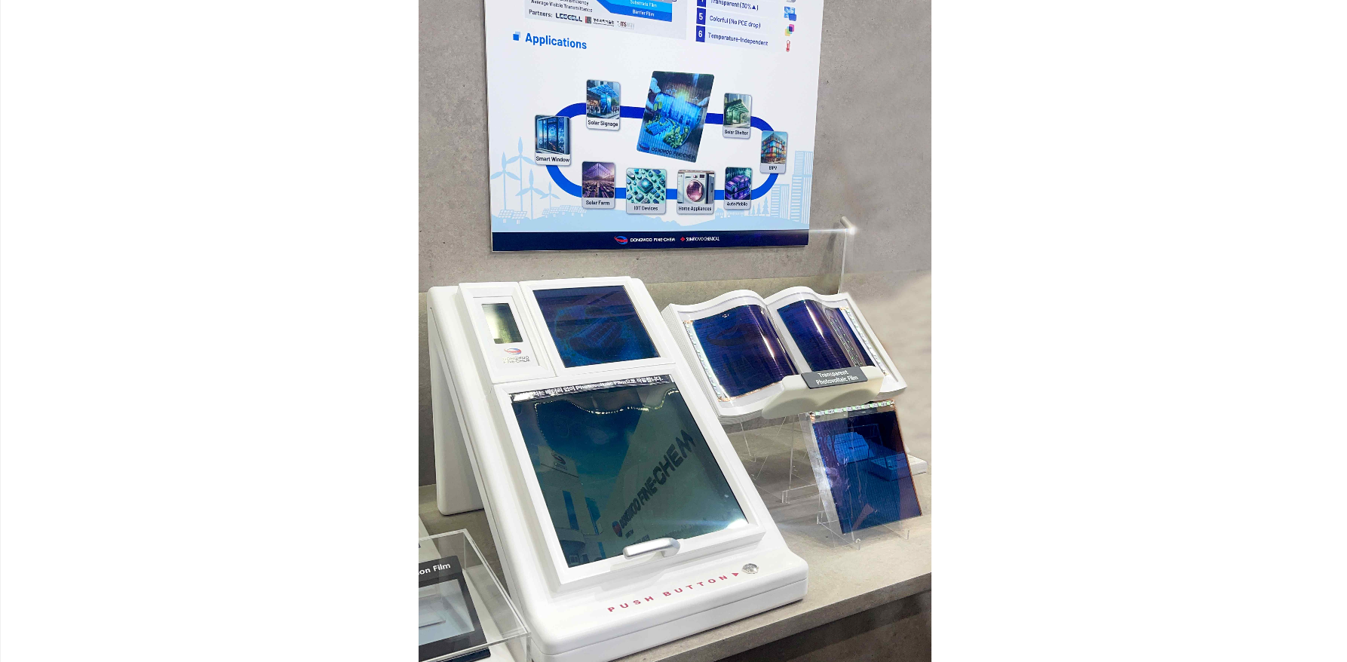▲ GIST Research Institute for Solar and Sustainable Energies participated in ‘2024 K-Display’ and presented a semitransparent solar film that combines the large-area solar cell production technology of Recell Co., Ltd., the flexible transparent electrode production technology of MSWAY Co., Ltd., and the functional film technology of Dongwoo FineChem Co., Ltd., focusing on the original technology of organic solar cells.

Recell Co., Ltd. is a manufacturer of organic-inorganic hybrid solar cell films founded by Professor Kwanghee Lee of the School of Materials Science and Engineering at GIST. It is working to advance roll-to-roll manufacturing technology with the goal of mass producing the first organic-inorganic hybrid solar cell film in Korea.

The research team also attracted great attention from visitors by exhibiting a mobility system that applied a semitransparent solar film as a power source to a smart window for vehicles at the Dongwoo Finechem booth.

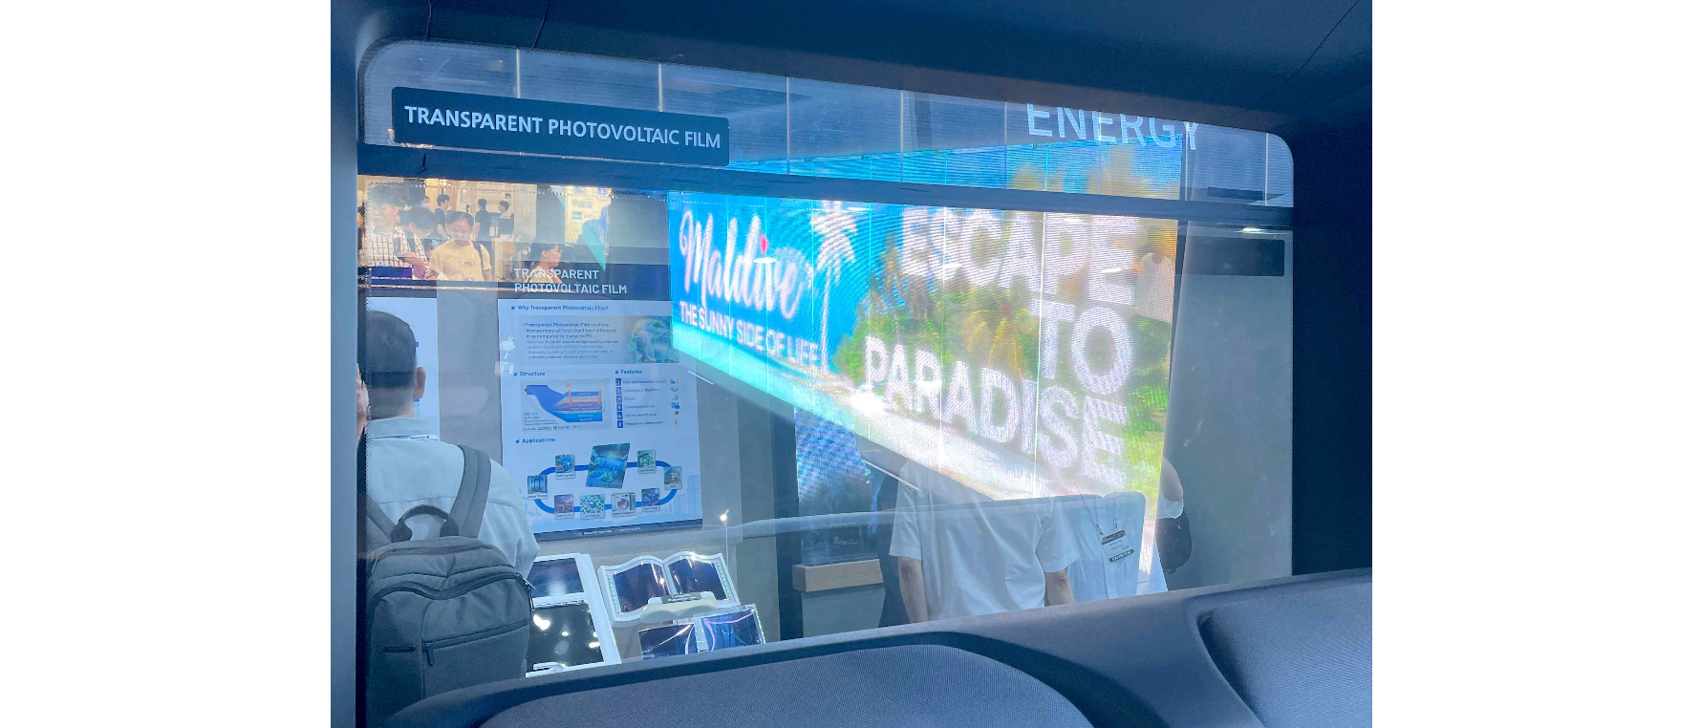▲ Dongwoo Finechem Co., Ltd. is exhibiting mobility that uses semitransparent solar film as a power source for smart windows for vehicles at its booth.

Dongwoo Finechem Co., Ltd. is a specialized company in the production of domestic semiconductor and display parts and materials, including transparent LED displays, high-functional films, semiconductors, high-purity chemicals for displays, alumina, and touch sensors. It is introducing products developed based on its unrivaled technological prowess for the development of the domestic and international semiconductor, display, and energy industries.

GIST Research Institute for Solar and Sustainable Energies Senior Researcher Hongkyu Kang said, "Participating in this exhibition was a good opportunity to widely publicize the potential of semitransparent solar films and expand cooperation with various industrial fields. The Research Institute for Solar and Sustainable Energies plans to actively promote industry-academic cooperation for the development of energy-related industries in the future."

Meanwhile, the 2024 Korea Display Industry Exhibition (K-Display 2024), which is in its 23rd year this year, is the largest display exhibition in Korea hosted by the Korea Display Industry Association. It was held at COEX in Seoul from August 14 to 16, with the participation of 135 companies and 427 booths from the two major domestic panel companies (Samsung and LG) with the world's best technology in the organic light-emitting diode (OLED) field and domestic and foreign small and medium-sized enterprises.

