“You who did not choose the set path are the hope of humanity” GIST to hold the second half of 2024 degree awarding ceremony

- On the 16th (Friday), a total of 170 people (54 doctoral students, 63 masters students, and 53 bachelor's students) were awarded degrees, producing a total of 8,348 advanced science and technology talents... PhD graduates published an average of 5.6 papers in SCI-level journals
- CEO Jeong Ji-seong of SOS Lab Co., Ltd. (Doctoral Program in Mechanical Engineering) said in his congratulatory address, "The process of thinking about how to create a better world beyond personal success will enrich and make life meaningful."
- President Kichul Lim "If innovation that will solve humanity's difficult problems is possible, you graduates who have chosen the path of scientific and technological innovation that no one has yet attempted will be the first hope."

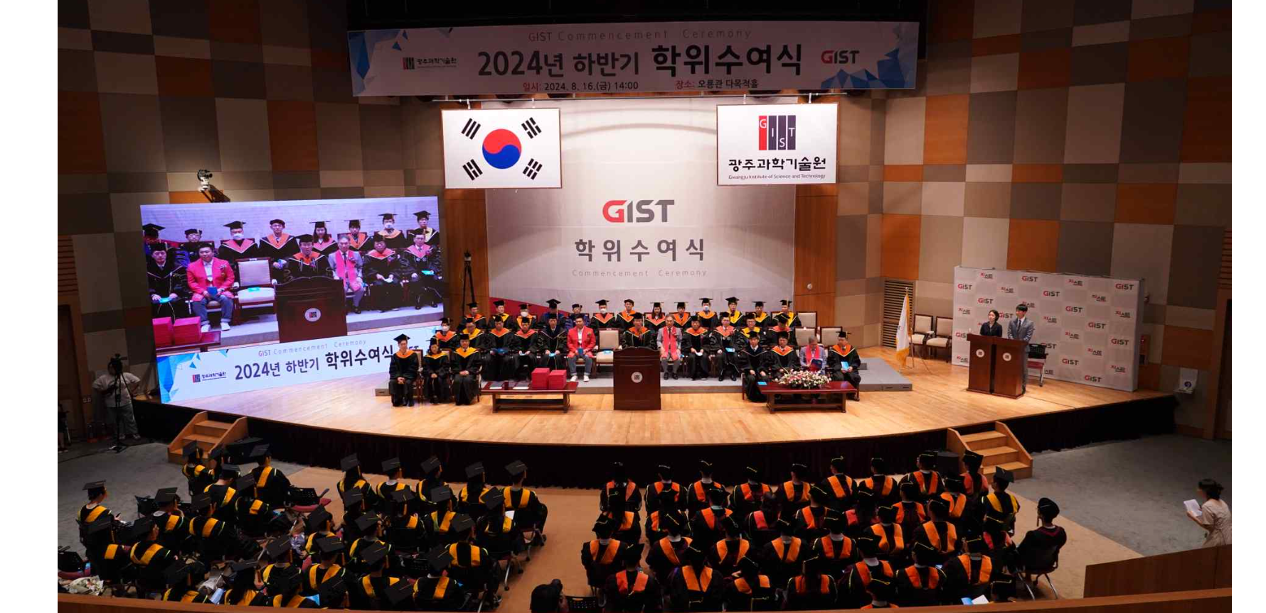▲ GIST is holding the second half of 2024 degree awarding ceremony on the 16th (Friday).

The Gwangju Institute of Science and Technology (GIST, President Kichul Lim) announced that it held the second half of 2024 degree awarding ceremony at the Oryong Hall auditorium at 2:00 PM on Friday the 16th.

On this day, GIST awarded degrees to 170 people, including 54 doctorates, 63 masters, and 53 bachelor's degrees. With this, since its establishment in 1993, GIST has produced a total of 8,348 advanced science and technology talents, including 1,945 doctorates, 5,086 masters, and 1,317 bachelor's degrees over the past 30 years.

The 54 students who received their doctoral degrees published an average of 5.6 papers per person in SCI (Science Citation Index) journals during their studies.

On this day, Haewon Ahn, a graduate of the School of Mechanical Engineering who received the Future Talent Award and the Honorable Mention Award, and Hyein Lee, a graduate of the Department of Chemistry who received the Merit Award and the Honor Award, enjoyed winning the awards.

The congratulatory address by CEO Ji-Seong Jeong, who completed his master's degree in the School of Mechanical Engineering (advisor: Professor Kyi Hwan) and founded SOS Lab, a LiDAR (Light Detection And Ranging) technology company while pursuing his doctorate in 2016, drew attention by going onto the stage.

SOS Lab, which was the first autonomous driving-related lidar startup to enter KOSDAQ in June of this year in recognition of its growth potential, recorded a 75% increase in sales and a 9% increase in employees last year.

“Rather than announcing our KOSDAQ listing, I wanted to share with you the stories of my struggles during our continued growth, which is why I am here today,” said CEO Ji-Seong Jeong. “In the early days of our business, when we were developing our first LiDAR product, we raised about 1 billion won and participated in CES (Consumer Electronics Show). This gave me the confidence that we were in no way falling behind our competitors who had received investments of 50 to 100 billion won and were releasing products, and that we could fully compete on the global stage.”

CEO Jeong also said, "You may think that you are just a frog in a well, but the well you have climbed into, GIST, is one of the most difficult wells in the world to climb. Your potential is great. The process of thinking about how to create a better world beyond personal success will ultimately enrich and make your life more meaningful."

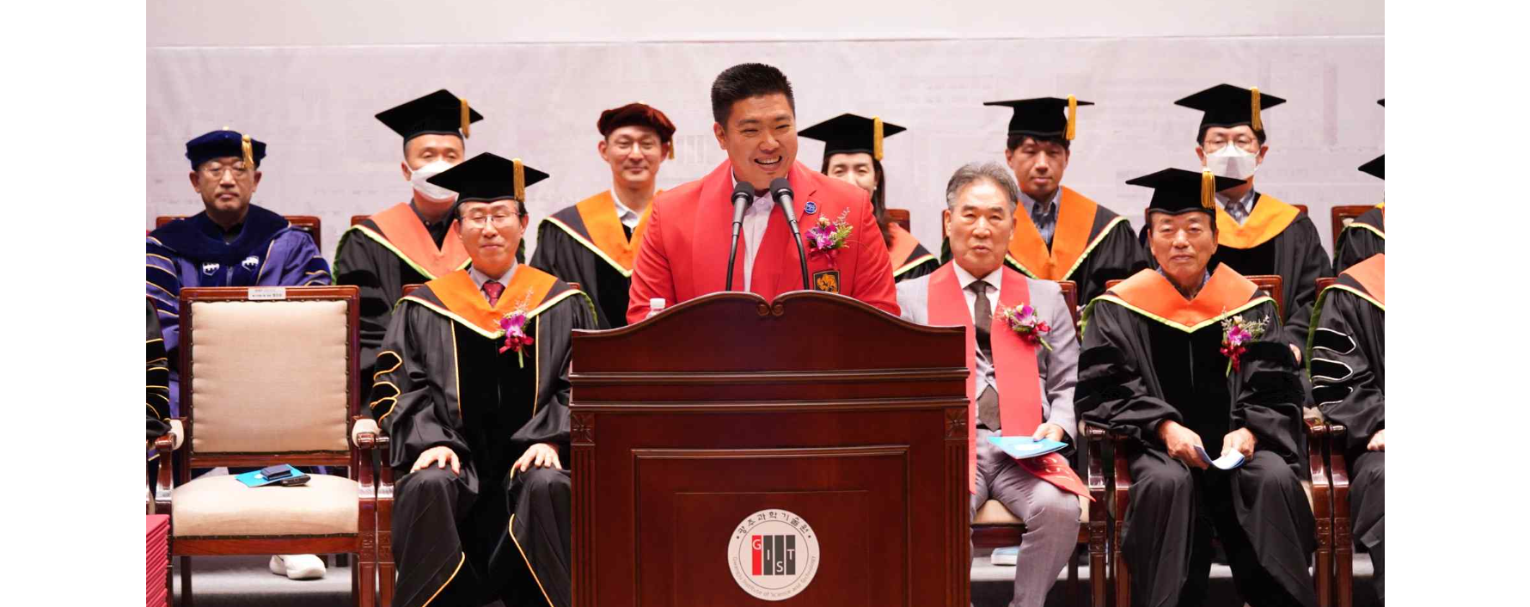▲ SOS Lab CEO Ji-Seong Jeong is giving a congratulatory speech.

President Kichul Lim said at the graduation ceremony, "Today, as we face the great transformation of AI civilization, the innovation capacity of a country determines global hegemony. This is why the shoulders of those graduating from science and technology universities are more important than ever."

He also said, "You did not choose a pre-determined path like a ready-made product built according to an assembly manual, but chose a path of scientific and technological innovation that no one has yet attempted. If innovation that will solve humanity's difficult problems is possible, you graduates will be the first hope."

Finally, President Lim said, "Today, as we tie a knot in the name of graduation, I hope you will recall the very beginning when you started tying the knot, recall the pure passion that the ‘very beginning’ contained, and start tying your new knot from tomorrow."

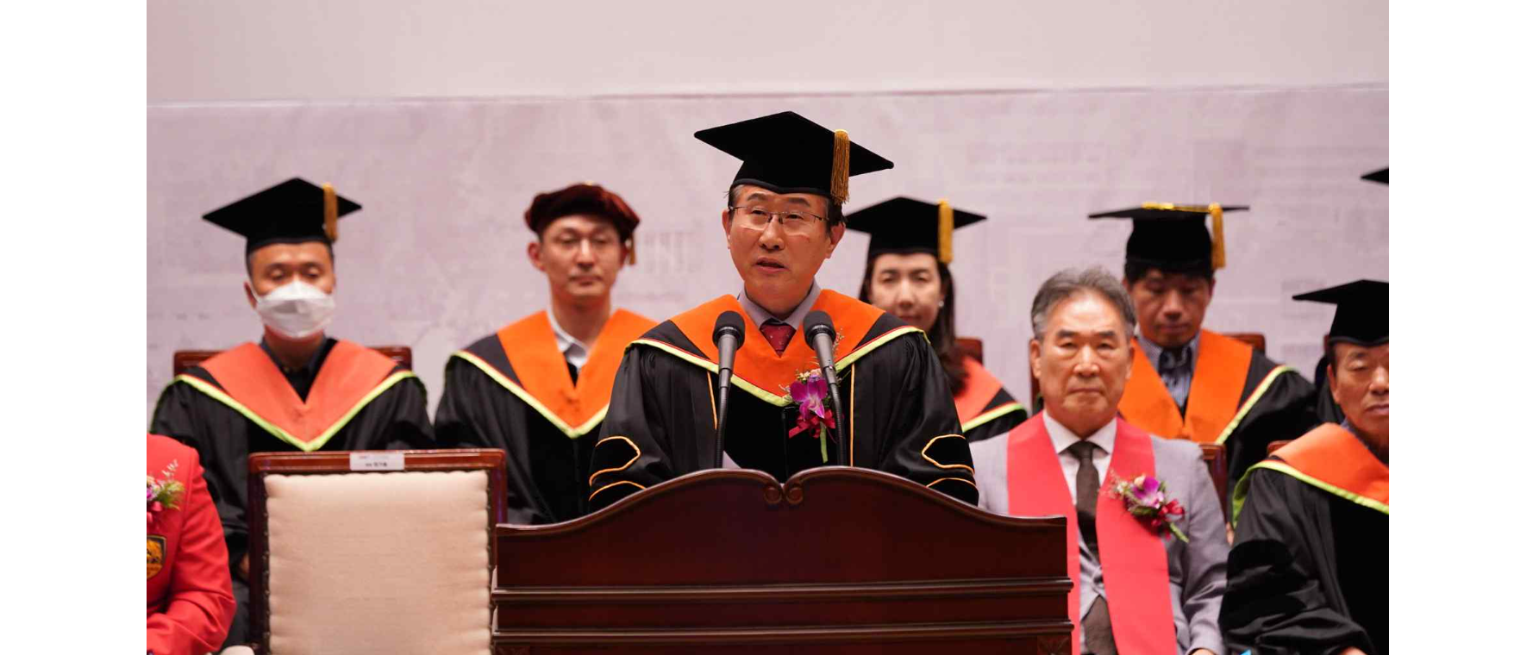▲ President Kichul Lim speaking at the degree ceremony.

Meanwhile, GIST is continuing active international cooperation by establishing a global R&D network, including joint research in the field of artificial intelligence (AI) with the Massachusetts Institute of Technology (MIT) in the United States.

GIST, the only domestic educational research institute that operates a supercomputer ranked within the world's top 500 ('Dream-AI' listed on 'TOP500'), is also building a full-cycle education system to foster future AI talent by promoting the establishment of an AI gifted school, which is scheduled to open in 2027, along with the AI Graduate School that opened in 2019 and the first AI Policy Strategy Graduate School in Korea, which will be launched in September of this year.

In addition, despite being a “young university” that celebrated its 30th anniversary last year, GIST was ranked 4th in the world (1st in Korea for 17 consecutive years) in the “paper citations per professor” category in the 2025 QS World University Rankings, and was selected as 1st in the entrepreneurship performance category in the “2023 Korea’s Best Entrepreneurial Universities” evaluation. Based on its world-class R&D competitiveness, GIST is leading the creation of social and economic value through the spread of research results.

