GIST and Hwasun-gun sign business agreement to cooperate in fostering future talents and developing cutting-edge industries

- Agree to cooperate in 4 areas including fostering local industries, discovering related projects, educational cooperation, and nurturing talent... “Expecting to establish a foundation for fostering educational and technical cooperation for attracting specialized industries in the advanced bio sector”
- Join hands to create biomedical industries in Jeonnam through fostering a biomedical cluster in the vaccine industry special zone (Hwasun-gun) + building an advanced bio campus (GIST) in the Hwasun vaccine industry special zone

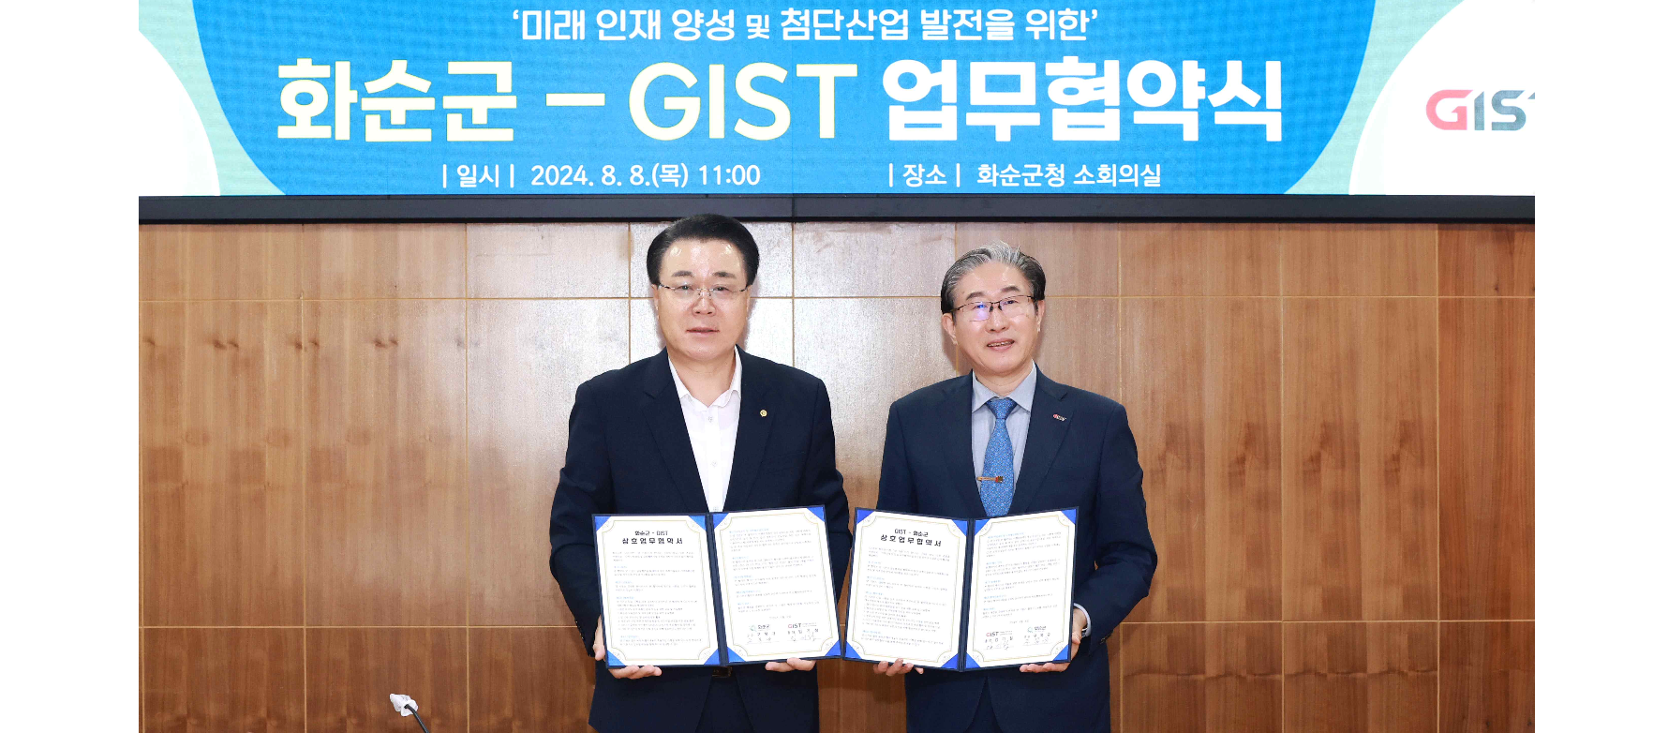▲ GIST and Hwasun-gun signed a business agreement (MoU) to foster future talent in cutting-edge science and technology fields and to foster regional specialized industries. (From left) Hwasun-gun Governor Bok-gyu Gu and GIST President Kichul Lim are taking a commemorative photo.

The Gwangju Institute of Science and Technology (GIST, President Kichul Lim) announced that it signed a business agreement (MOU) with Hwasun-gun, Jeollanam-do (Governor Bok-gyu Gu) to foster future talents in cutting-edge science and technology fields and foster regional specialized industries.

The signing ceremony was held on Thursday, August 8 at the Hwasun County Office with around 10 people in attendance, including GIST President Kichul Lim, Vice President for Public Affairs Yonghwa Chung, International and Public Affairs Dean Jae Gwan Kim, School of Life Sciences Professor Chang-Duk Jun, and Hwasun County Governor Bok-gyu Gu, Deputy Governor Jong-cheol Kang, and Planning and Audit Office Director Gyeong-woo Lim.

The main contents of the agreement include: ▴ Fostering regional industries: Education and technology cooperation for attracting specialized industries in the advanced bio field, etc. ▴ Discovering linked projects: Joint cooperation for discovering linked projects related to the government's 4th Industrial Revolution and selecting public projects ▴ Education cooperation: Joint cooperation for the development of education in Hwasun-gun and fostering local talent ▴ Talent cultivation: Cooperation in opening GIST Techno Management Business Academy (GTMBA) curriculum and selecting scholarship students, etc.

Hwasun-gun has been designated as a ‘National Advanced Strategic Industry Bio-Specialized Complex’ and a ‘Global Bio Campus’ by the World Health Organization (WHO), and plans to grow into a top-level biomedical cluster in Korea with global competitiveness.

In addition, in line with the current government's pledge for balanced development, we plan to focus on attracting the Gwangju-Jeonnam Advanced Medical Complex, leading the development of innovative treatments and new drugs through the linkage of the bio and medical industries, and promoting new growth in the region by creating jobs through attracting bio companies.

Hwasun-gun Governor Bok-gyu Gu said, "If GIST actively utilizes its new technologies, accumulated knowledge, and excellent research facilities, as well as human and material resources, and the two organizations cooperate jointly, Hwasun-gun will be able to make a bigger leap forward in fostering future talents in the region along with the development of future cutting-edge bio industries. Let's create new opportunities together by collaborating in various fields between the two organizations in the future."

GIST, which has grown into a top-class research-oriented university under the banner of internationalization and convergence, is also focusing on activating startups and commercializing technology to transform into a “value creation platform” that turns accumulated knowledge value into business value.

In particular, in celebration of the 30th anniversary of its establishment last year, the goal is to provide solutions to solve difficult problems for humanity and the nation, and based on mission-oriented research and development (R&D) in the field of healthcare security including advanced bio, it is promoting the domestic production of medical devices and commercialization of new drugs, and is leading the creation of the biomedical industry in the Jeonnam region through measures such as the establishment of the GIST-Jeonnam Advanced Bio Campus in the Hwasun Vaccine Industrial Complex.

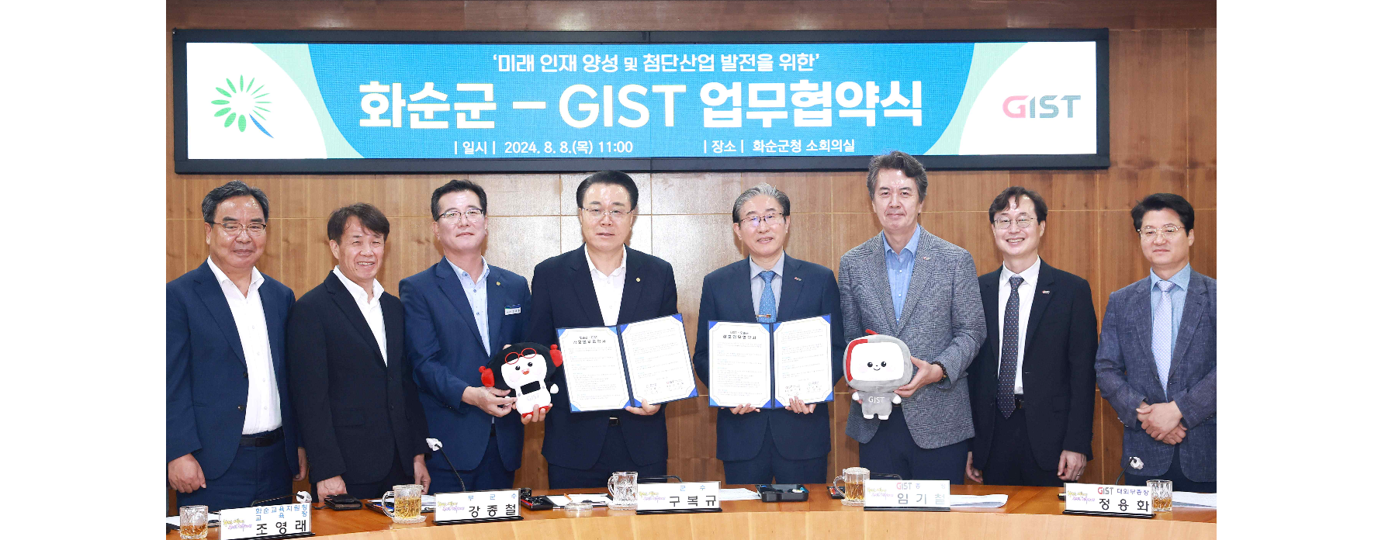▲ GIST and Hwasun-gun signed a business agreement (MoU) to foster future talent in the field of advanced science and technology and to foster regional specialized industries, and attendees are taking a commemorative photo.

President Kichul Lim said, "GIST is striving to become a university that can contribute to the national economy while leading the innovation economy together with the region based on fostering science and technology talents. Recently selected for the Global Leading Research Center (IRC) support project in the advanced bio field, GIST is expected to make a substantial contribution to achieving the grand goal of establishing a cultural tourism industry, advanced complex, and global bio campus pursued by Hwasun-gun through fostering AI-based digital industries."



