GIST AI Graduate School, AI+X Experience Camp for General High School Students in Jeonnam Area Held... 5th Year This Year, Starting in 2020

- 60 first and second year students from general high schools in Jeollanam-do participated on the 26th and 27th, and received special lectures from professors at the GIST AI Graduate School, as well as the opportunity to acquire the latest AI knowledge such as MobileX and SmartX, and experience various AI technologies
- “In the coming future, a virtuous cycle of collaborative ecosystems will be created through AI technology innovation through open encounters between AI technology and target fields (X)... I hope this will be an opportunity to nurture dreams of growing into key AI talents”

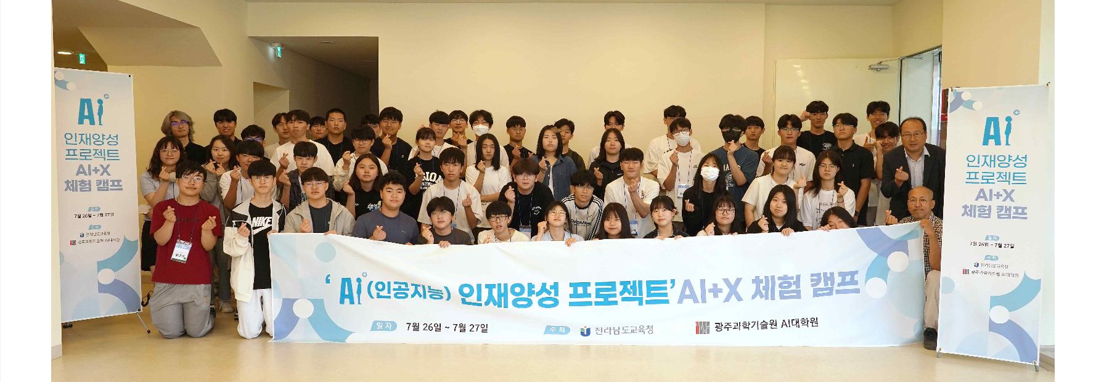▲ High school teachers and students from Jeonnam Province who participated in the GIST ‘AI Talent Development Project: AI+X Experience Camp’ event are taking a commemorative photo with officials from the GIST AI Graduate School.

The Gwangju Institute of Science and Technology (GIST, President Kichul Lim) announced that its AI Graduate School (Dean Jongwon Kim) held the ‘AI Talent Development Project: AI+X Experience Camp’ jointly with the Jeollanam-do Office of Education for high school students in the Jeollanam-do area to foster software talent for the artificial intelligence (AI) era.

This camp, held for two days and one night from July 26th (Friday) to 27th (Saturday) at Ted Hall, X+AI Studio, and Metaverse Studio in the AI Graduate School, was attended by 60 first and second year students from general high schools in Jeollanam-do who were pre-recruited.

The AI+X Experience Camp has been held every July since 2020 for five years to provide high school students near GIST who are interested in science with the opportunity to participate in the latest AI lectures and experiments and to tour the excellent educational environment of the GIST AI Graduate School so that they can pursue their dreams as future scientists.

This year's AI+X Experience Camp consists of ▴ StarMOOC: Computer System Learning for AI-based Cloud ▴ Special lectures on digital transformation and artificial intelligence ▴ Experimental program for AI+X experience.

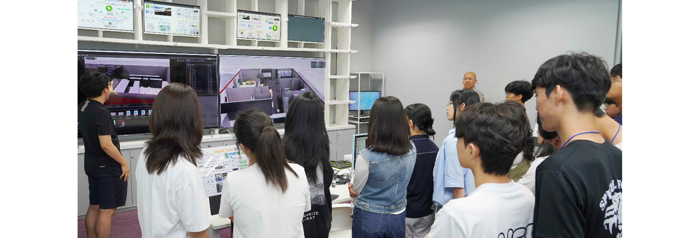▲ GIST researchers are participating as instructors and exploring SmartX with participating students.

The first day of the camp began with a welcoming speech by Dean Jongwon Kim, followed by ▴ a special lecture by AI Graduate School faculty, ▴ a tour of the open space ‘Dreaming AI Space’ in the lobby of the AI Graduate School, which includes the only Top 500 listed supercomputer among domestic universities for coding and communication, and ▴ the MobileX experience (AI drone, Amazon Web Services (AWS) DeepRacer & NVIDIA DeepStream and ▴ the SmartX experience (data transmission and computer vision utilization) in which researchers participated as instructors.

One of the students who attended the camp said, "It was great to hear and experience a lot about AI, which will become more important in the future, for two days and one night, and it was a meaningful experience to learn about the types of AI, machine learning, and deep learning."

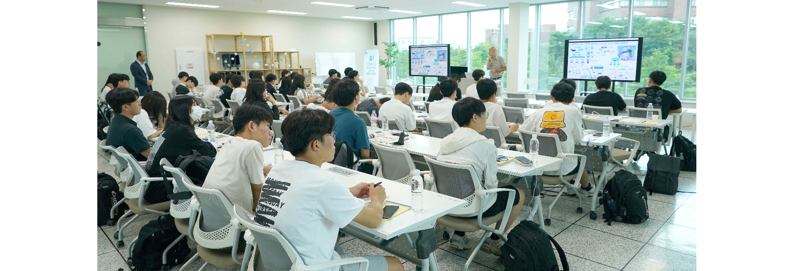▲ On the first day of the event, Dean Jongwon Kim of the GIST AI Graduate School introduces the GIST AI Graduate School and AI+X Experience Camp program to participating students.

Dean Jongwon Kim said, "In the coming future, a virtuous cycle of collaboration ecosystem will be created through AI technology innovation through open encounters between AI technology and target fields (X). The doors of GIST AI Graduate School are always open to future scientists interested in AI, and we hope that the AI+X Experience Camp will be an opportunity to foster the dream of growing into a key AI expert."

Meanwhile, in order to foster global AI innovation talents that connect education, research, and entrepreneurship, the GIST AI Graduate School, which was newly established in October 2019, has produced 35 AI experts with master's and doctoral degrees, starting with its first doctorate in 2023, and has since established a field-oriented research system that focuses on AI basics and core education, technology verification, and entrepreneurship.

In accordance with the DNA (Data-Network-AI) strategy for responding to the 4th Industrial Revolution, the largest AI computing infrastructure and verification test bed in Korea to be built in the ‘AI Industrial Convergence Complex’ are being fostered through verification-oriented education and research and development that are linked step-by-step with the educational and practical environment of the AI Graduate School.



