"Leading the Future Advanced Laser Industry Across the Continent" Korea-Czech Republic Begin Full-Scale Cooperation in Ultra-Powerful Laser Scientific Research

- GIST Advanced Photonics Research Institute-Czech ELI Beamline MOU signed, promoting research cooperation on ultra-strong laser and laser plasma application technology... Fruition of research cooperation relationship that has continued since 2011
- Meeting of large-scale laser research facilities representing Korea and Europe... Development of various application technologies such as laser medicine, laser nuclear fusion, ultra-strong laser defense technology development, and ultra-precision inspection analysis method expected to continue
- In line with the Czech nuclear power plant contract, Korea-Czech research cooperation in future cutting-edge science and technology is expected to accelerate

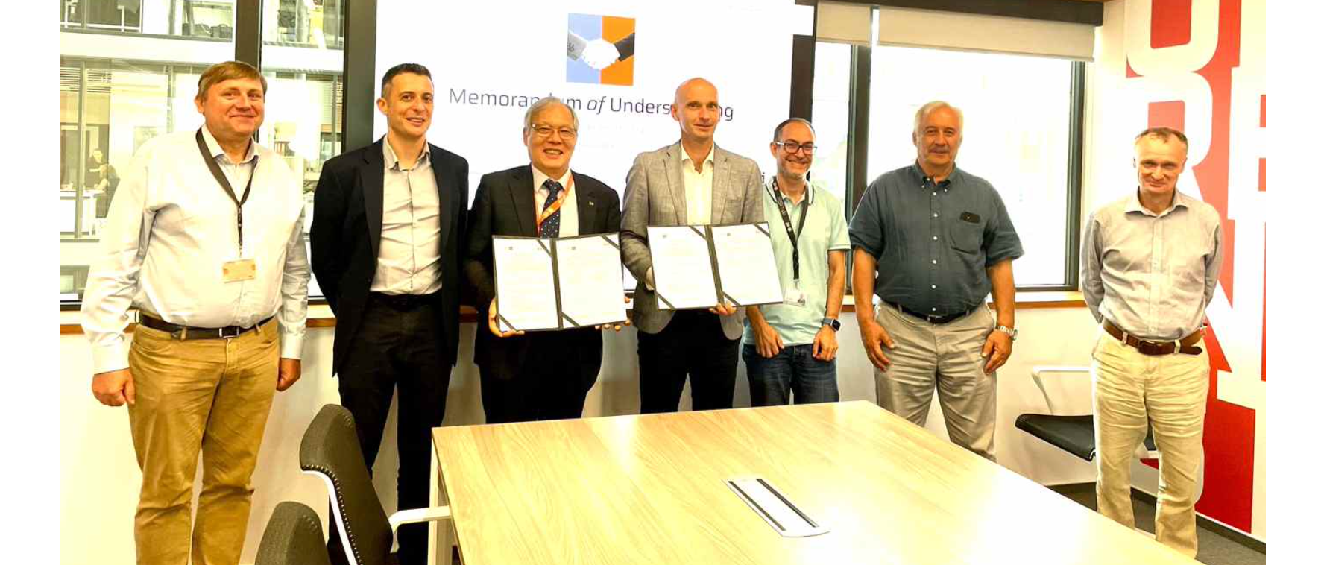▲ GIST Advanced Photonics Research Institute and Czech ELI Beamline researchers are taking a commemorative photo after signing a business agreement. (From left) Dr. Pavel Bakule, ELI Beamline Research Institute Director Daniele Margarone, GIST Advanced Photonics Research Institute Director Do-Kyeong Ko, ELI Beamline Operations Director Roman Hvězda, Dr. Lorenzo Giuffrida, Dr. Sergei Bulanov, and Dr. Stefan Weber

The Gwangju Institute of Science and Technology (GIST, President Kichul Lim) announced that the Advanced Photonics Research Institute (Director Do-Kyeong Ko) signed a Memorandum of Understanding (MOU) with the ELI Beamlines*, a giant laser science research facility in the Czech Republic, and will begin collaborating on the development of cutting-edge technologies using petawatt high-intensity lasers.

The signing ceremony was held on Tuesday, July 23, at the ELI beamline in Dolní Břežany near Prague, Czech Republic, with the attendance of GIST Advanced Photonics Research Institute Director Do-Kyeong Ko and ELI Beamline Director Roman Hvězda.

* ELI: Extreme Light Infrastructure-Beamlines

Through this agreement, the two organizations agreed to promote ▴ personnel exchanges, ▴ joint experiments, and ▴ exchange of research information in the fields of ultra-strong laser technology and laser plasma technology.

In the future, it is expected that world-class achievements will be created in basic research such as fine particle quantum phenomena, space plasma, and laser accelerator research, as well as in the development of various applied technologies such as laser medical technology, laser nuclear fusion technology, ultra-strong laser defense technology development, and ultra-precision inspection and analysis methods.

The ELI beamline is a major laser research facility representing the European Union (EU), equipped with a 10-petawatt laser, and conducts pioneering research such as laser particle acceleration and extreme condition plasma research centered on an extensive research network within Europe.

The GIST and ELI beamline researchers have been collaborating on research since 2011, and with this agreement, the researchers from both institutions are expected to take a leap forward as leading groups in ultra-strong laser science research.

Director Do-Kyeong Ko said, "With the recent order for the Czech nuclear power plant, Europe's interest in Korea's excellent nuclear power plant construction technology is increasing, and Korea-Czech industrial technology development cooperation is accelerating. In line with this, the world-class ultra-strong laser facilities of both countries have agreed to research cooperation, and it is expected that they will become a strong alliance that will develop future cutting-edge technologies across the continent."

Meanwhile, the GIST Advanced Photonics Research Institute, which holds the world record for the highest laser focus intensity, has an ultrashort photon beam research facility equipped with a 4 PW (petawatt) ultra-strong laser and has achieved excellent research results in the development and application of ultra-strong lasers. Based on the results of basic science research, the Advanced Photonics Research Institute is expanding its research areas to various applied research fields such as national defense, medicine, safety, and precision measurement.



