GIST Supercomputing Center Holds DLI Day (HPC-AI Common Infrastructure Training) with NVIDIA

- GIST Supercomputing Center, which is leading the construction of a super-large AI infrastructure by building and operating the only Top500 supercomputer (Dream-AI) among domestic universities and research institutes, continues to conduct education with NVIDIA for the second year
- Providing the latest HPC utilization technology and NVIDIA DLI hands-on opportunities, drawing great interest... “We will promote global industry-academia-research open collaboration for HPC-specialized education in the future mobility and digital twin fields”

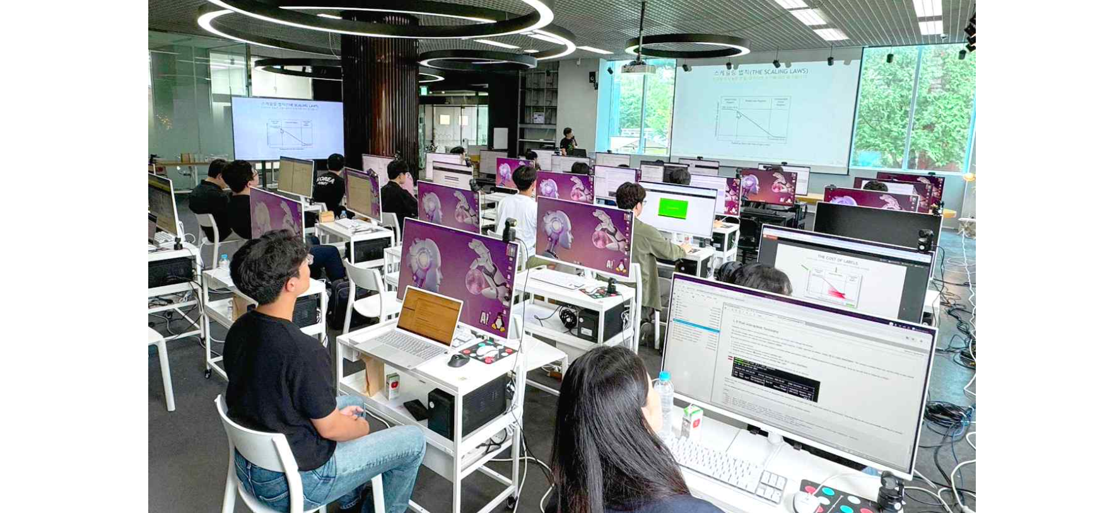▲ Learning methodologies to train deep learning models using multi-node GPUs at the GIST Supercomputing Center DLI Day with NVIDIA.

The Gwangju Institute of Science and Technology (GIST, President Kichul Lim) announced that it held DLI* Day together with the Supercomputing Center (Director JongWon Kim) and NVIDIA*.

* NVIDIA: An American multinational corporation and technology company that produces computer graphics processing units and multimedia devices. Its specialty is GPUs, the core chips of graphics cards. Currently, 125 of the world's top 500 fastest supercomputers are based on NVIDIA GPUs, and there are more than 600 applications that use NVIDIA computing platforms.

GIST is continuing its close partnership with NVIDIA by conducting related education this year following the GIST-NVAITC HPC-AI Day* education last year.

* GIST-NVAITC HPC-AI Day: On August 10, 2023, NVIDIA LLM (Large-Scale Language Model) research and development experts learned about Korean-based language model building methodologies, such as OpenAI's ChatGPT model, through the HPC-AI shared infrastructure built by the GIST Supercomputing Center.

This year, on Tuesday, the 23rd, NVIDIA experts were invited to the X+AI Studio on the first floor of the AI ​​Graduate School to conduct a ‘multi-node GPU programming training’ to efficiently utilize the multi-node clustering service of 32 or more GPUs, which was provided for the first time in Korea by the GIST Supercomputing Center.

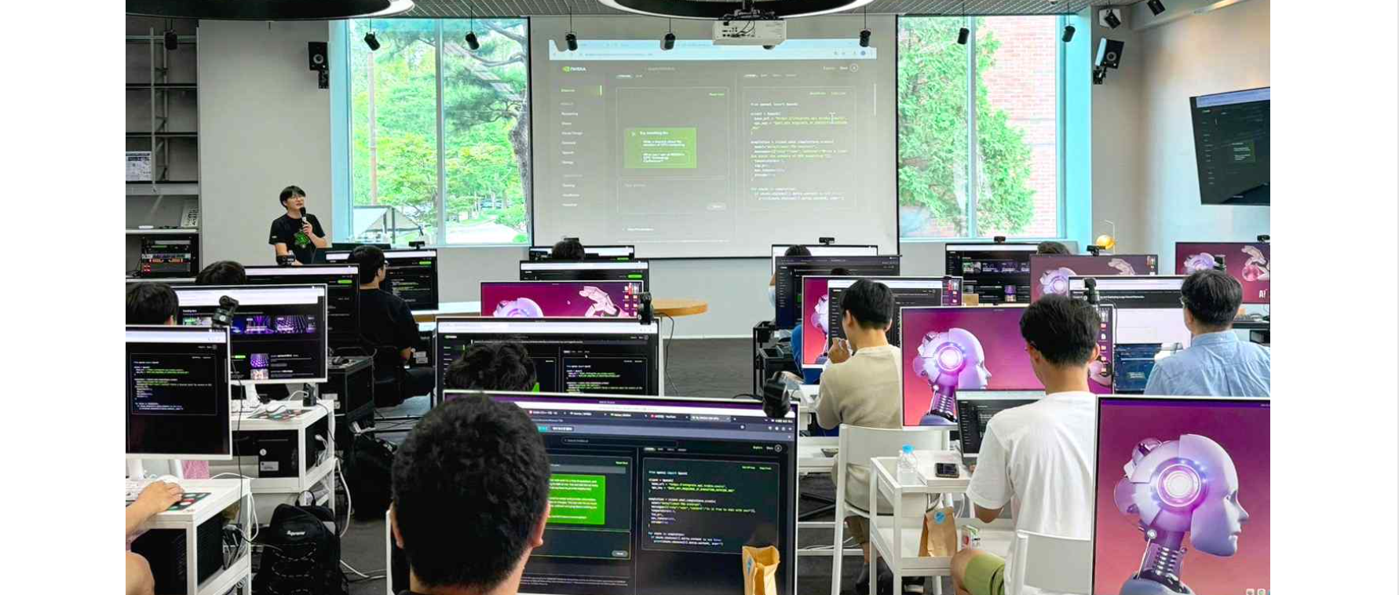▲ An NVIDIA Multi GPU expert, invited by the GIST Supercomputing Center for the first time in Korea, is conducting hands-on training to help people efficiently utilize the multi-node clustering service of 32 or more GPUs.

A total of 28 people, including GIST faculty and students, as well as researchers from Korea Aerospace University, Hallym University, Chonnam National University, and Chosun University, participated and showed great interest.

On this day, students practiced the latest technologies and methodologies of deep learning models using supercomputers to perform large-scale calculations required for research by utilizing multiple GPUs through the HPC-AI shared infrastructure (Dream-AI) built at GIST.

One researcher who participated in the training said, "It was a valuable opportunity to learn the latest technologies using HPC, and I think it will be a great help in my research as I was able to experience NVIDIA DLI* training deep learning models."

* NVIDIA DLI: NVIDIA Deep Learning Institute (DLI) teaches how to train data-parallel deep learning models on multi-node GPUs.

Director JongWon Kim said, "GIST Supercomputing Center is a specialized autonomous driving ultra-high performance computing center designated by the Ministry of Science and ICT, which has the highest performance supercomputer among domestic education and research institutions. We plan to continue to promote global industry-academia-research open collaboration so that HPC specialized education can be conducted in the future mobility and digital twin fields."

Meanwhile, the GIST Supercomputing Center, which hosted and organized this training, is the only domestic education and research institution to have built and operated a global Top 500* listed supercomputer (Dream-AI) along with an HPC-AI shared infrastructure encompassing networks, storage, integrated control, and development environments.

* Top 500: This is a ranking of the world's top 500 supercomputers announced at the International Supercomputing Conference (SC), the largest international conference in the field of supercomputing.

The Supercomputing Center invites domestic and global experts from various fields every year to host HPC training to promote research such as large-scale AI learning using HPC-AI public infrastructure. Schools, research institutes, and companies that wish to utilize HPC-AI public infrastructure can apply through the HPC-AI public infrastructure service portal (openhpc.kr).

