GIST invites visually impaired ensemble 'Hanbit Art Troupe' to perform to improve awareness of disabilities, delivering warm emotions and resonance

- Office of Human Rights and Legal Affairs, Cultural Experience-type Education to Improve Awareness of Disabilities in the Workplace on the 11th (Thursday)
- Hanbit Art Troupe's excellent performance, singing, and lectures combined with a story-centered concert 'Work Plus Us' successfully held

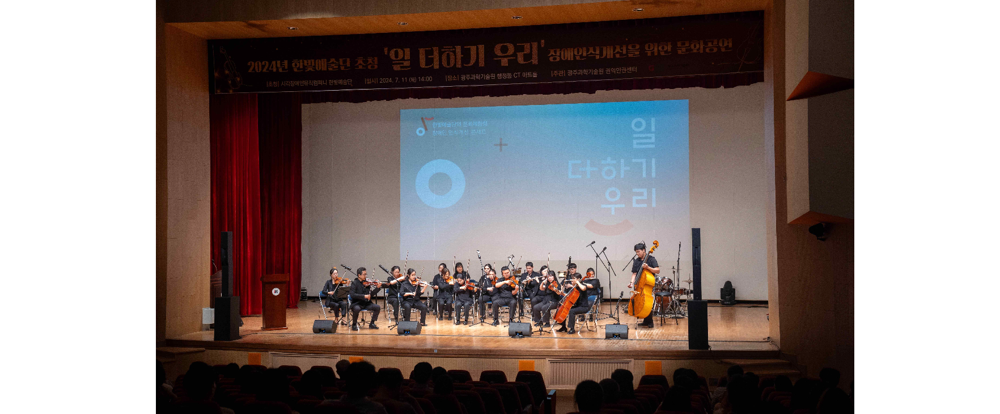▲ Hanbit Art Troupe is holding a cultural performance to improve awareness of disabilities at CT Art Hall in the Main Admin Building.

The Gwangju Institute of Science and Technology (GIST, President Kichul Lim) announced that on Thursday the 11th, it invited the ‘Hanbit Art Troupe’ to hold a performance titled ‘Work Plus Us’ at the CT Art Hall in the Main Admin Building to improve awareness of disabilities in the workplace.

About 250 GIST faculty and staff members attended the performance, which was designed to naturally eliminate prejudice against the disabled and create artistic empathy regardless of whether the disabled or non-disabled are in attendance.

Hanbit Arts Troupe is Korea's first and the world's only professional performance troupe for the visually impaired, founded in 2003 by visually impaired people with musical talent.

They have performed at major domestic performance halls such as Sejong Center for the Performing Arts and Lotte Concert Hall, and in particular, in 2022, they became the first disabled music group to pass the screening for the Seoul Arts Center and hold a solo concert at the concert hall. They are also actively engaged in domestic and international activities, such as performing at the closing ceremony of the 2014 Sochi Winter Olympics in Russia, the 2018 Pyeongchang Paralympic Games, and the Korea-ASEAN Summit.

On this day, the members of the Hanbit Arts Troupe synchronized their timing through a receiver instead of the conductor's hand gestures, and memorized all the music scores to achieve perfect harmony, leaving the audience with a gentle feeling of emotion.

The Hanbit Arts Troupe, which received applause and cheers from the audience throughout the performance, performed a total of 11 songs including encores through performances by the ‘Chamber Orchestra’, ‘Project The Band’, and ‘Brass Ensemble’. In particular, vocalist Ji-ho Kim of the ‘Project The Band’ team sang Jo Deok-bae’s ‘If You Come Into My Heart’ rhythmically, leading to applause and creating a concert-like atmosphere.

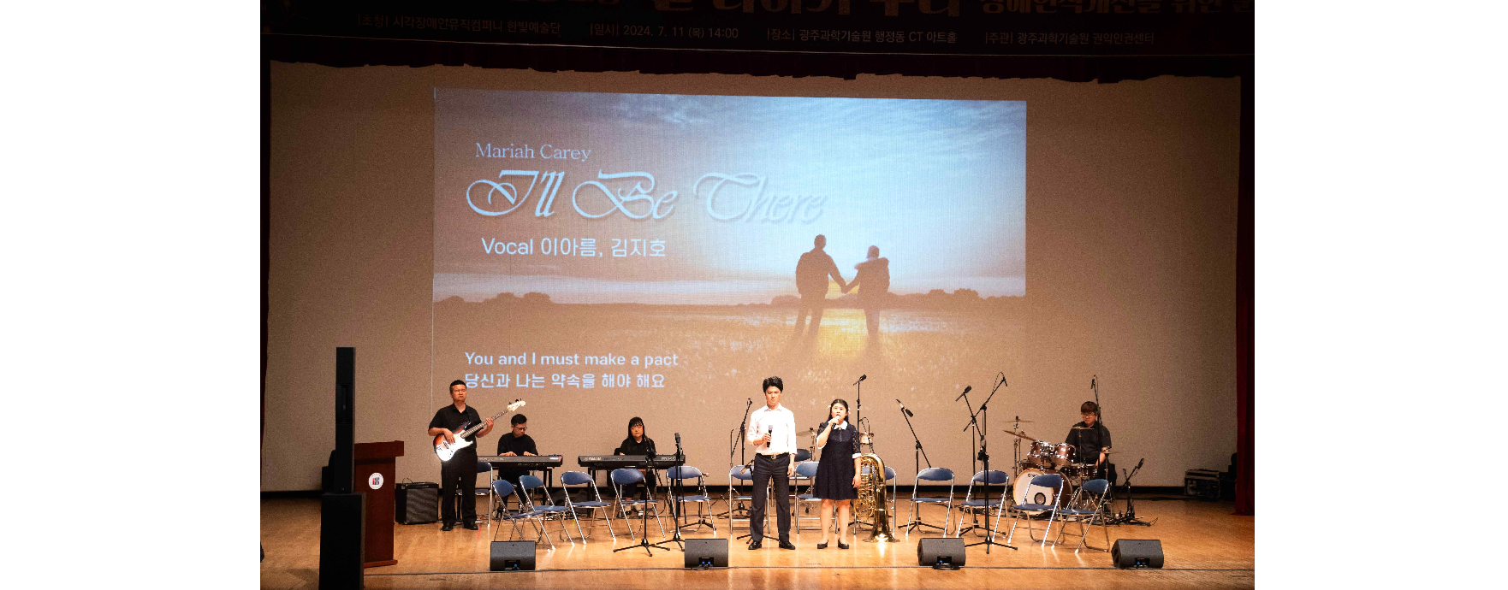▲ Hanbit Art Troupe Project The Band is performing. (Vocals: Ji-ho Kim, A-reum Lee)

One GIST member who attended that day said, "Despite the discomfort, through constant effort, the high-quality performance and the members' passion for music delivered a message of hope and positivity. It was an opportunity to think again about the culture of consideration and sharing."

Meanwhile, the Hanbit Art Troupe's invited performance 'One Plus Us' was held by the GIST Office of Human Rights and Legal Affairs with the support of the Korea Employment Promotion Agency for the Disabled to improve awareness of disabilities in the workplace.



