GIST-Chonnam National University undergraduate students hold programming competition '1st Algorithm Masters'... 100 college students from Gwangju area participate and compete

- The largest offline algorithm competition hosted by a student group in Korea... Total prize money of 1.5 million won
- Also attracting corporate sponsorship from Amazon Web Services (AWS)... Opportunity to hire CJ Olive Networks interns for winners of the Encouragement Award or higher “We will support information sharing among participants and hold the competition every year”

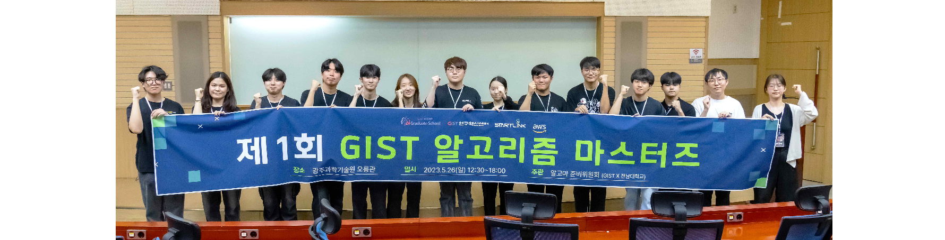▲ The Algoma Preparatory Committee is taking a commemorative photo after the conclusion of the ‘1st Algorithm Masters’ event.

The Gwangju Institute of Science and Technology (GIST, President Kichul Lim) announced that it successfully held the 1st Algorithm Masters, a college programming competition hosted by undergraduate students.

‘Algorithm Masters’ is a programming competition that aims to strengthen the university student network in the Gwangju area and guarantee educational opportunities for university students outside the metropolitan area. After preliminary applications in April and main applications in May, the final competition was recently held at GIST Oryong Hall.

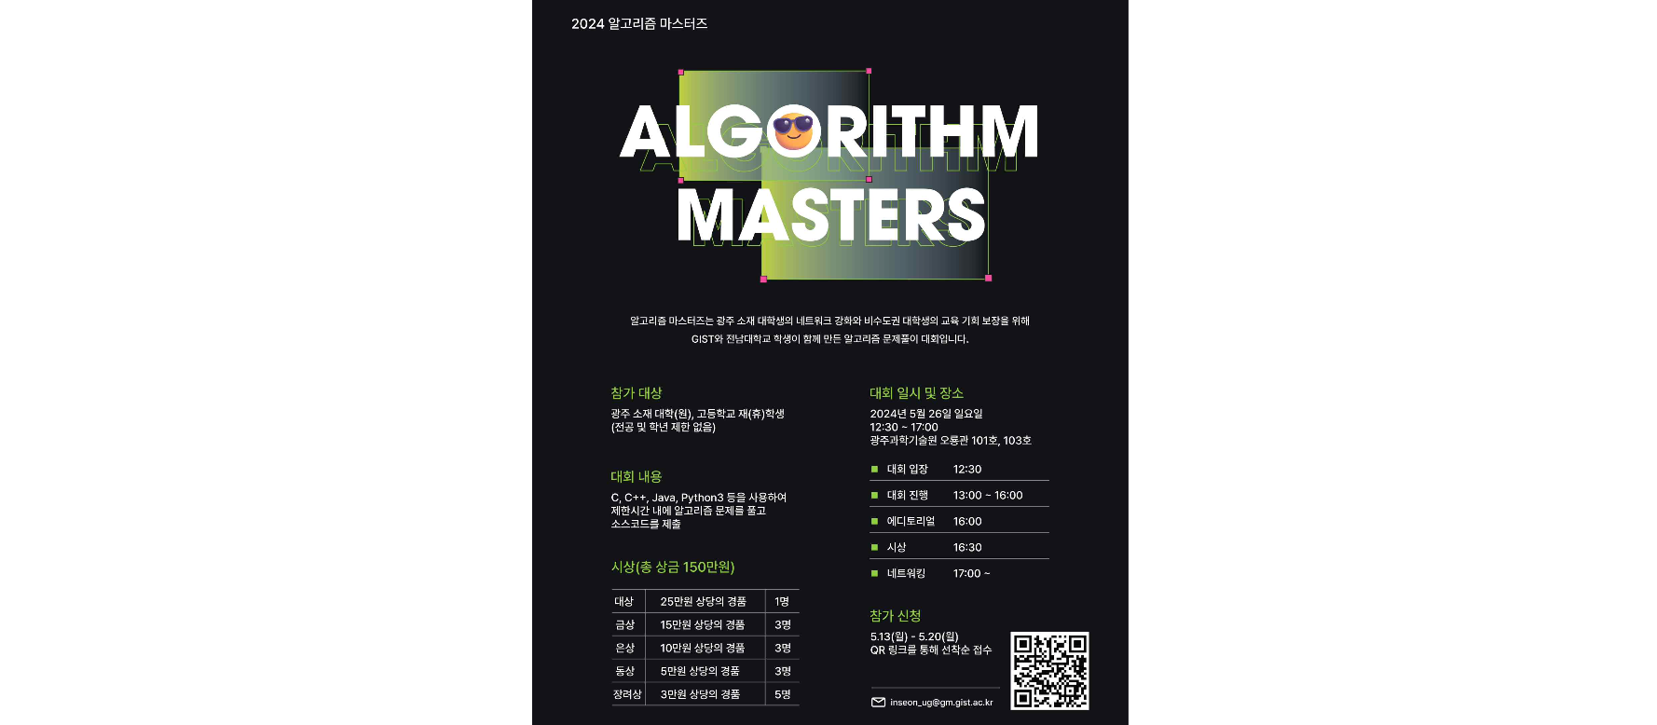▲ GIST Algorithm Masters Official Poster

About 100 students from GIST, Chosun University, Chonnam National University, and other universities in the Gwangju area participated in a heated competition, and one student from Mokpo Yeongheung High School also participated, drawing attention.

The competition was conducted by having participants log into the competition system and submit their codes to the competition server. The rankings were relayed in real time based on the current scores and problem-solving speed scored by the competition server.

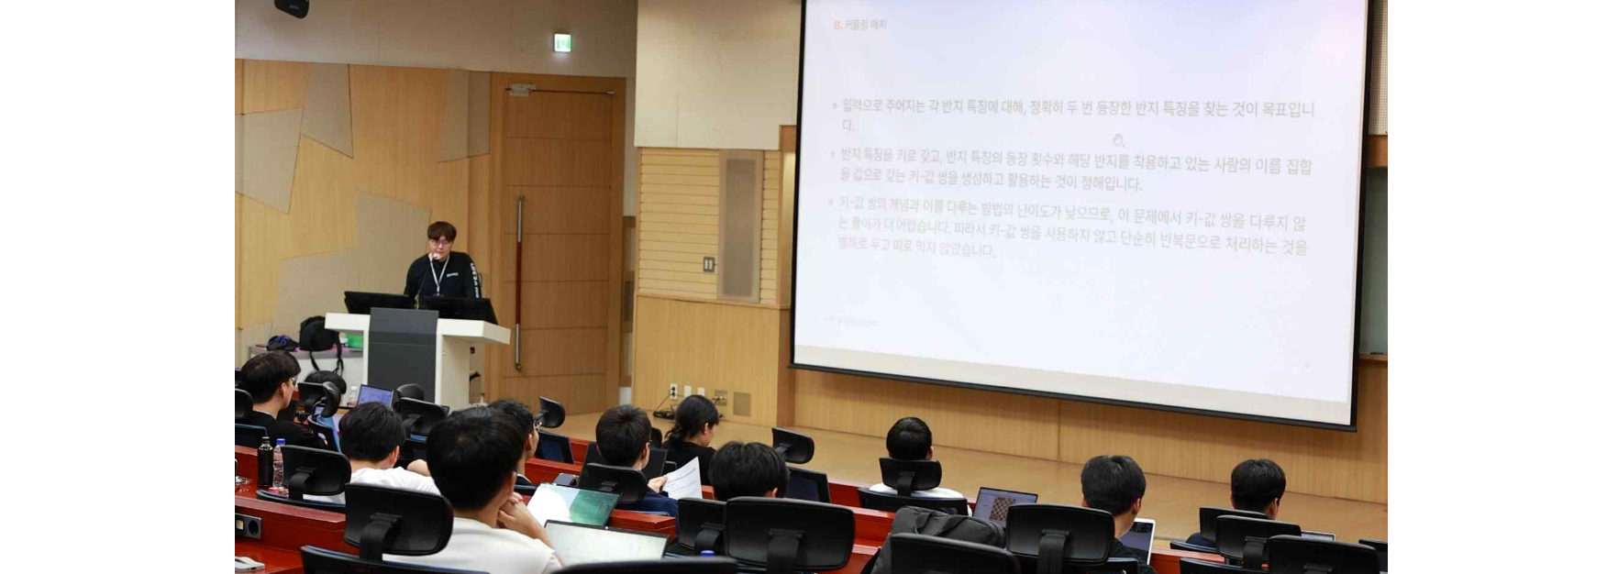▲ Hye-geun Song, the chair of the examination committee, is explaining the problem.

The total prize money for the competition is 1.5 million won, and winners of the encouragement award or higher will be given the opportunity to become interns at CJ Olive Networks.

The awards ceremony was held in Room 101 of Oryong Hall on the day of the competition ▴ Grand Prize (AI Graduate School Dean Award) Ho-jun Lee (GIST) ▴ Amazon Web Services (AWS) Special Award Yeon-woo Kim (GIST) ▴ Gold Prize Geun-seong Kim (Chonnam National University), Chae-hyeon Lim (GIST), Song-don Lee (GIST) ▴ Silver Prize Seon-mo Kim (GIST), Jeong-hun Seong (GIST), Hyeon-su Jang (Yeongheung High School) ▴ Bronze Prize Ji-in Kim (Chonnam National University), Joo-heon Song (Chosun University), Chan-hyeong Baek (Chosun University) ▴ Encouragement Prize Seon-myeong Kim (GIST), Geum-hwan Hwang (GIST), Jae-hyeong Kim (GIST), Do-hyeon Ko (GIST), Yeong-jin Jo (Chonnam National University), and 16 other participants were awarded.

The ‘Algoma Preparatory Committee’, which hosted the ‘1st Algorithm Masters’, is a student union organization formed voluntarily by GIST and Chonnam National University undergraduate students. In order to successfully host this competition, it attracted sponsorship from universities and companies, including GIST and AWS.

Most of the members belong to student groups related to programming (Info Team, Wing, PIMM) and entrepreneurship (MOP) at GIST and Chonnam National University, and the share common interests in the PS (Problem Solving) field and promoting student culture through events.

The response from participants was positive. According to the Algoma Steering Committee’s own feedback survey, all 24 respondents said they would like to participate again next year, and when asked about their overall satisfaction with the event, they gave an average score of 4.6, which is close to ‘very satisfied’ (5 points: very satisfied, 1 point: very dissatisfied).

In a survey asking why they participated (multiple responses allowed), nearly half of the participants, 41.7%, responded that they participated in this competition because they wanted to develop their algorithmic capabilities.

▲ Infographic of responses to the Algoma Steering Committee’s own survey regarding reasons for participation

“It wasn’t a long time to prepare for the competition, but we were able to successfully complete this competition thanks to the active cooperation and support of the GIST AI Graduate School, Research Innovation Center, and other related parties,” said In-seon Hwang, the chairperson of the ‘Algoma Steering Committee.’ He added, “We will continue to support algorithm study and information sharing among participants through the participant Discord channel and hold the competition annually.”



