“Going beyond schools and departments to solve creative problems” GIST-Hannam University co-hosts ‘Micro Design Challenge Hackathon’

- From July 9th (Tuesday) to 12th (Friday), 4 days of creative convergence education and innovative prototype production practice based on design thinking methodology... 32 undergraduate students from GIST and Hannam University formed 5 teams to produce prototypes
- “Introducing a new type of educational paradigm that blurs the boundaries between academics and schools”... The ‘E1I5’ team that produced ‘a robot/application to promote adoption of abandoned animals and prevent abandonment’ for the grand prize

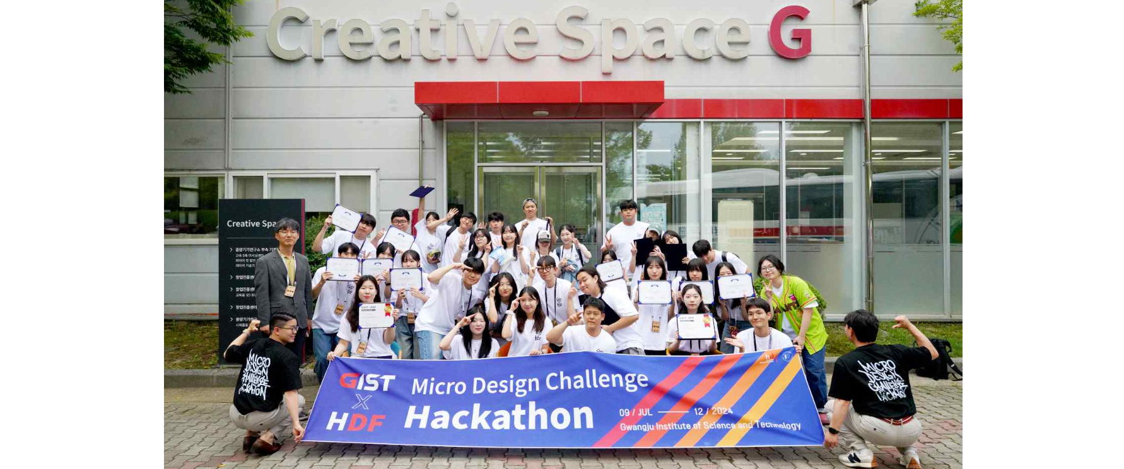▲ GIST Korea Culture Technology Research Institute and Hannam University Design Factory co-hosted the ‘Micro Design Challenge Hackathon’ and participants took a group photo.

The Gwangju Institute of Science and Technology (GIST, President Kichul Lim) announced that it held the 'Micro Design Challenge Hackathon' co-hosted by GIST Korea Culture Technology Institute (Director Kyung-Joong Kim) and Hannam University Design Factory* to foster multidisciplinary creative convergence talent and discover innovative ideas.

This event was held at 'Creative Space G', a complex startup space on the GIST campus, for four days from Tuesday, July 9th to Friday, July 12th, where professional capabilities in engineering, design, and management could demonstrate mutual synergy. Trainees were recruited in advance so that a total of 32 college students participated, including 10 GIST undergraduate students and 22 Hannam University video design and management students.

* Design Factory: A multidisciplinary creative convergence educational innovation platform where students from different majors gather in teams to share ideas and develop creative prototypes requested by companies by breaking down the boundaries between departments.

This hackathon competition was conducted through the process of taking theoretical training such as deriving ideas, defining problems, and establishing business strategies based on the design thinking* methodology, and forming teams in each field to materialize the ideas.

Trainees consisting of various majors were divided into five teams and listened to lectures on design thinking methodology by Professor Hyun-woong Jin (Department of Business Administration) and Professor Geum Yoo (Department of Media and Film) at Hannam University and participated in the hackathon's main theme, 'Delight and Fun'. They selected subtopics such as freedom, inclusion, and interaction, and went through the process of producing and verifying their ideas as prototypes according to their respective major capabilities using the 3D printer and laser processing machine provided at GIST's 'Creative Space G'.

* design thinking: A product service development method that focuses on solving customer problems. It refers to a method of applying design thinking not only to the product appearance or development stage but also to the entire process, including demand research, planning, and marketing.

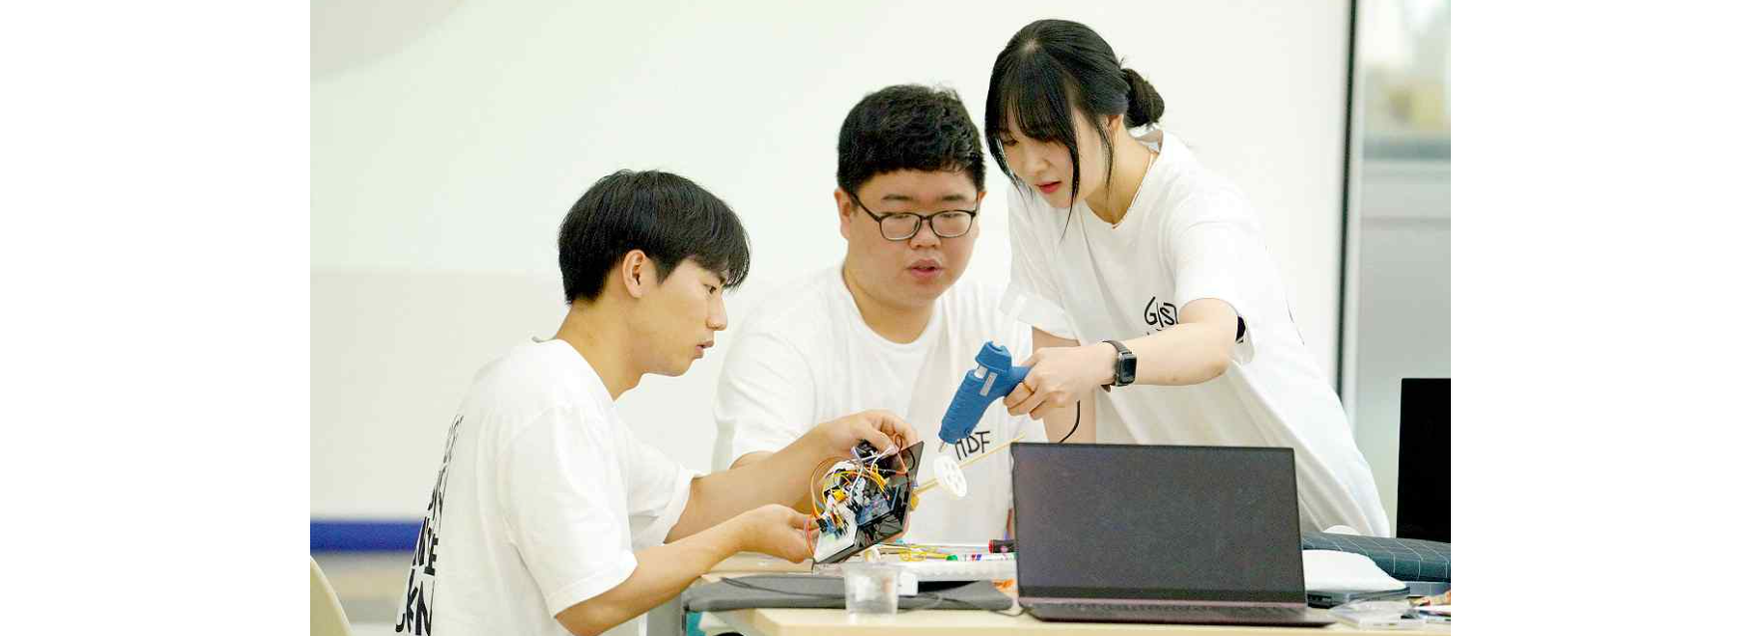▲ Students who participated in the ‘Micro Design Challenge Hackathon’ are creating a prototype at GIST ‘Creative Space G’.

Among the entries from a total of 5 teams, the grand prize winner was the 'E1I5 team' (GIST School of Electrical Engineering and Computer Science students Dae-hee Go and Byeong-hyeok Kwak, Hannam University students Ye-ji Lee, Chae-young Lee, Jun-hee Park and Min-ki Choi) won. The first prize went to the ‘Money Game Team’ (GIST School of Mechanical Engineering student Mi-hye Jeon and 5 others) and the ‘Wheist Team’ (GIST Division of Liberal Arts and Sciences Do-wan Kwon and 6 students).

Regarding this hackathon, which was held at GIST for four days, Korea Culture Technology Institute Director Kyung-Joong Kim said, "It is most significant in that it introduced a new type of educational paradigm that broke down the boundaries between academics and schools."

Director Kim also said, "Recently, creative problem-solving capabilities through multidisciplinary-based education are becoming more important. Using this hackathon as an opportunity, we will actively pursue various collaborative projects to fully demonstrate convergent thinking and creative capabilities among students in engineering, art, and management fields."



