“The Science and Technology Institute’s older sister and older brother came to our school!” GIST holds a ‘Visiting Science Camp’ with approximately 20 students visiting middle schools in Myeon-do

- The student social contribution group ‘PIUM’ visited Juam Middle School (Suncheon) and Bonghwang Middle School (Naju) with Professors Kangwook Kim and Yunho Lee to provide science classes, special lectures, and career mentoring.
- “Providing equal educational opportunities without obstacles to more science dreamers”

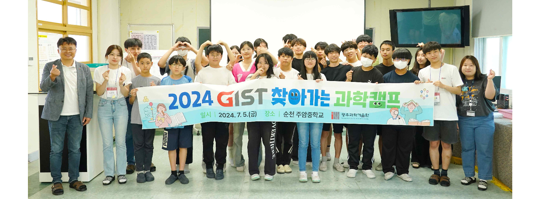▲ GIST social contribution group ‘PIUM’ visits Suncheon Juam Middle School to hold a ‘Visiting Science Camp’ and take commemorative photos with students.

The Gwangju Institute of Science and Technology (GIST, President Kichul Lim) has a social contribution group called ‘PIUM*’ and announced visits to Juam Middle School (Suncheon-si) and Bonghwang Middle School (Naju-si) in Jeollanam-do as part of its knowledge sharing social contribution activities to hold a ‘Visiting Science Camp’.

GIST has been conducting various science camps and educational volunteer services for elementary, middle, and high school students since 2010, and it is operating in a more systematic and efficient manner by integrating and expanding existing social contribution and career mentoring programs.

* PIUM (Positive, Interaction, Understanding, Mind): Just as you sow seeds and give water and fertilizer to make flowers bloom, it contains the meaning of making flowers bloom in society and spreading the scent of GIST through social contribution activities.

The ‘GIST Visiting Science Camp’, which has been running for the third year this year, is a representative program of ‘Pium’, a social contribution group composed of GIST students who directly visit middle schools in educationally underprivileged areas such as Gwangju, Jeollanam-do, North Korea, and remote islands to provide interesting and diverse classes and special lectures as well as opportunities to improve science learning skills and creative thinking, including career mentoring.

The first science camp of this year was held on the 5th (Friday) for 20 students from Juam Middle School in Suncheon City, and the second science camp was held on the 12th (Friday) for 22 students from Bonghwang Middle School in Naju City.

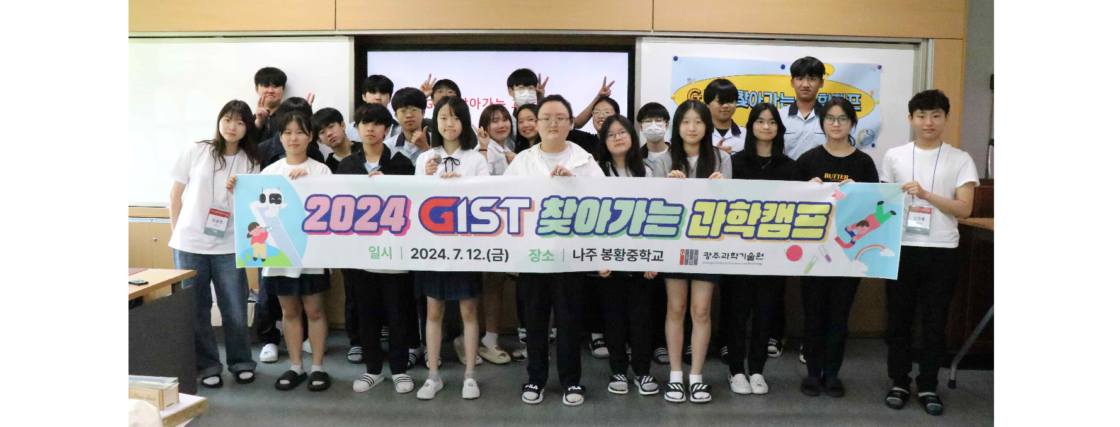▲ GIST social contribution group ‘PIUM’ visits Bonghwang Middle School in Naju to hold a ‘Visiting Science Camp’ and took a commemorative photo with students.

The science camp featured a variety of interesting and diverse programs, such as ▴ making an obstacle-avoidance autonomous car (AI), ▴ making an eco-friendly water bottle (earth & environment), and ▴ learning breadboards and making acrylic lamps (electricity).

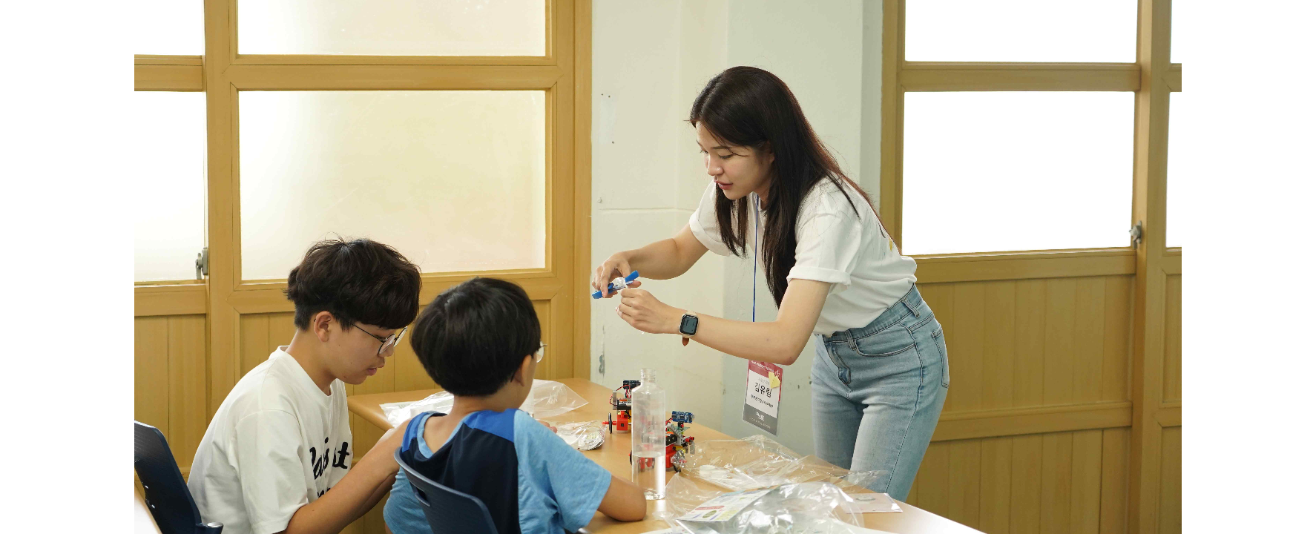▲ GIST social contribution group ‘PIUM’ is conducting the ‘Oh, make a bouncy ball’ program with Juam Middle School students during the ‘Visiting Science Camp’.

In particular, Professor Kangwook Kim (School of Electrical Engineering and Computer Science) and Professor Yunho Lee (School of Earth Sciences and Environmental Engineering) accompanied the visits to Juam Middle School and Bonghwang Middle School, respectively, to teach 'electromagnetic wave technology, a key technology for human development' (Professor Kang-wook Kim) and 'sustainable water science and engineering' (Professor Yunho Lee). Special lectures and career mentoring were conducted on the topic, and student interest and participation were higher than ever.

President Kichul Lim said, "I am happy to be able to utilize GIST’s excellent human resources to carry out knowledge sharing activities and practice social responsibility. We will strive to lay the foundation for nurturing future scientific talent by expanding our social contribution activities and providing equal educational opportunities to more science dreamers without obstacles."

Meanwhile, GIST's social contribution group 'PIUM' is actively volunteering to share knowledge through ▴ visiting science camps, ▴ online mentoring (online learning and career mentoring) ▴ science camps (AI science camps, offline experiential AI education programs), etc.



